拆解过程
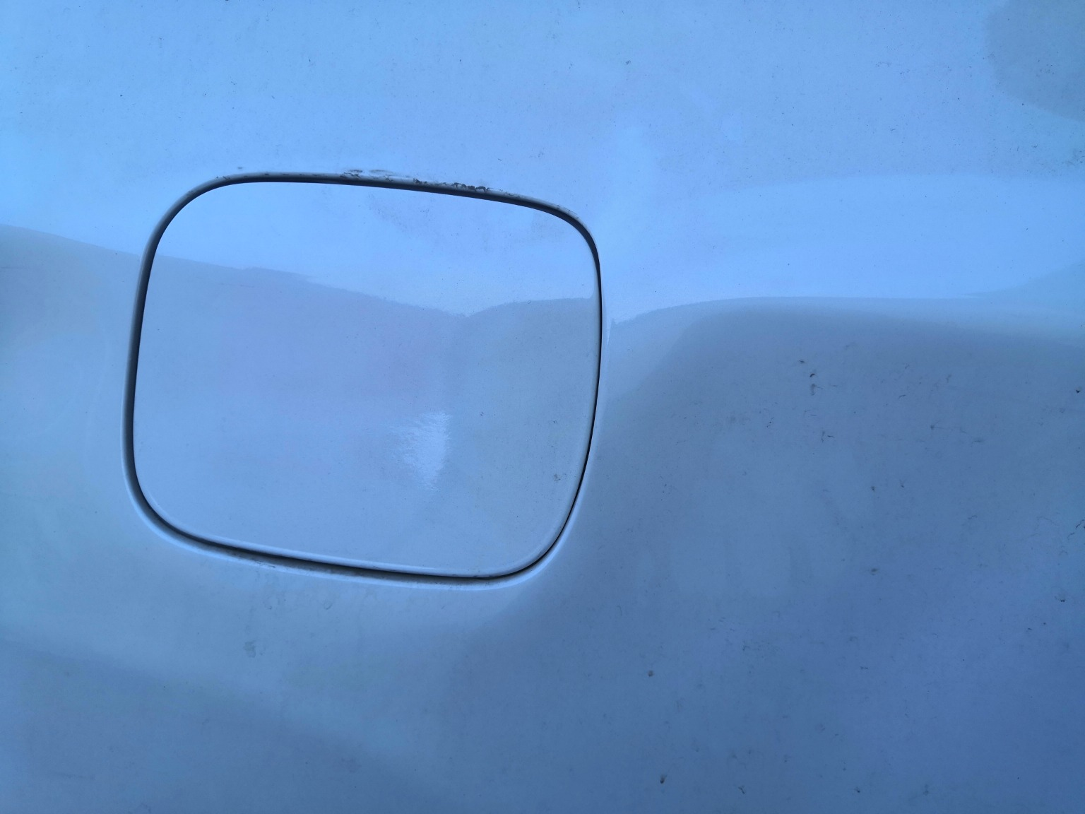 | 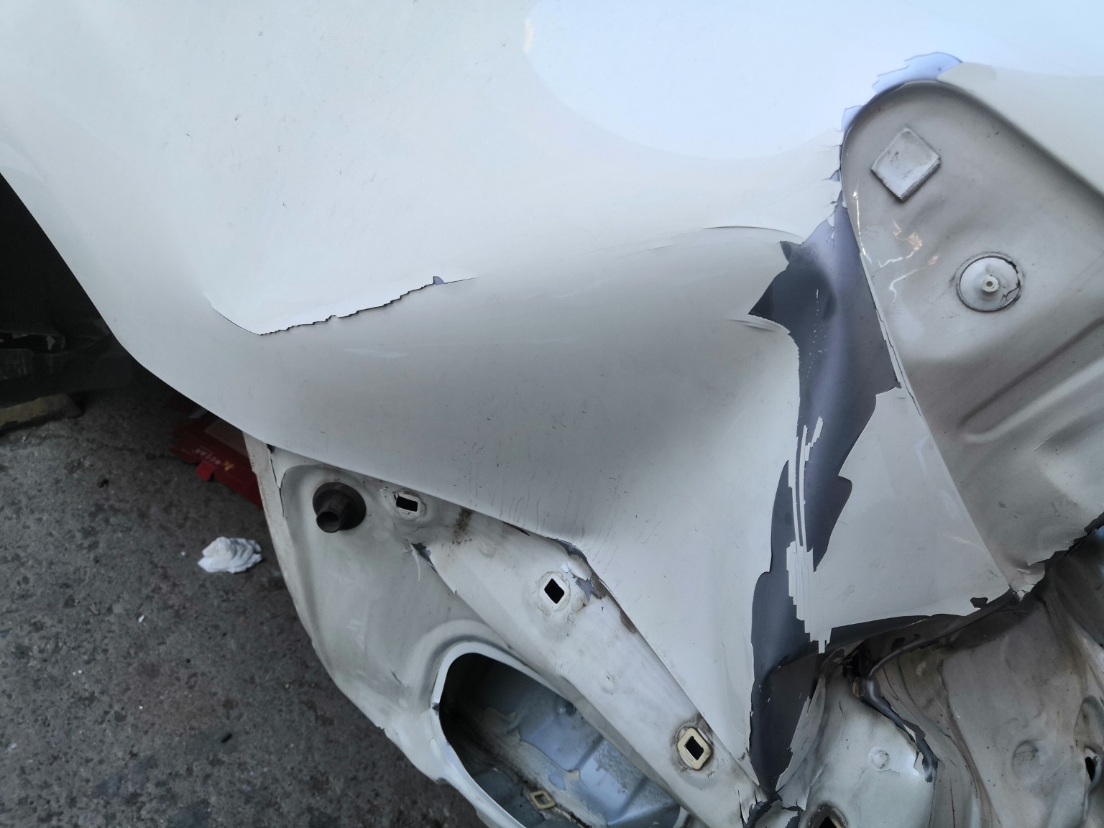 | 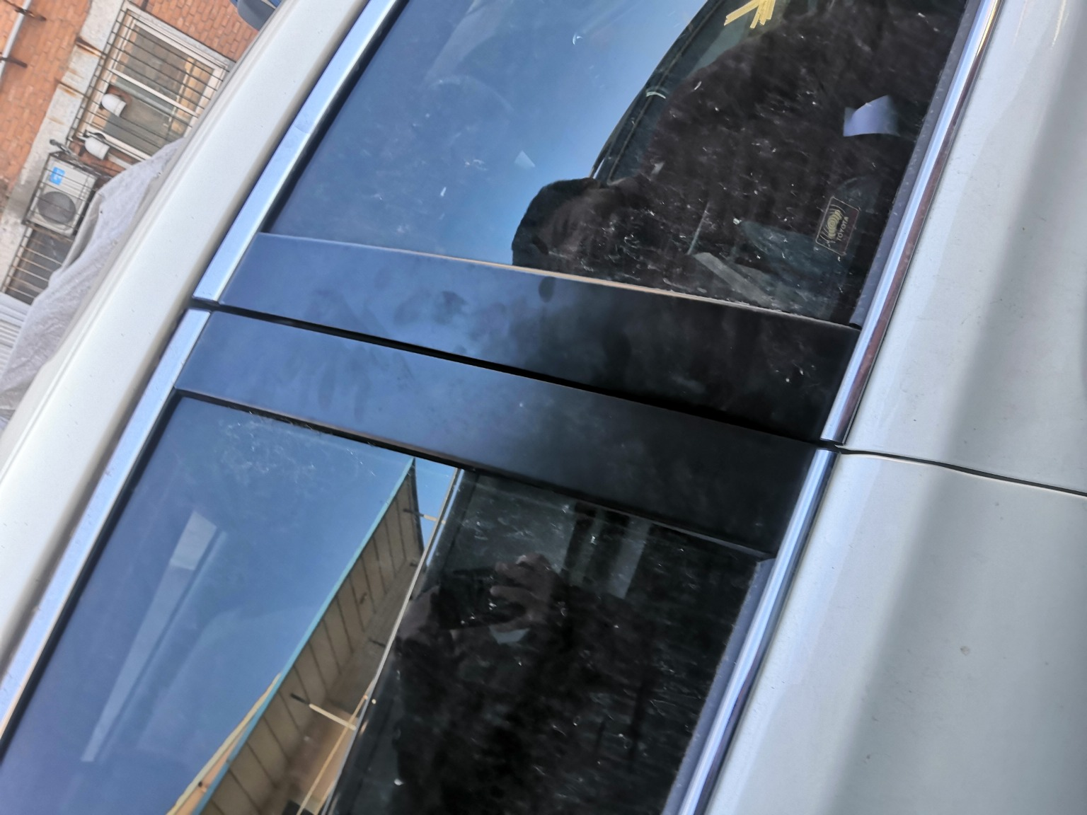
IMG_20201127_133350.jpg | IMG_20201127_133344.jpg | IMG_20201127_133519.jpg
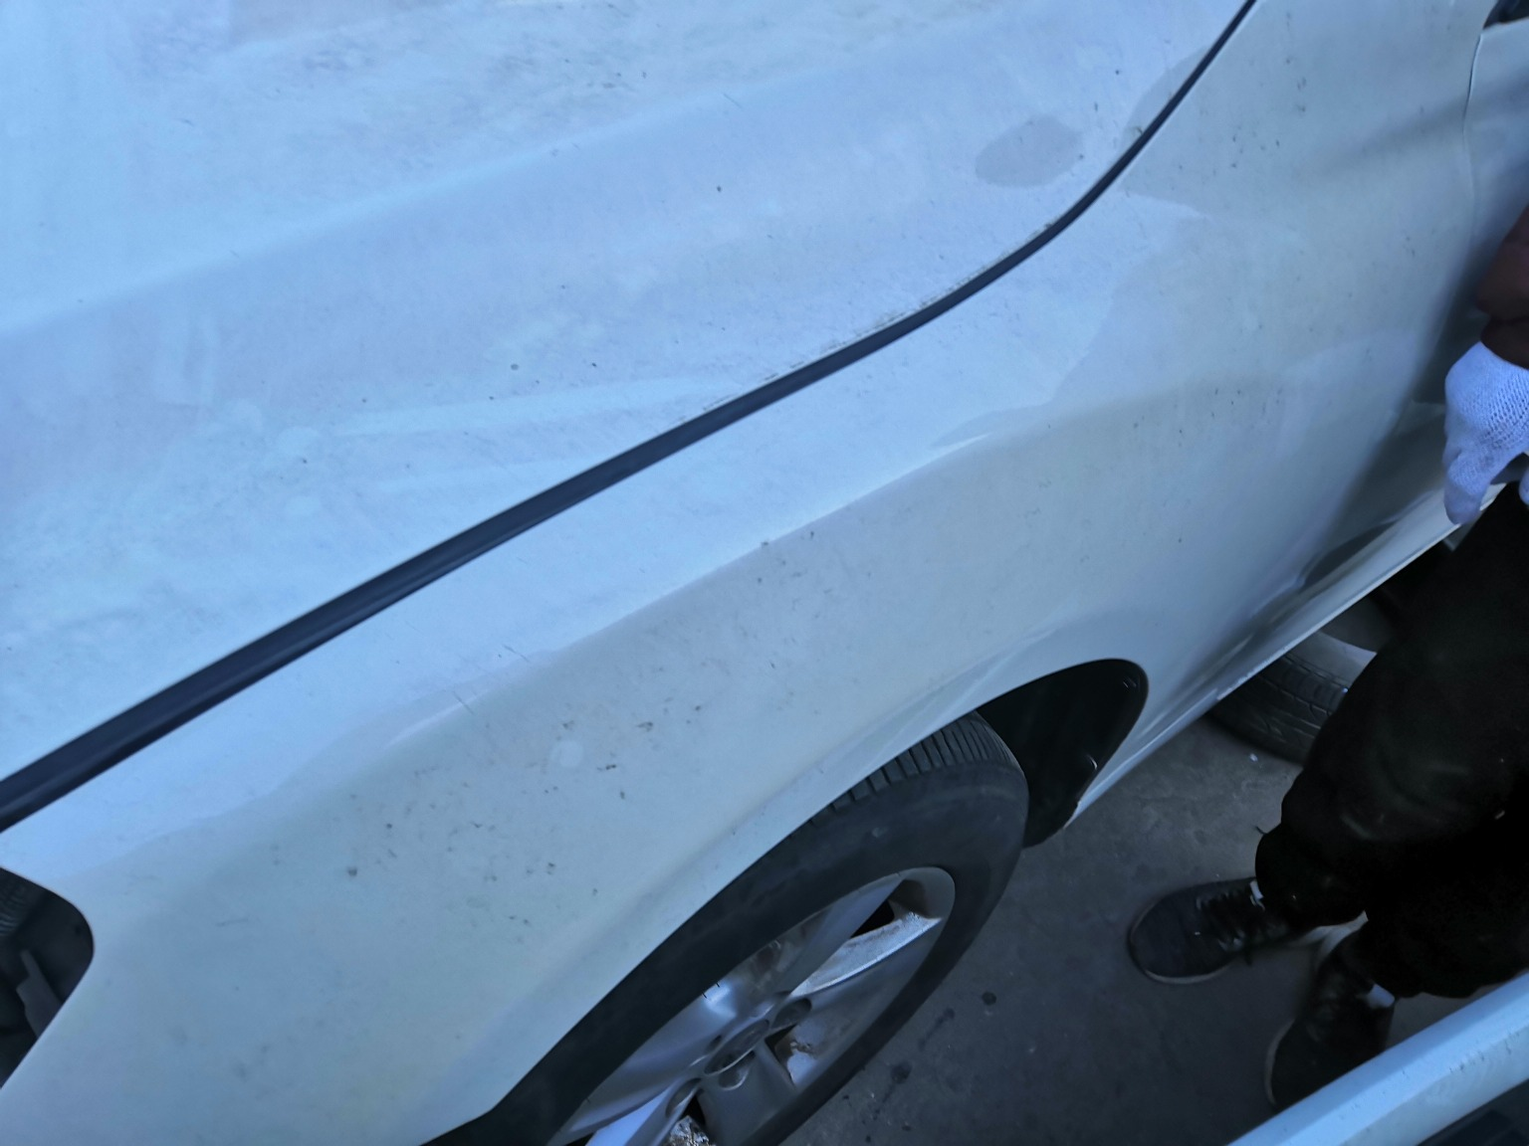 | 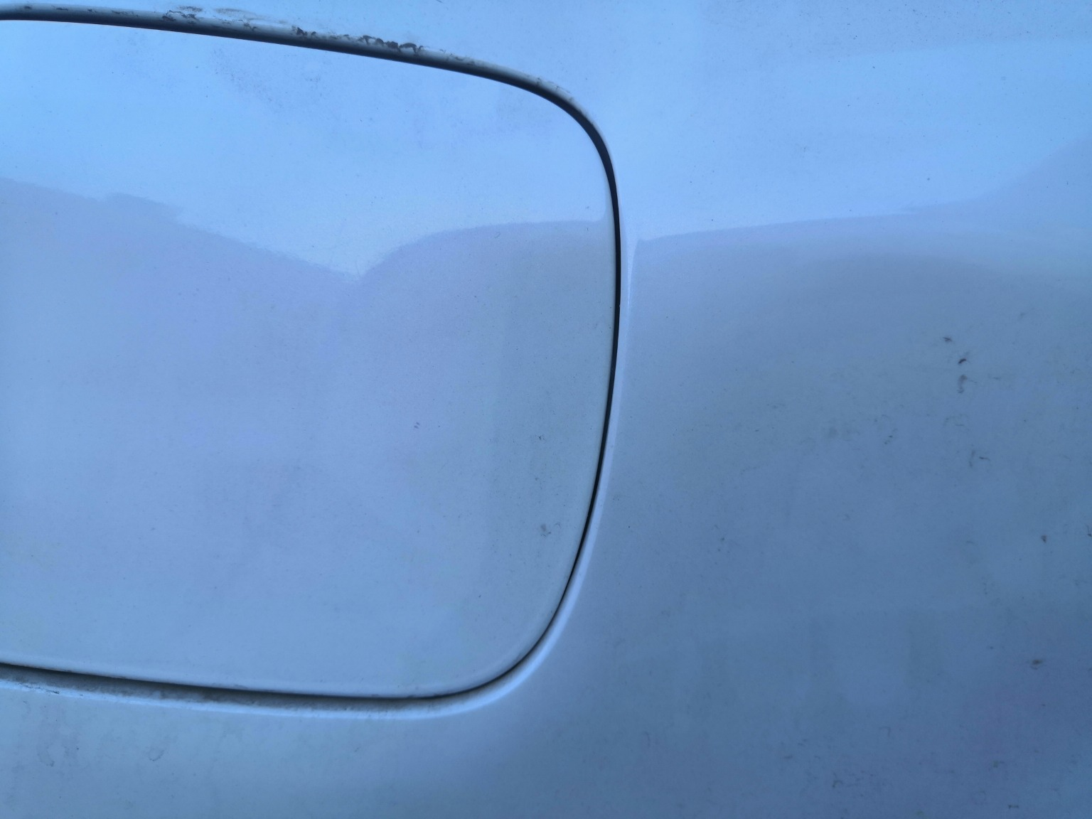 | 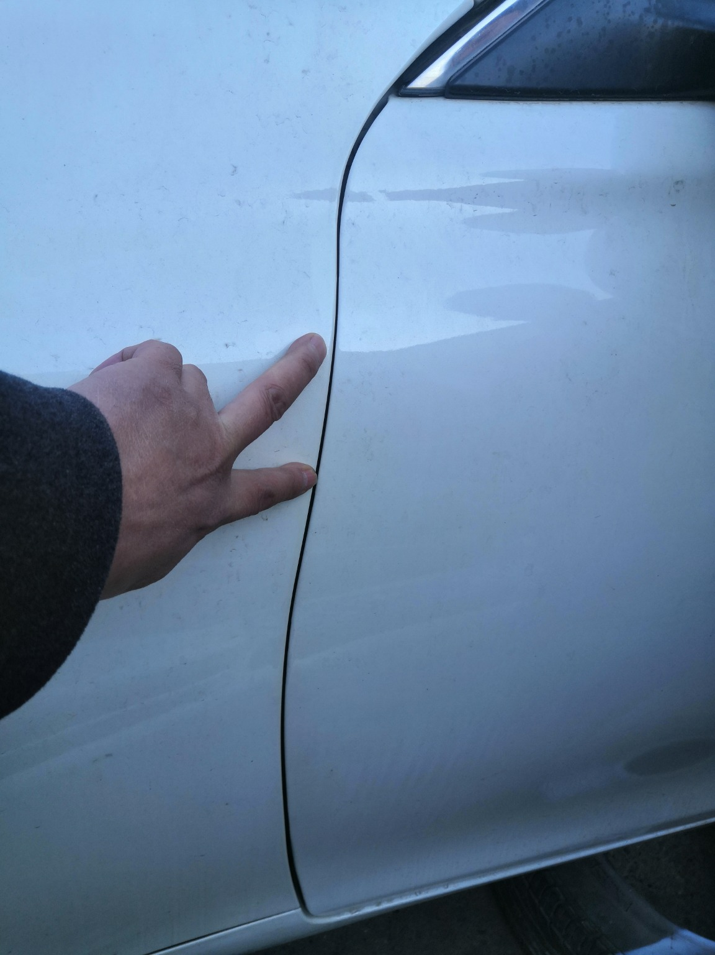
IMG_20201127_133450.jpg | IMG_20201127_133348.jpg | IMG_20201127_133446.jpg
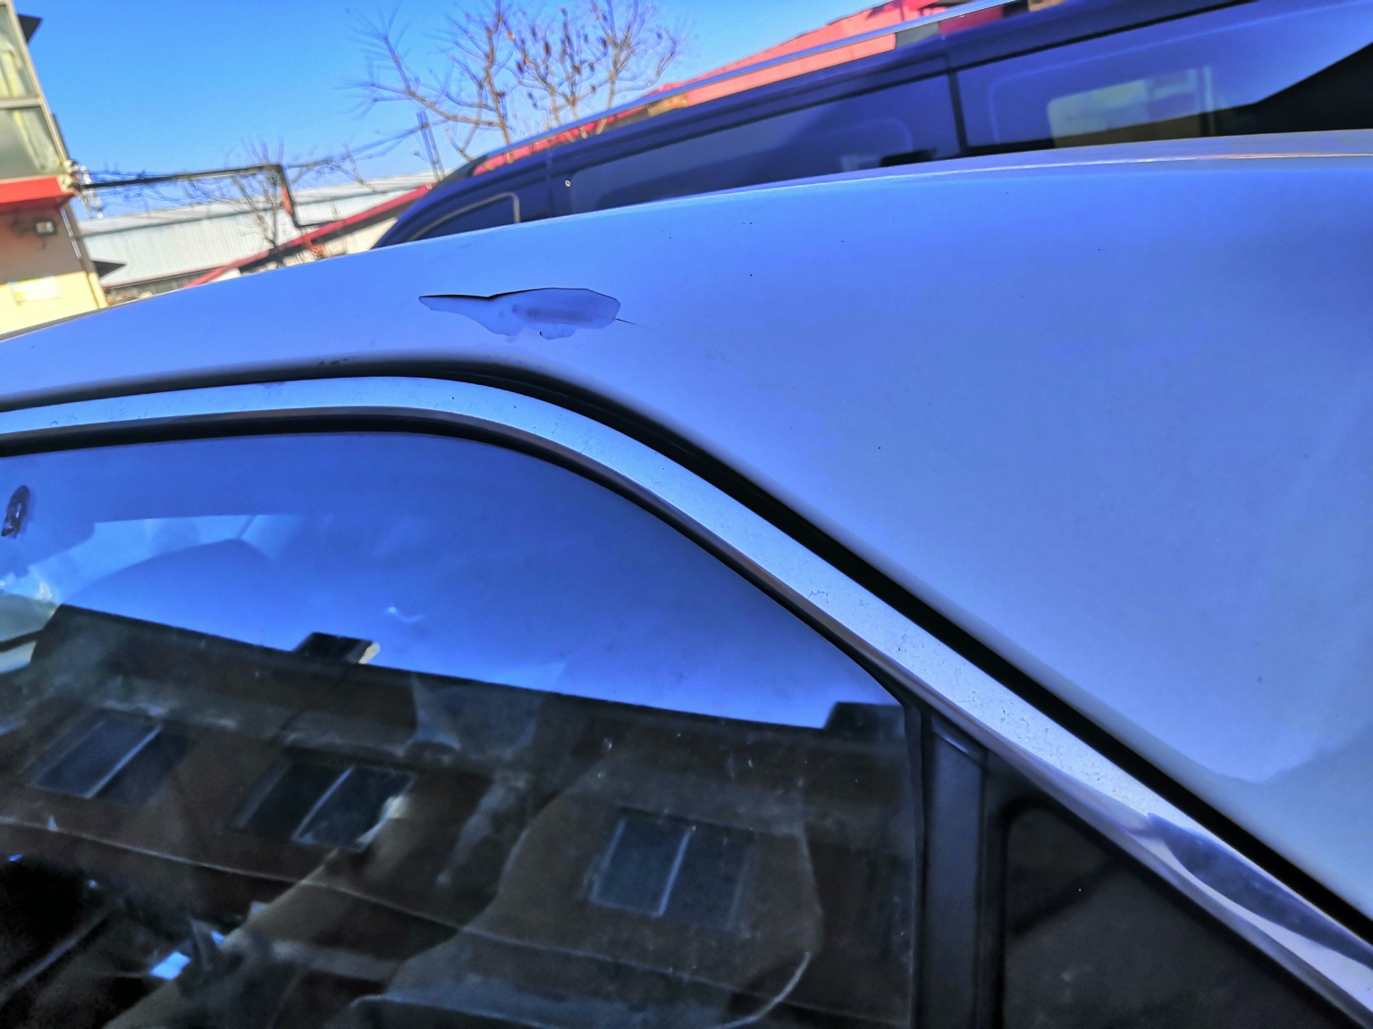 | 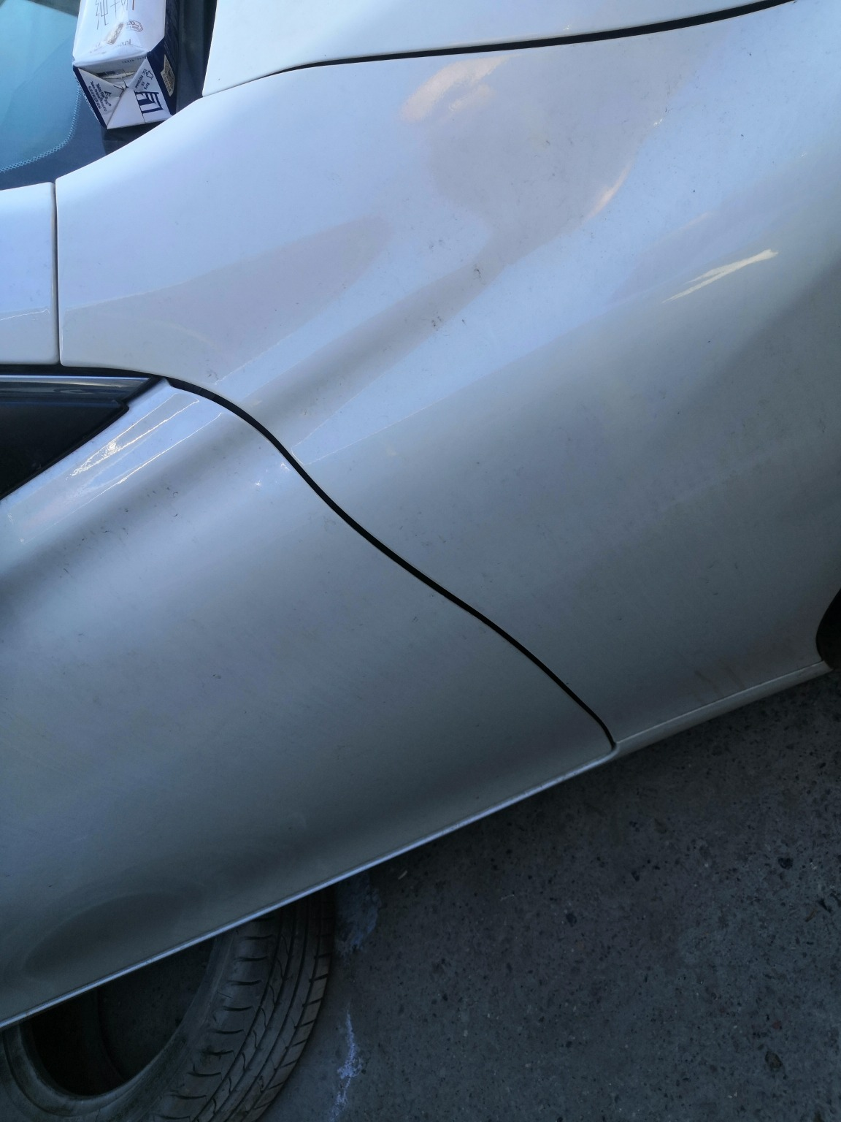 | 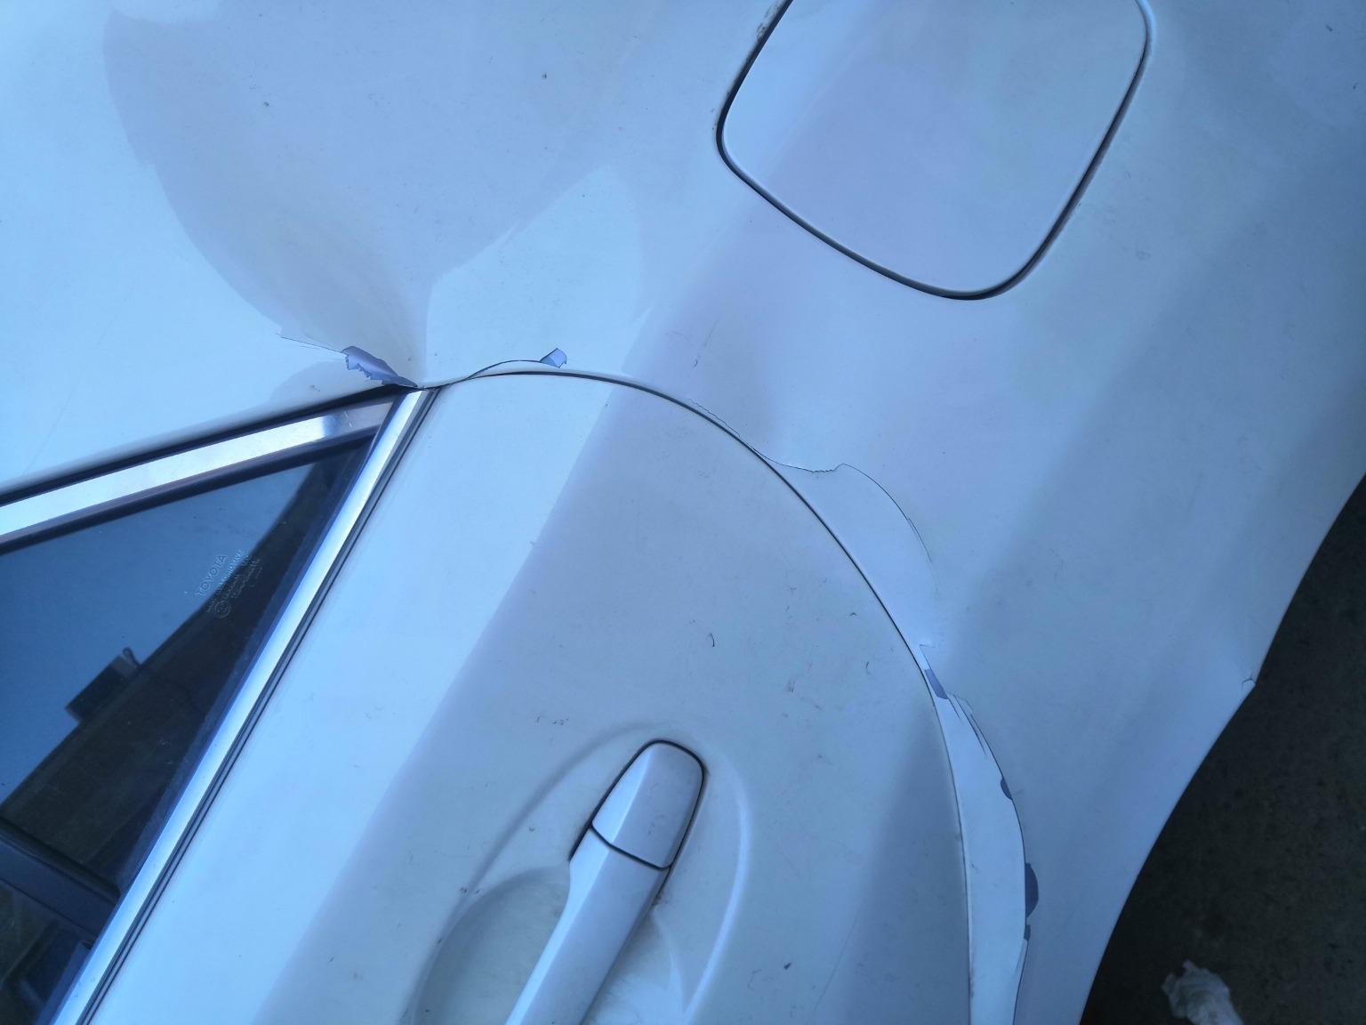
IMG_20201127_133412.jpg | IMG_20201127_133509.jpg | IMG_20201127_133355.jpg

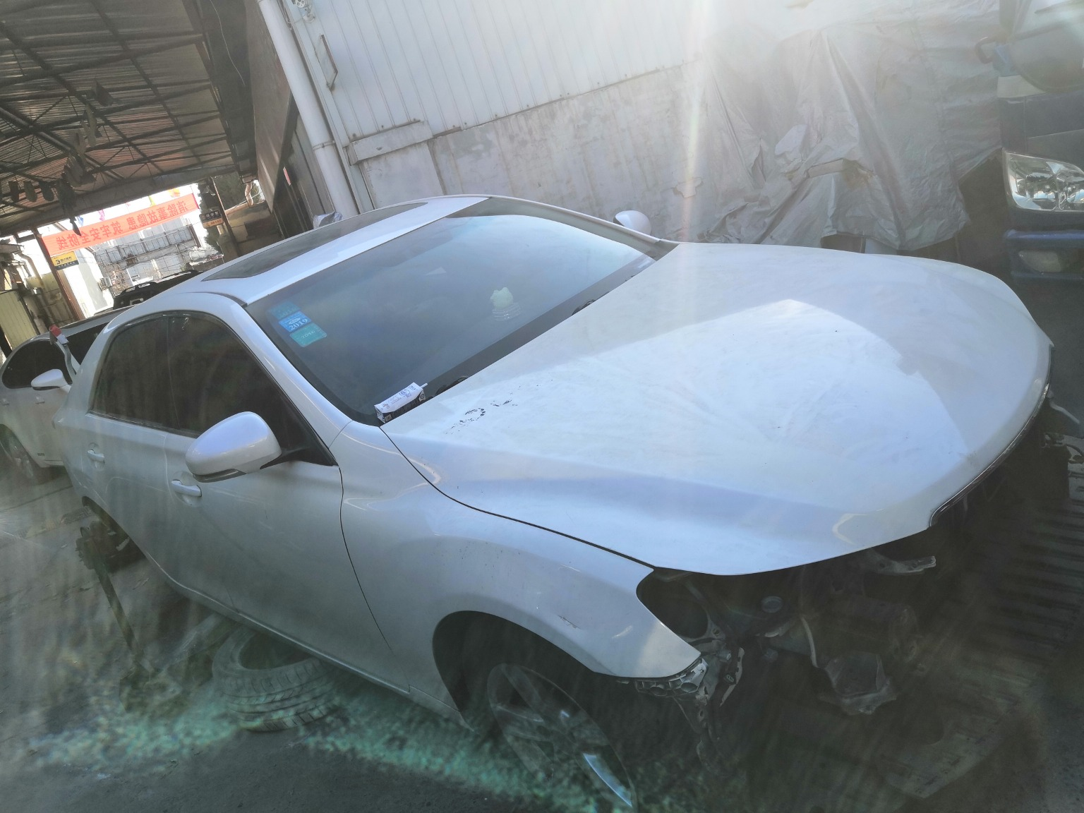 | 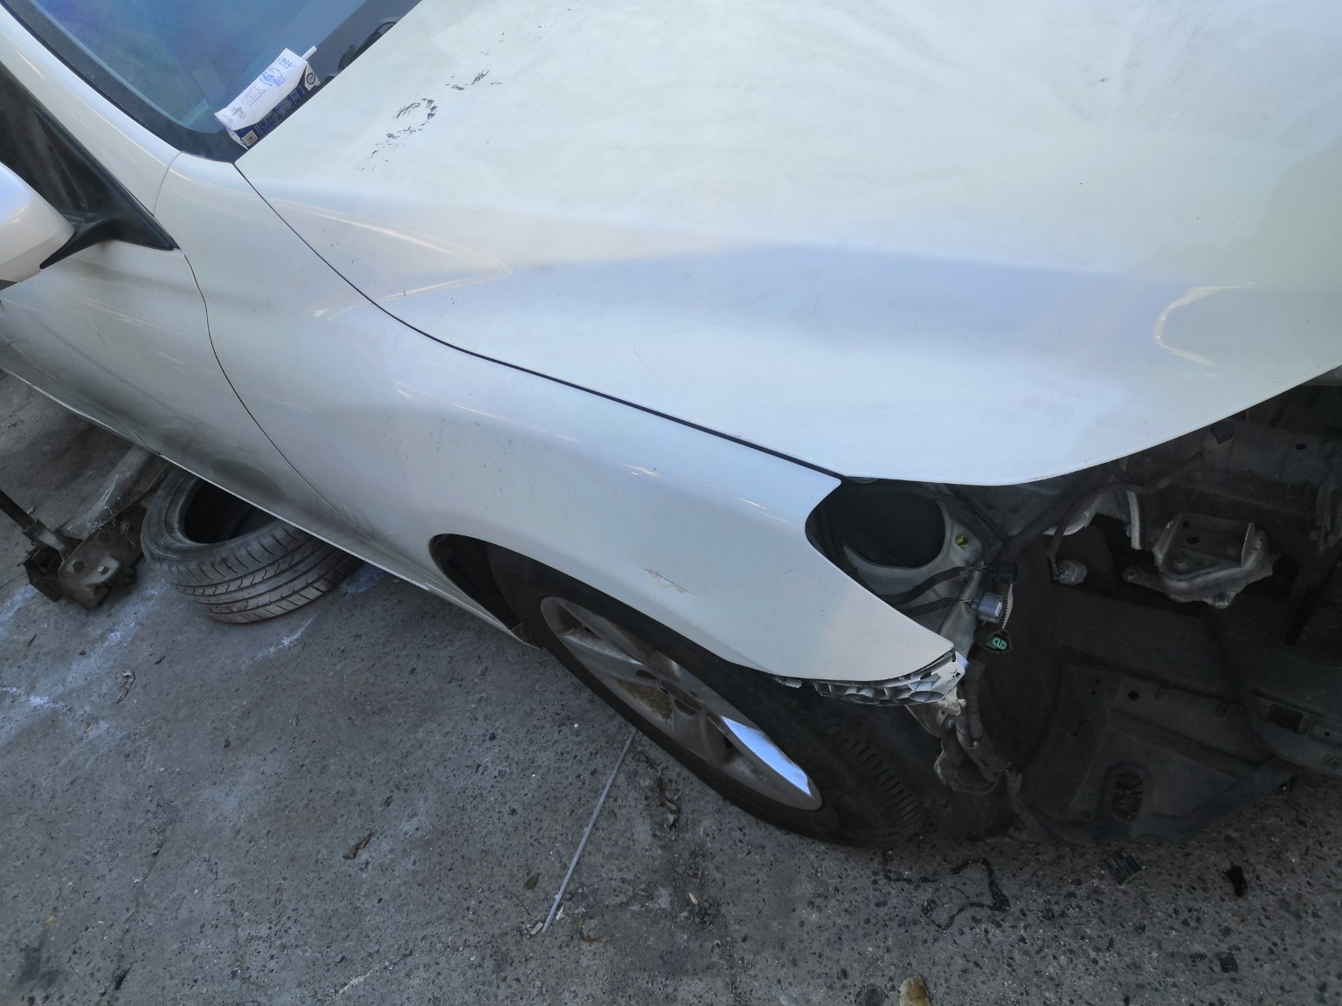 | 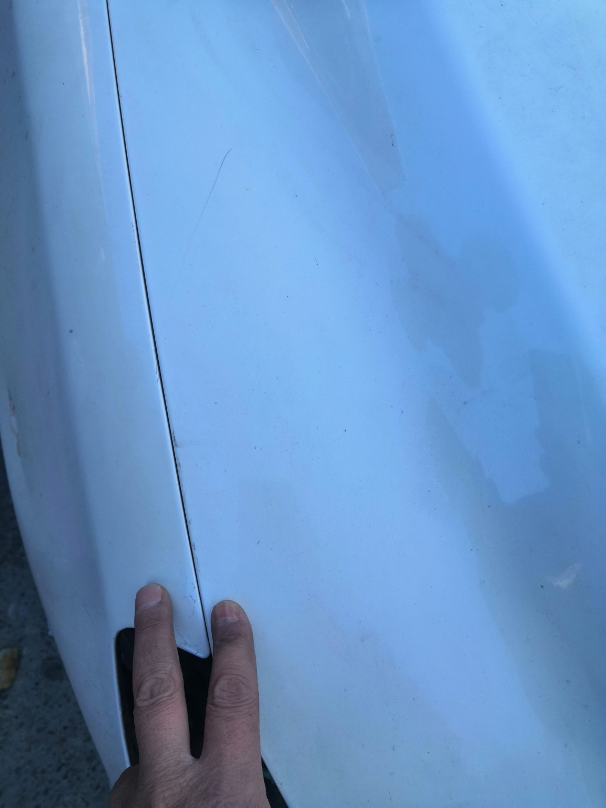
IMG_20201127_133312.jpg | IMG_20201127_133501.jpg | IMG_20201127_135318.jpg
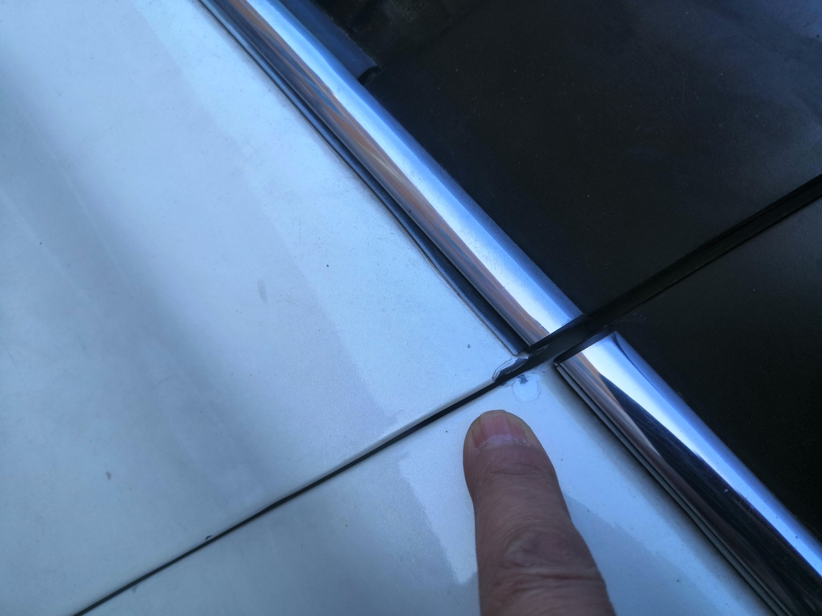 | 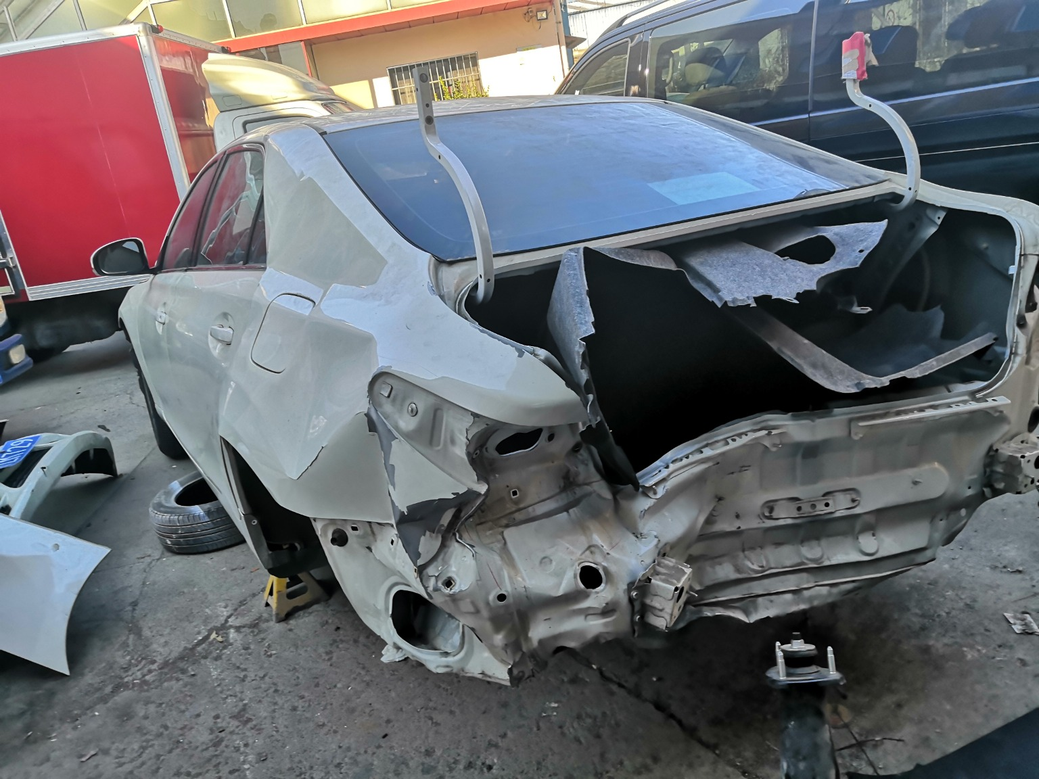 | 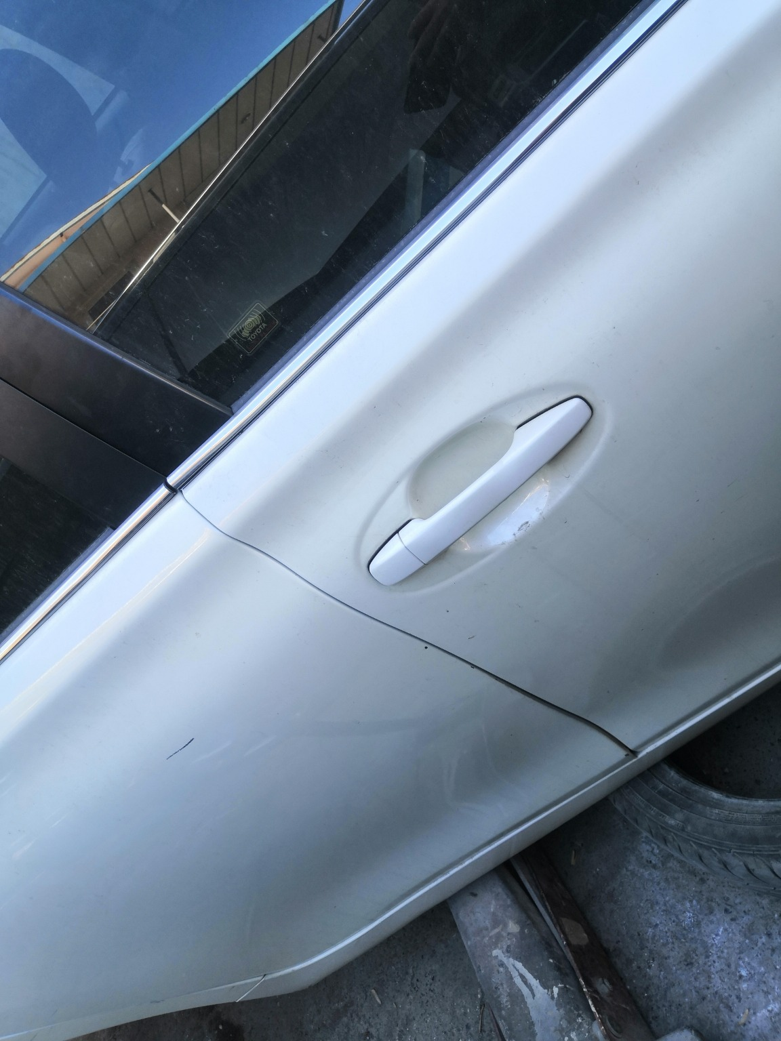
IMG_20201127_133433.jpg | IMG_20201127_133336.jpg | IMG_20201127_133515.jpg
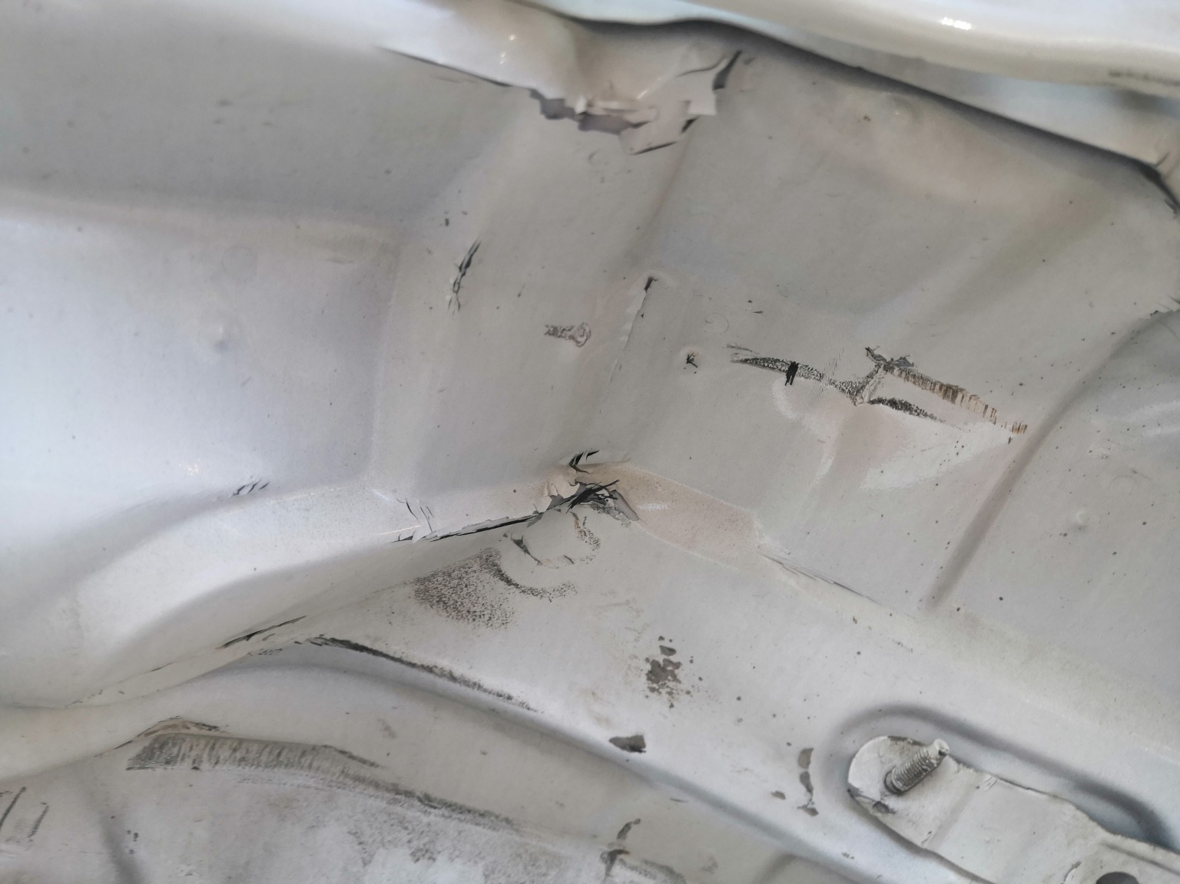 | 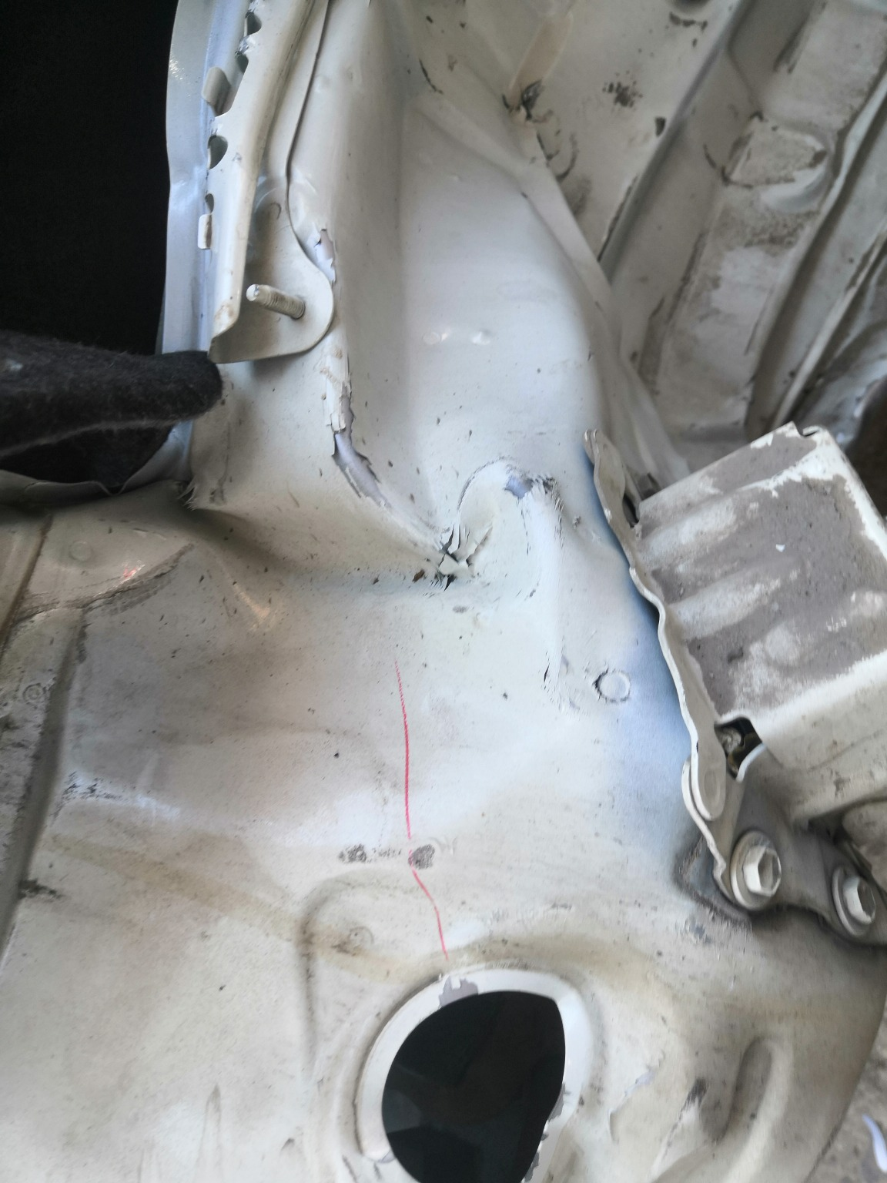 | 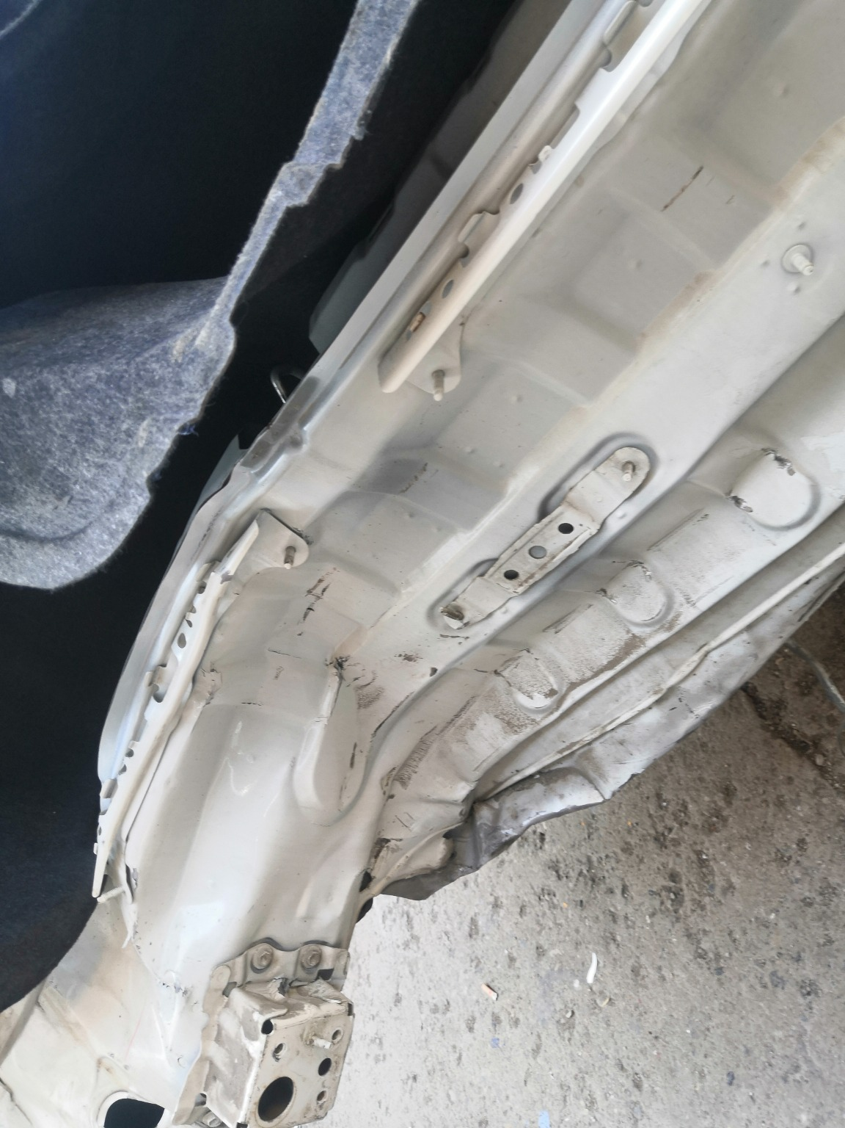
IMG_20201127_133600.jpg | IMG_20201127_133547.jpg | IMG_20201127_133543.jpg

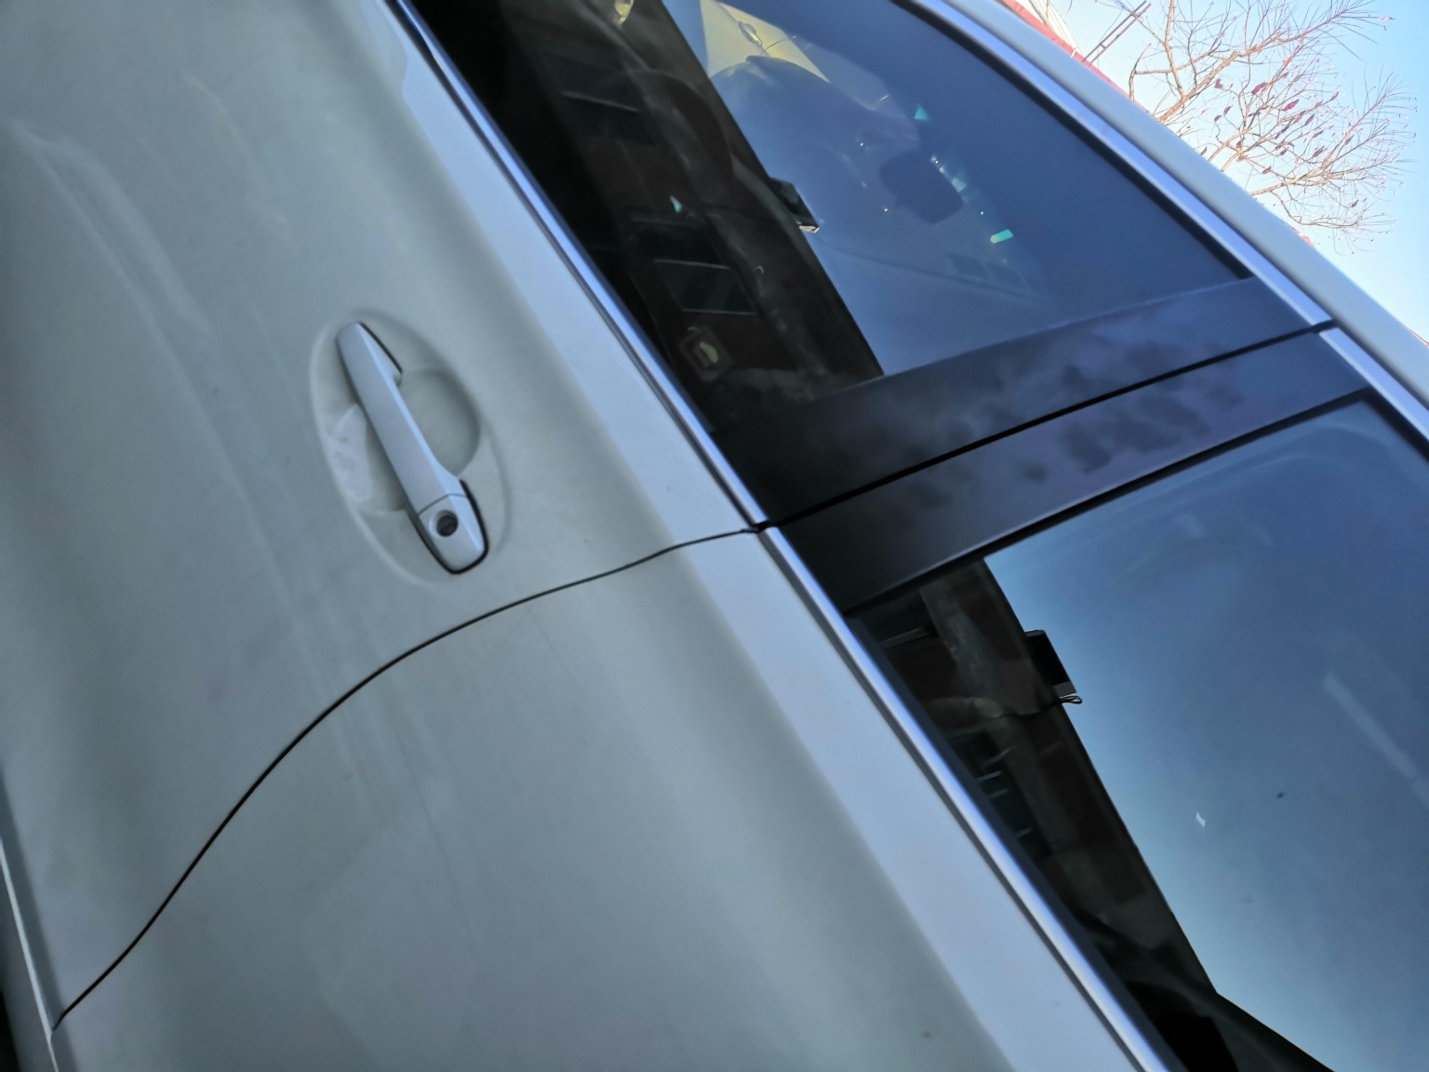 | 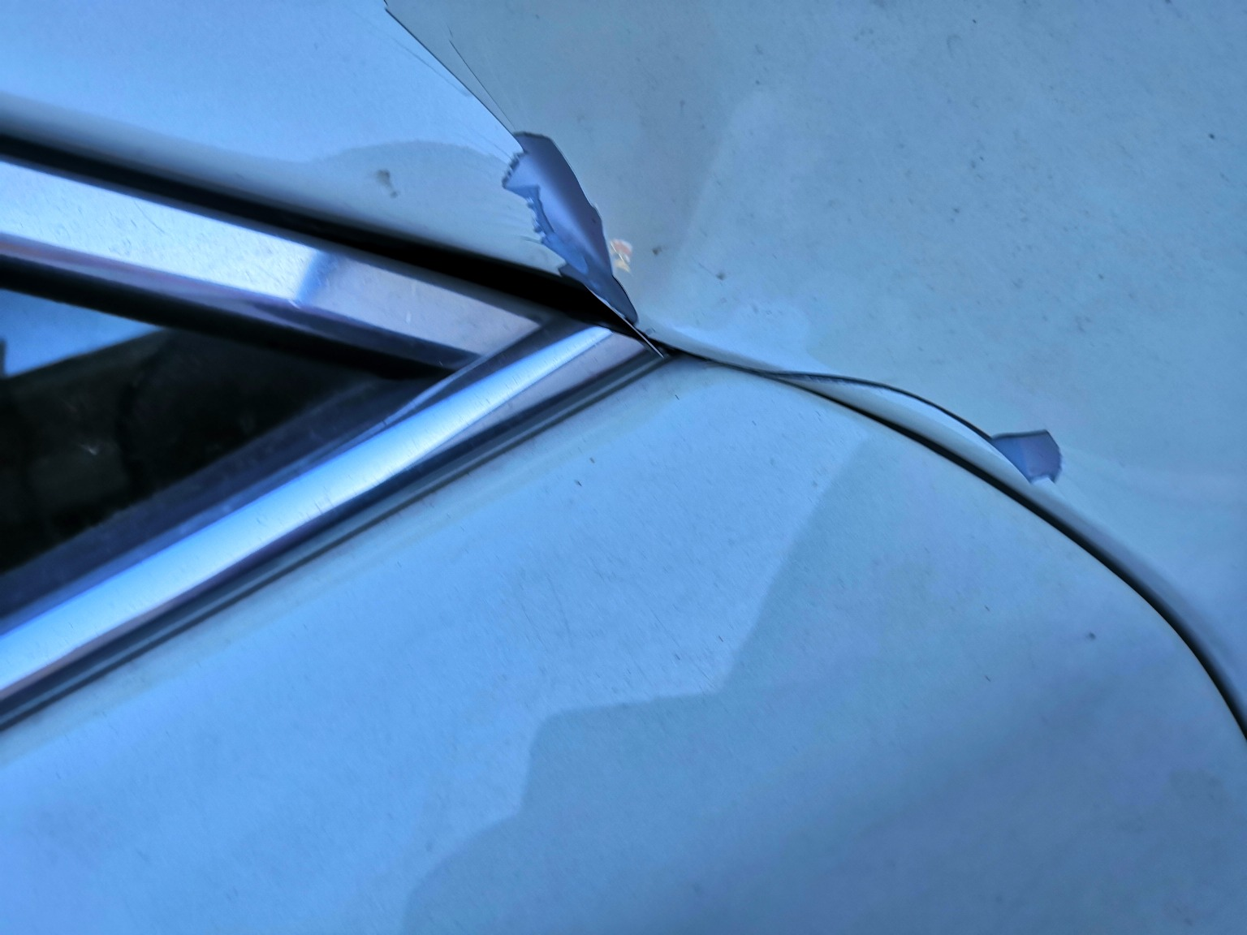 | 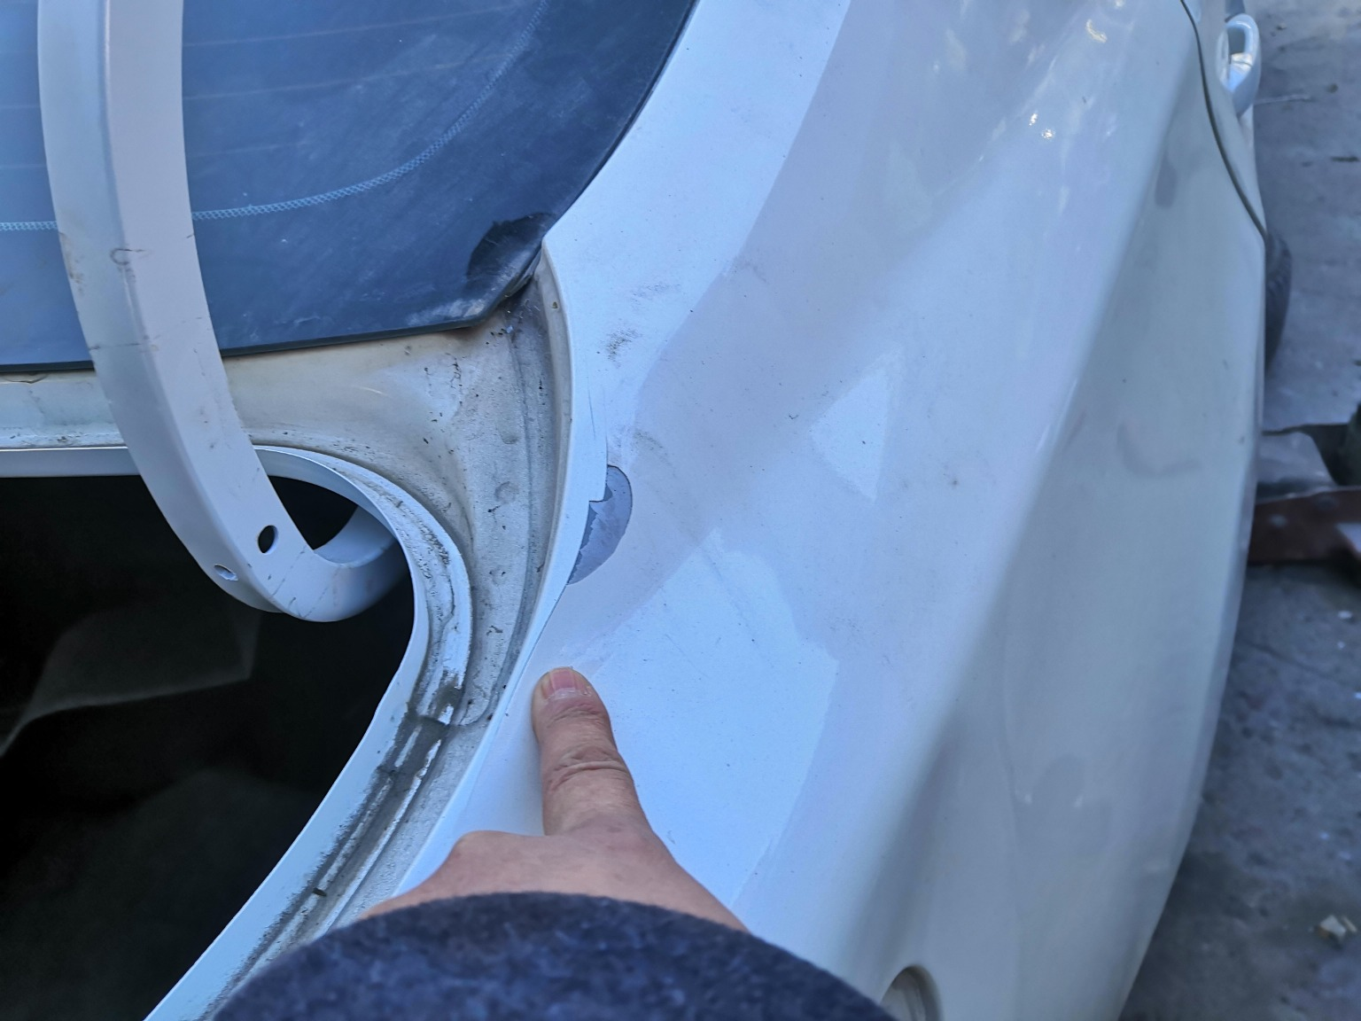
IMG_20201127_133430.jpg | IMG_20201127_133358.jpg | IMG_20201127_133531.jpg
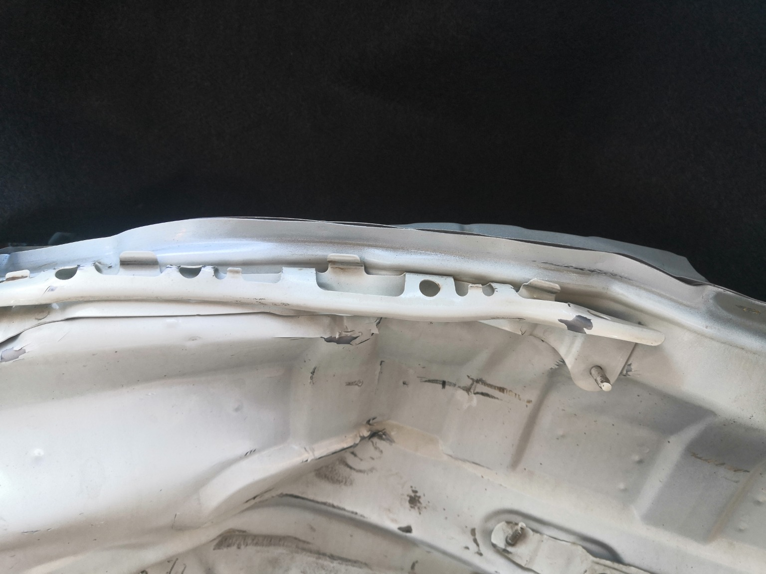 | 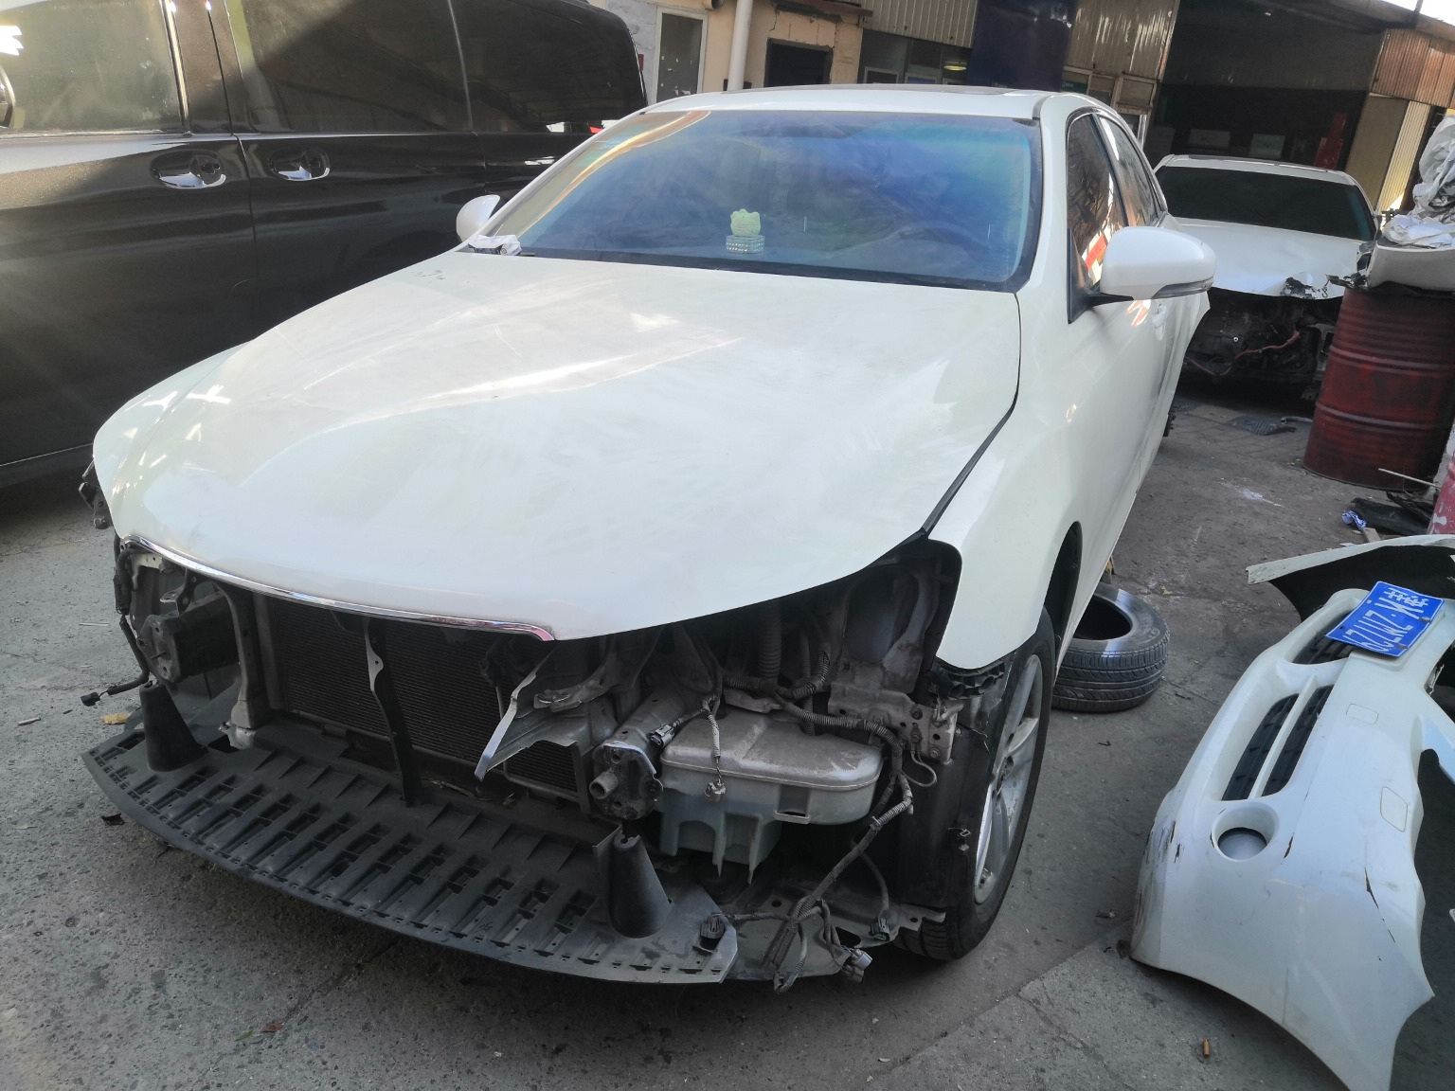 | 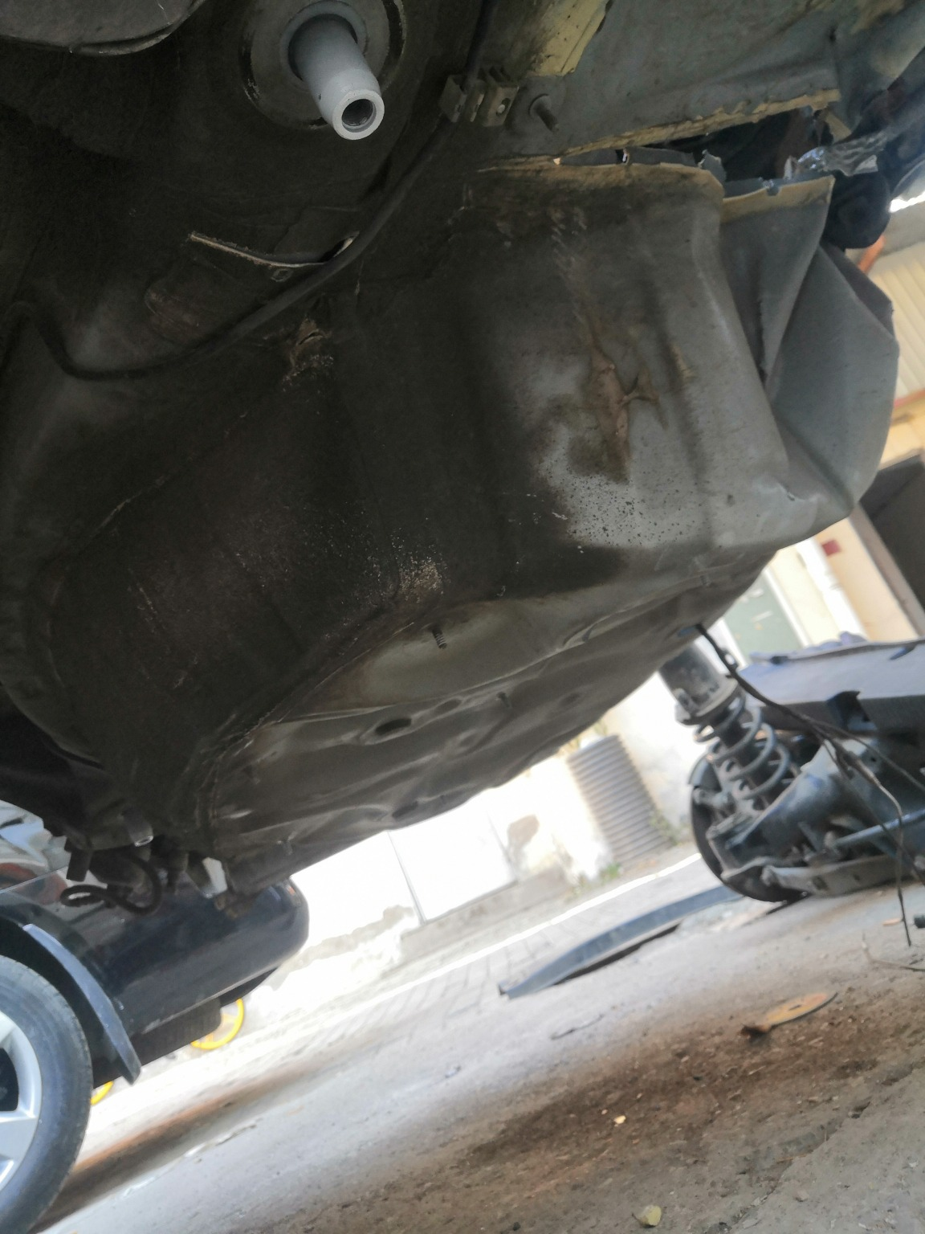
IMG_20201127_133603.jpg | IMG_20201127_133302.jpg | IMG_20201127_133800.jpg
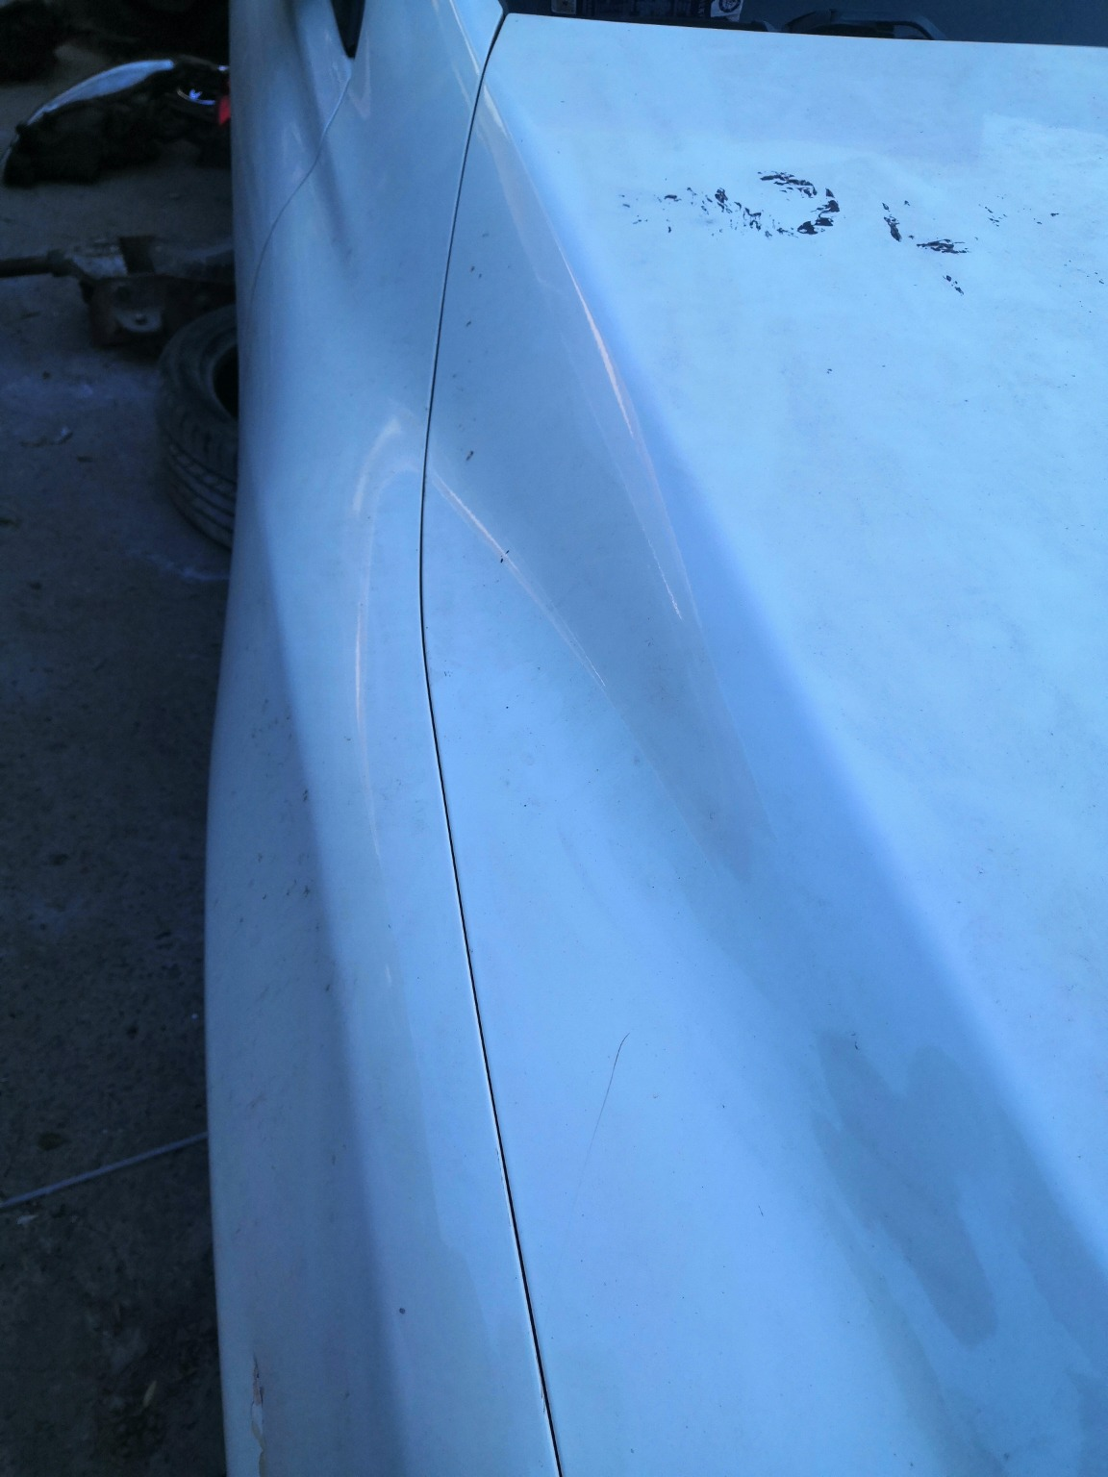 | 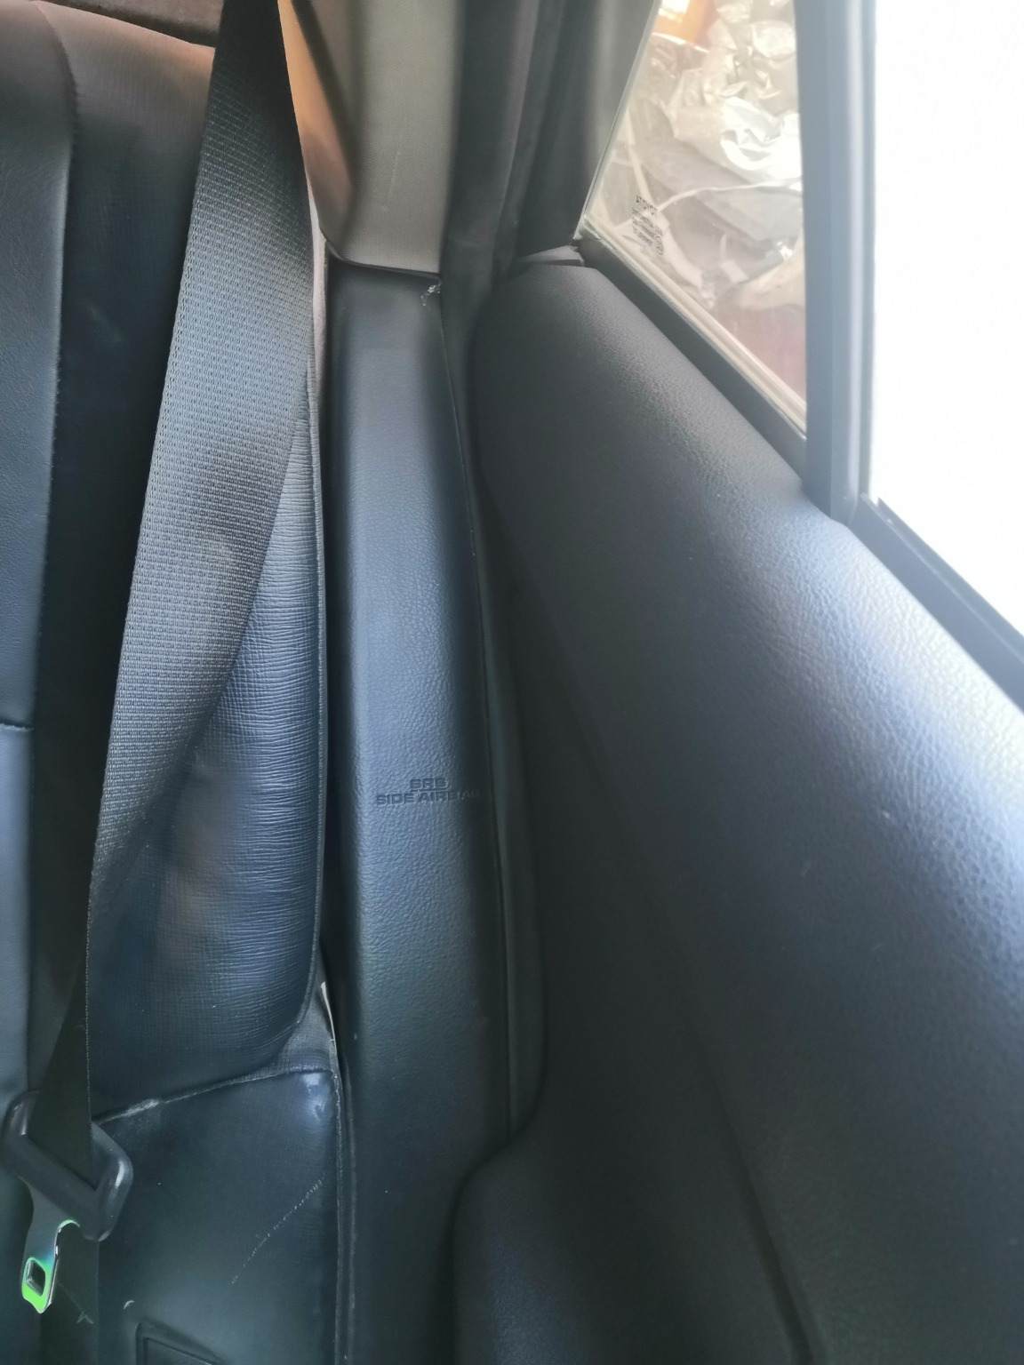 | 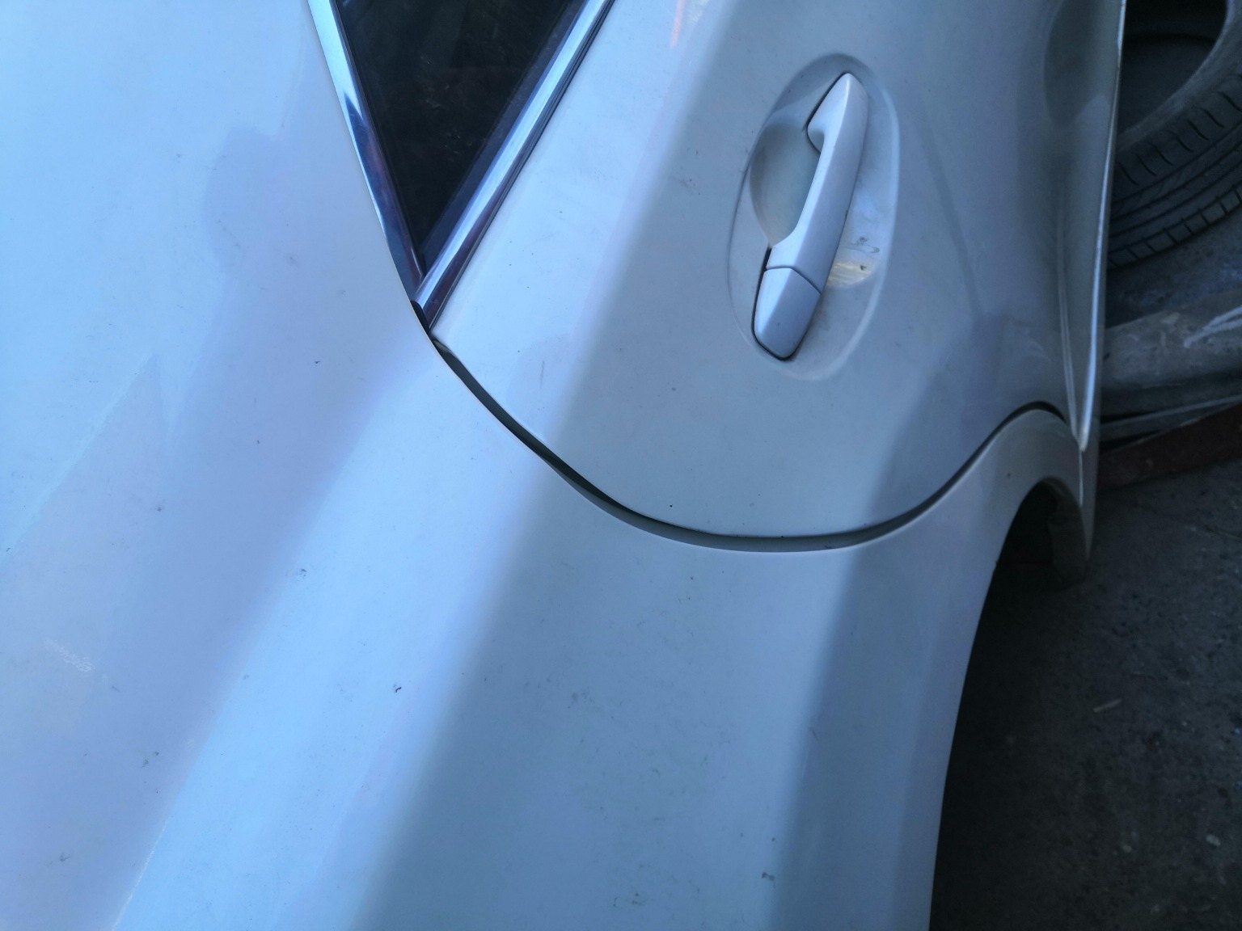
IMG_20201127_135321.jpg | IMG_20201127_135221.jpg | IMG_20201127_133525.jpg

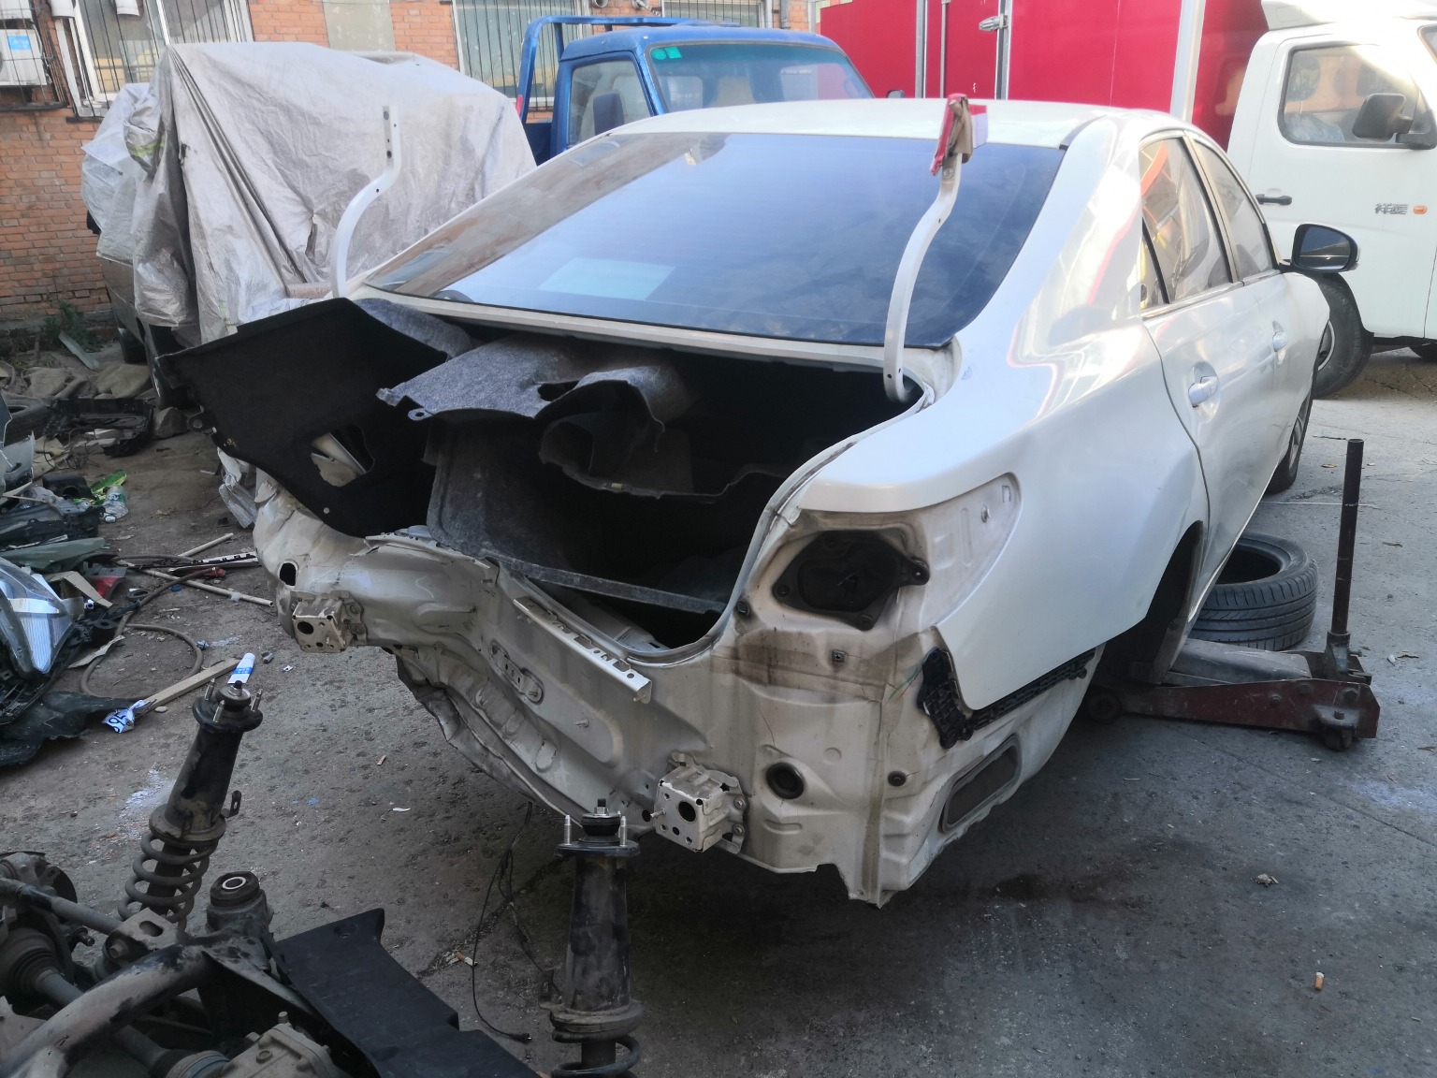 | 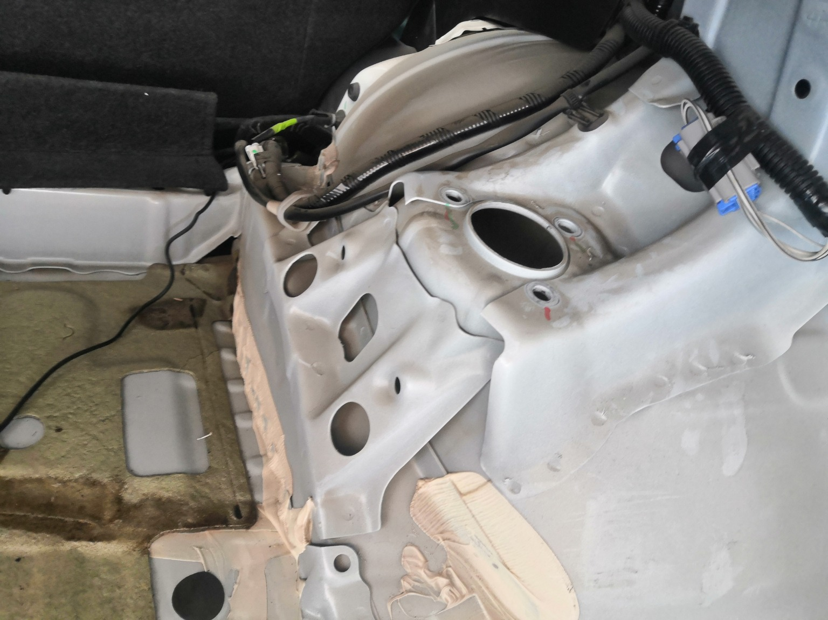 | 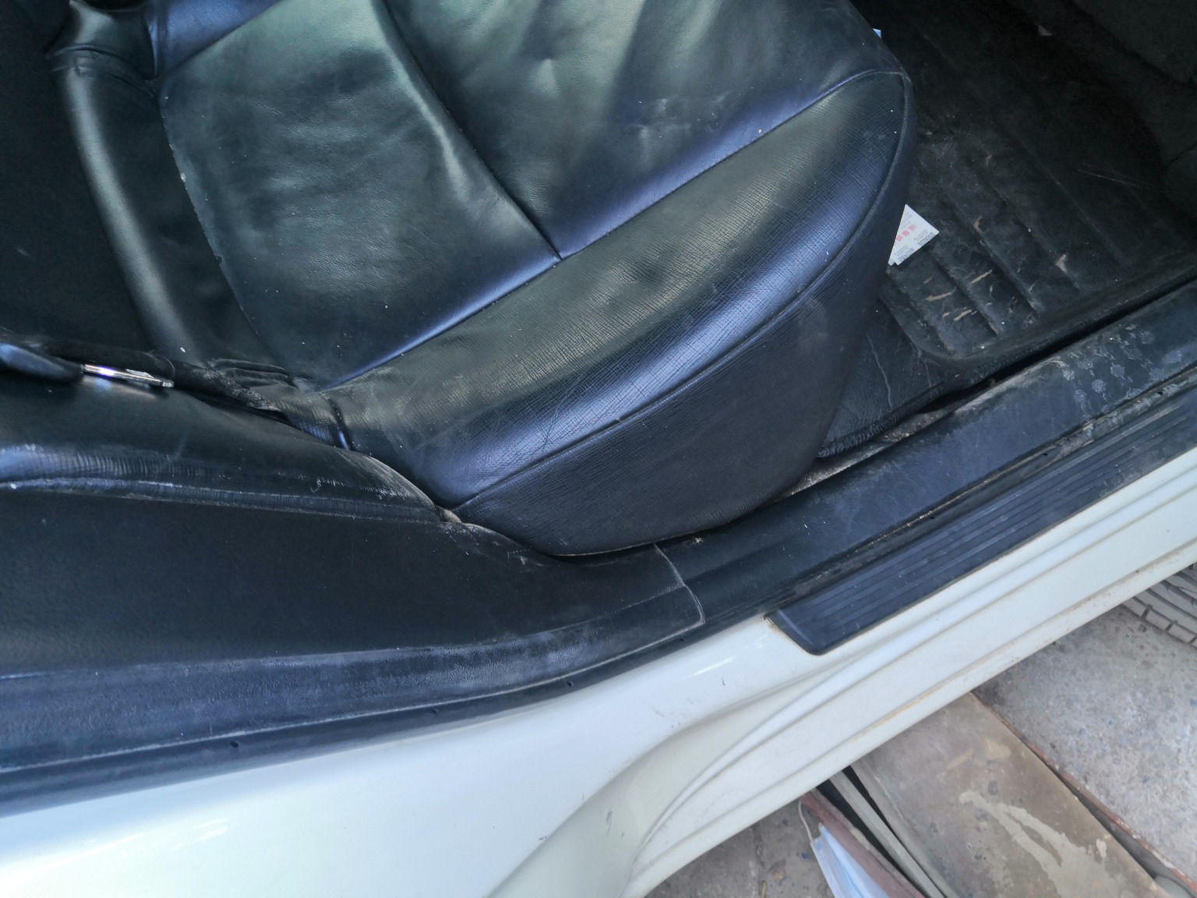
IMG_20201127_133328.jpg | IMG_20201127_133719.jpg | IMG_20201127_135212.jpg
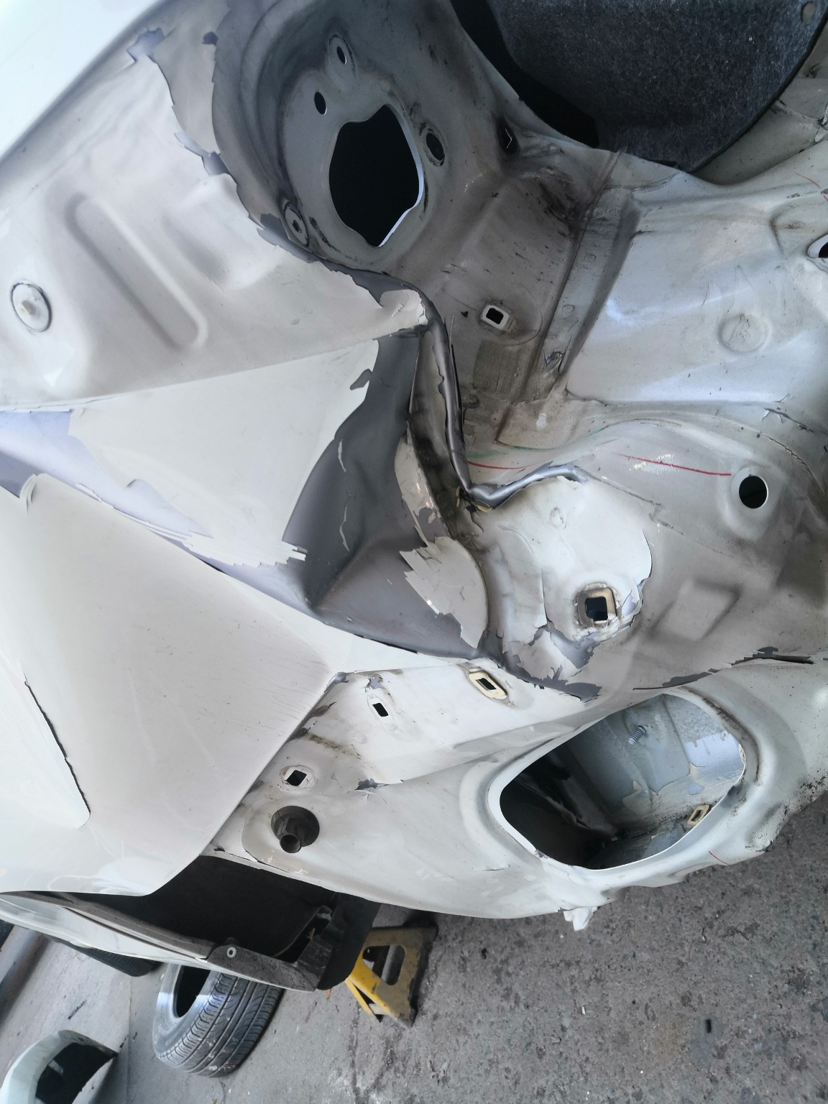 | 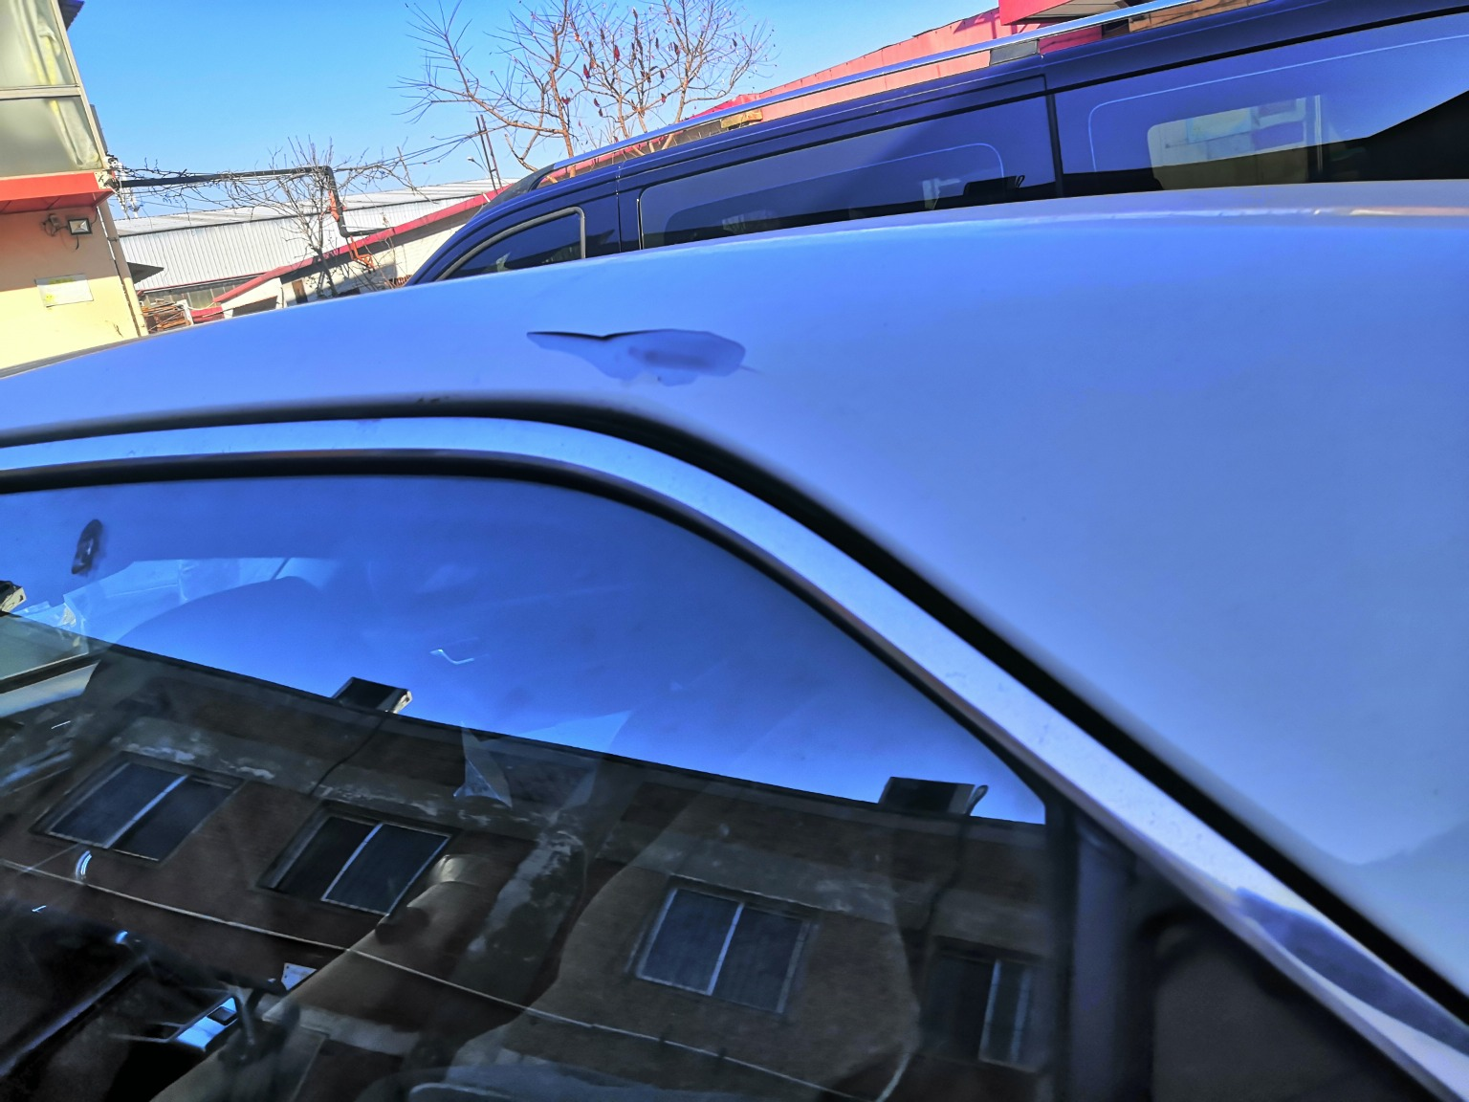 | 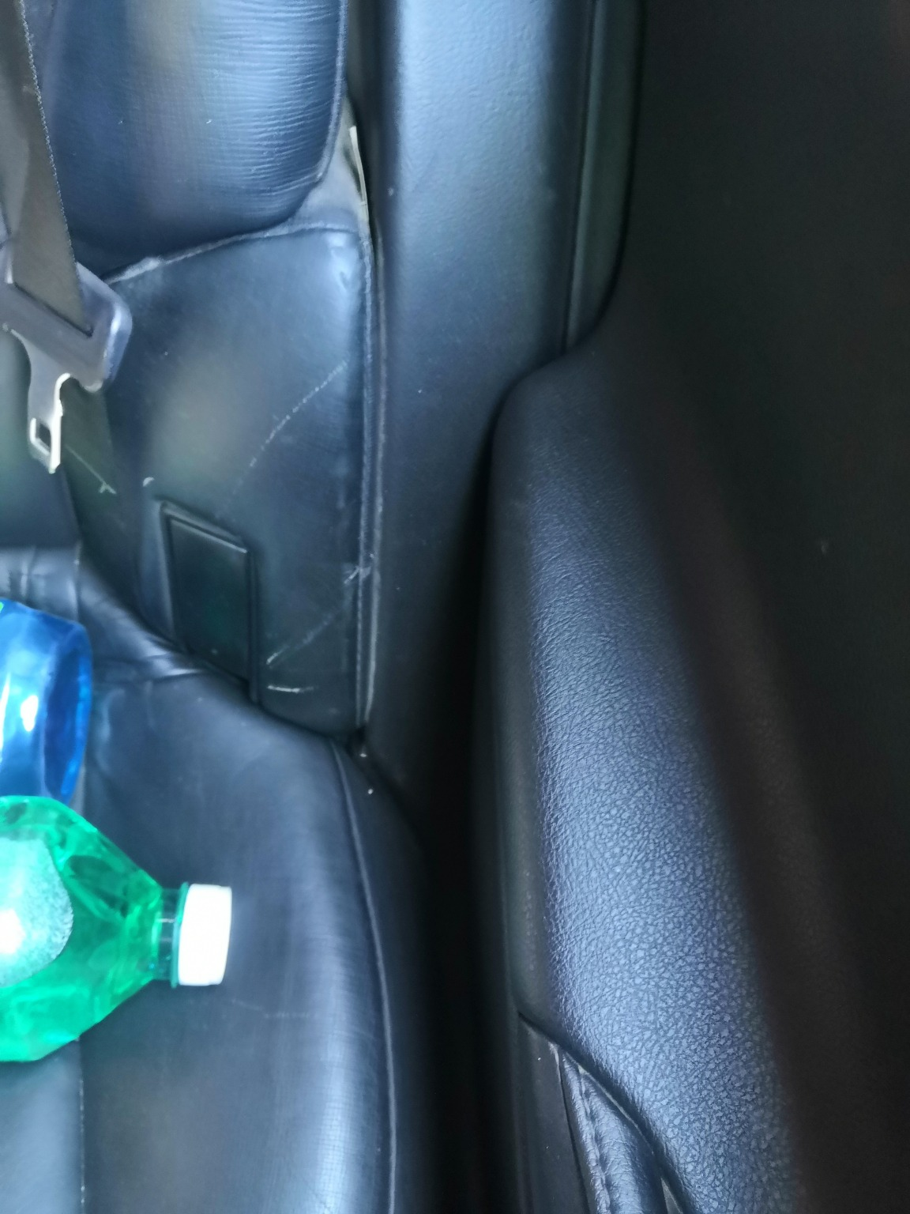
IMG_20201127_133608.jpg | IMG_20201127_133408.jpg | IMG_20201127_135224.jpg
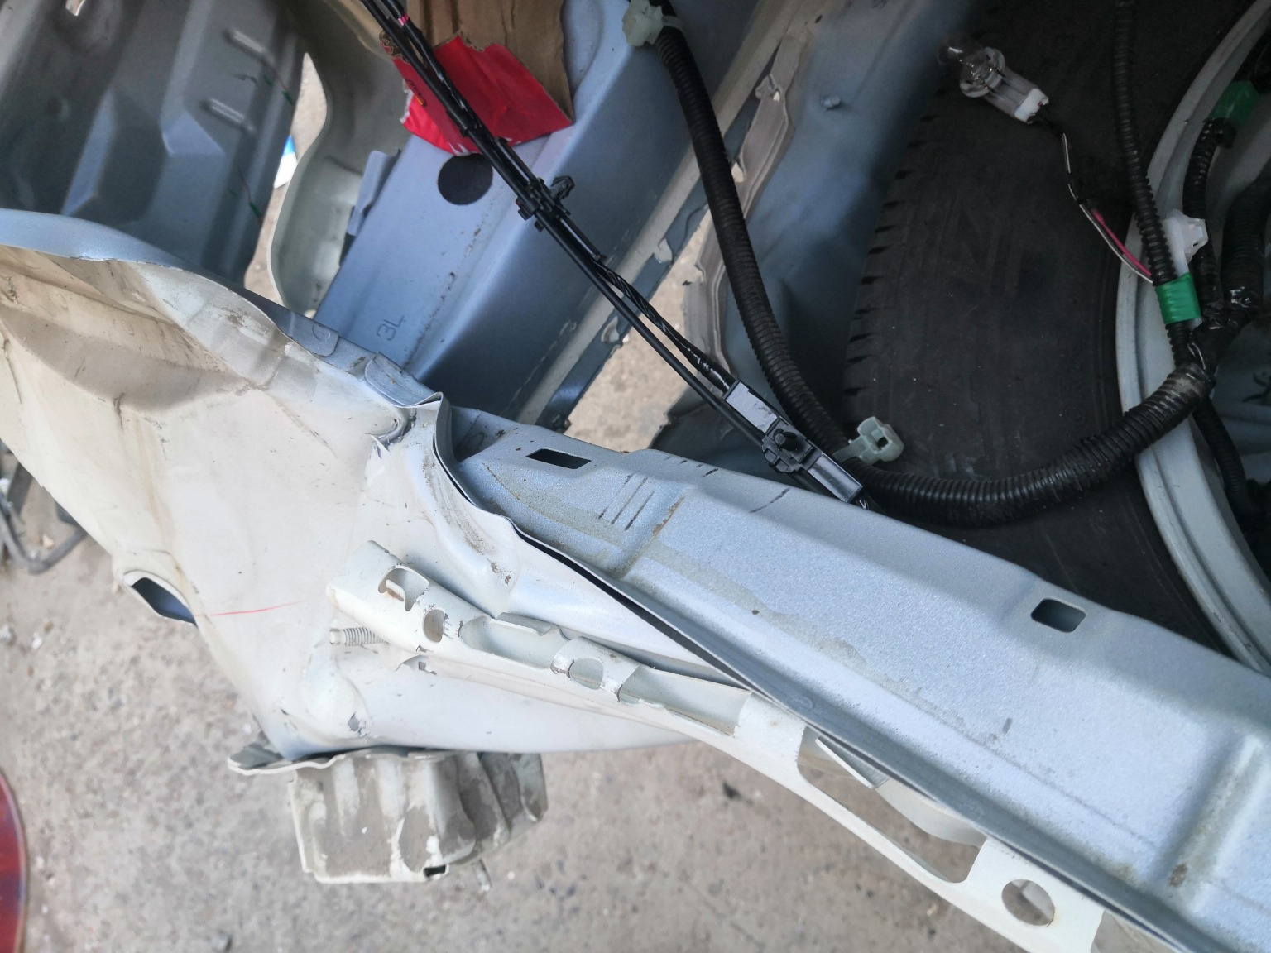 | 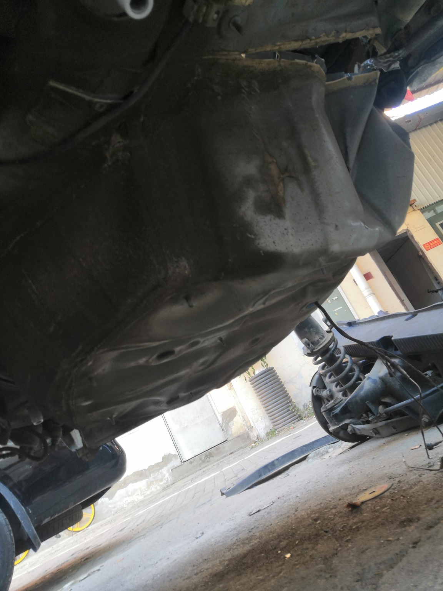 | 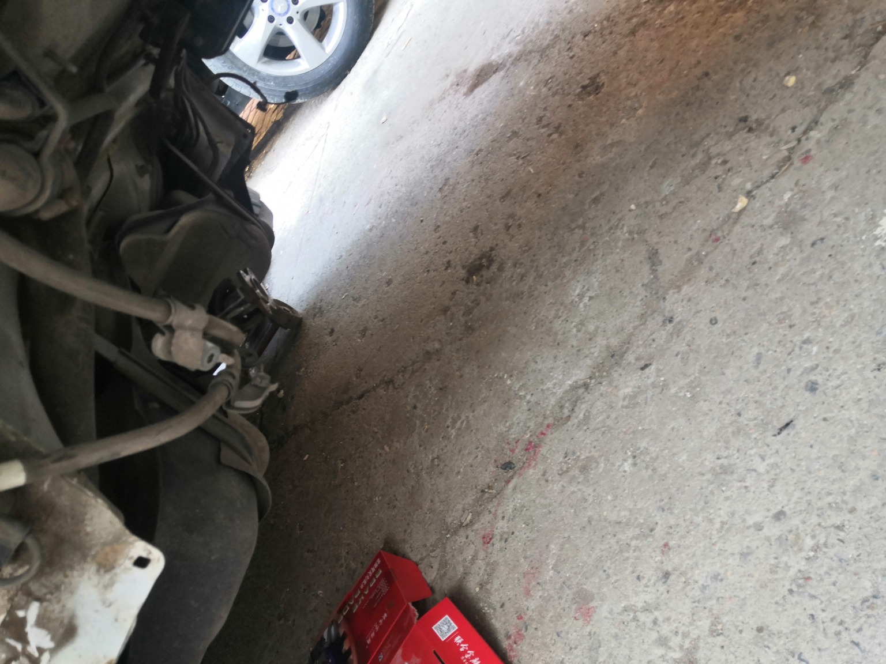
IMG_20201127_133708.jpg | IMG_20201127_133802.jpg | IMG_20201127_133810.jpg

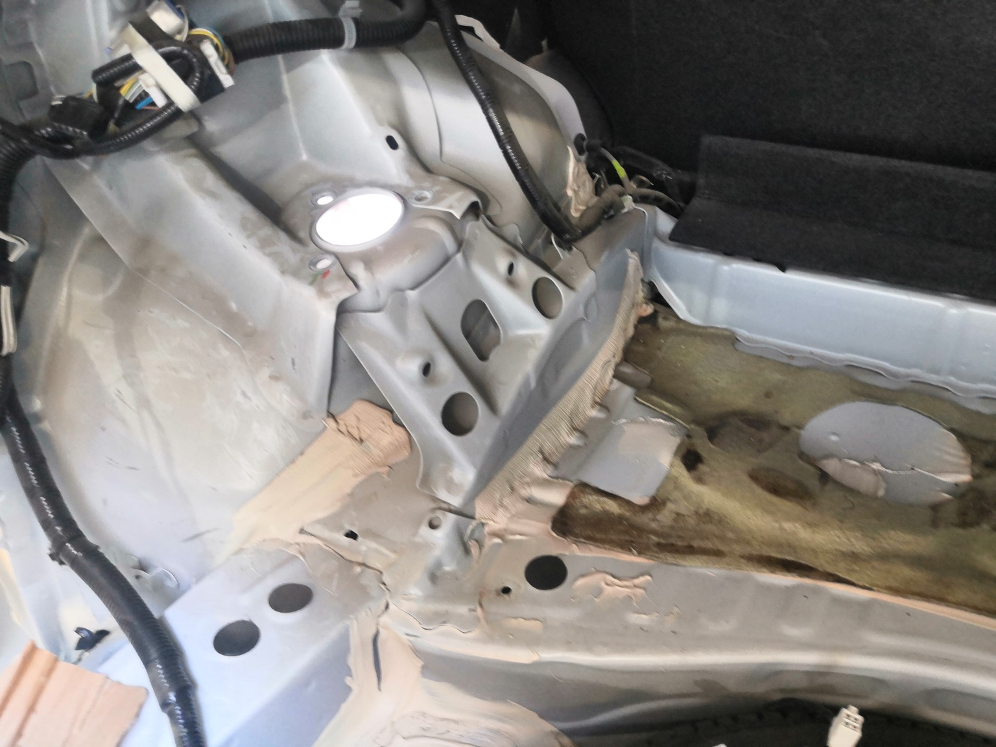 | 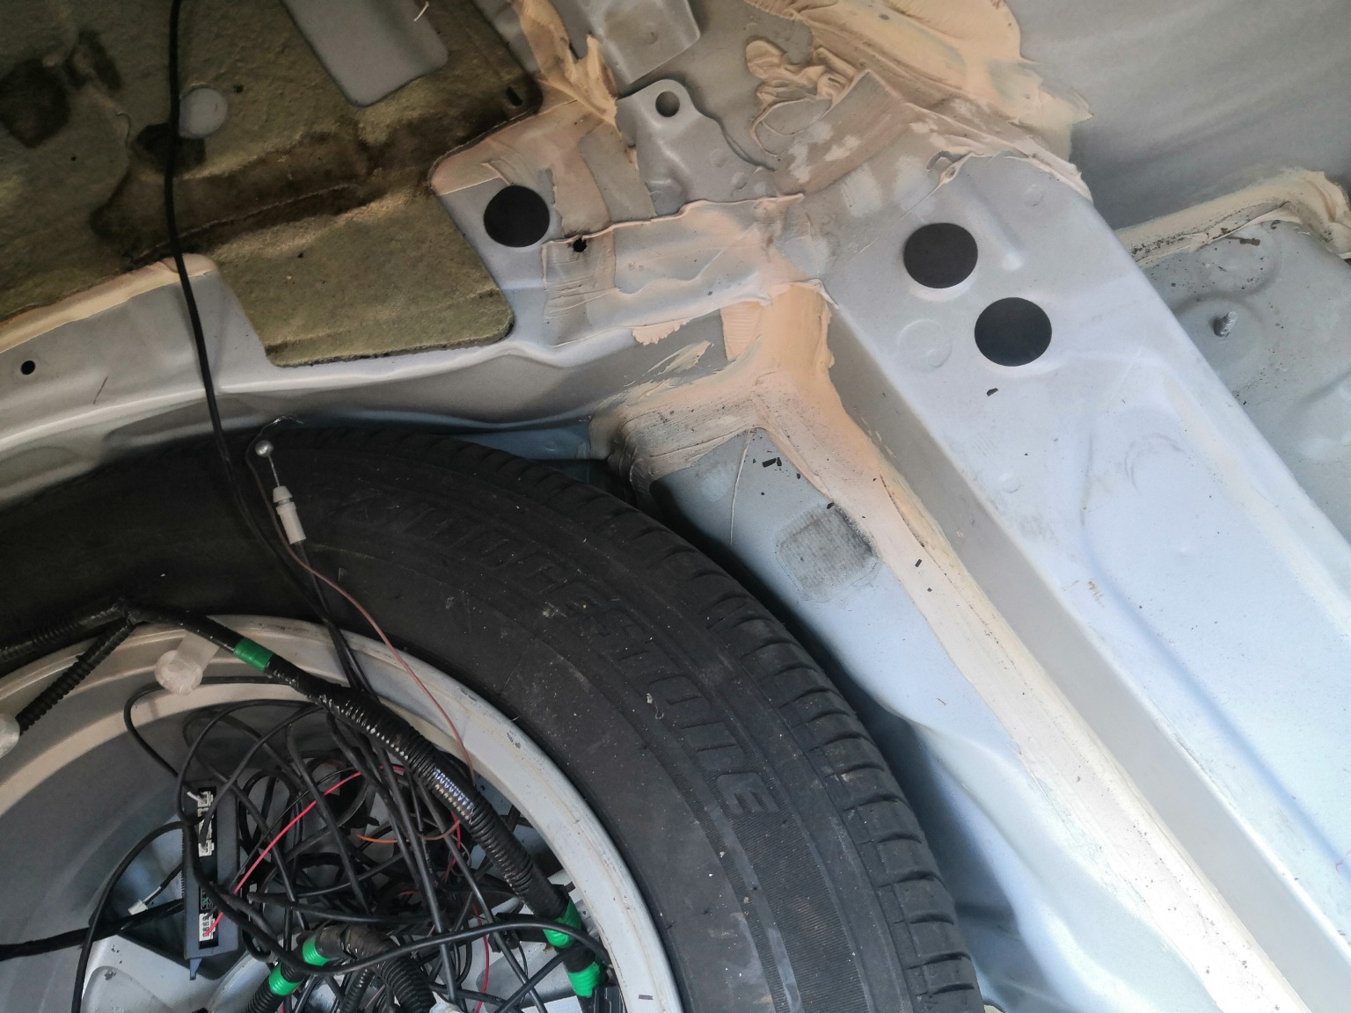 | 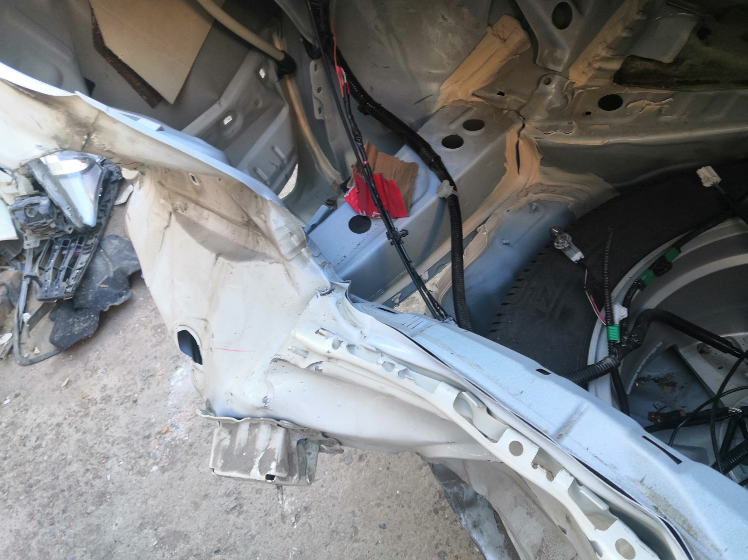
IMG_20201127_133711.jpg | IMG_20201127_133723.jpg | IMG_20201127_133702.jpg
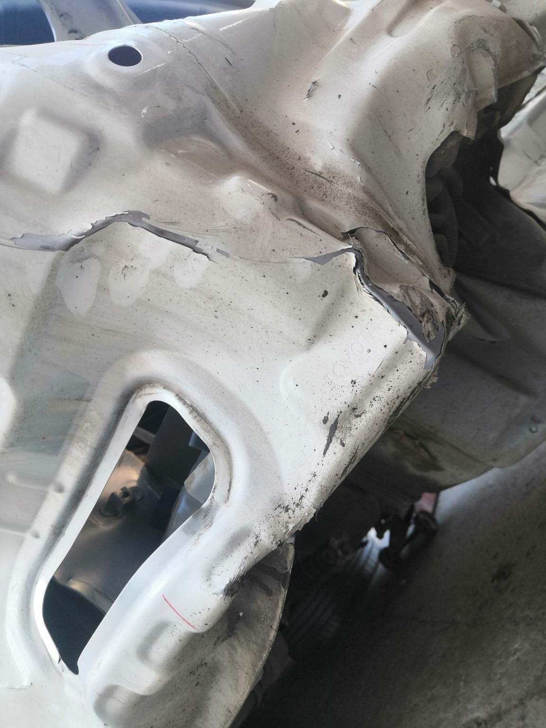 | 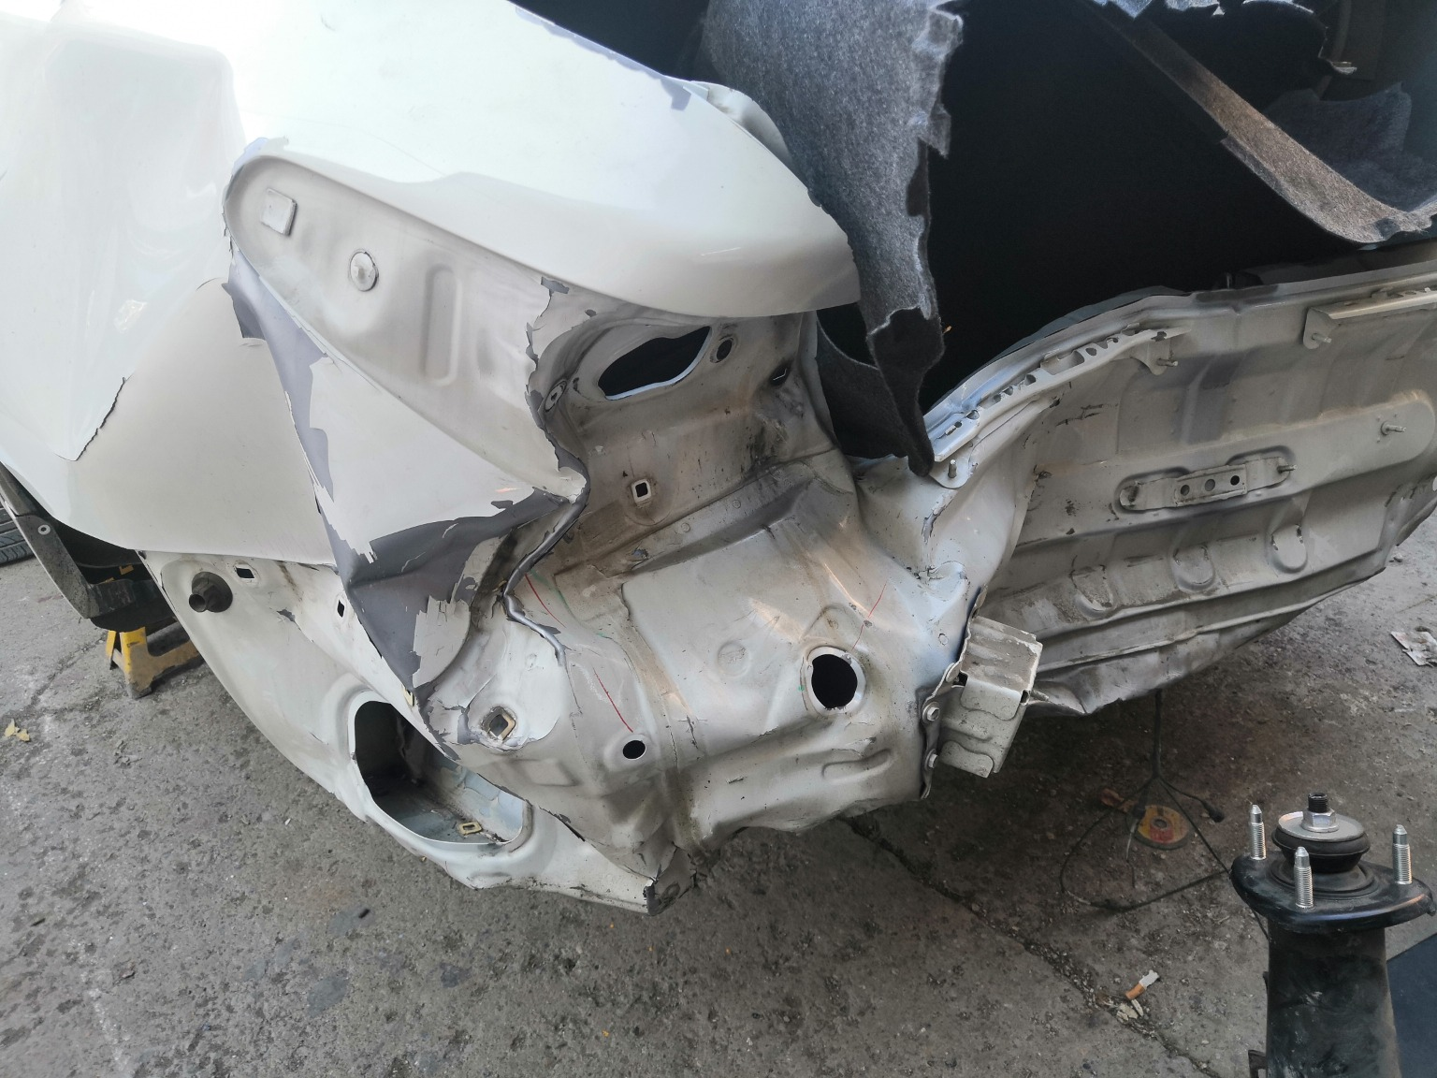 | 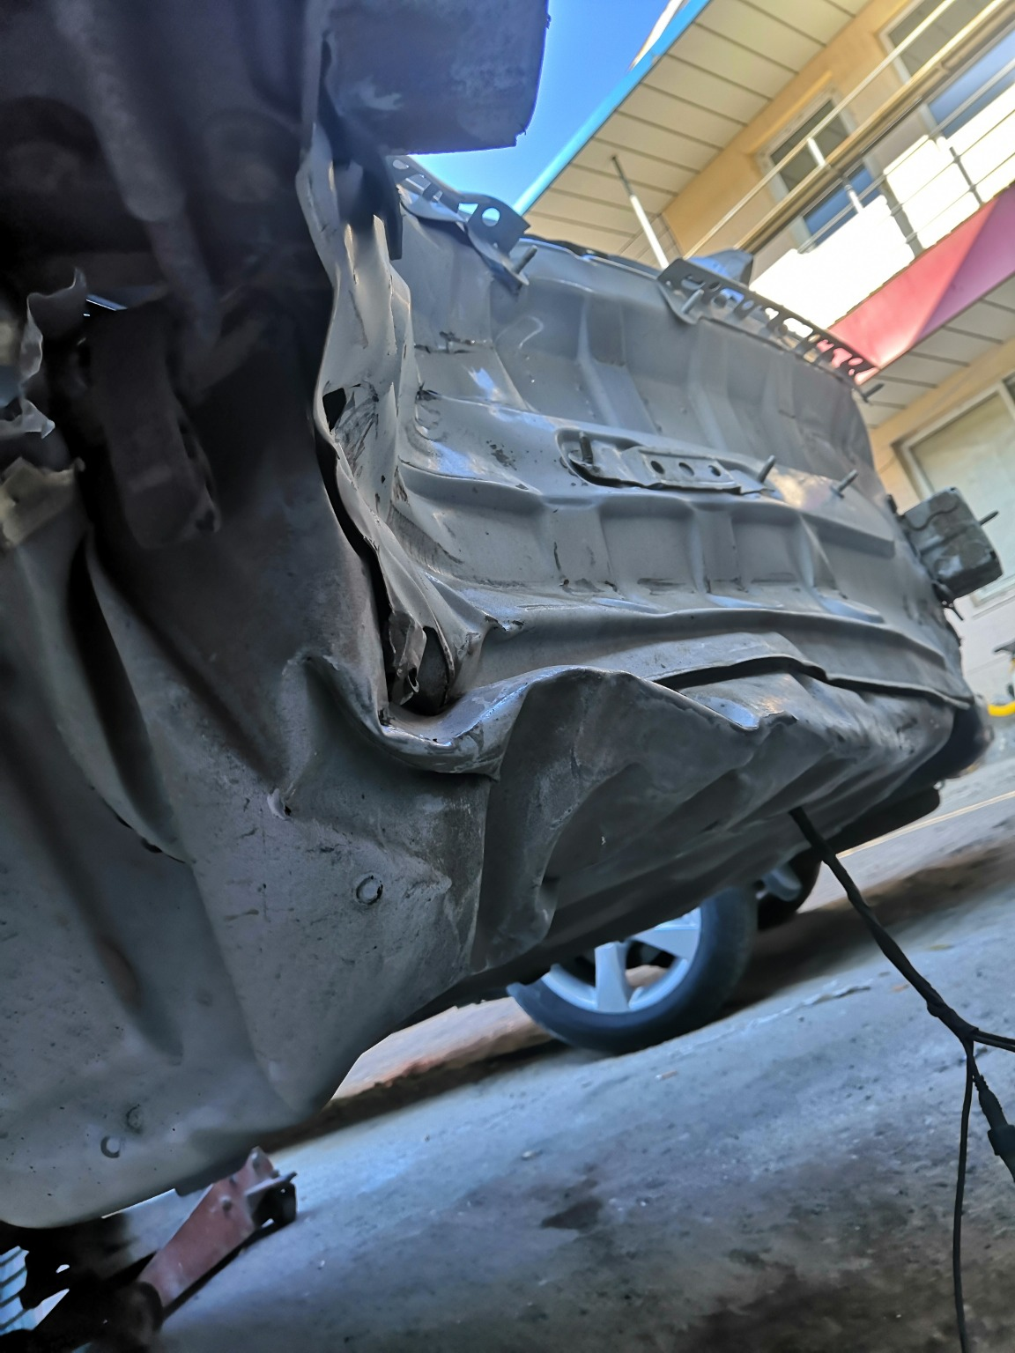
IMG_20201127_133747.jpg | IMG_20201127_133341.jpg | IMG_20201127_133743.jpg
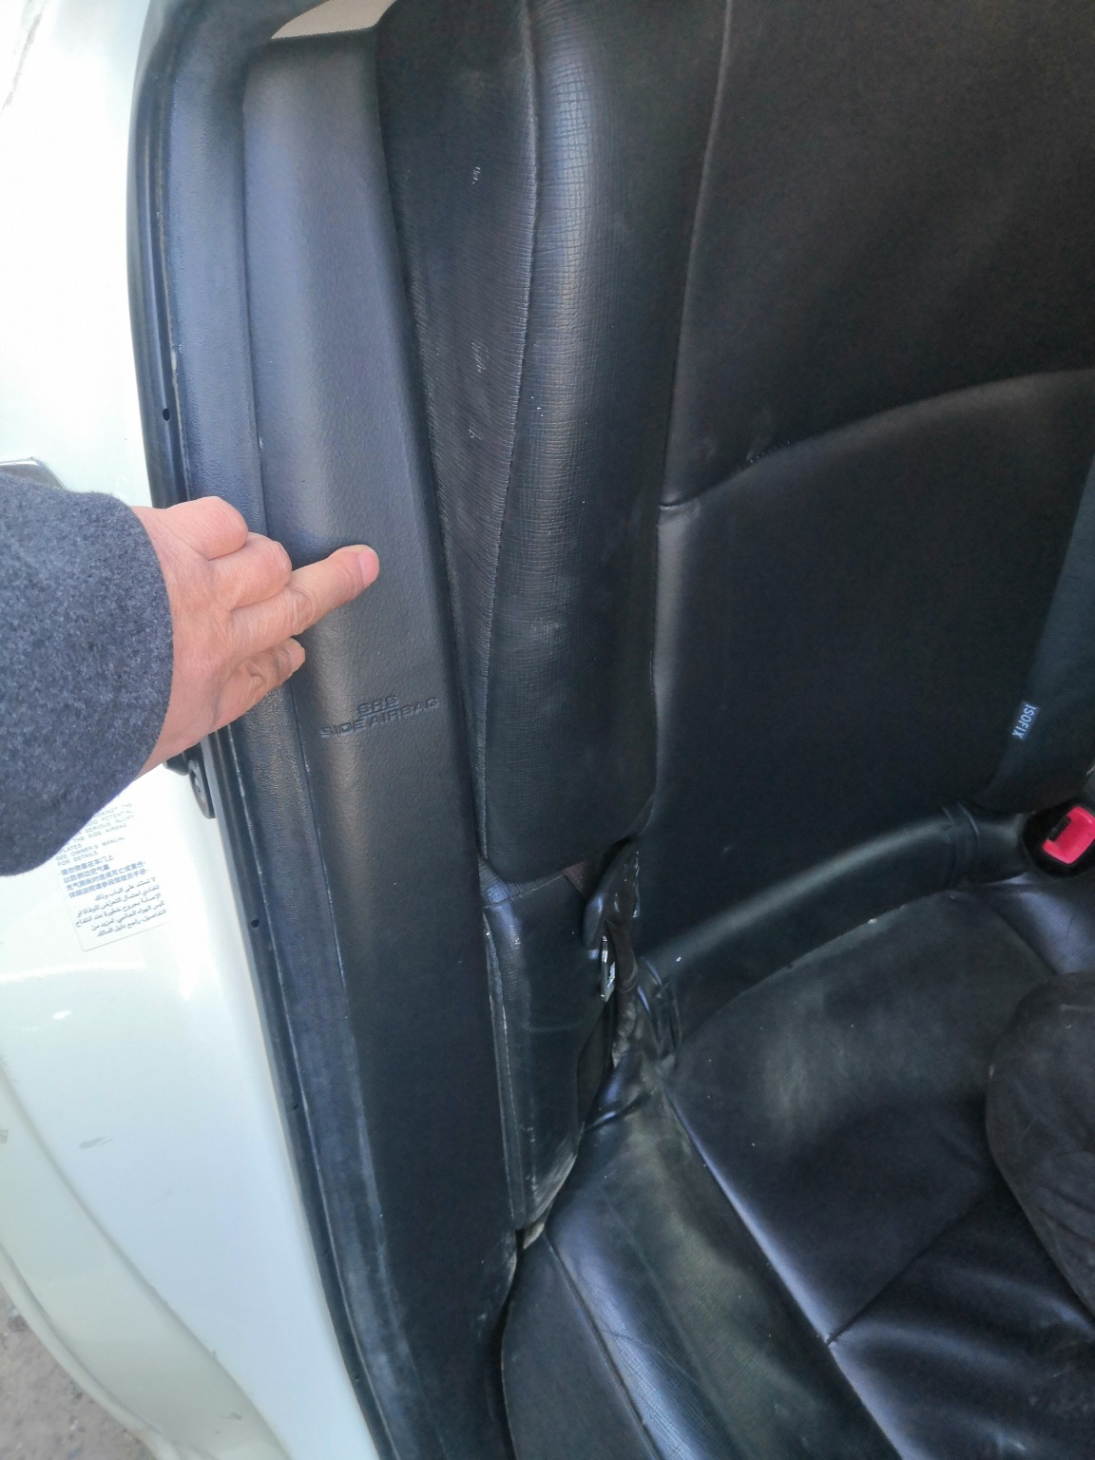 | 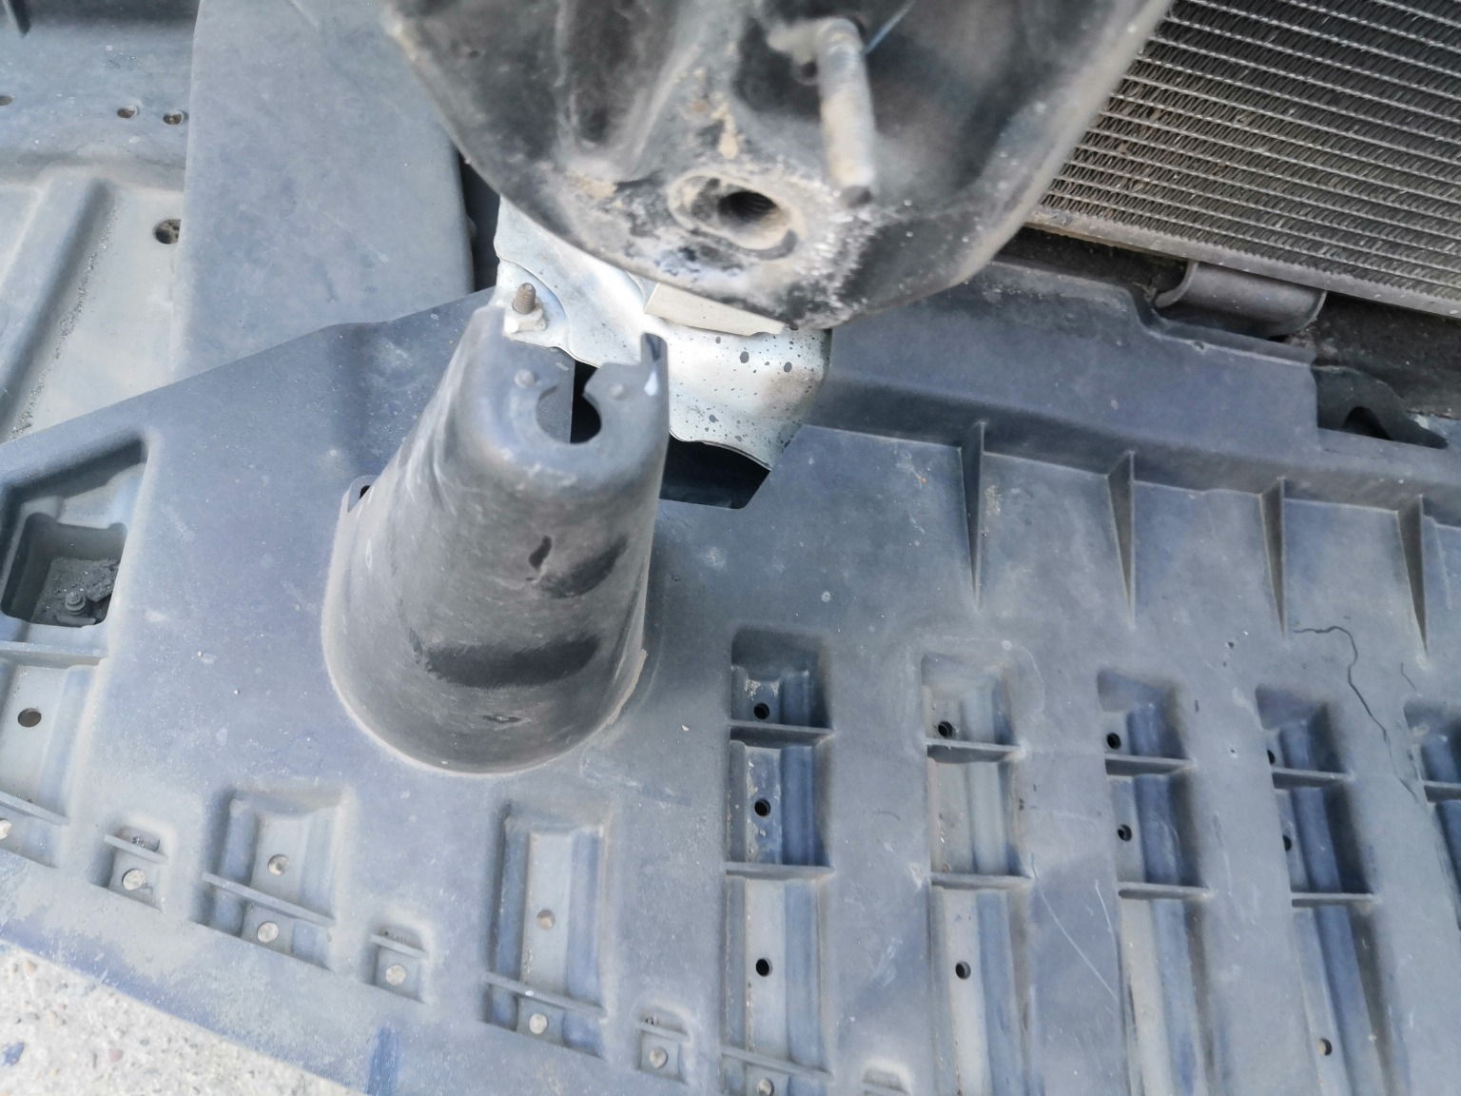 | 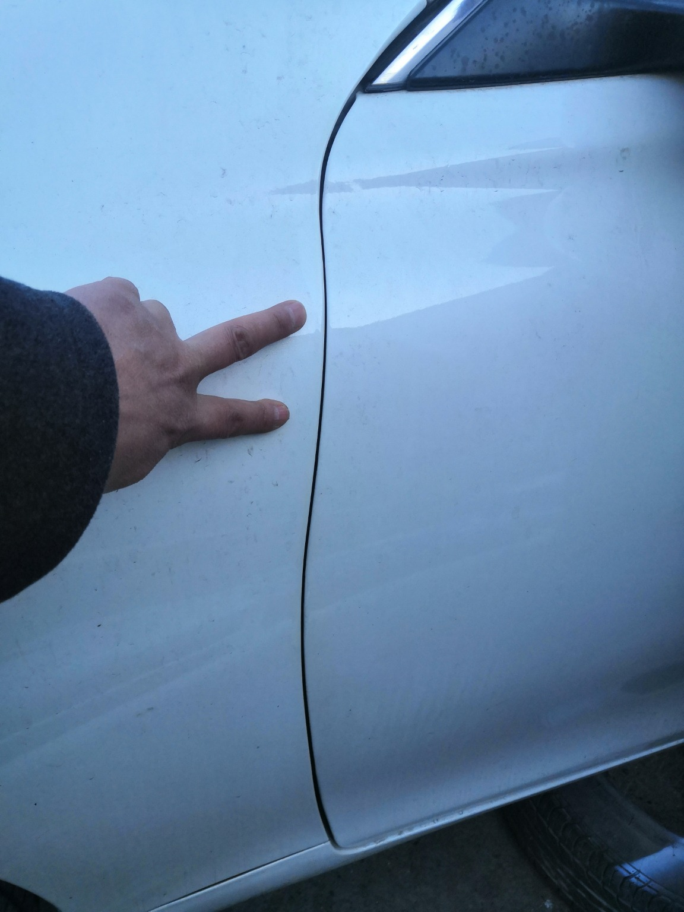
IMG_20201127_135156.jpg | IMG_20201127_133914.jpg | IMG_20201127_133444.jpg

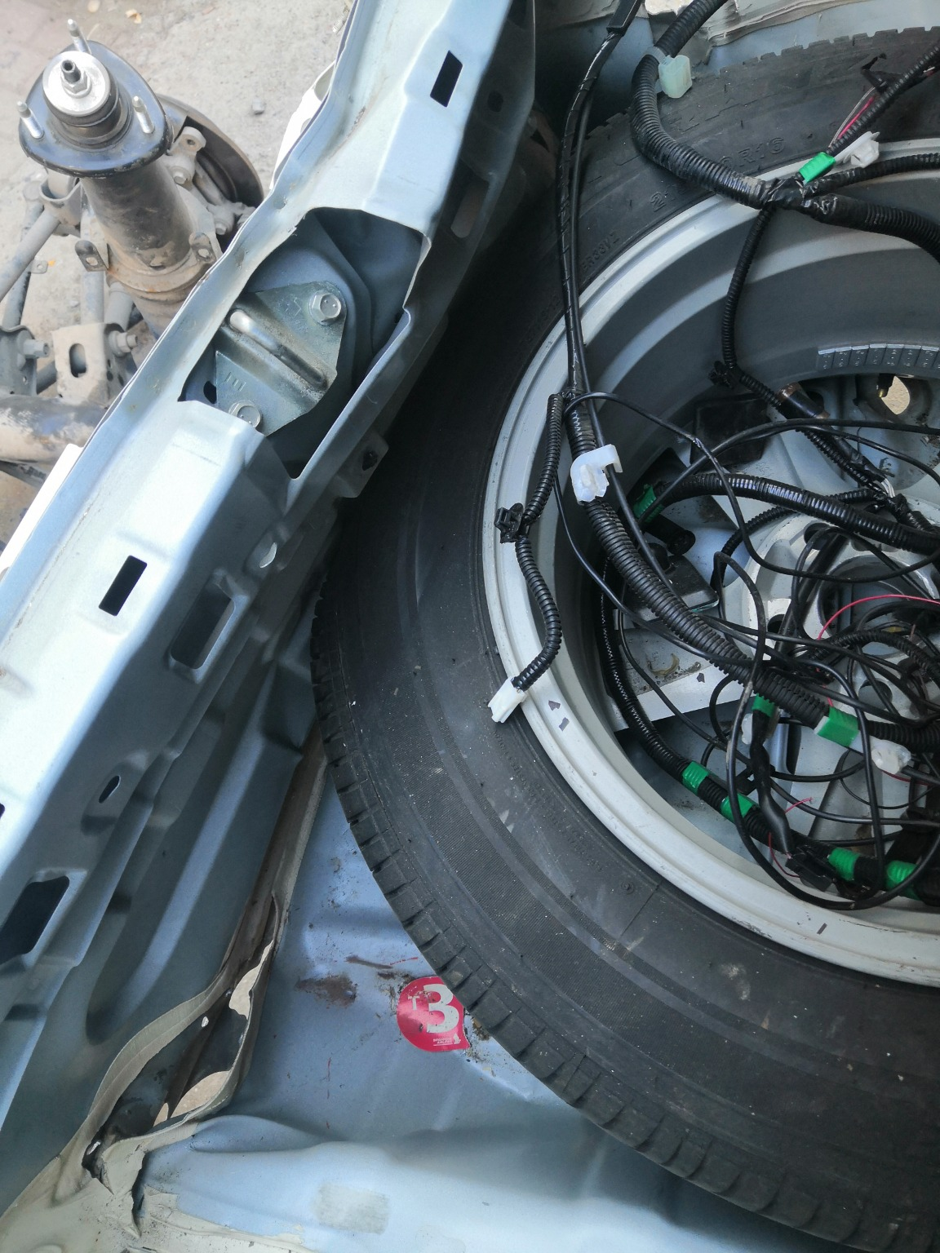 | 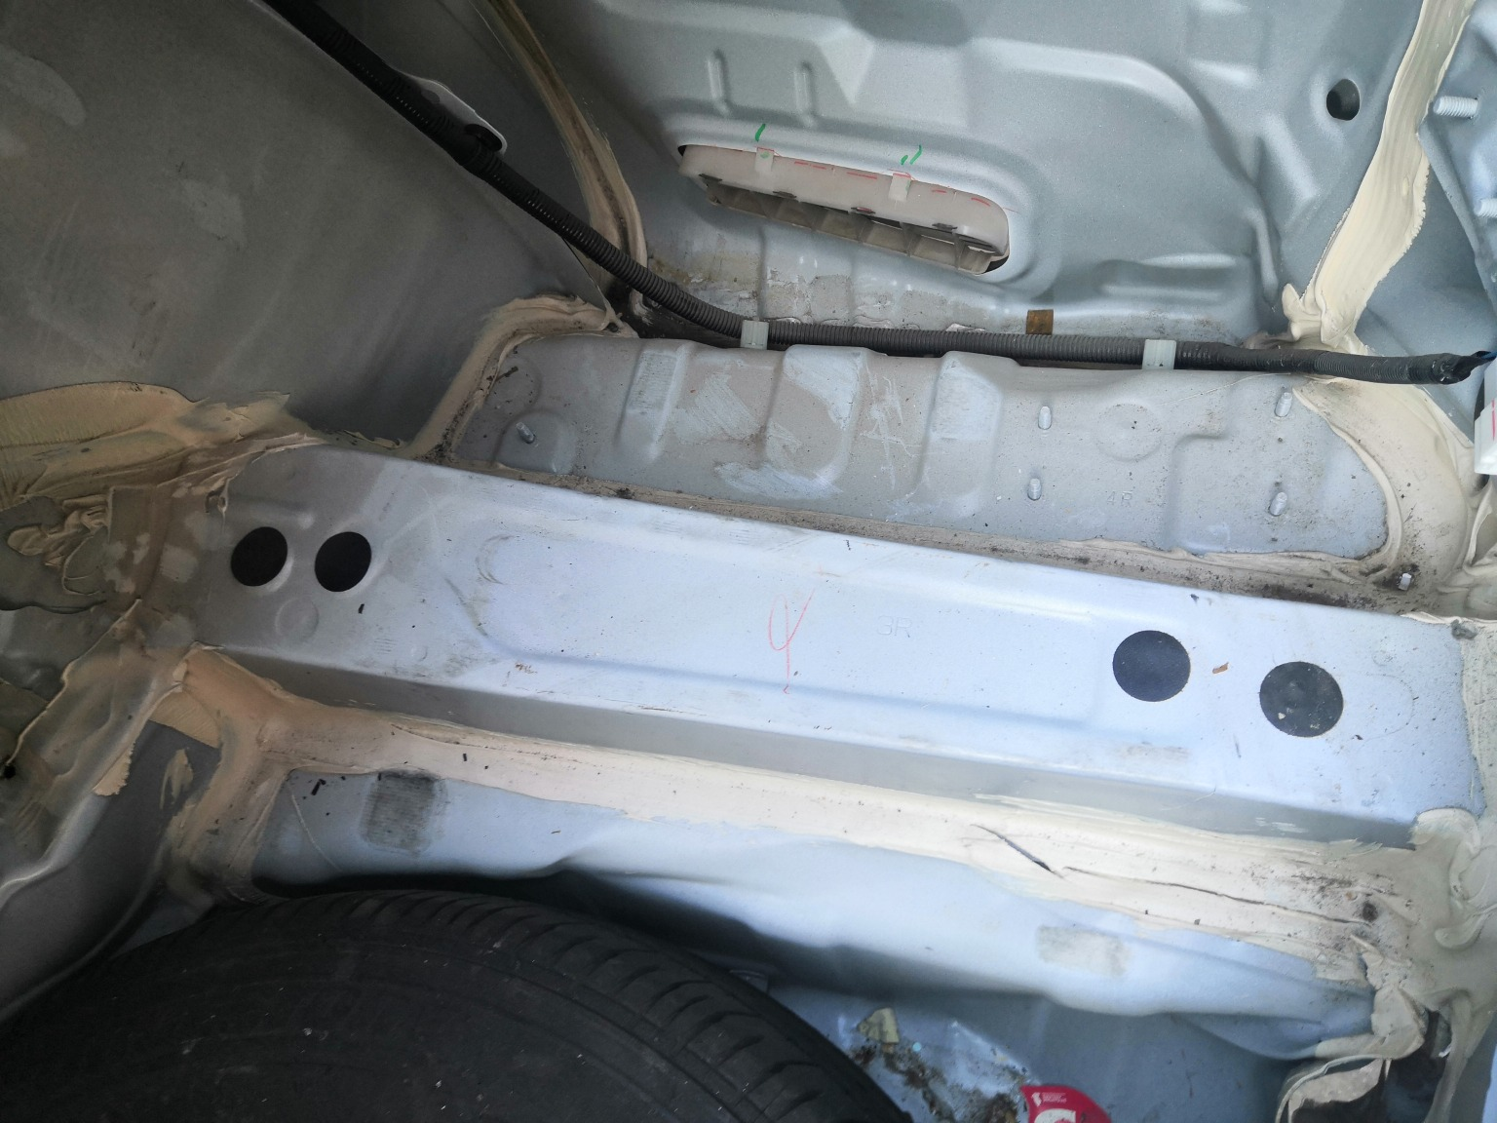 | 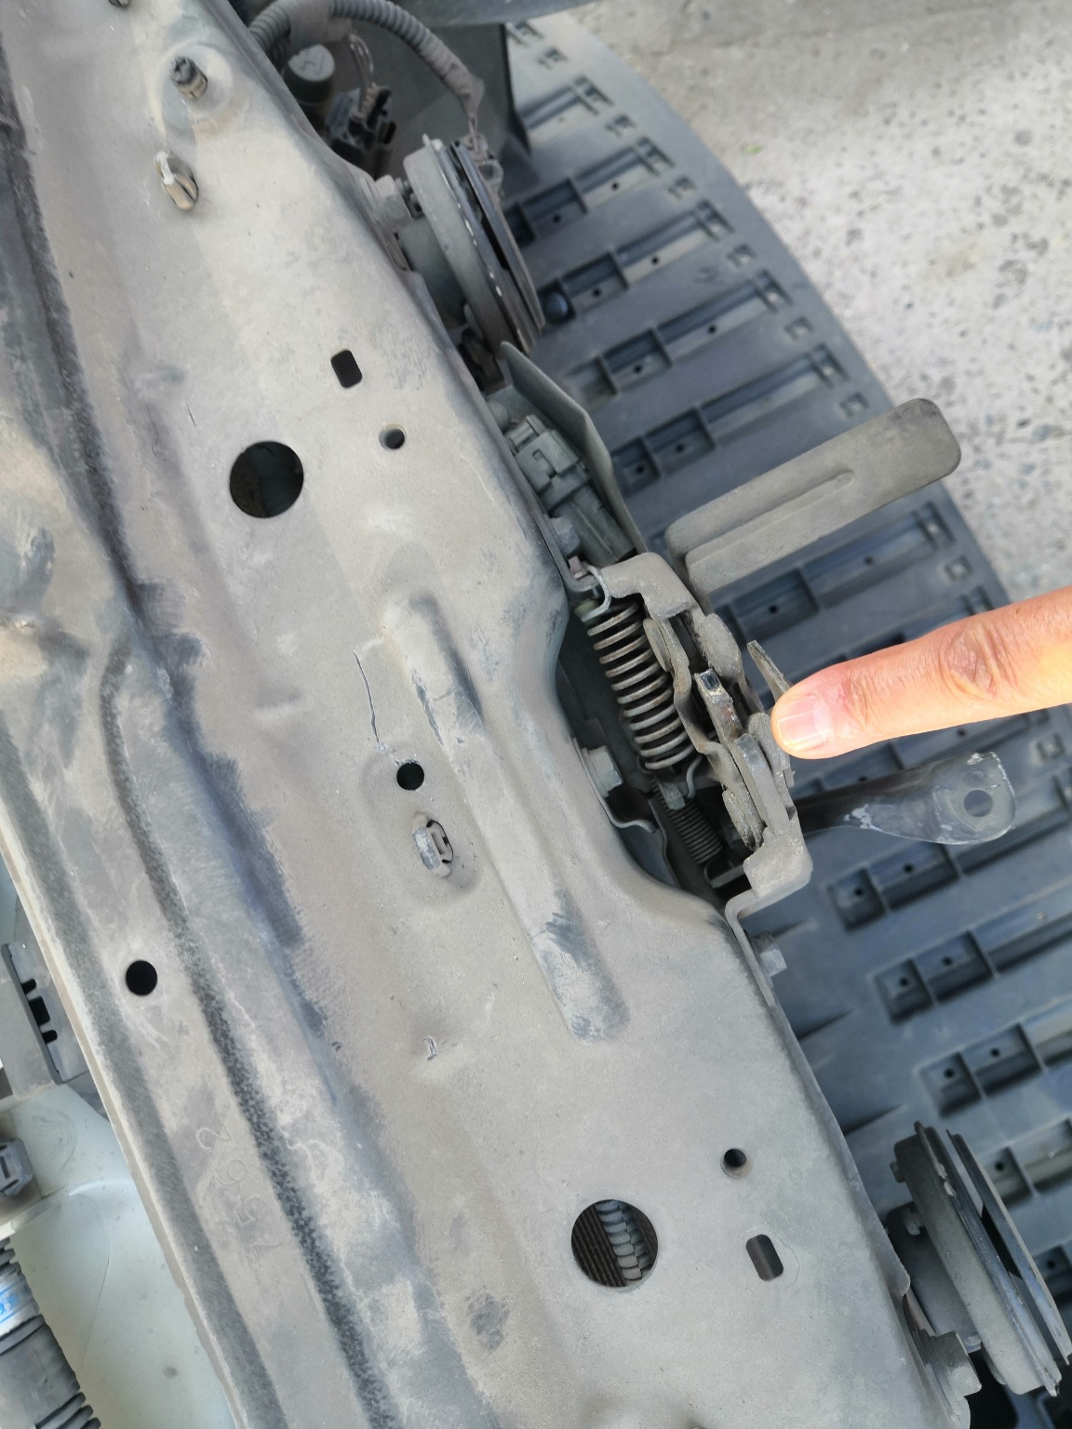
IMG_20201127_133730.jpg | IMG_20201127_135414.jpg | IMG_20201127_133841.jpg
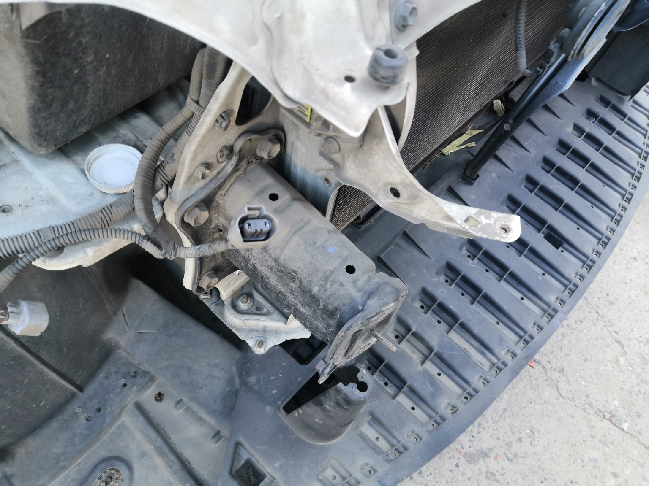 | 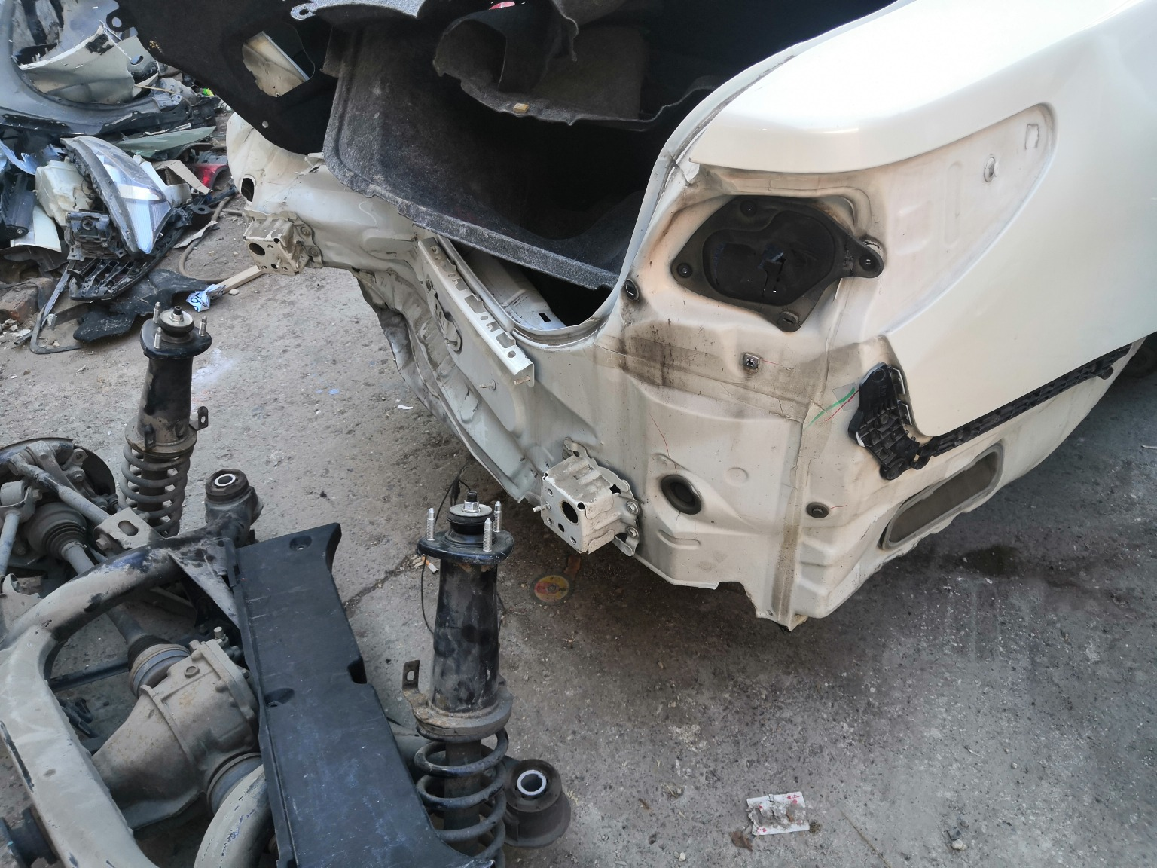 | 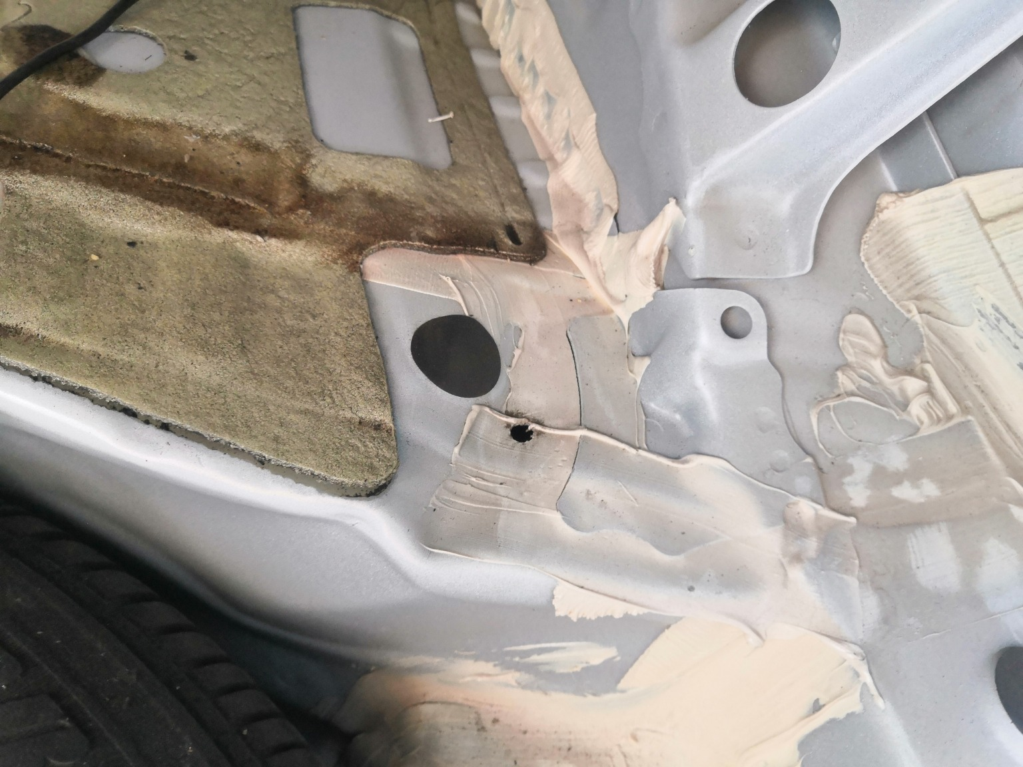
IMG_20201127_133851.jpg | IMG_20201127_133539.jpg | IMG_20201127_133717.jpg
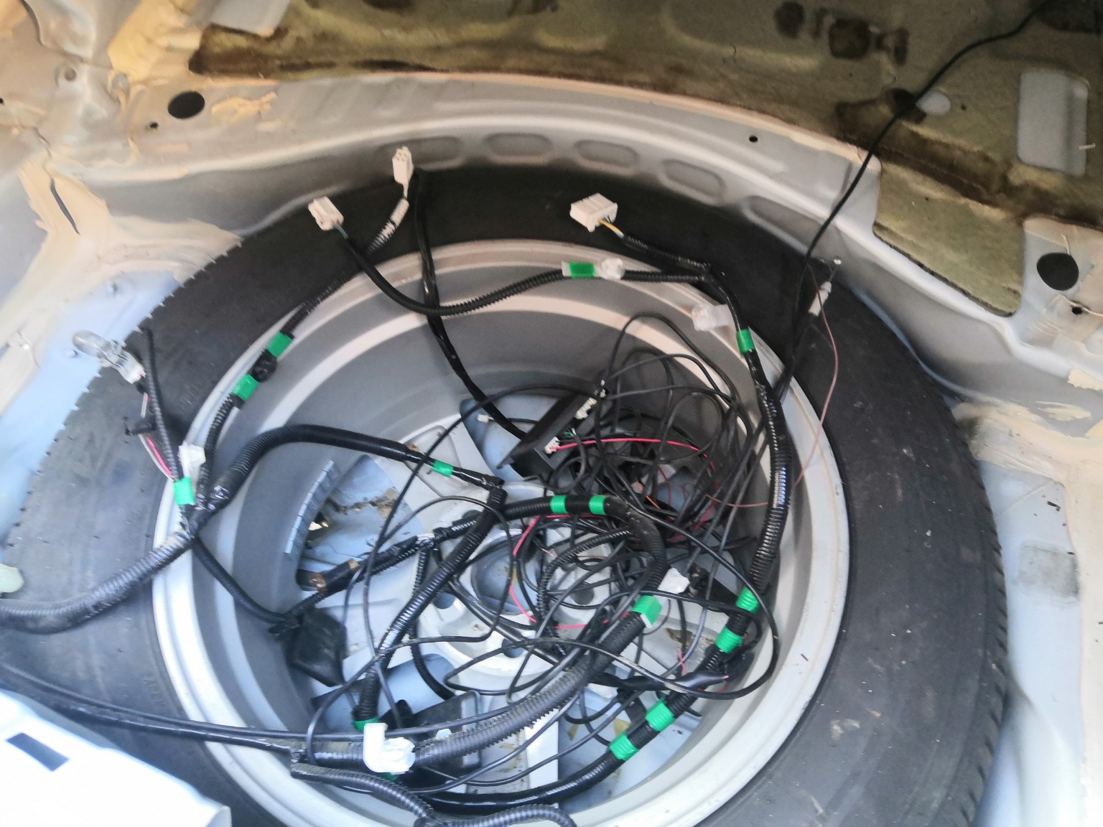 | 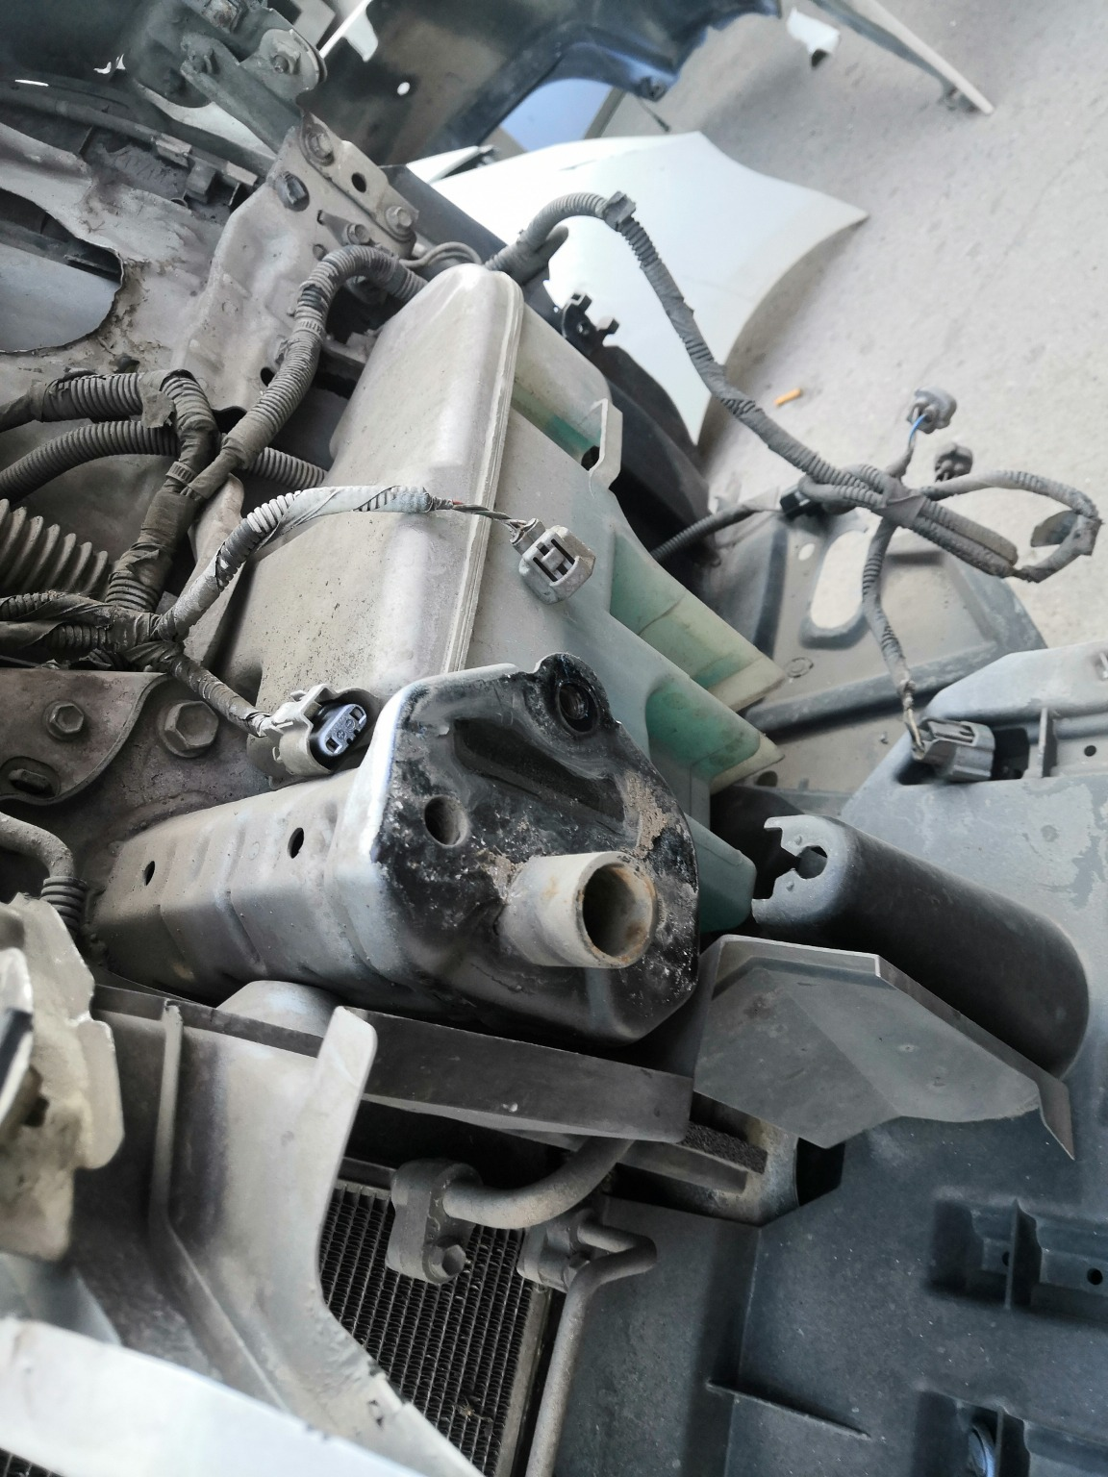 | 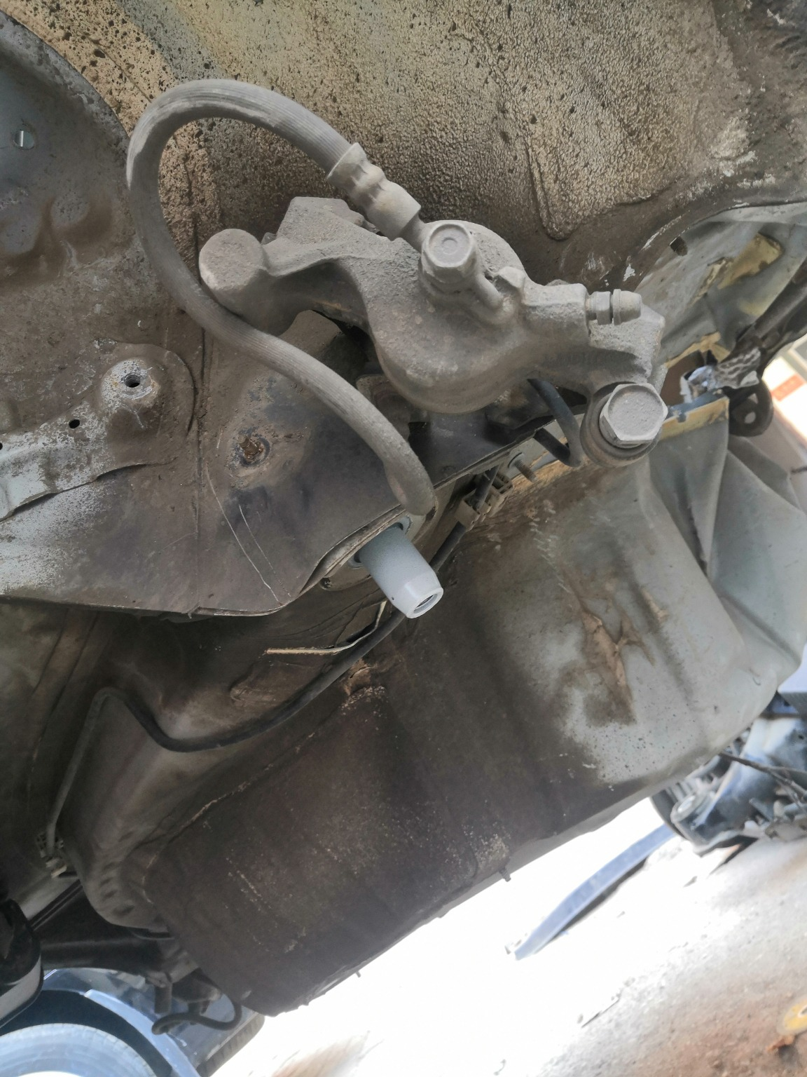
IMG_20201127_133734.jpg | IMG_20201127_133909.jpg | IMG_20201127_133757.jpg

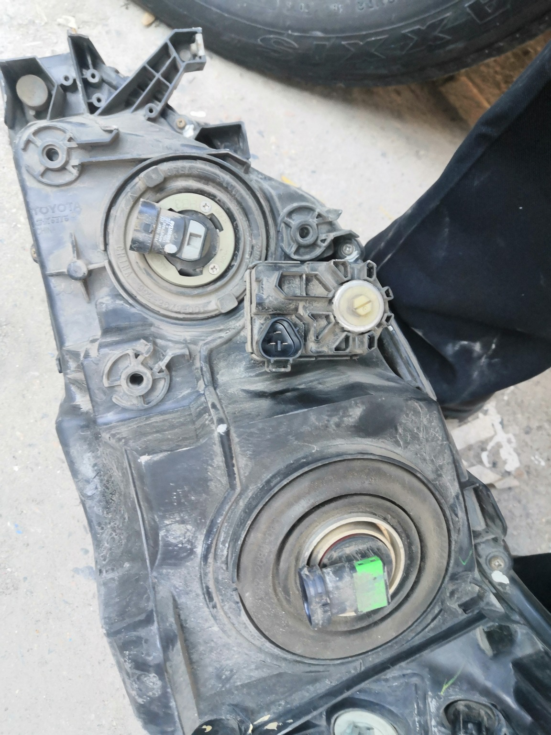 | 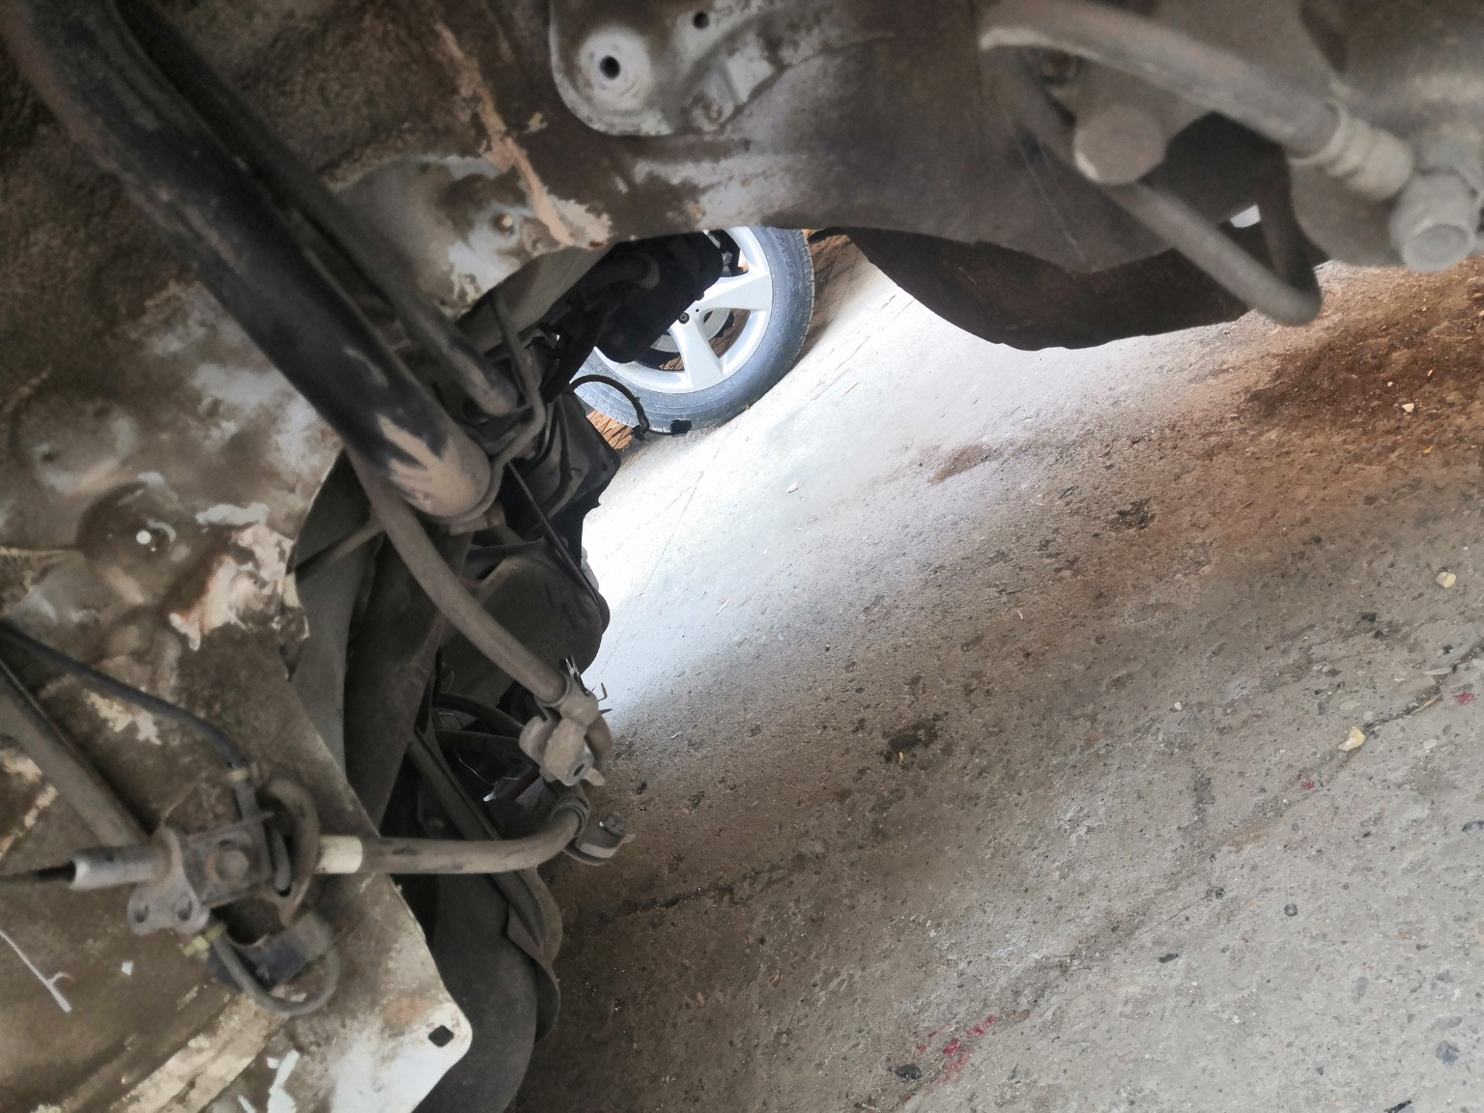 | 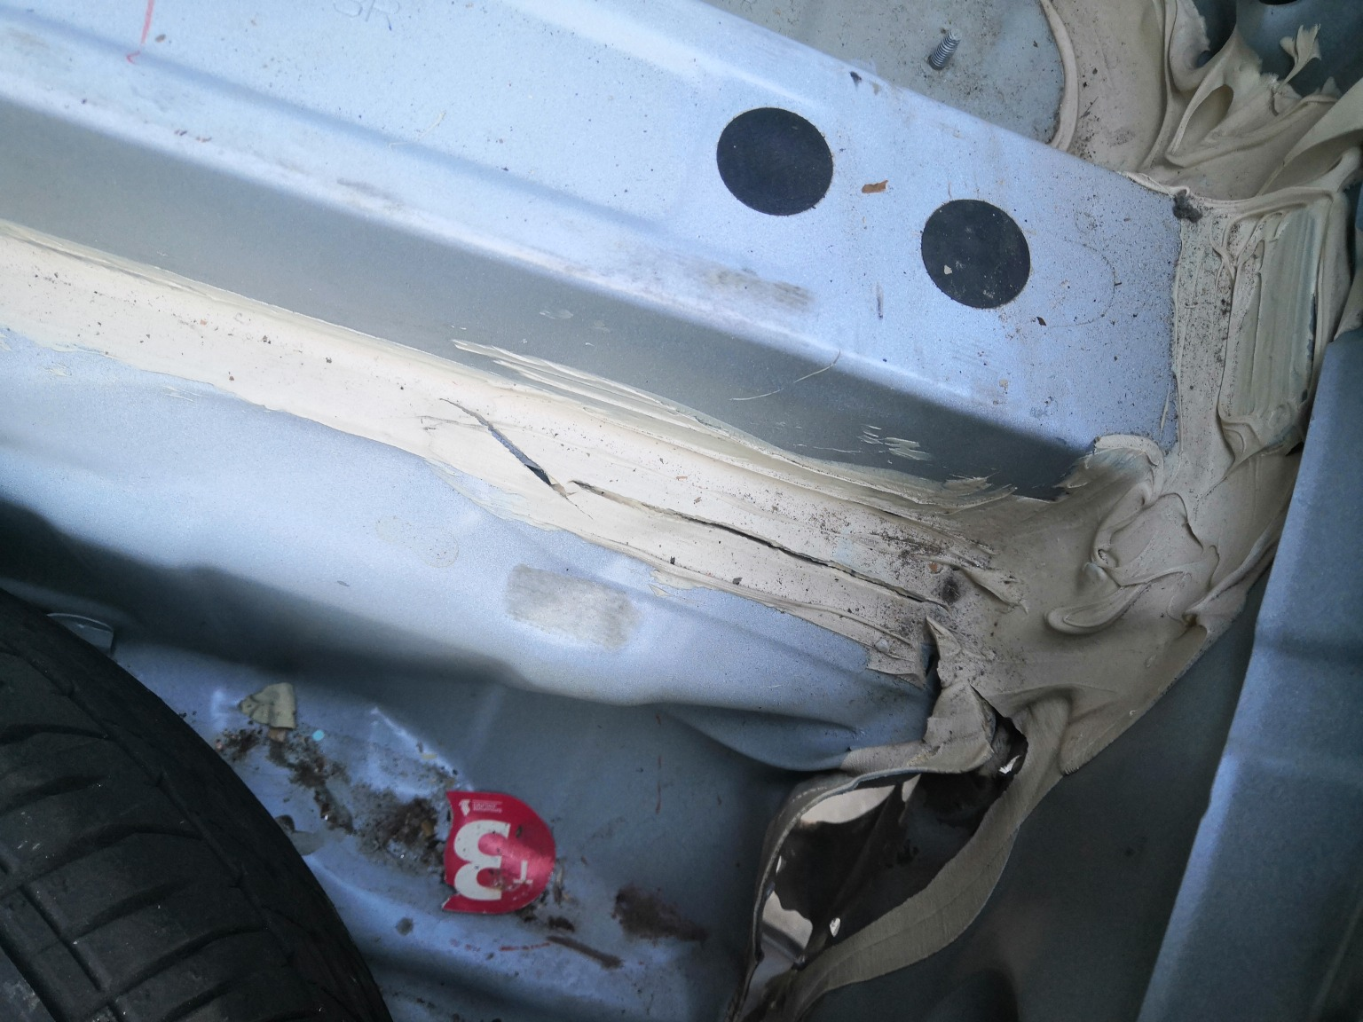
IMG_20201127_135139.jpg | IMG_20201127_133813.jpg | IMG_20201127_135420.jpg
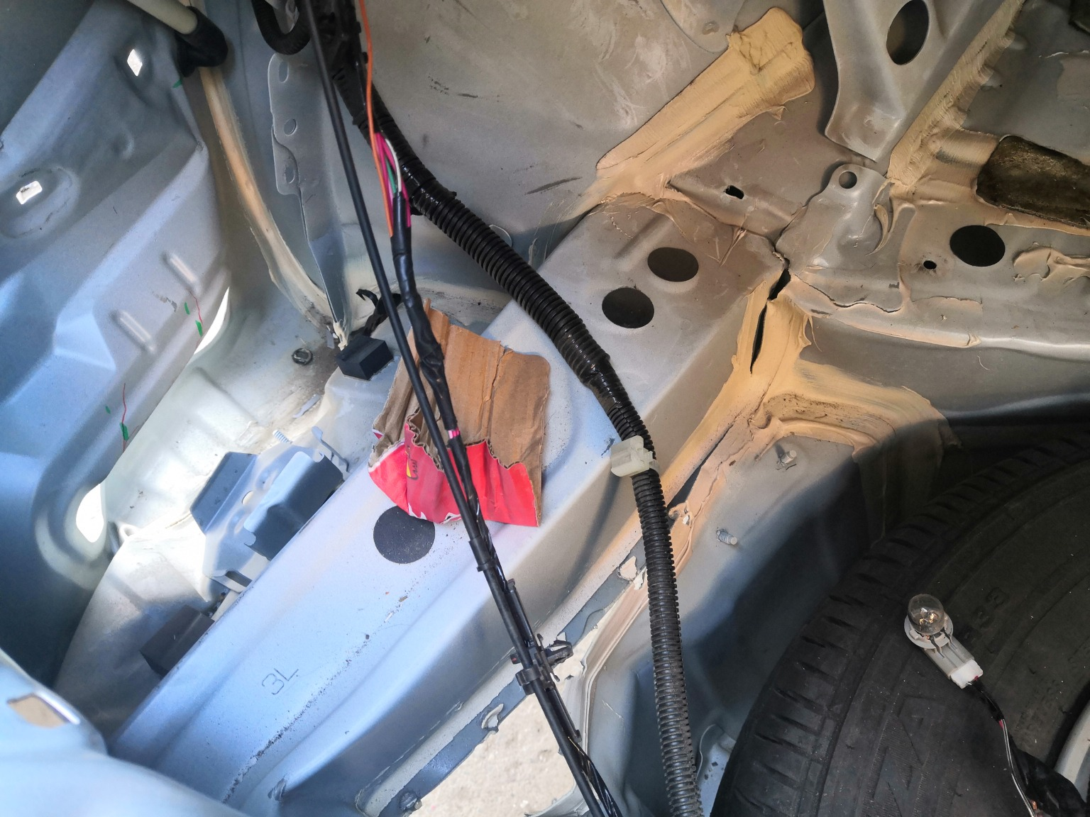 | 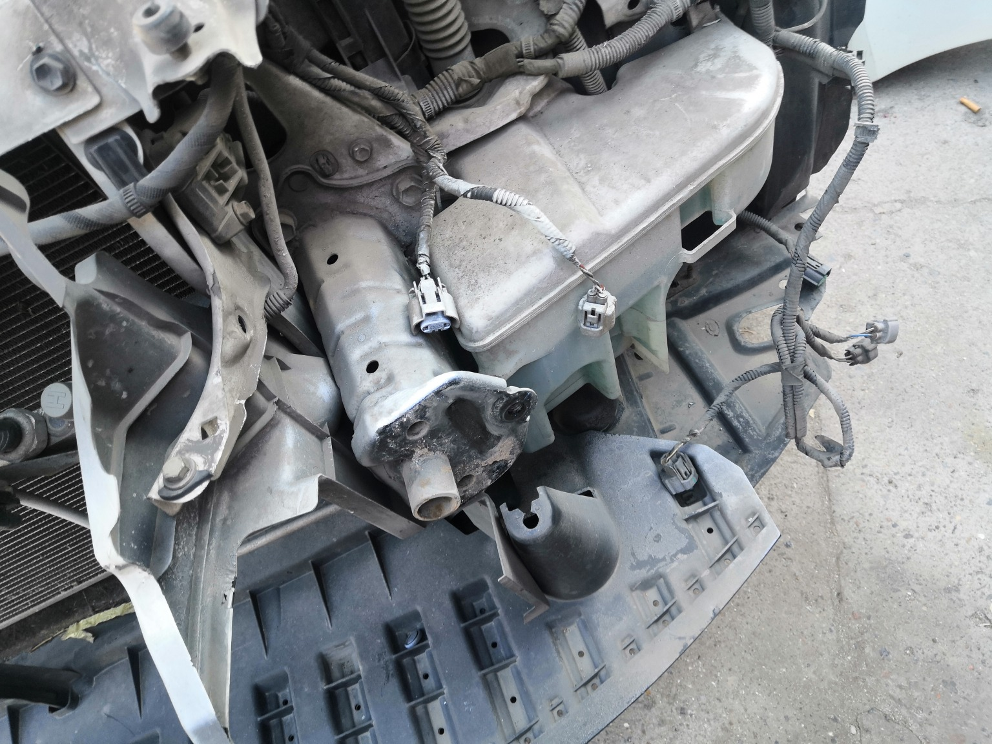 | 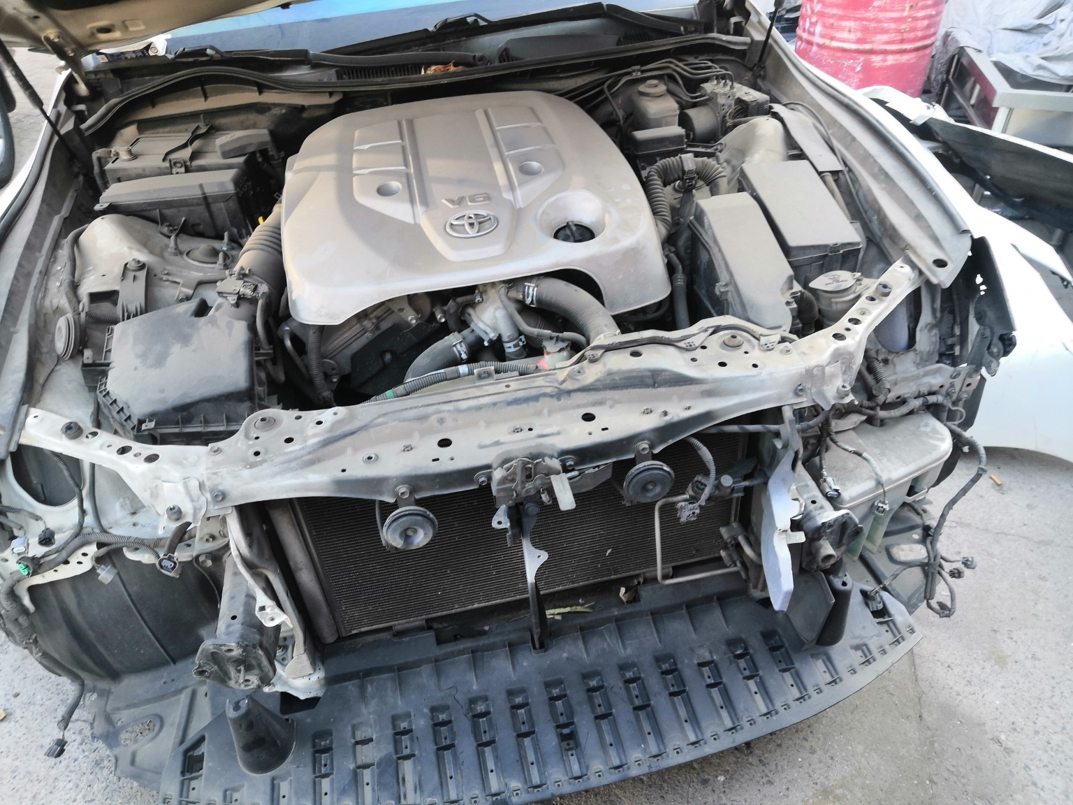
IMG_20201127_135409.jpg | IMG_20201127_133904.jpg | IMG_20201127_133828.jpg
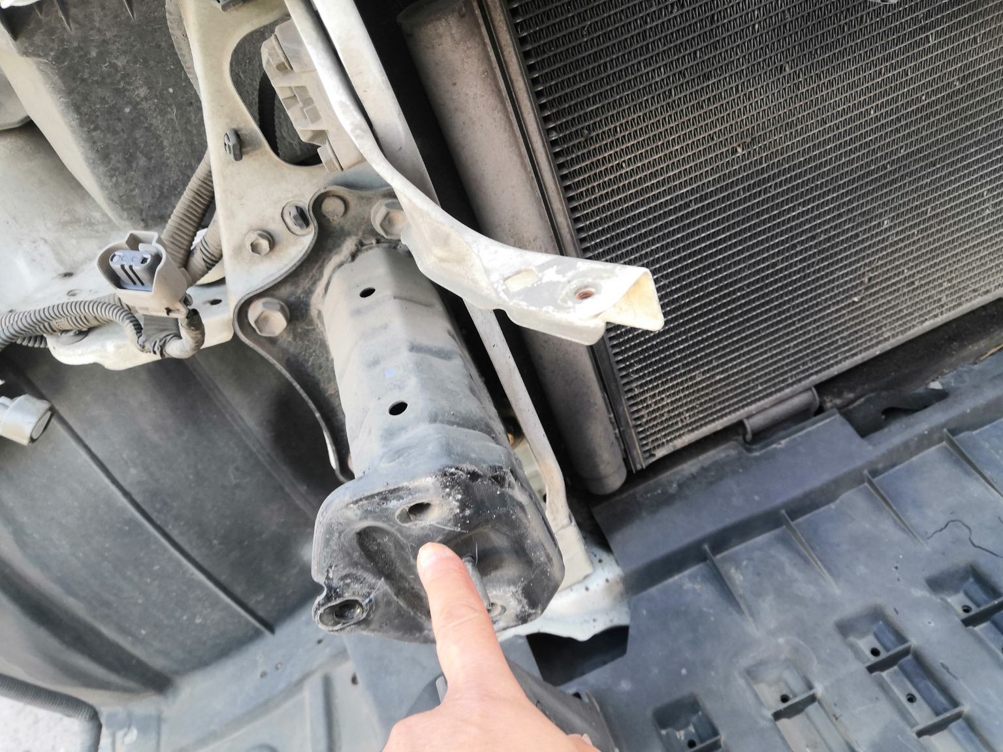 | 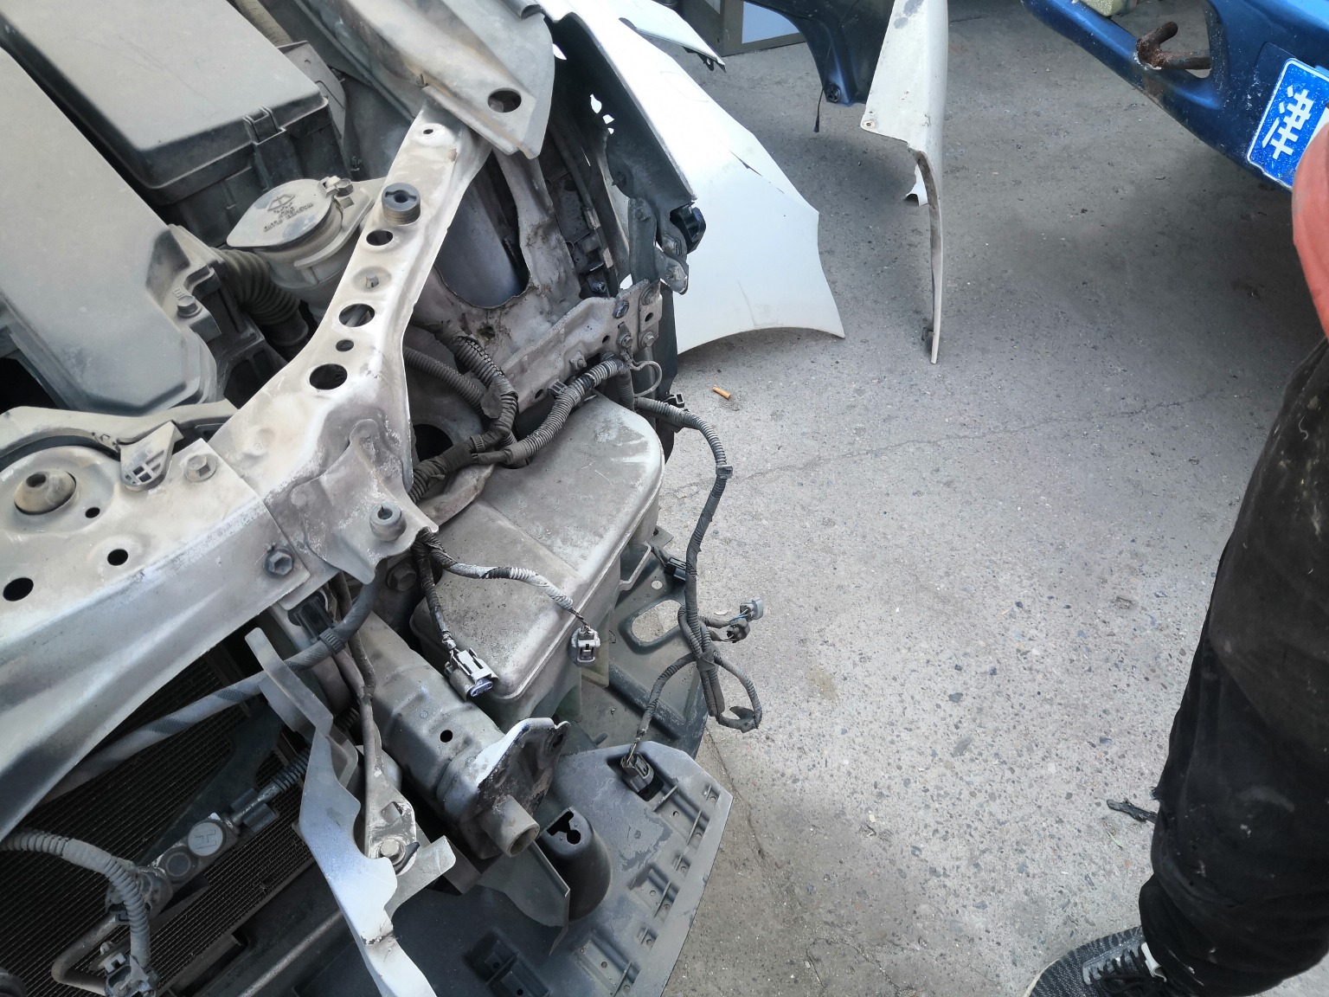 | 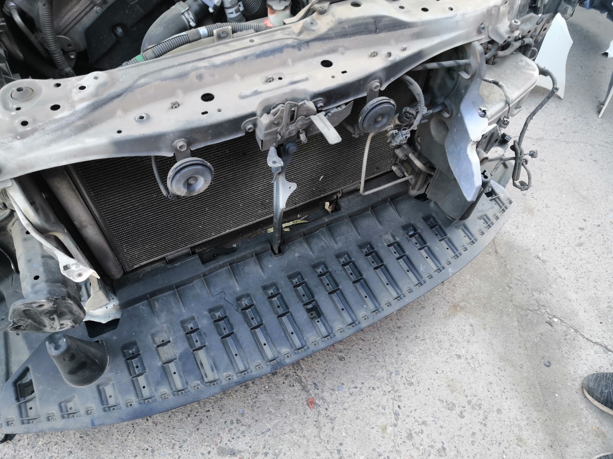
IMG_20201127_133900.jpg | IMG_20201127_133834.jpg | IMG_20201127_133831.jpg

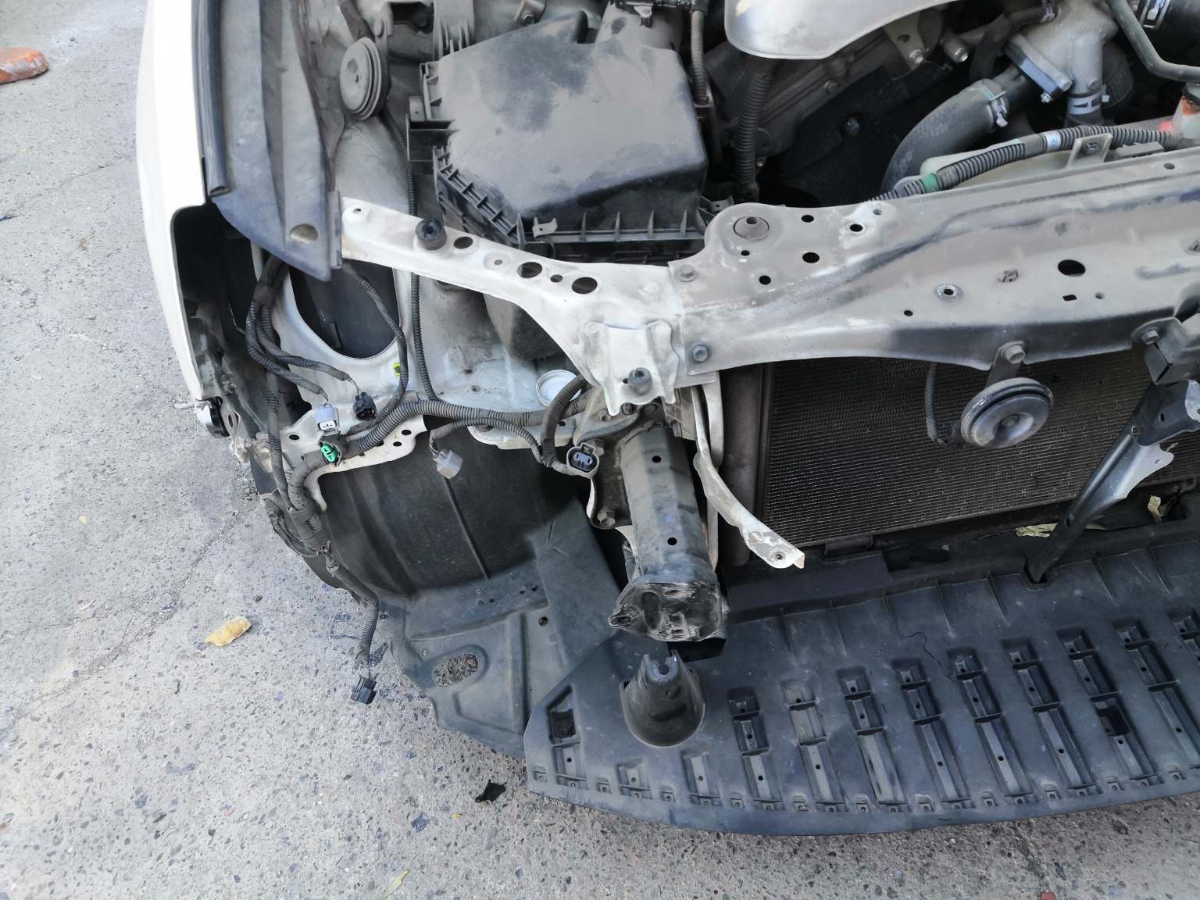 | 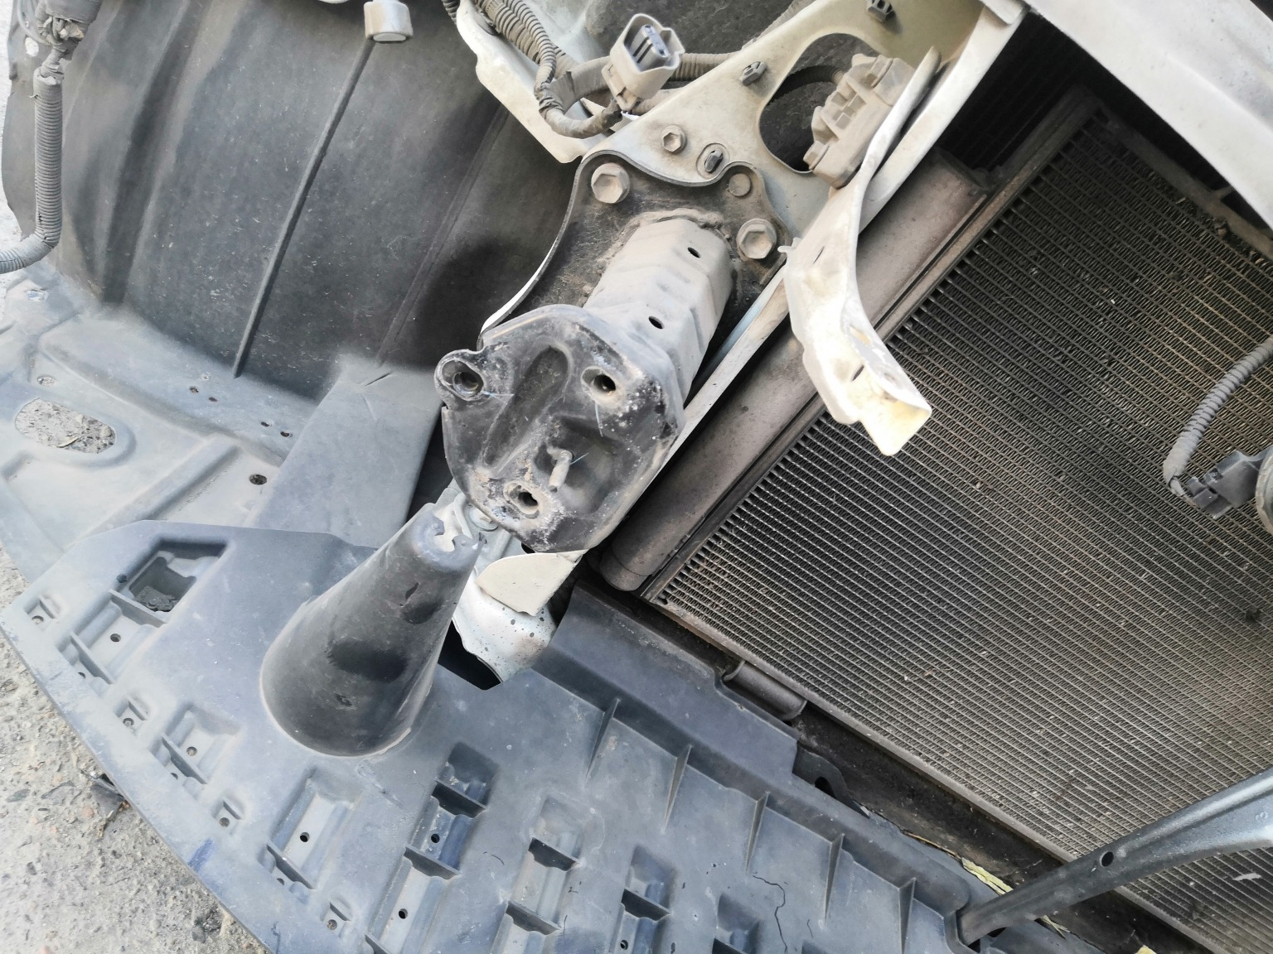
IMG_20201127_133830.jpg | IMG_20201127_133912.jpg

配件拆解
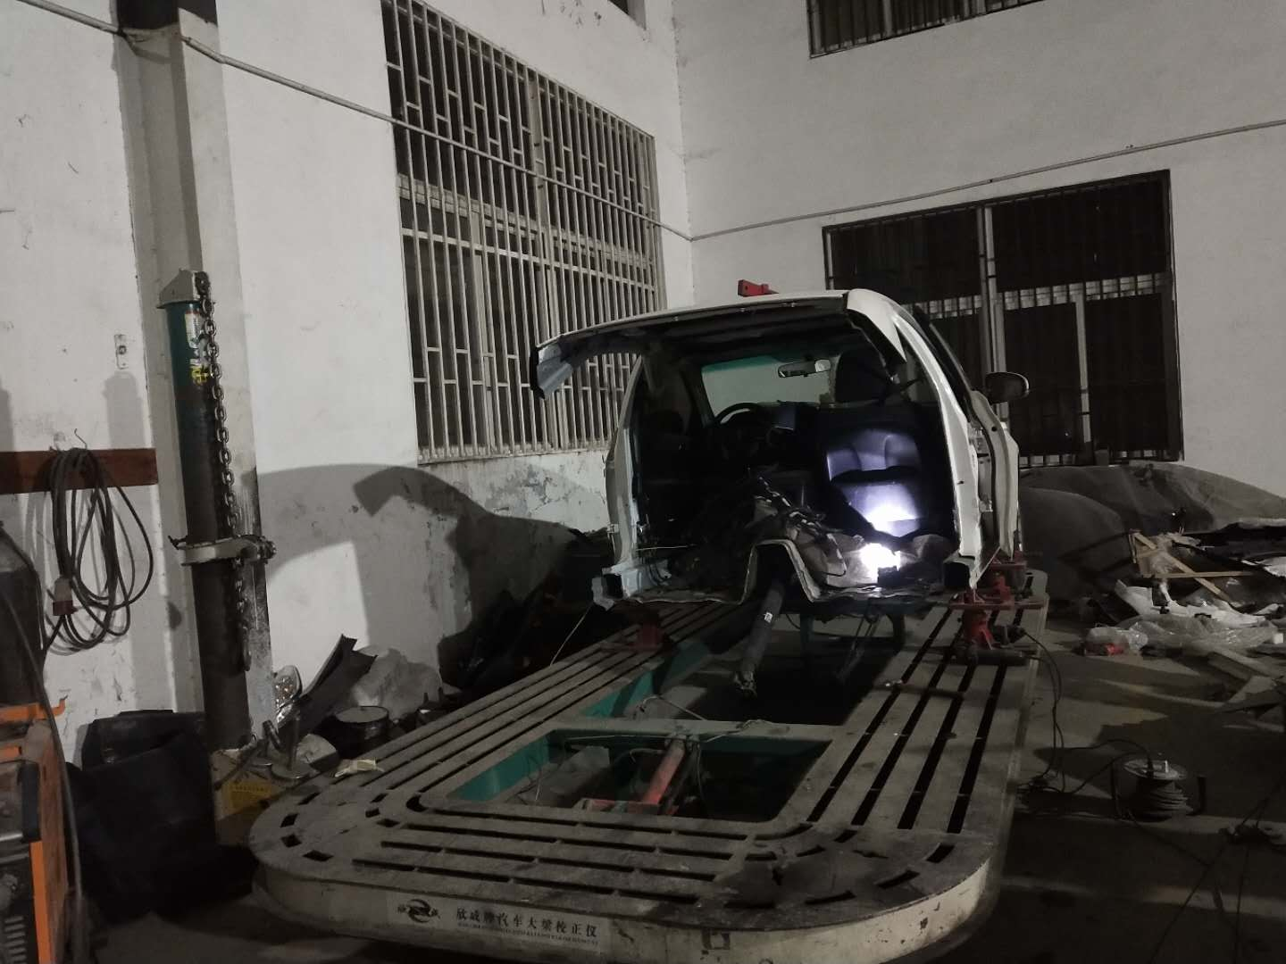 | 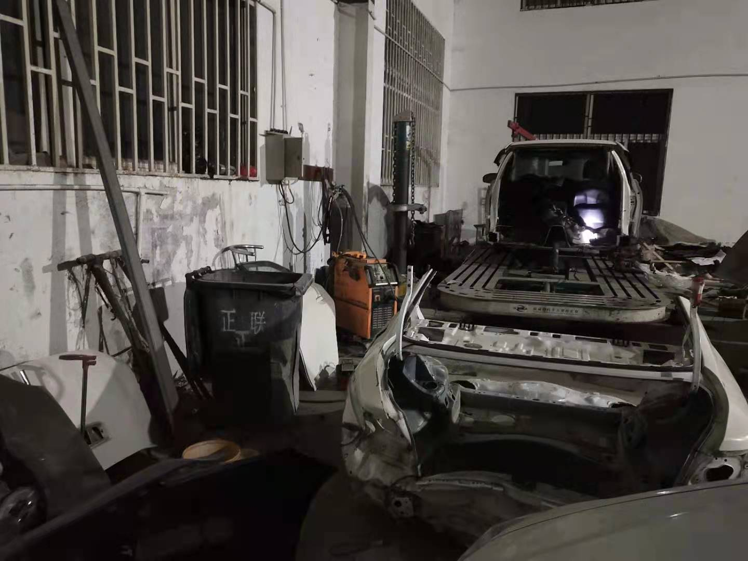 | 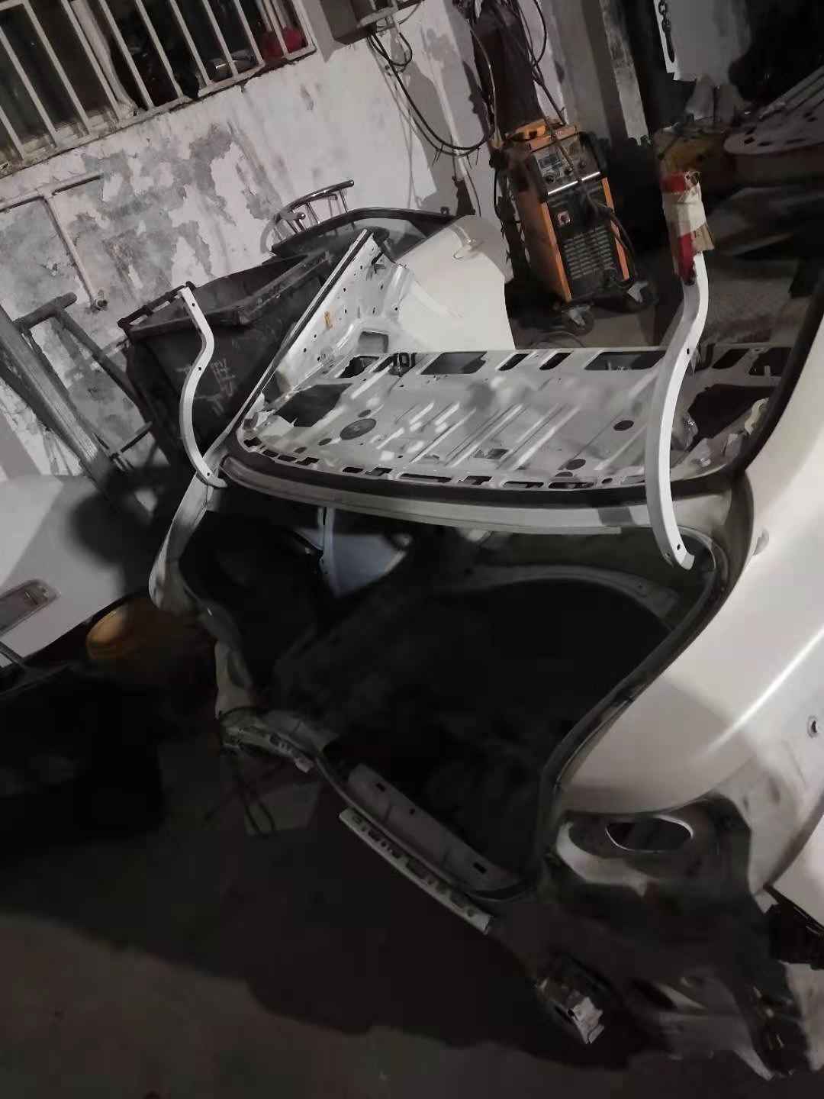
微信图片_20201215104826.jpg | 微信图片_20201215104839.jpg | 微信图片_20201215104843.jpg
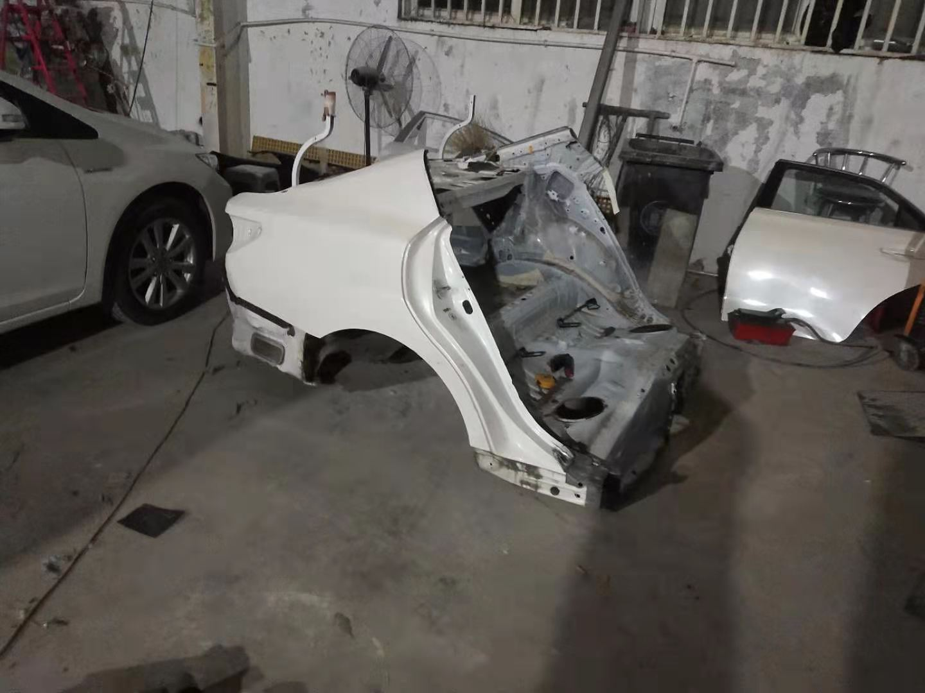 | 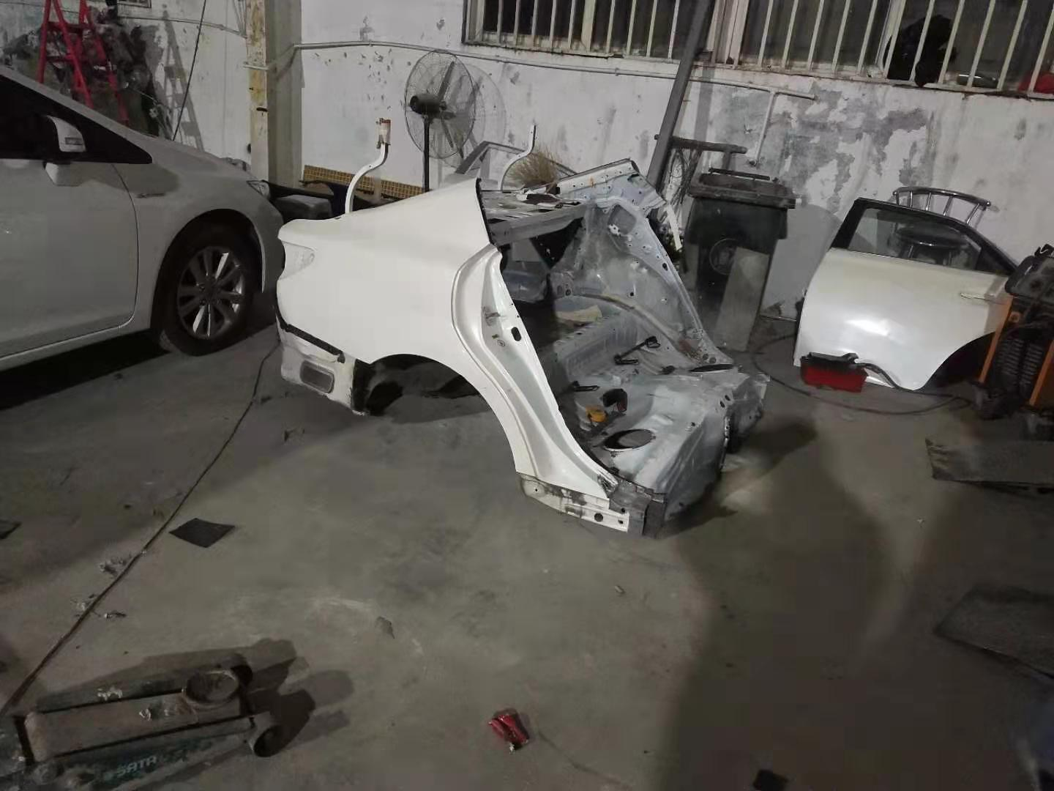 | 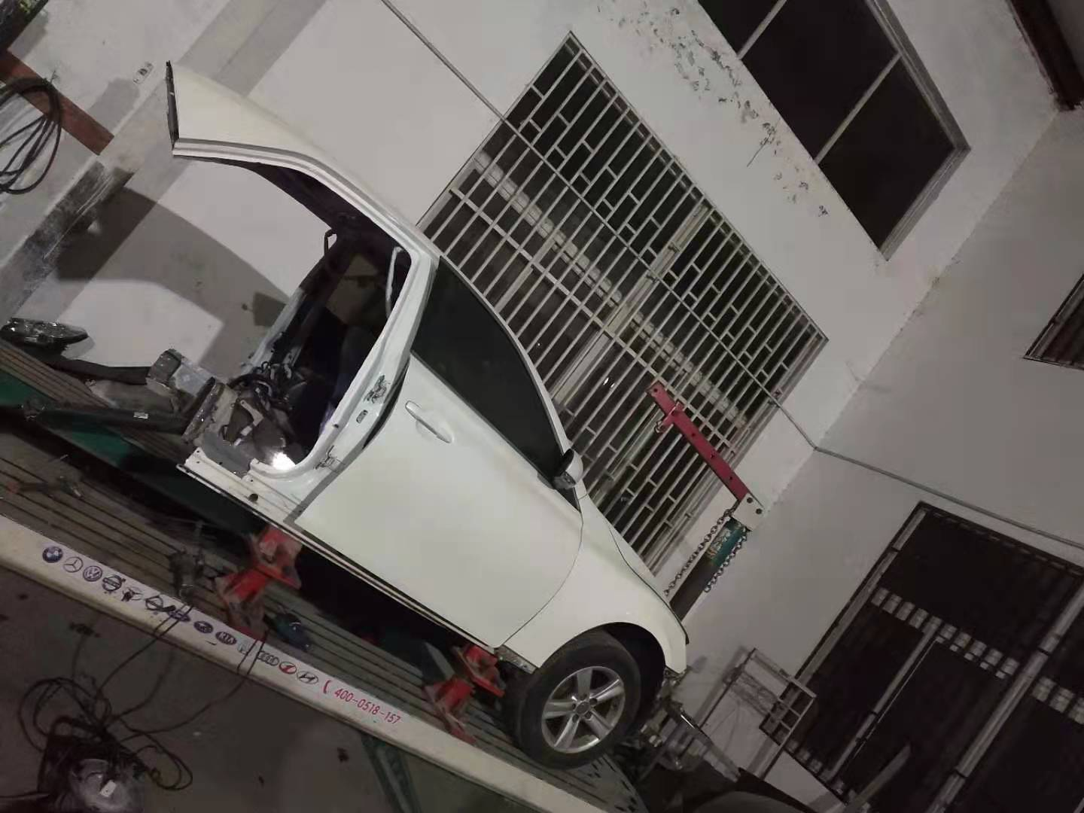
微信图片_20201215104846.jpg | 微信图片_20201215104850.jpg | 微信图片_20201215104854.jpg
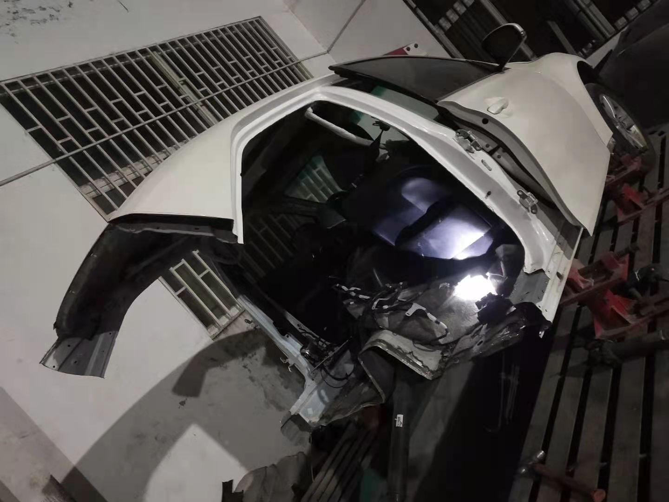 | 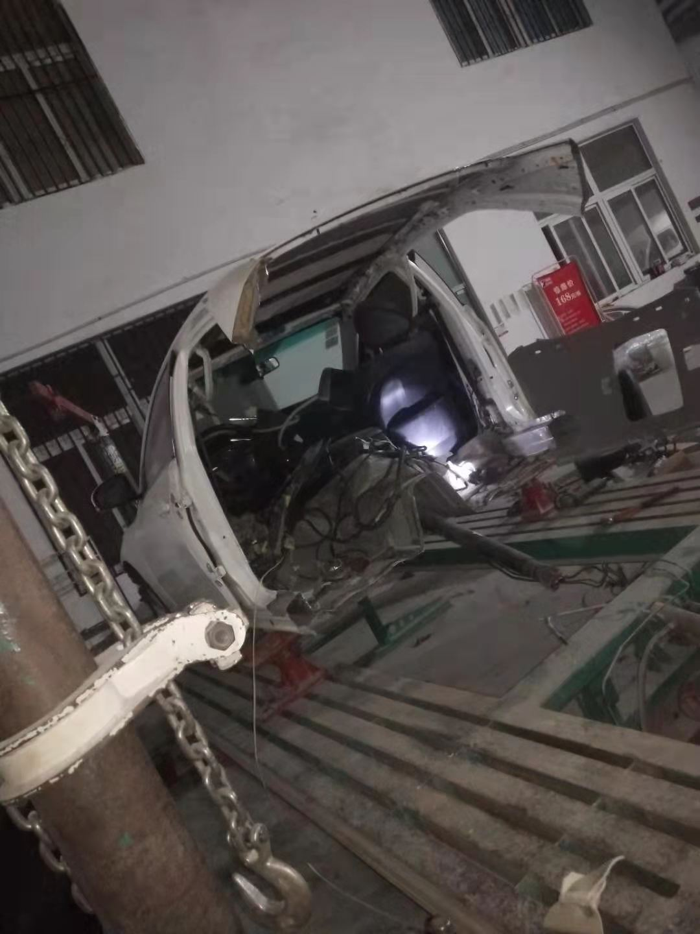 | 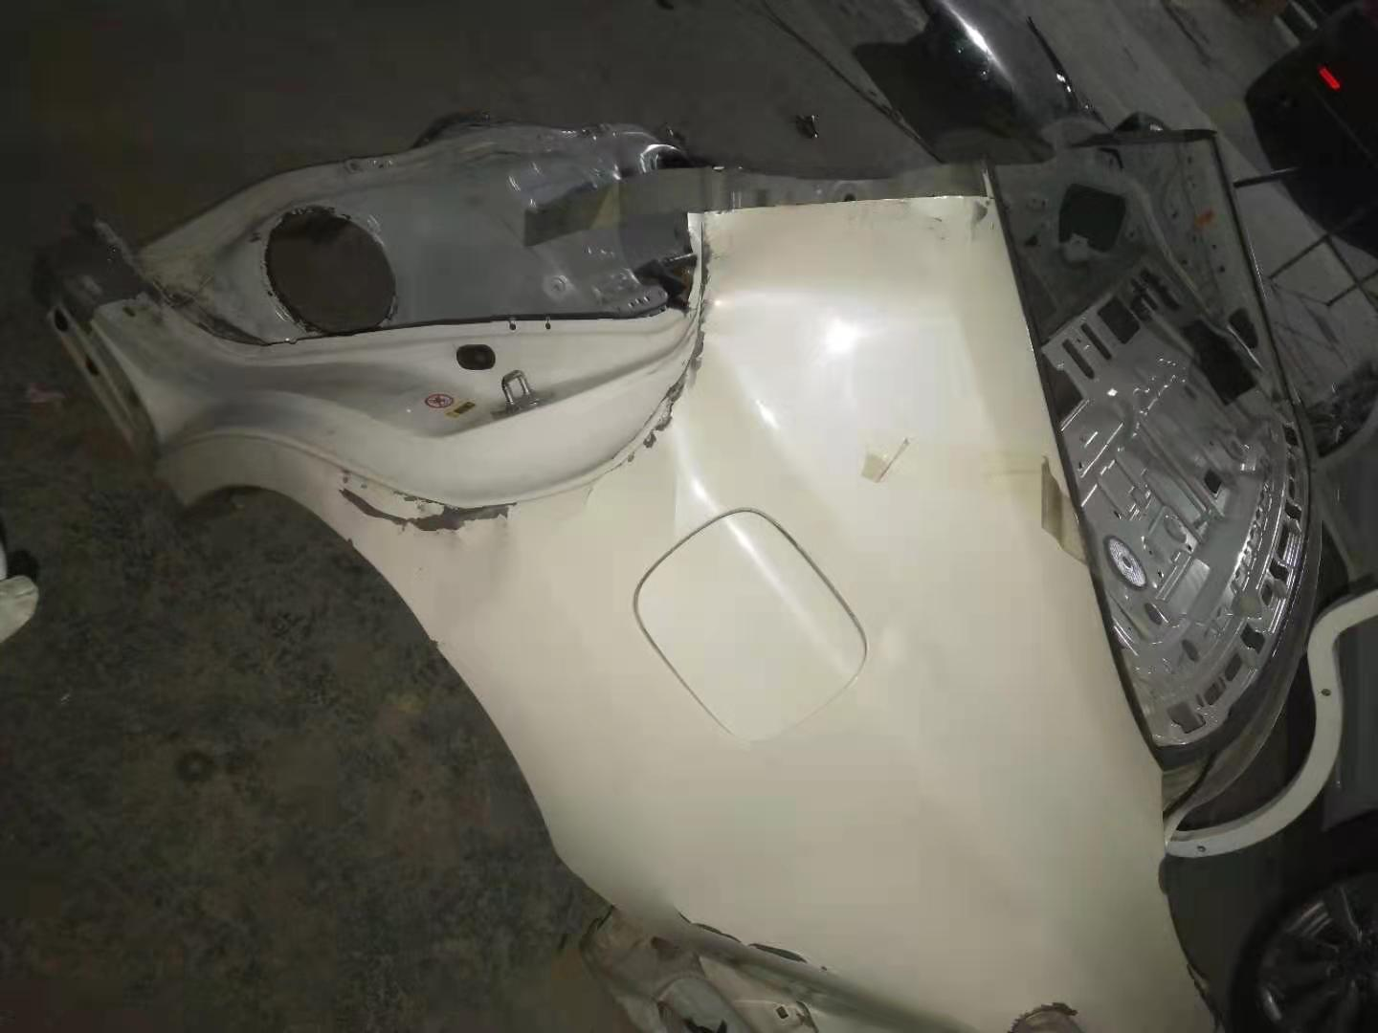
微信图片_20201215104857.jpg | 微信图片_20201215104901.jpg | 微信图片_20201215104905.jpg

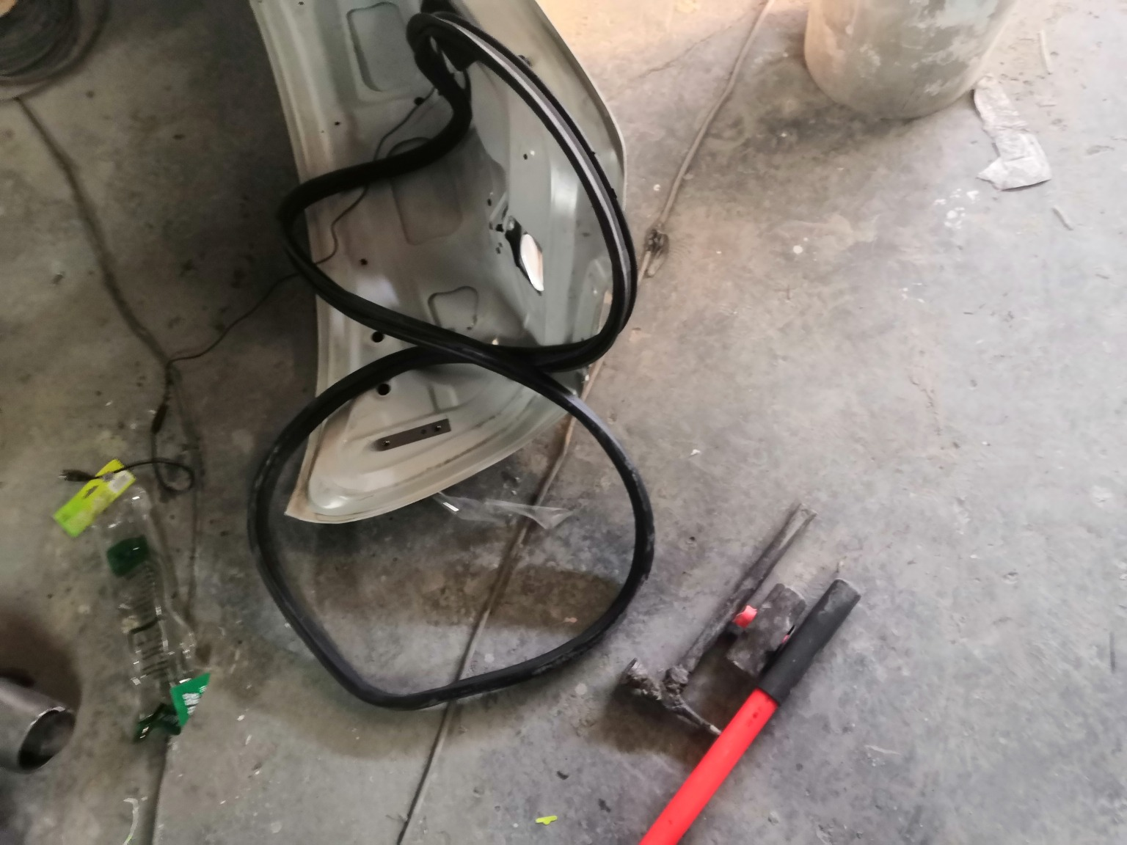 | 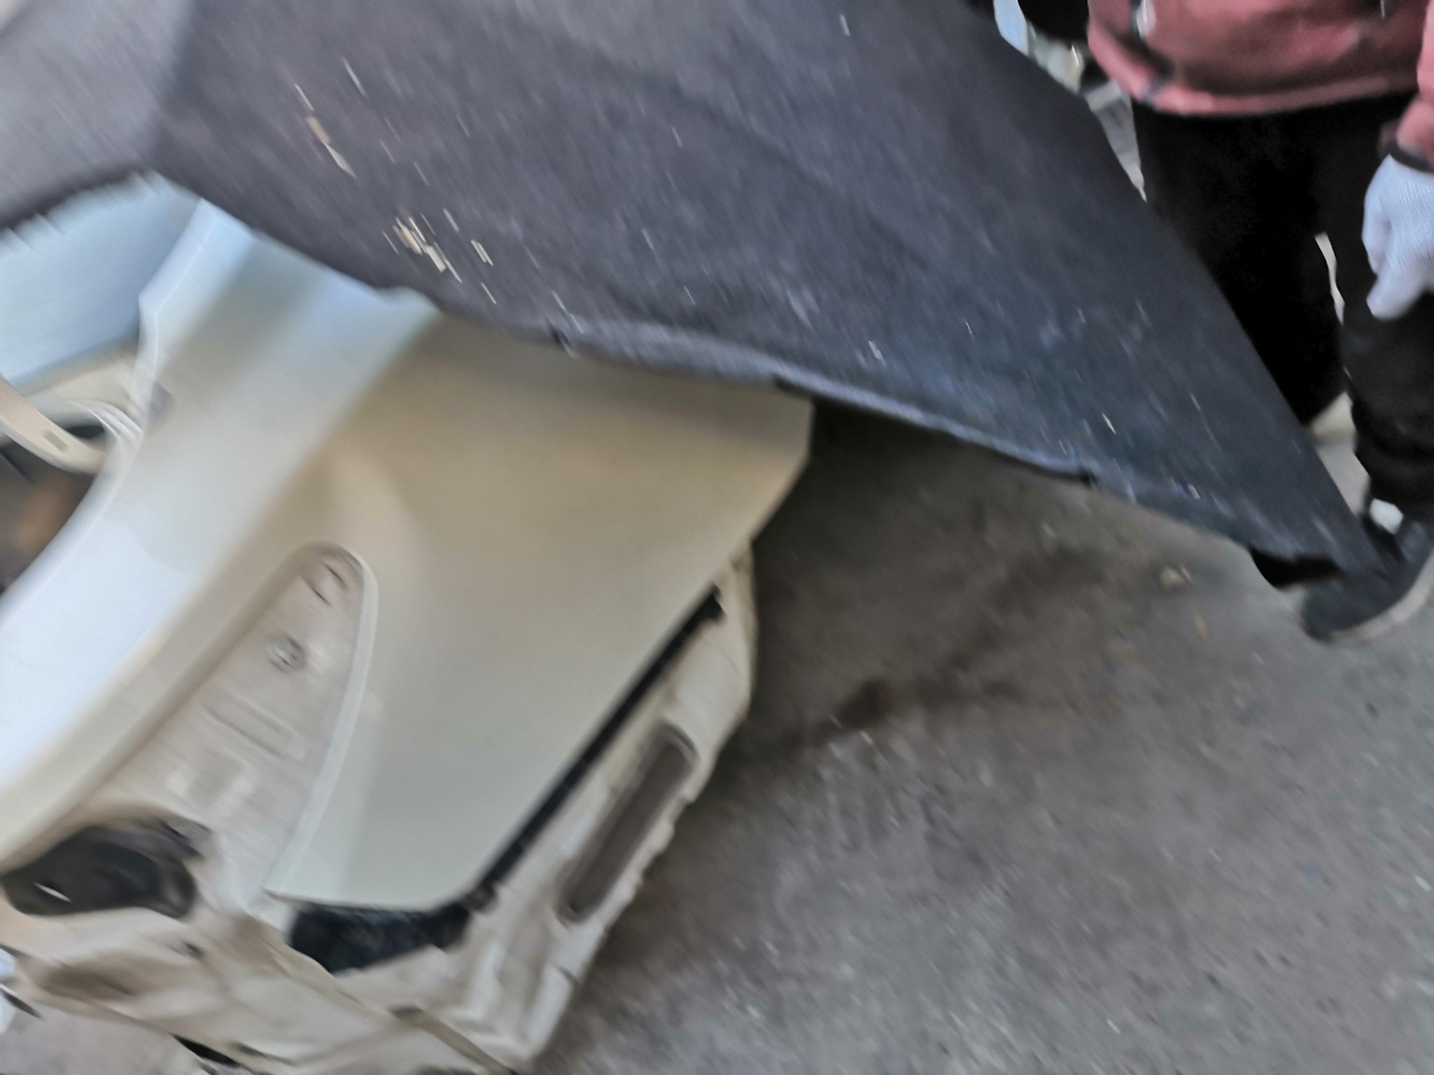 | 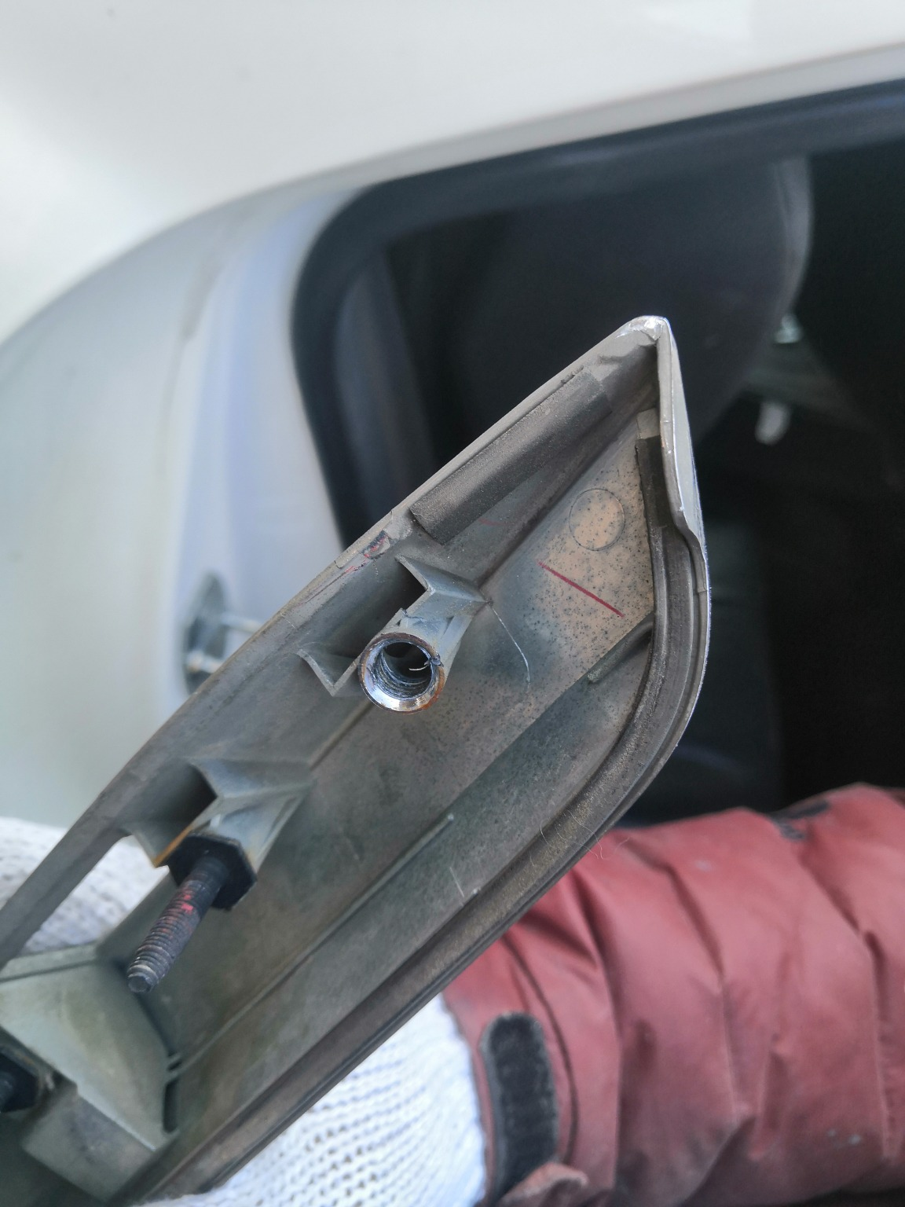
IMG_20201127_134316.jpg | IMG_20201127_134908.jpg | IMG_20201127_135027.jpg
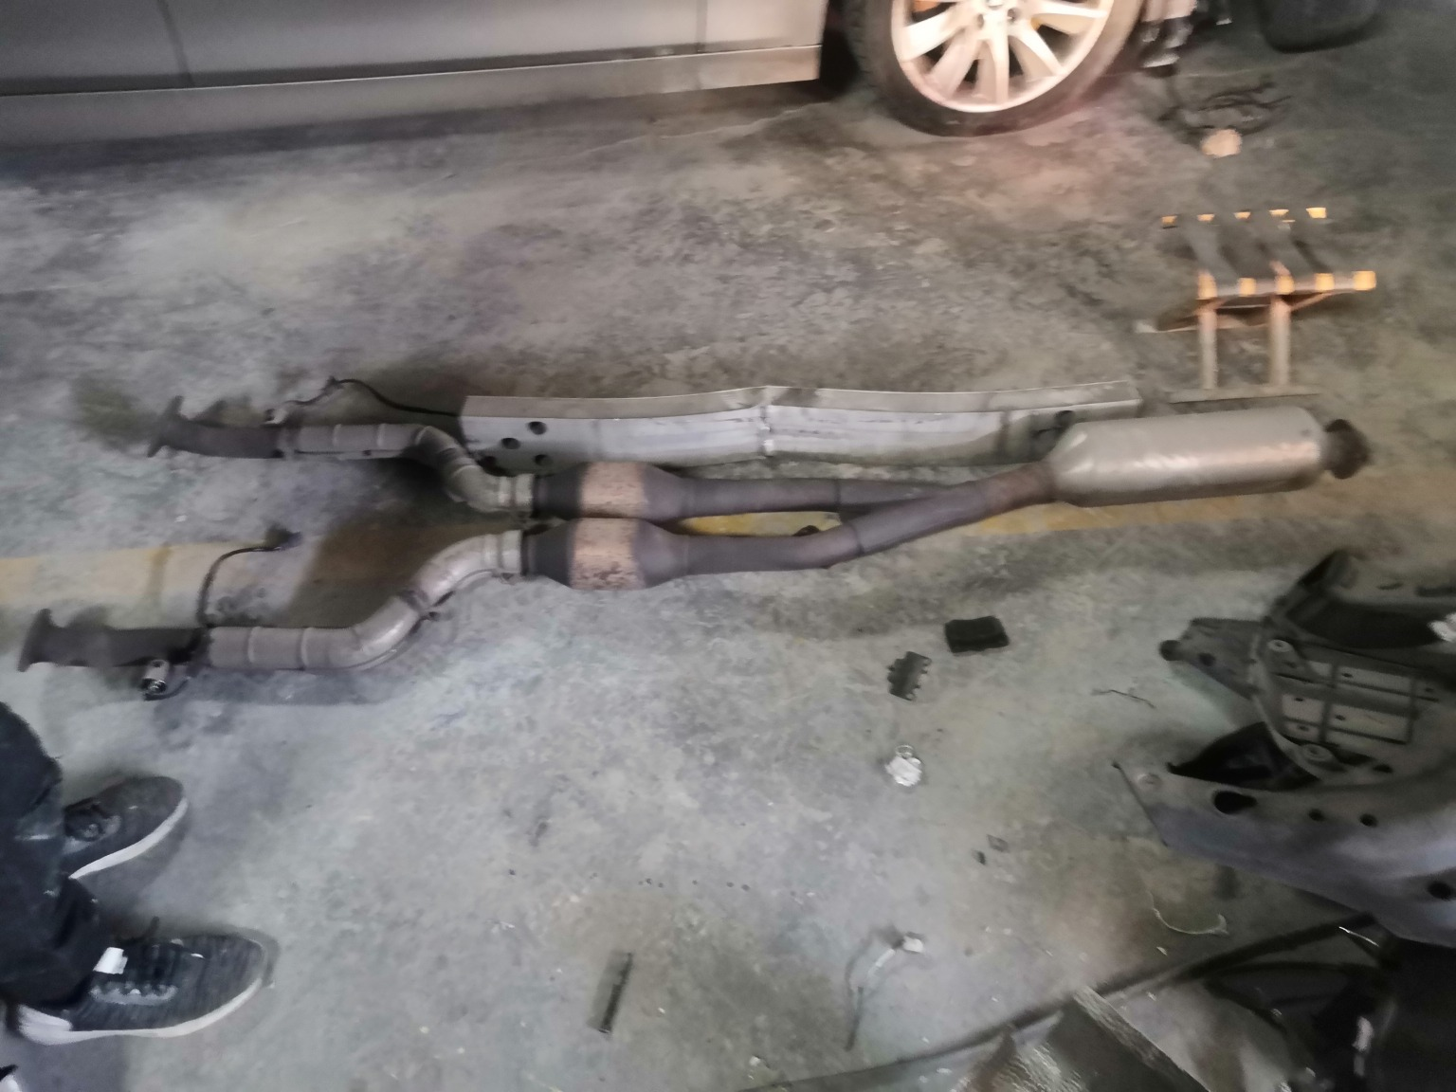 | 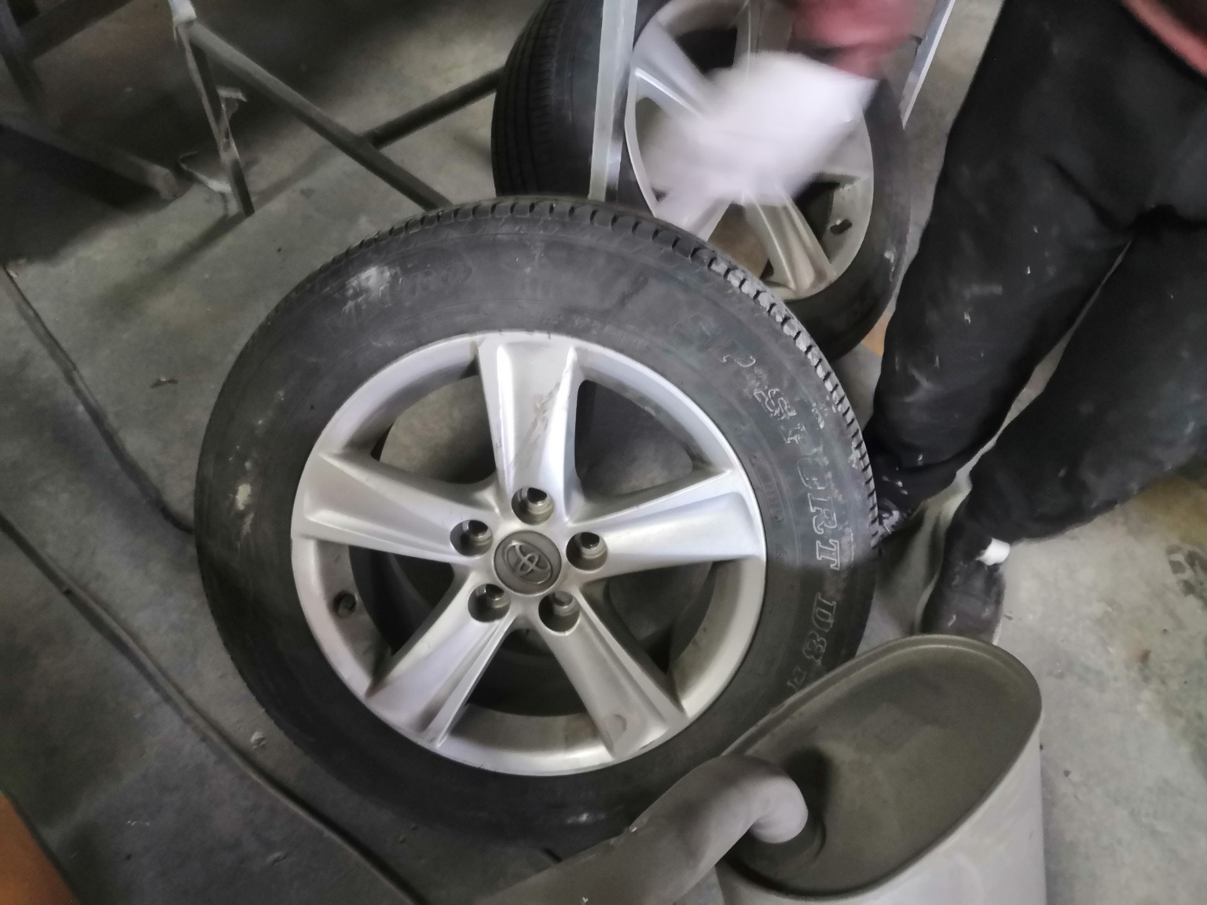 | 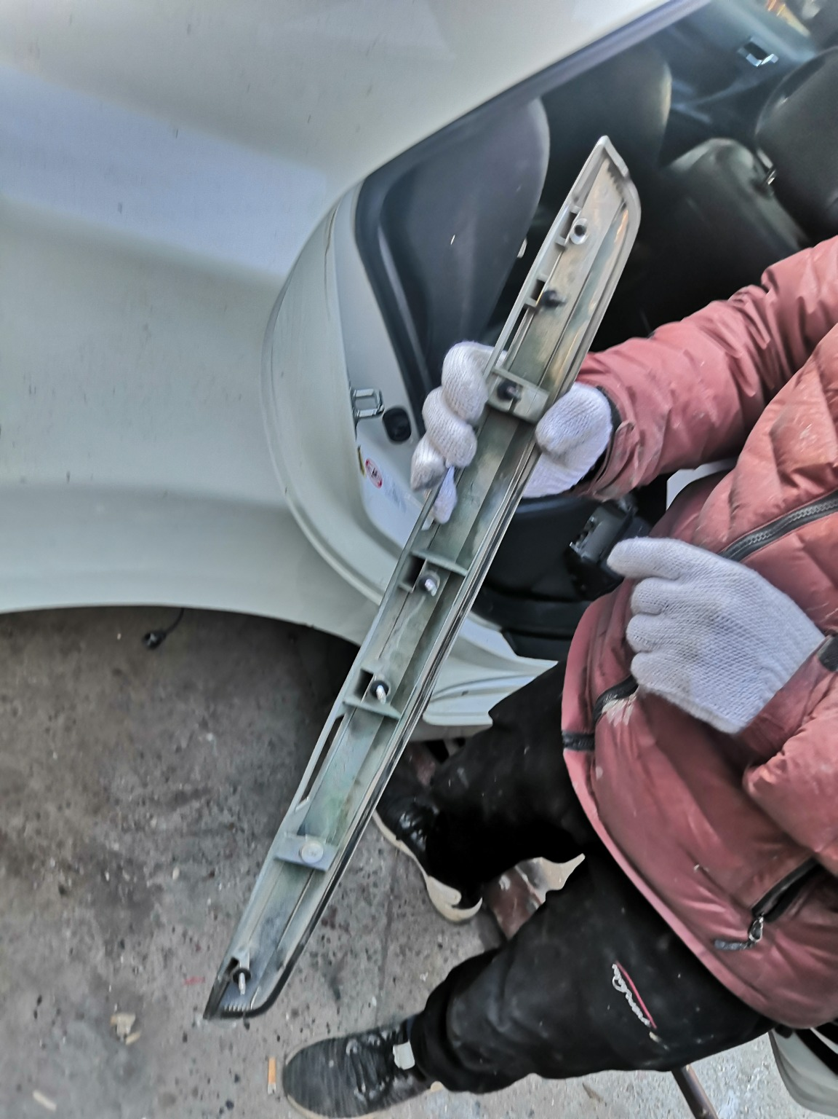
IMG_20201127_134650.jpg | IMG_20201127_134434.jpg | IMG_20201127_135024.jpg
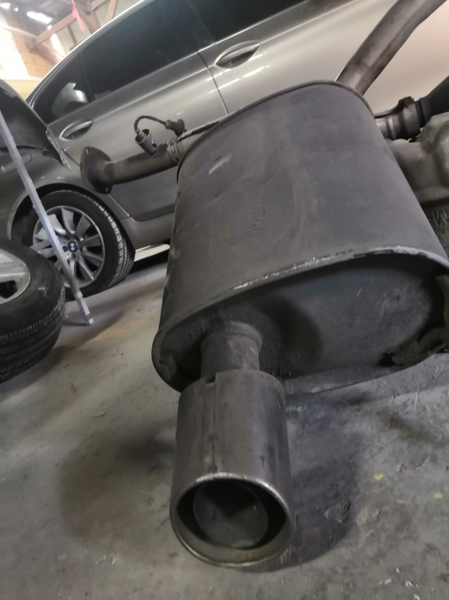 | 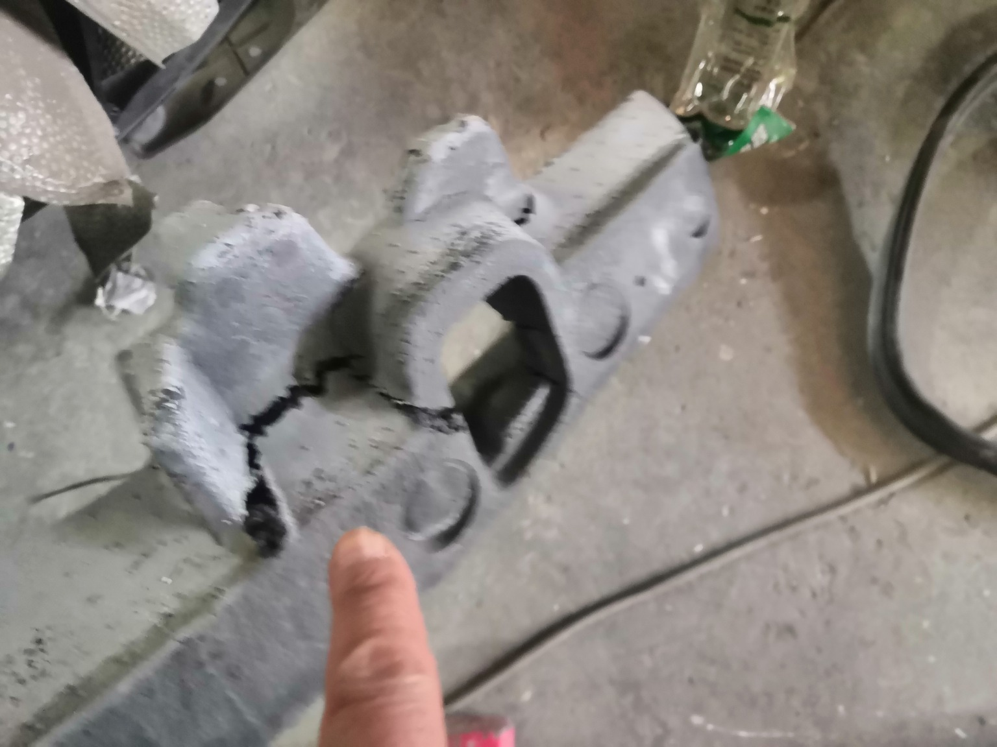 | 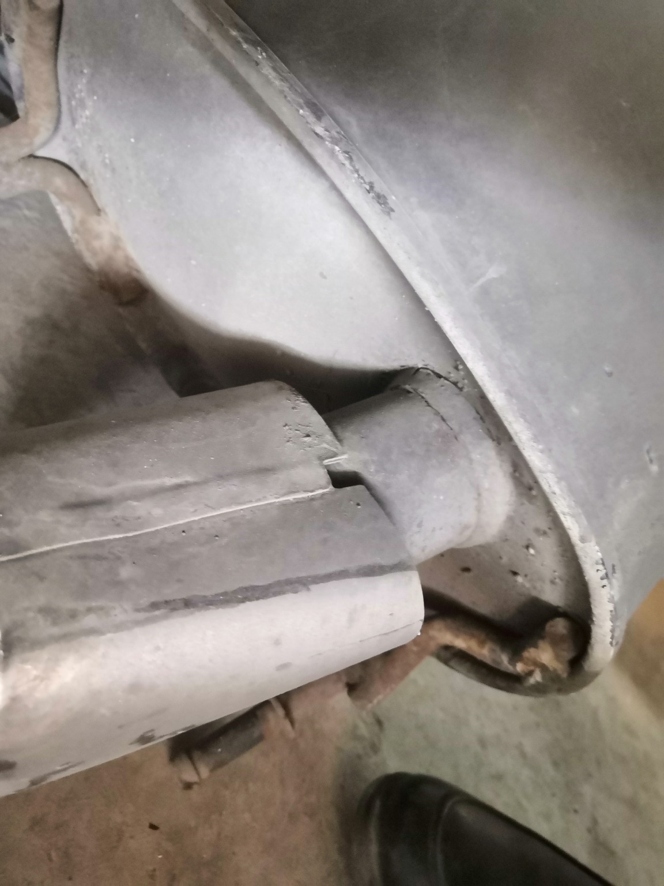
IMG_20201127_134413.jpg | IMG_20201127_134447.jpg | IMG_20201127_134349.jpg

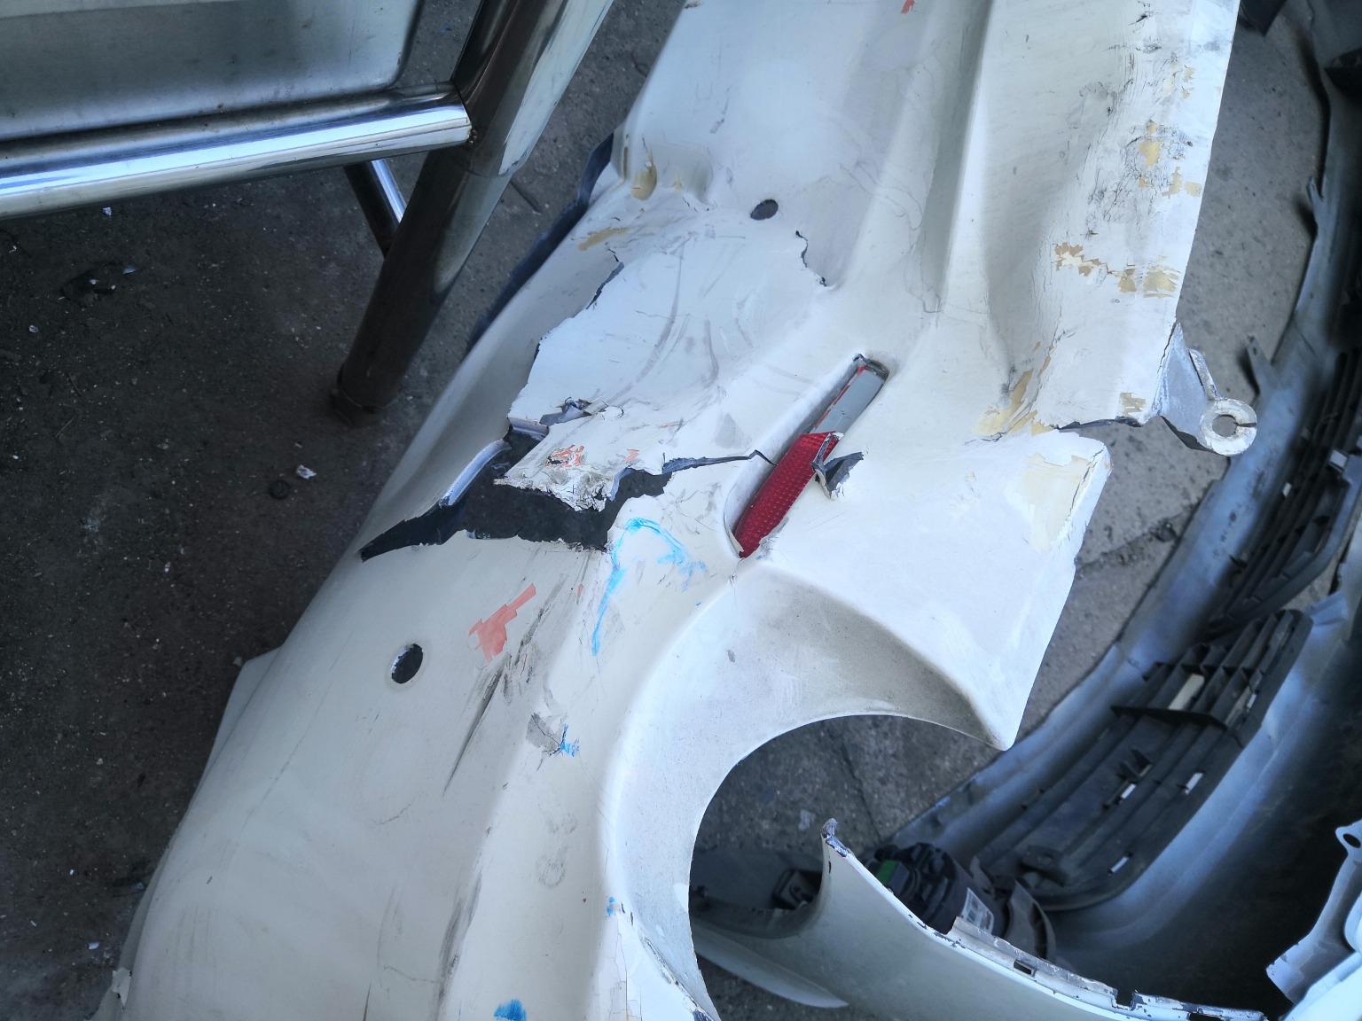 | 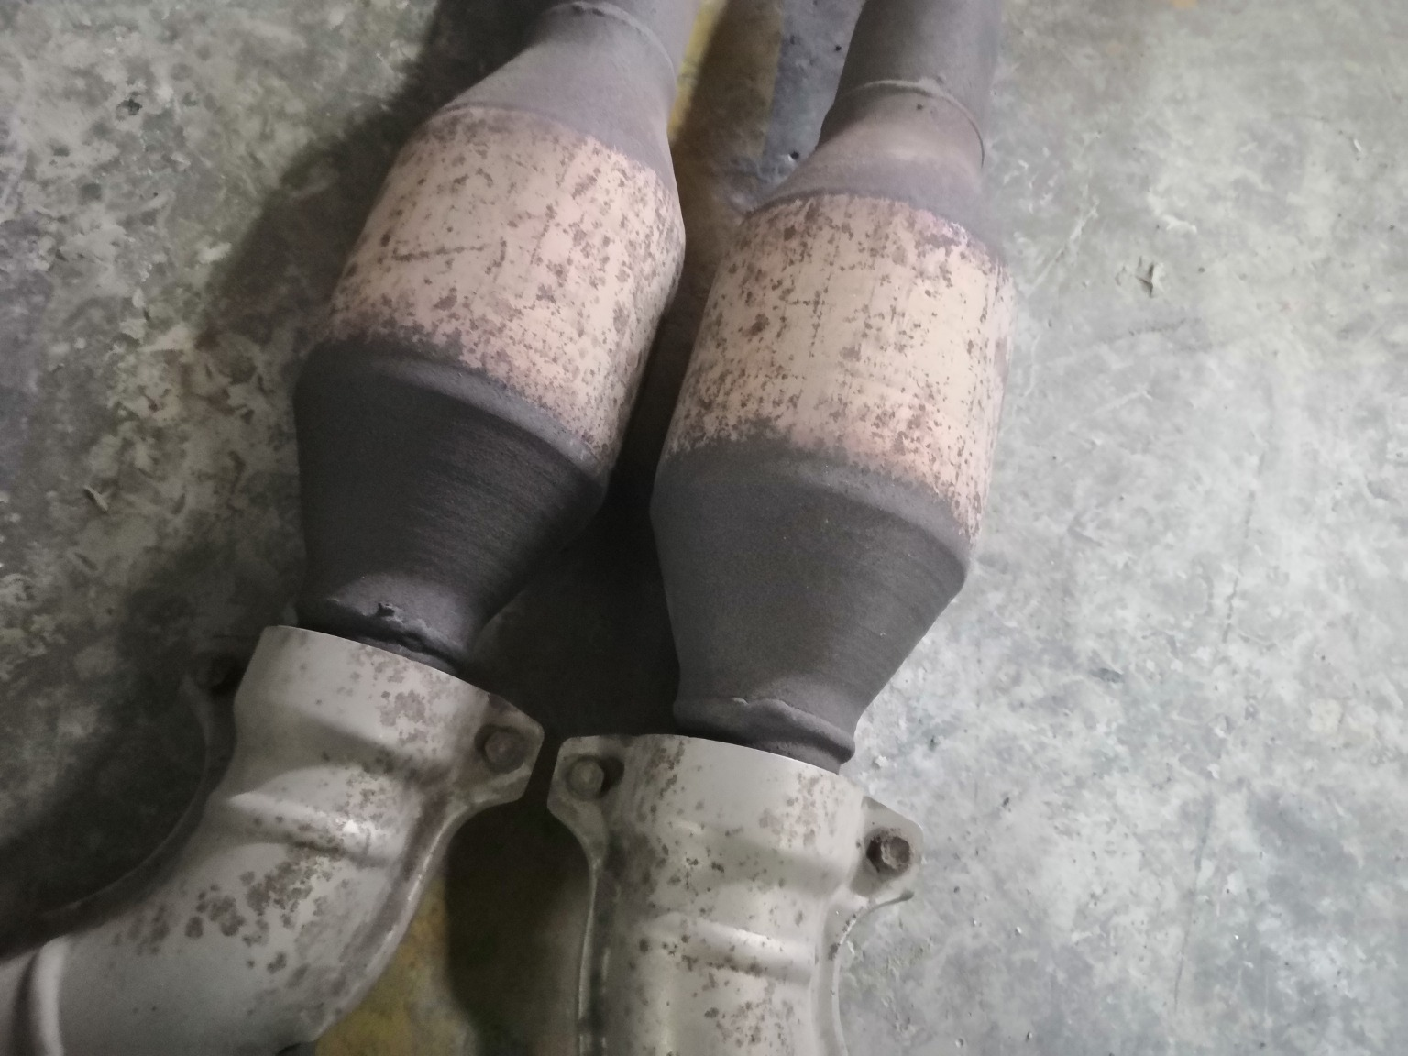 | 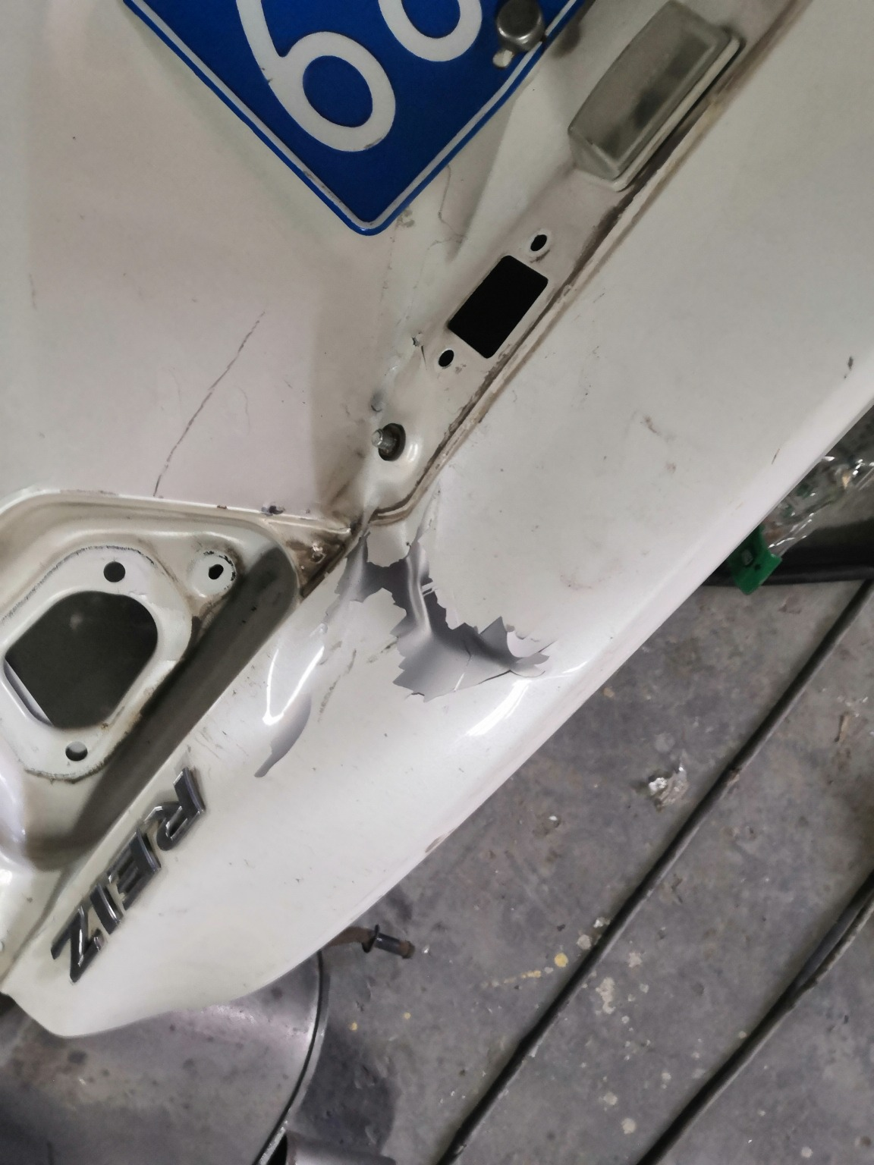
IMG_20201127_134006.jpg | IMG_20201127_134718.jpg | IMG_20201127_134243.jpg
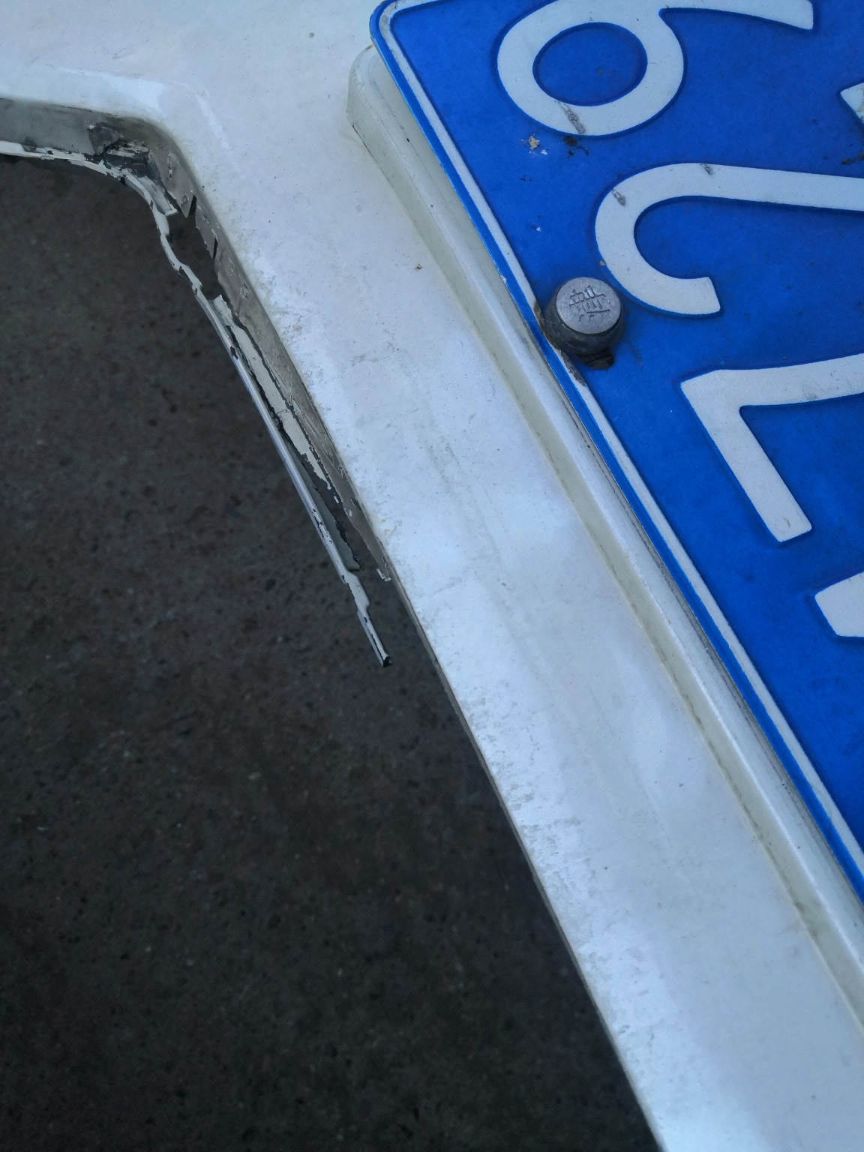 | 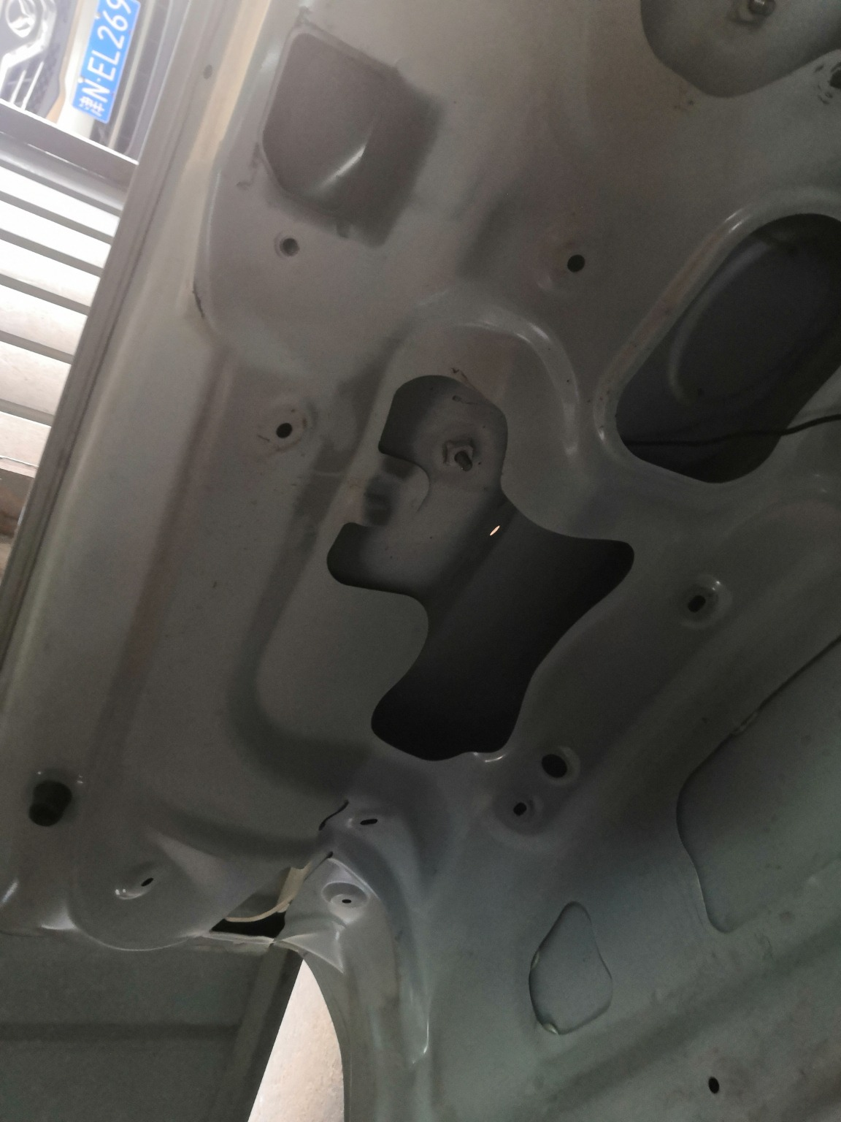 | 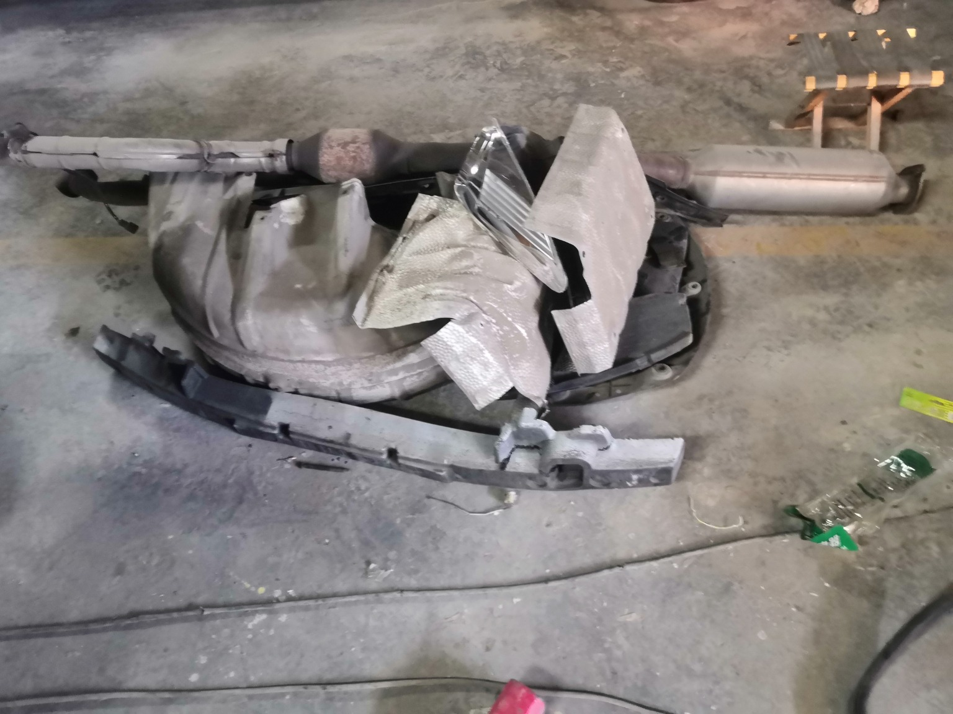
IMG_20201127_133929.jpg | IMG_20201127_134303.jpg | IMG_20201127_134422.jpg
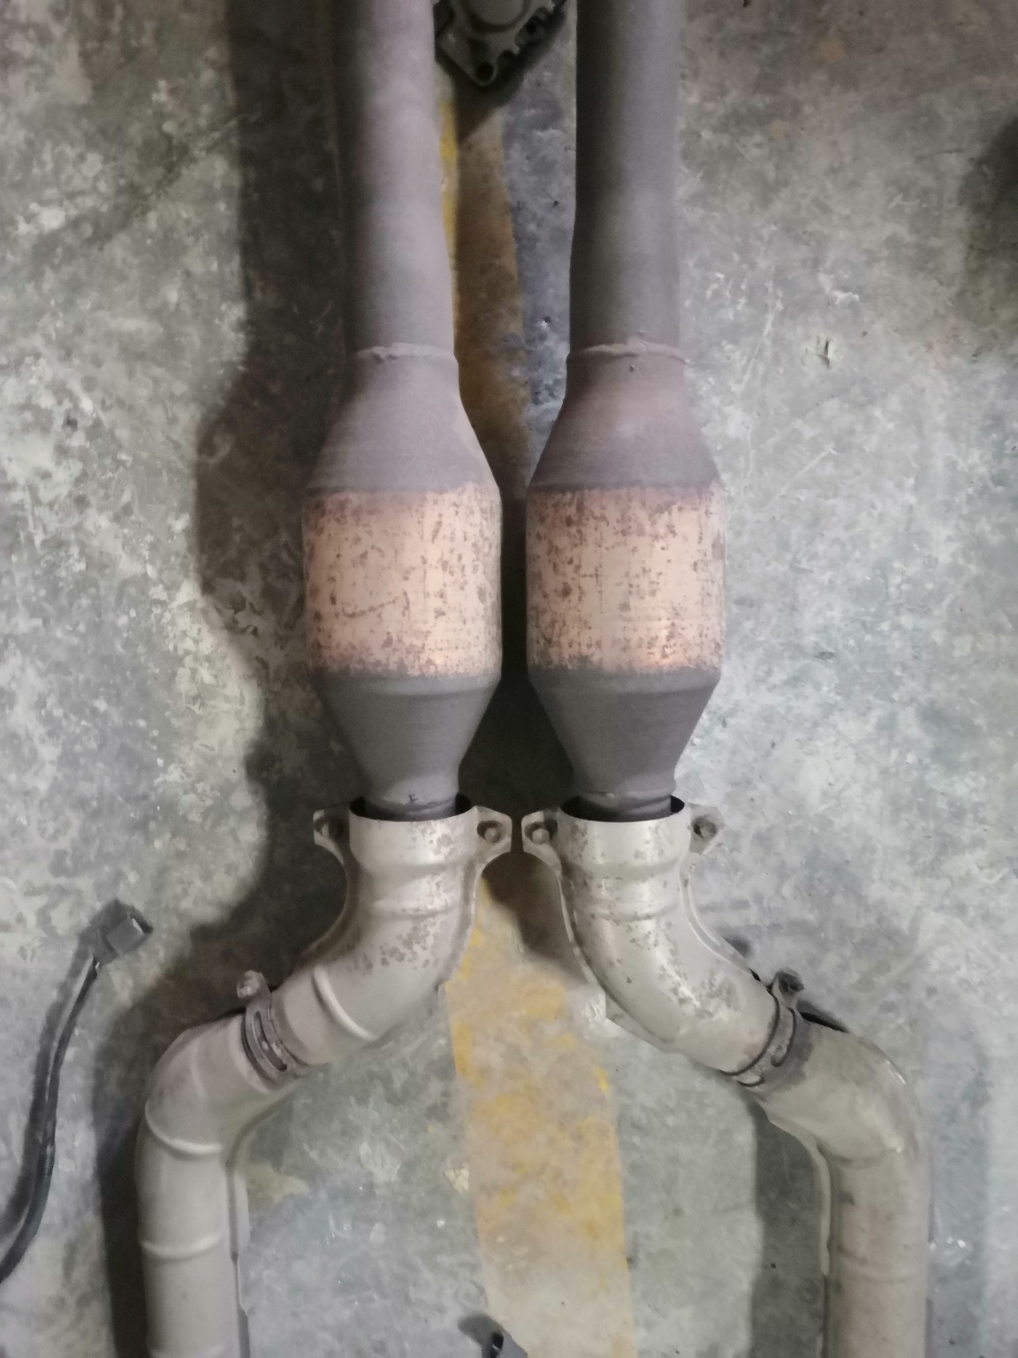 | 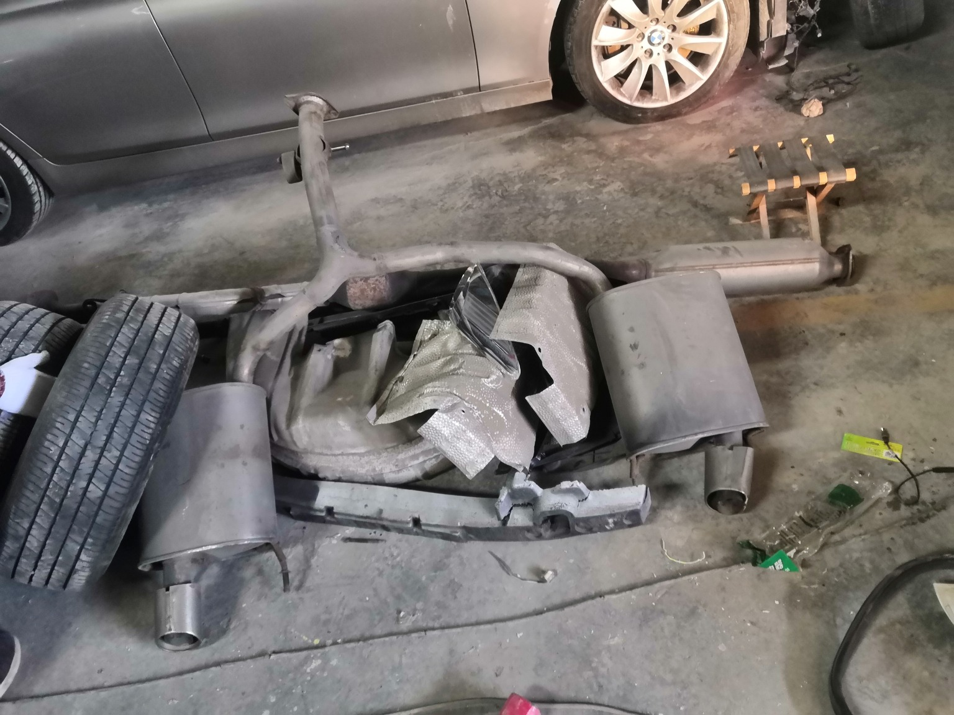 | 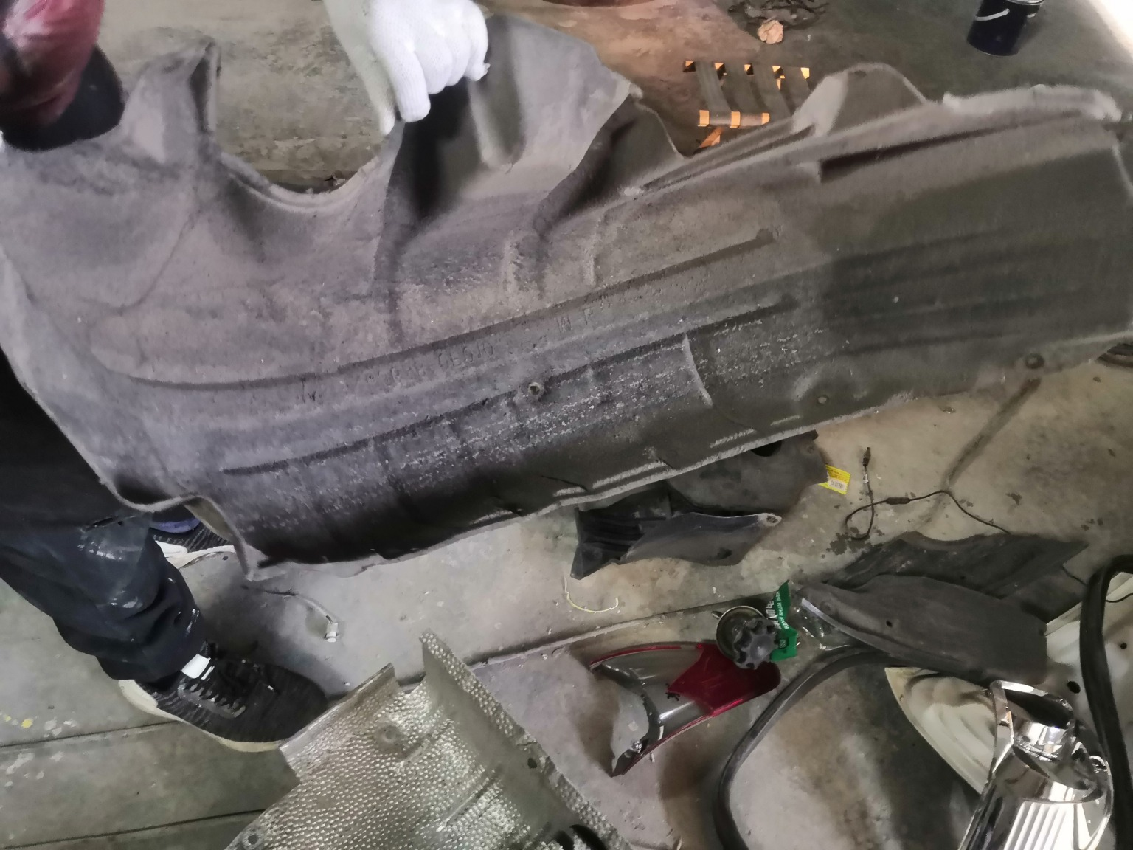
IMG_20201127_134725.jpg | IMG_20201127_134325.jpg | IMG_20201127_134602.jpg

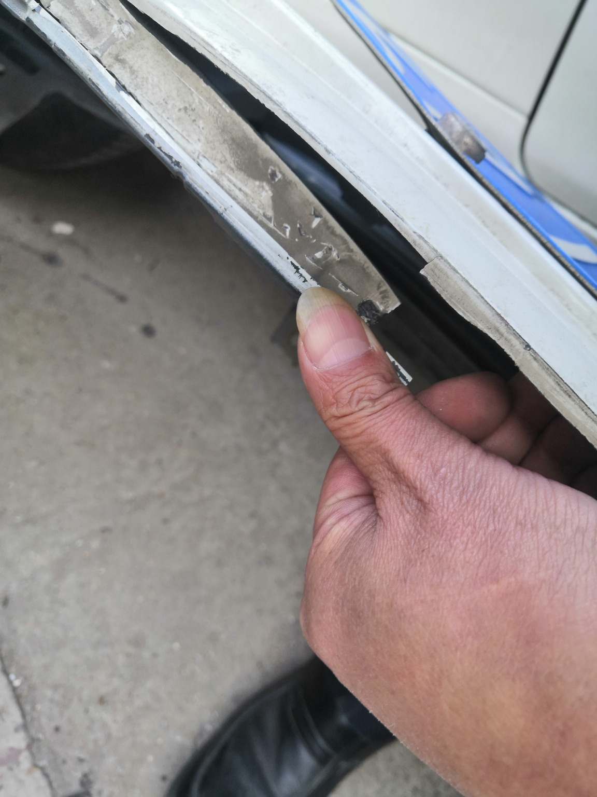 | 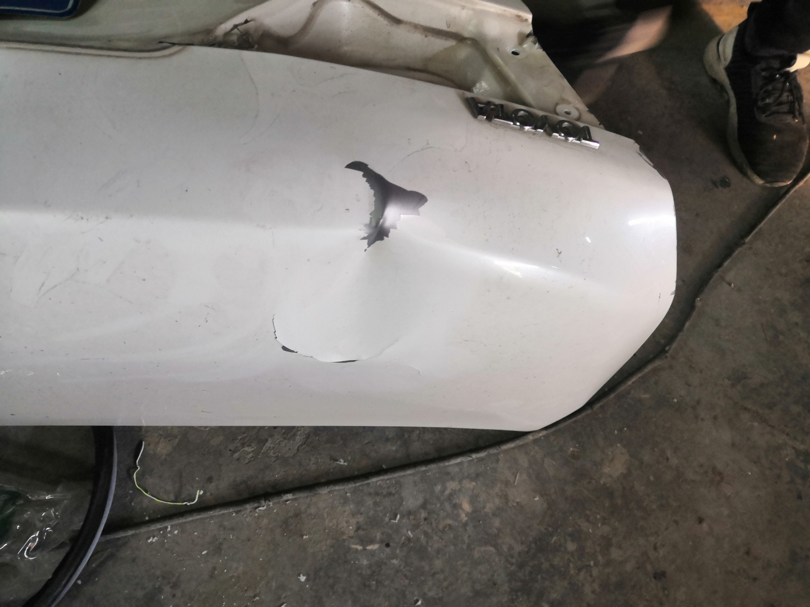 | 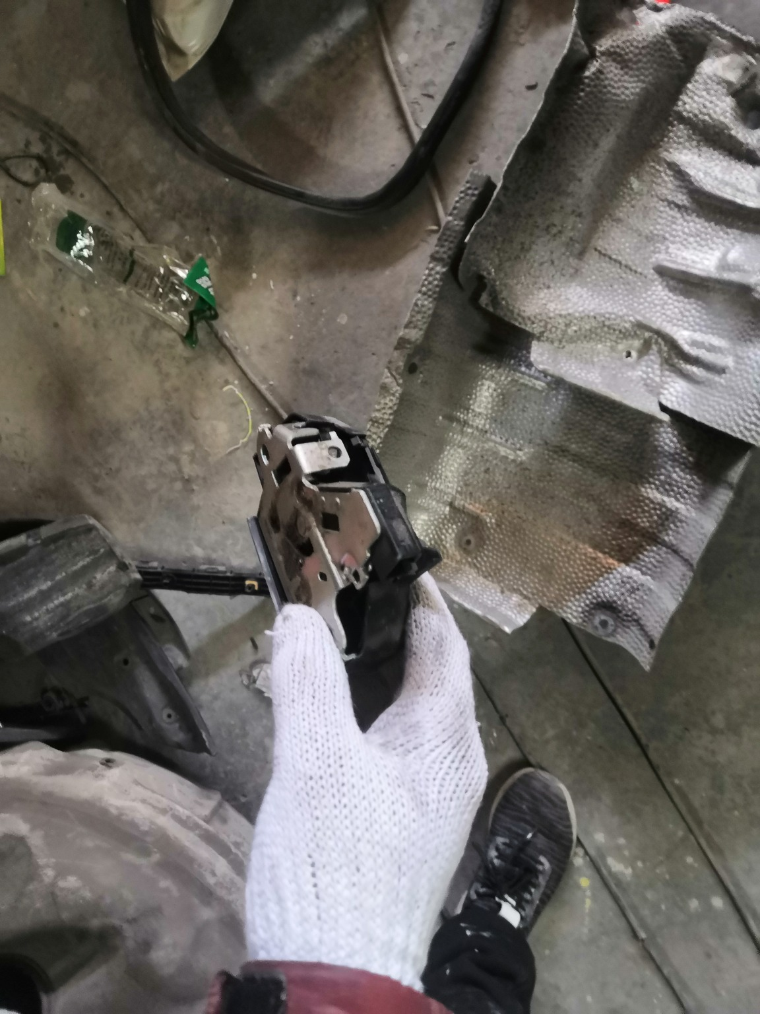
IMG_20201127_133948.jpg | IMG_20201127_134246.jpg | IMG_20201127_134515.jpg
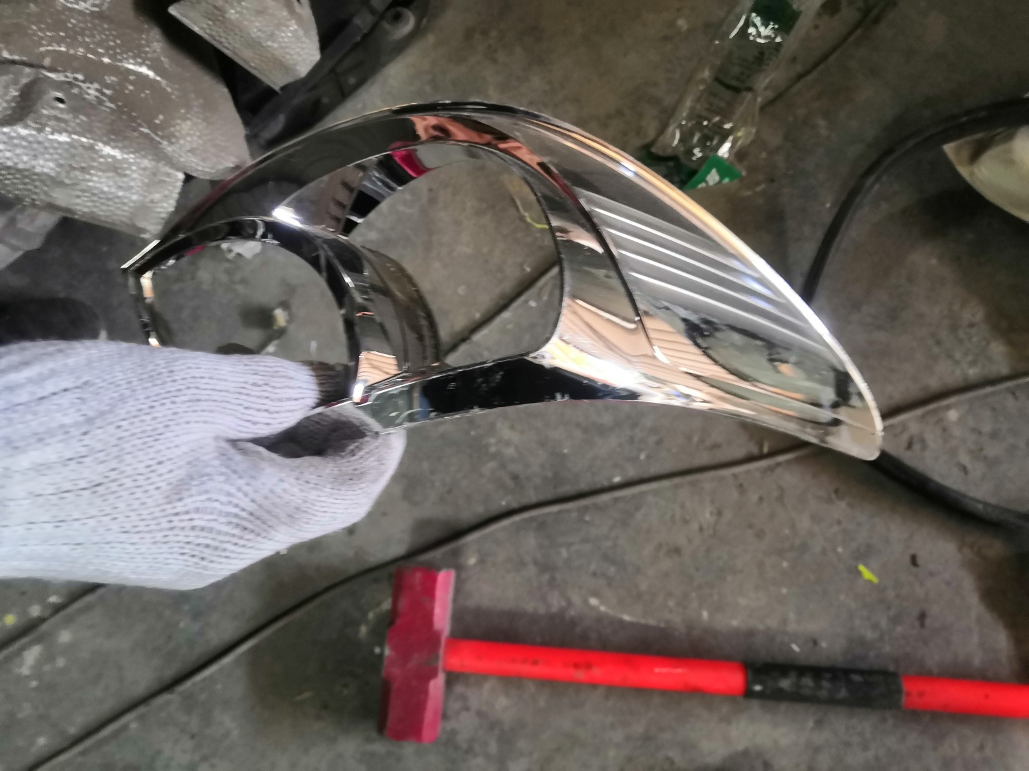 | 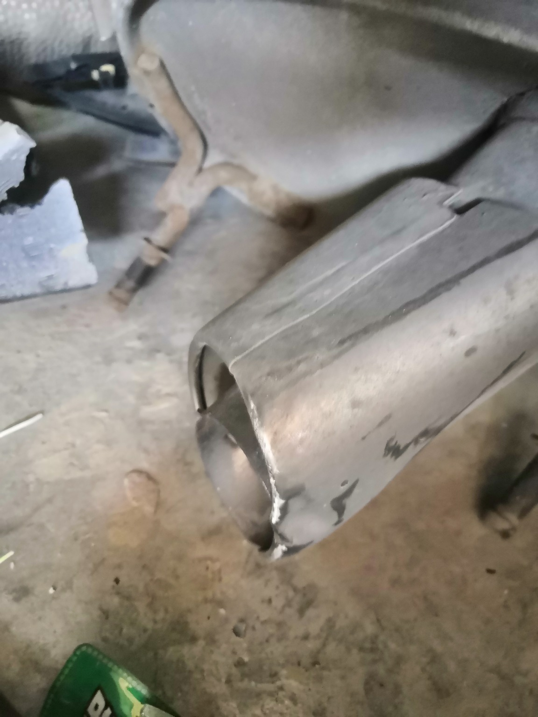 | 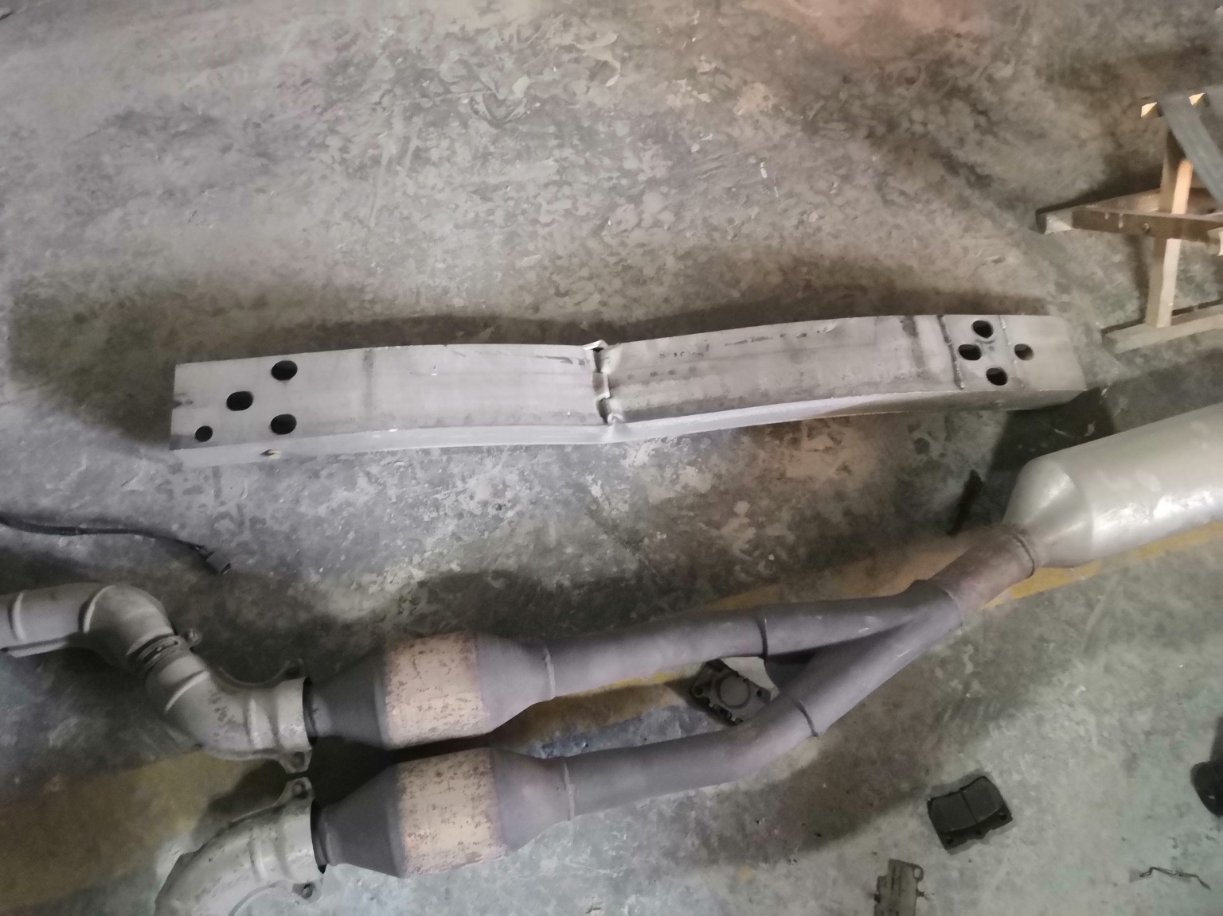
IMG_20201127_134456.jpg | IMG_20201127_134344.jpg | IMG_20201127_134657.jpg
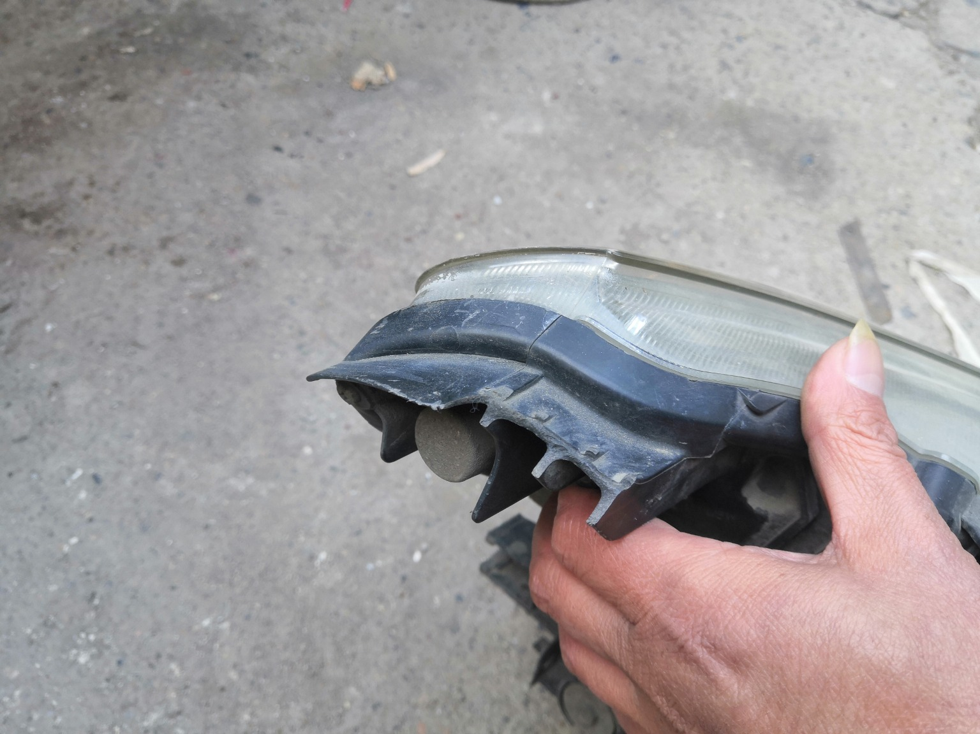 | 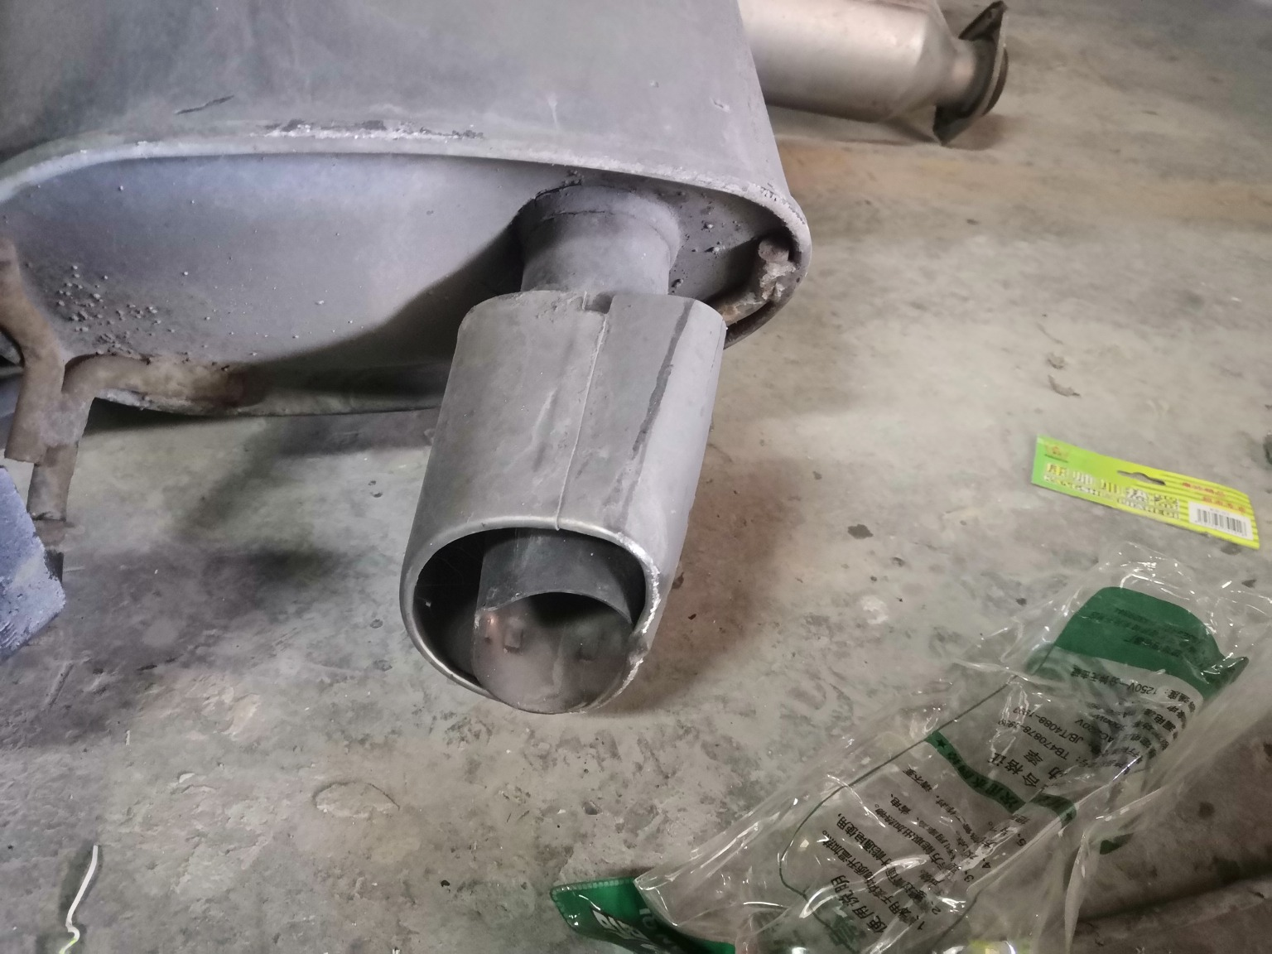 | 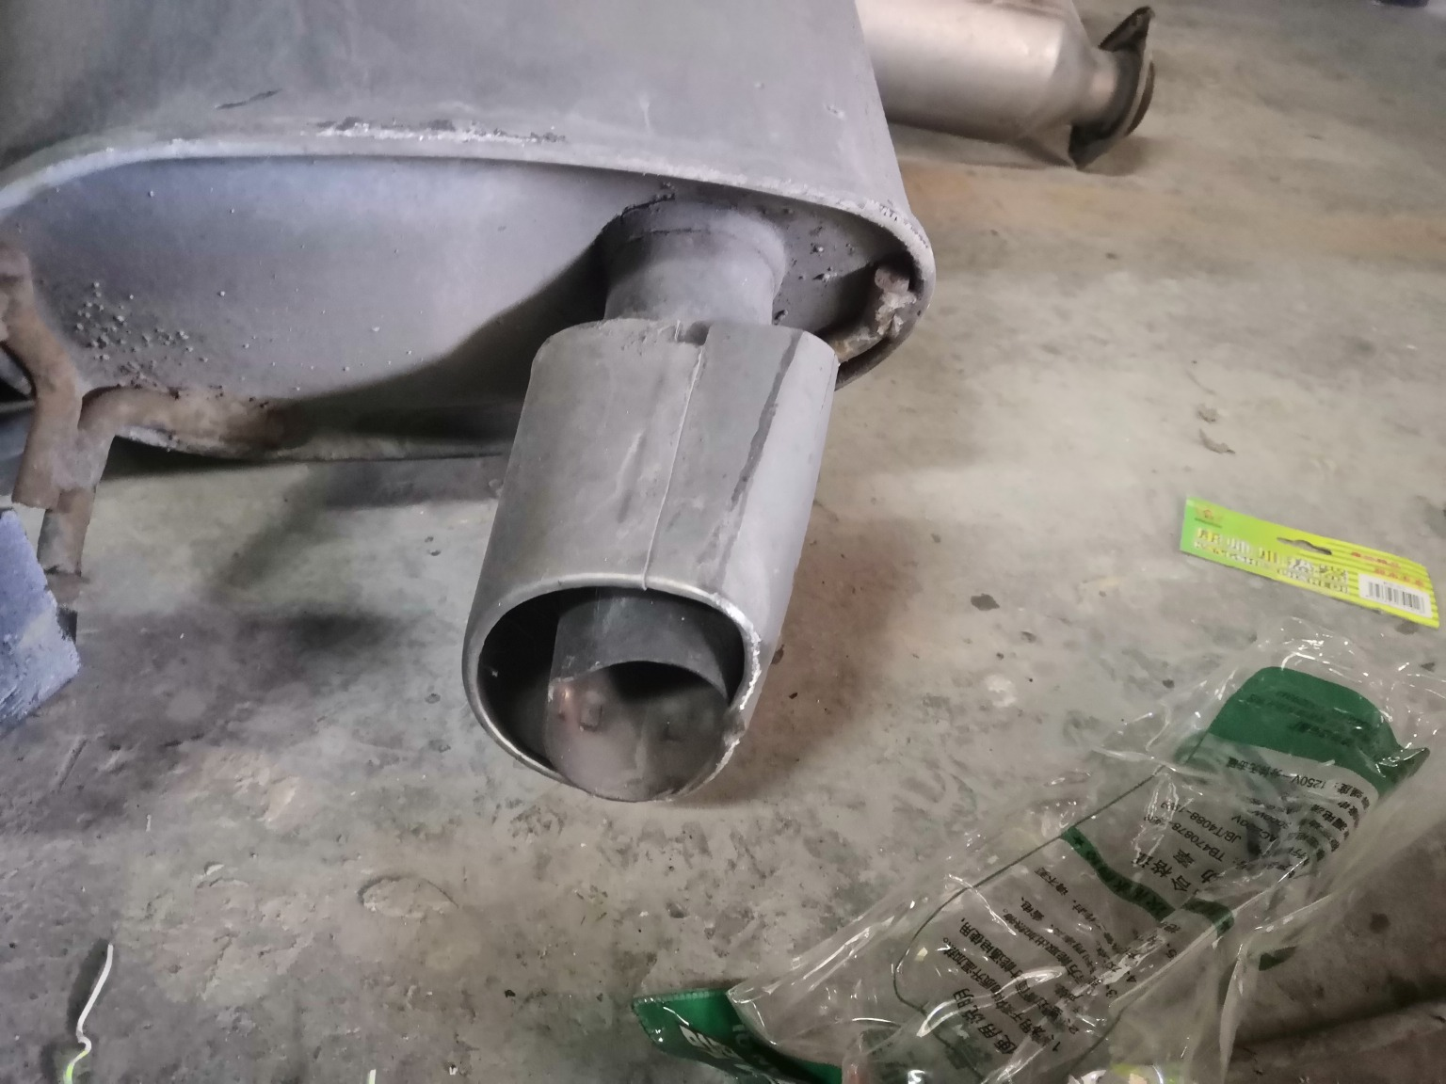
IMG_20201127_134937.jpg | IMG_20201127_134405.jpg | IMG_20201127_134407.jpg

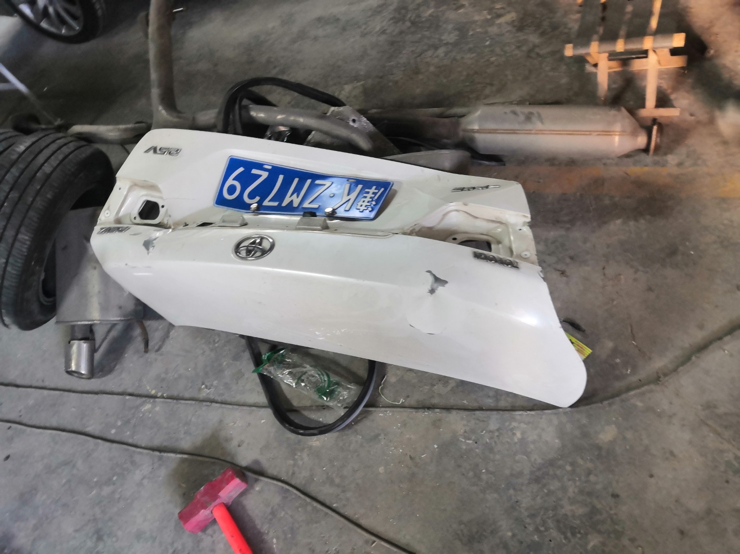 | 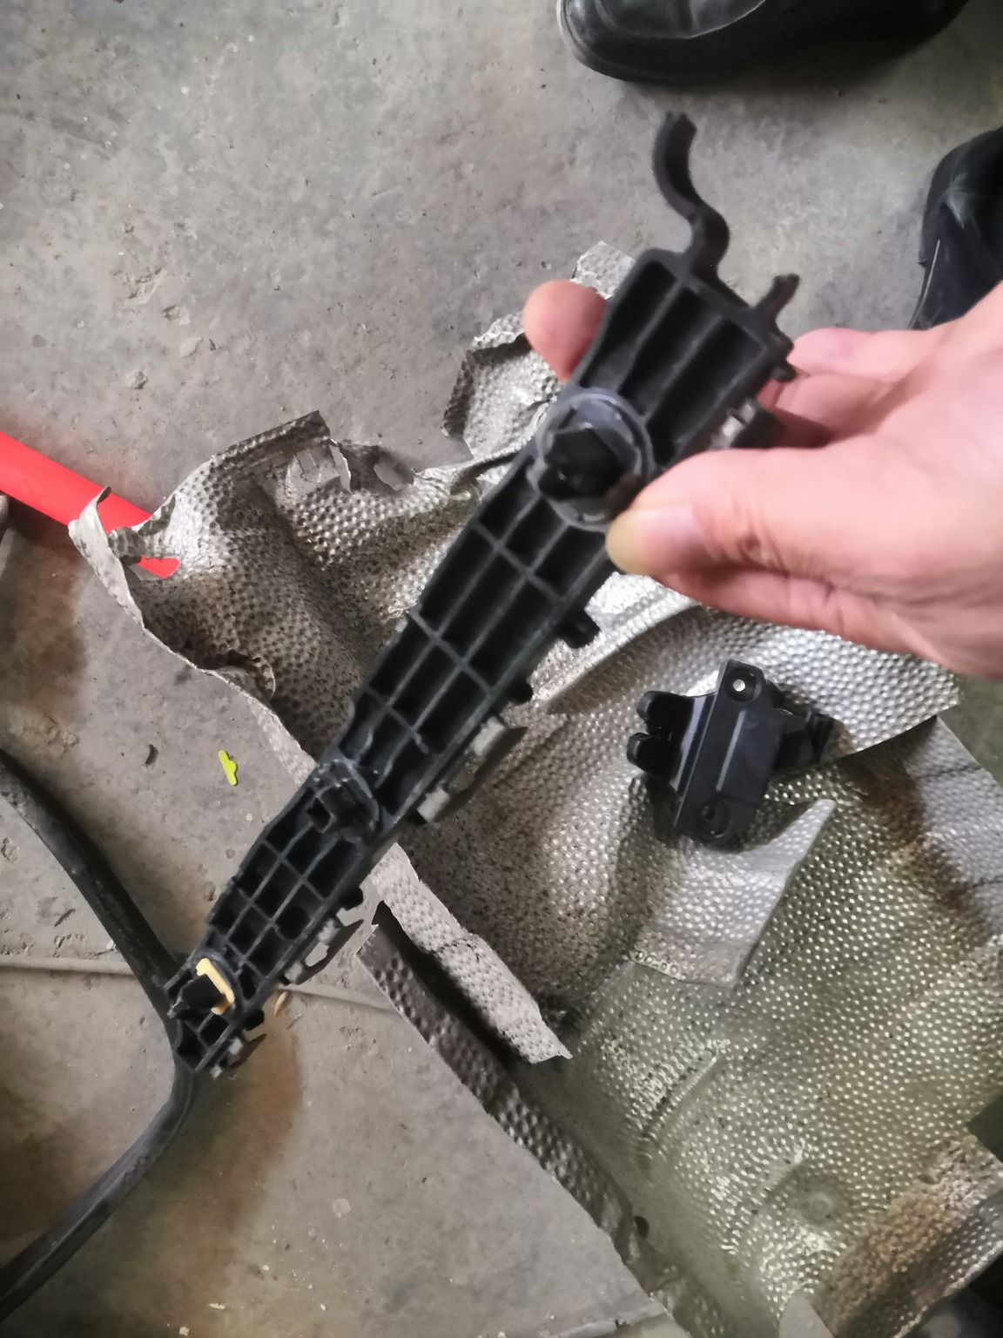 | 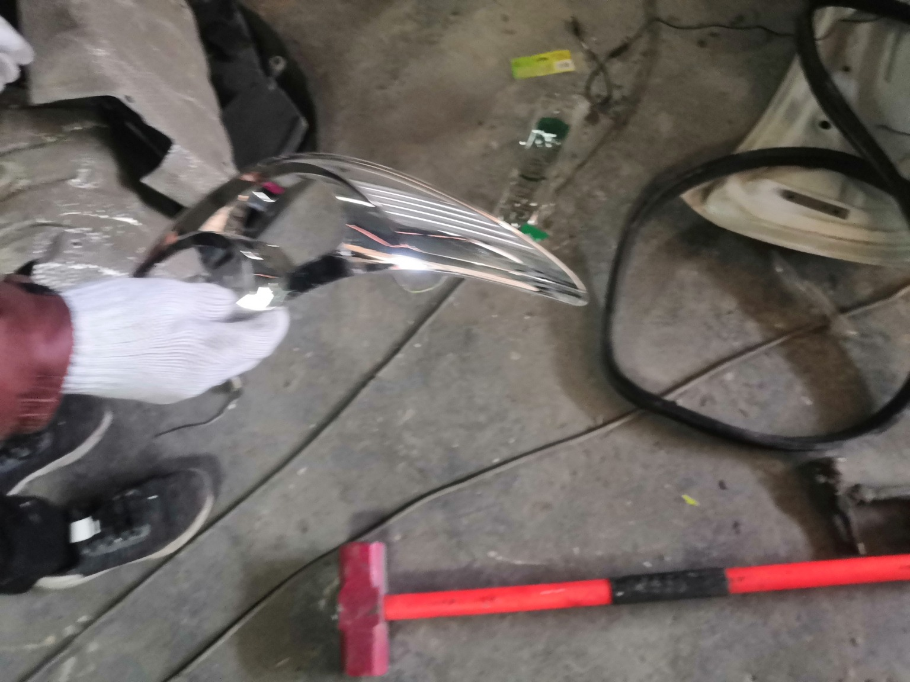
IMG_20201127_134235.jpg | IMG_20201127_134526.jpg | IMG_20201127_134453.jpg
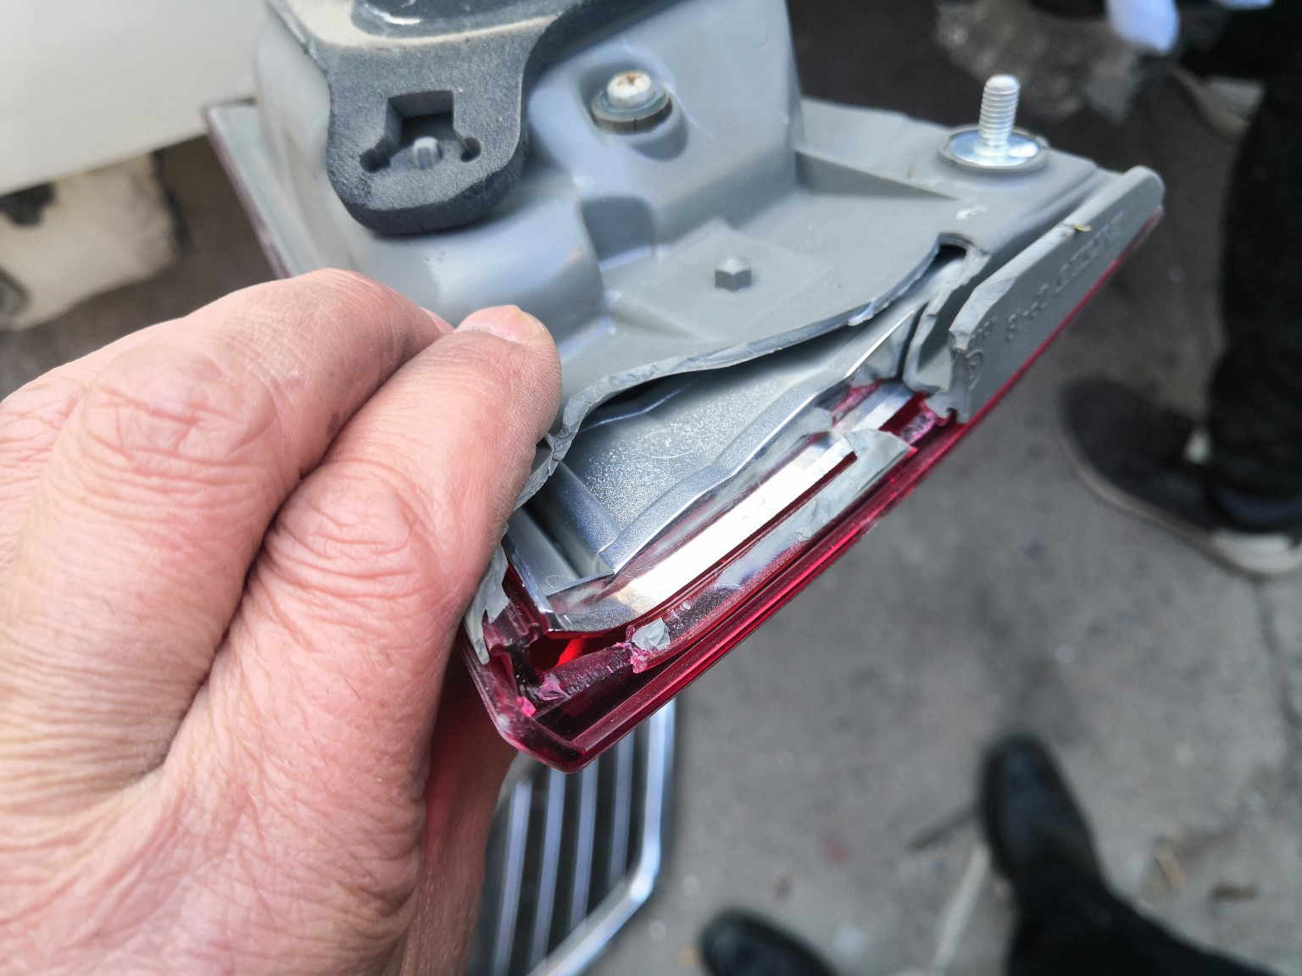 | 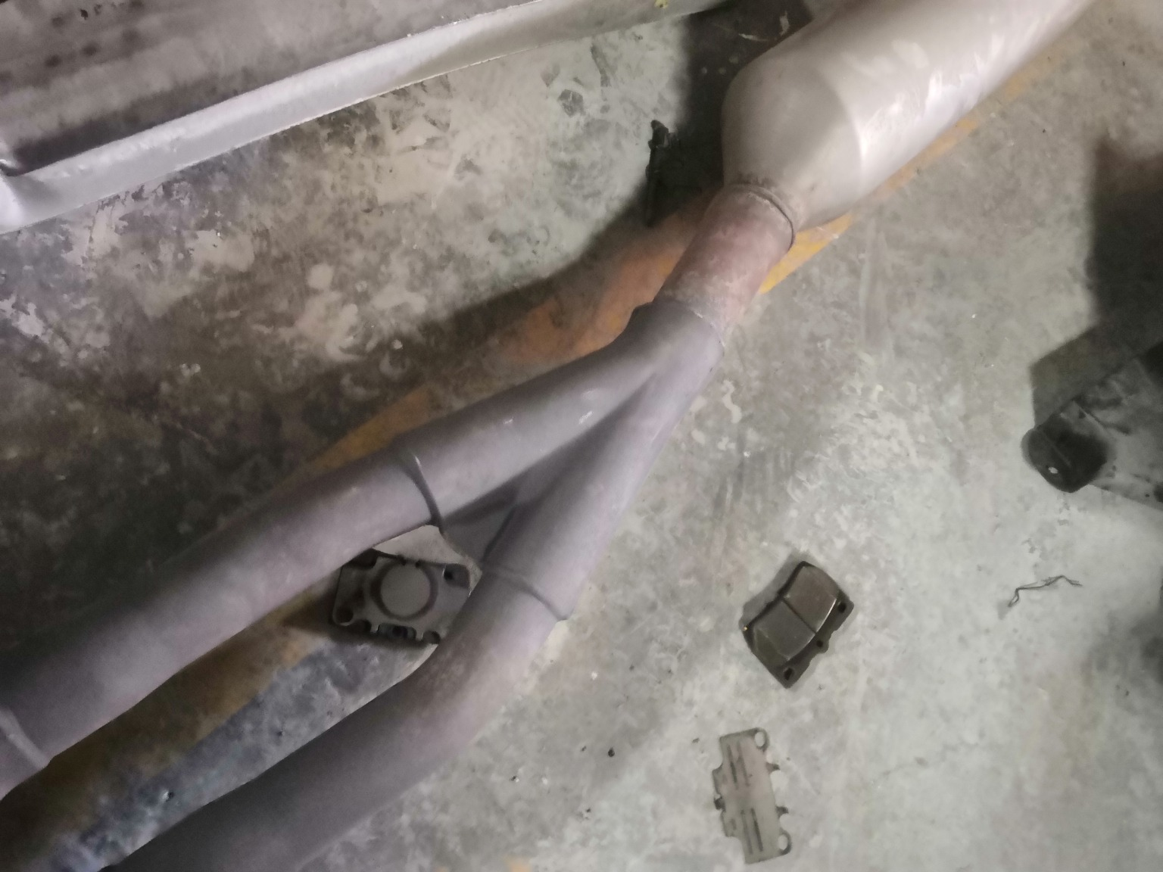 | 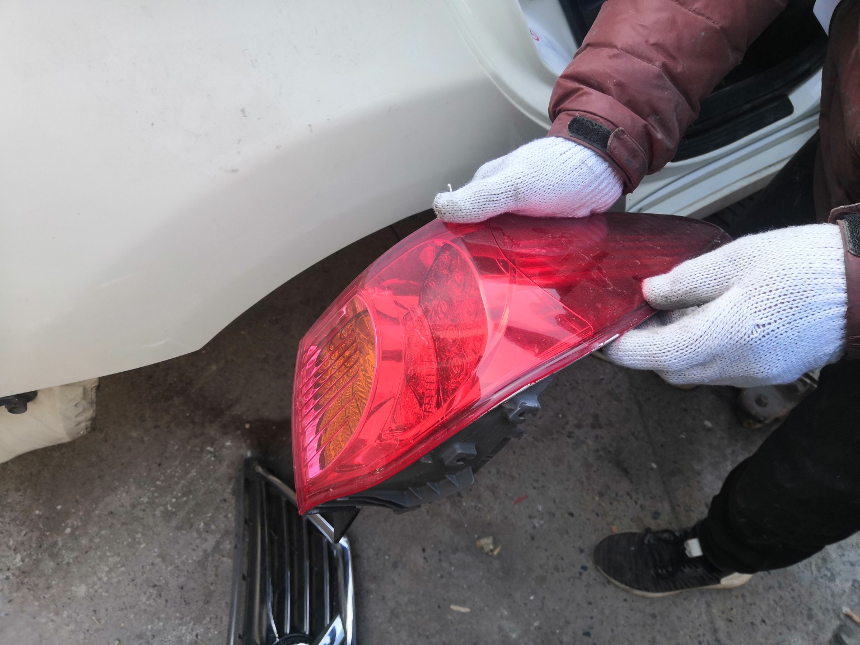
IMG_20201127_135050.jpg | IMG_20201127_134721.jpg | IMG_20201127_135036.jpg
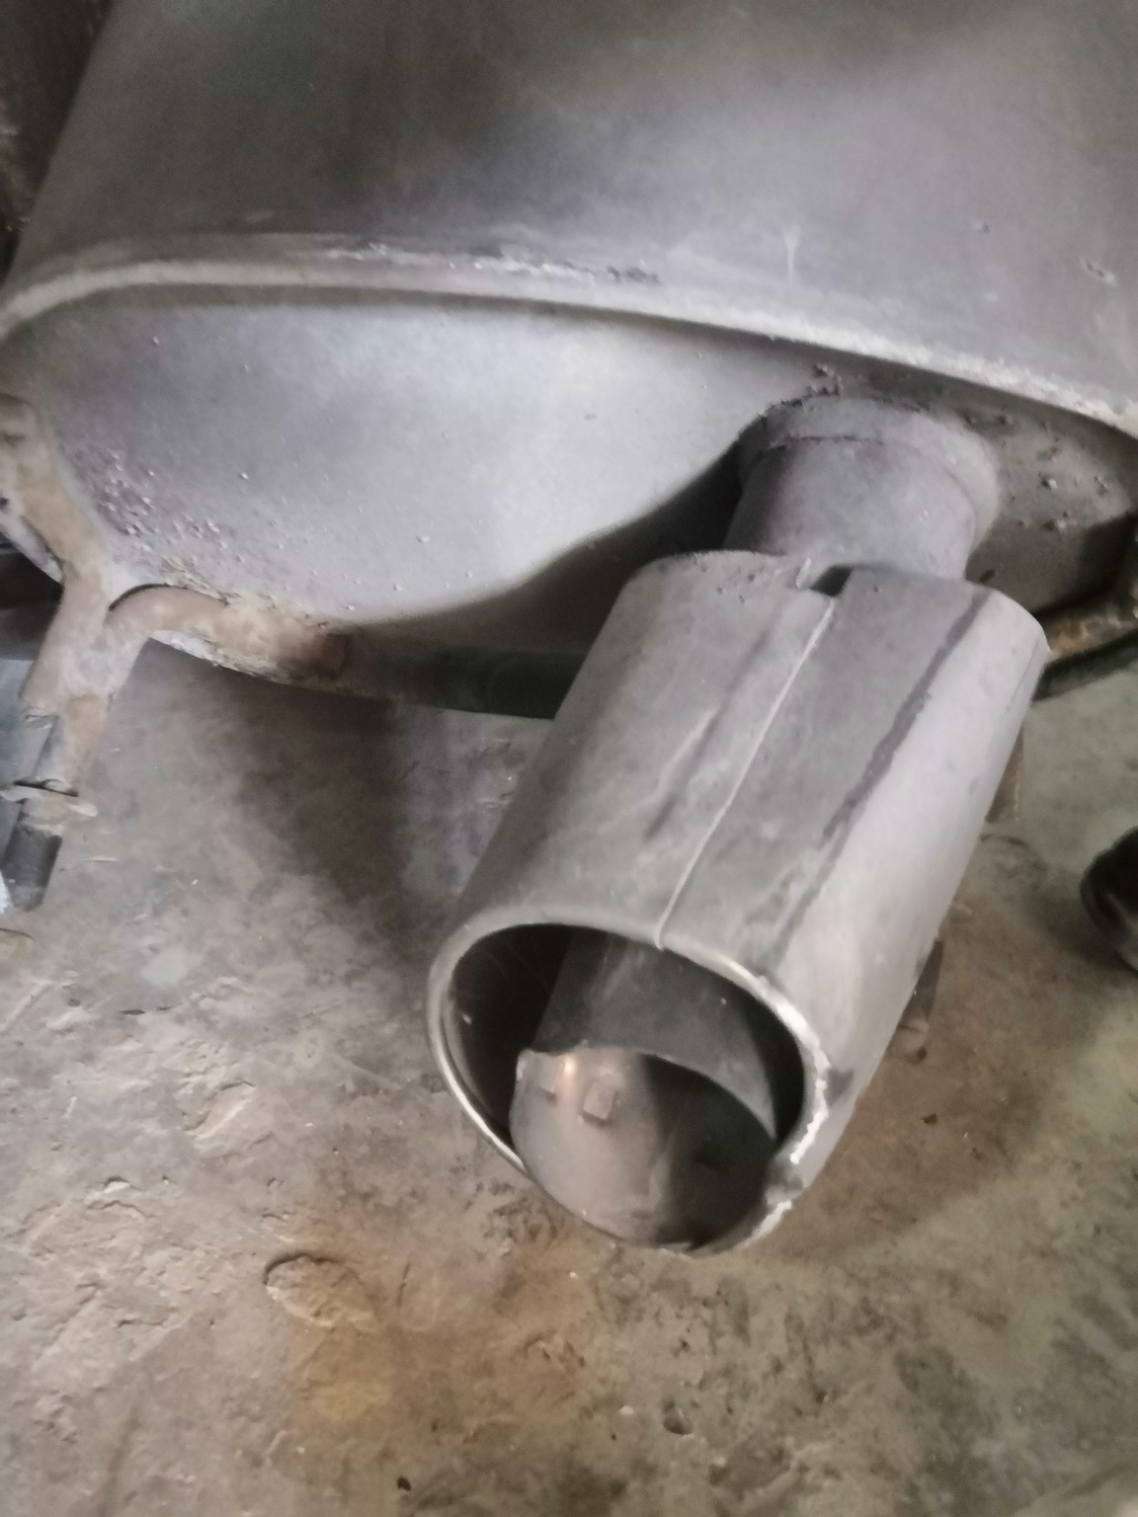 | 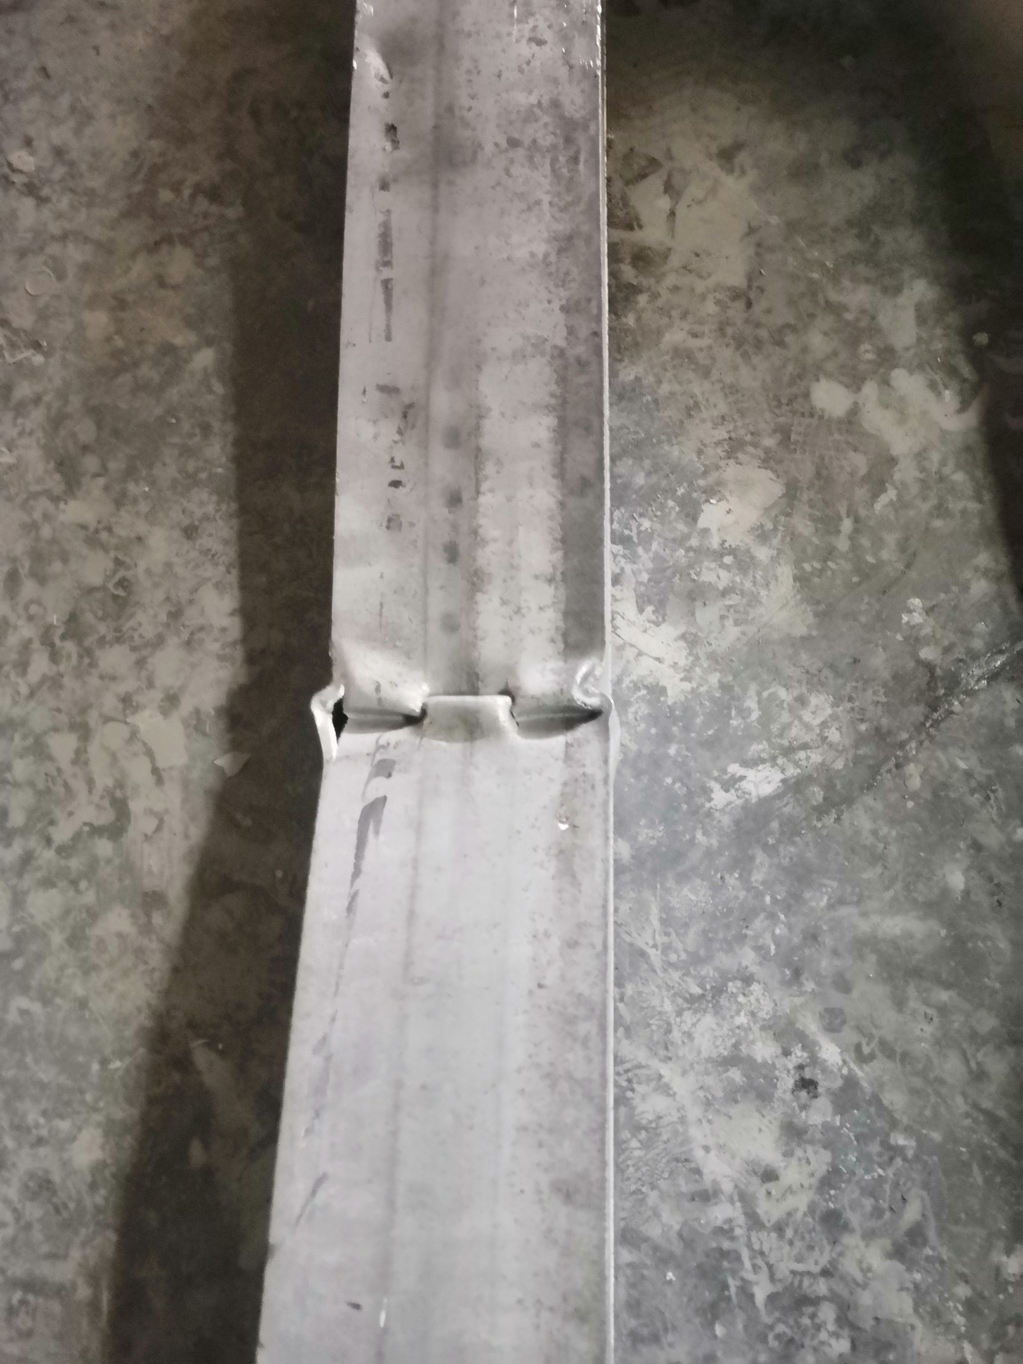 | 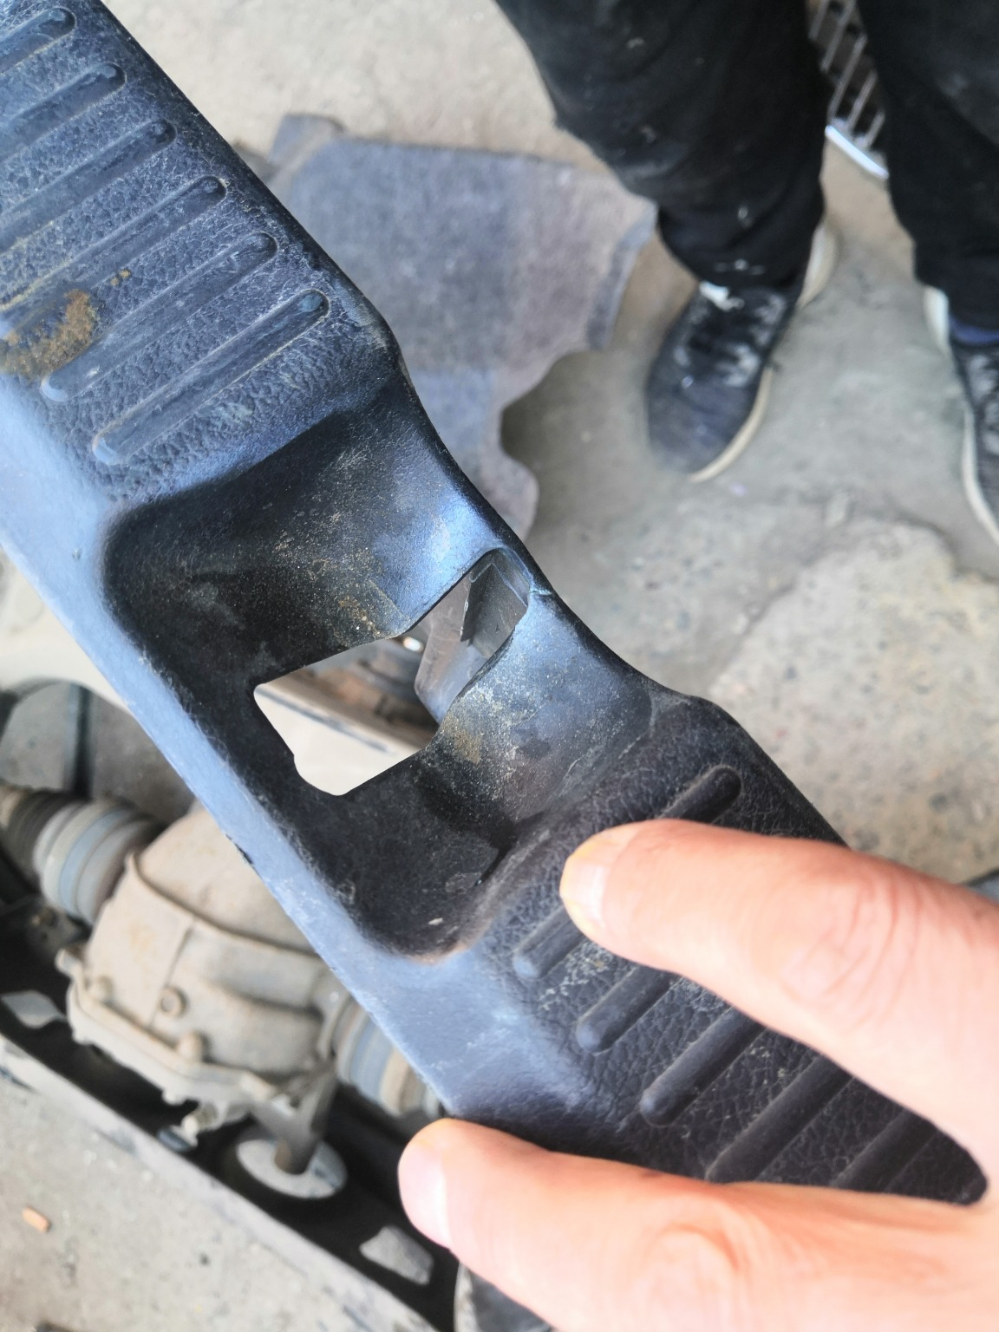
IMG_20201127_134354.jpg | IMG_20201127_134700.jpg | IMG_20201127_134100.jpg

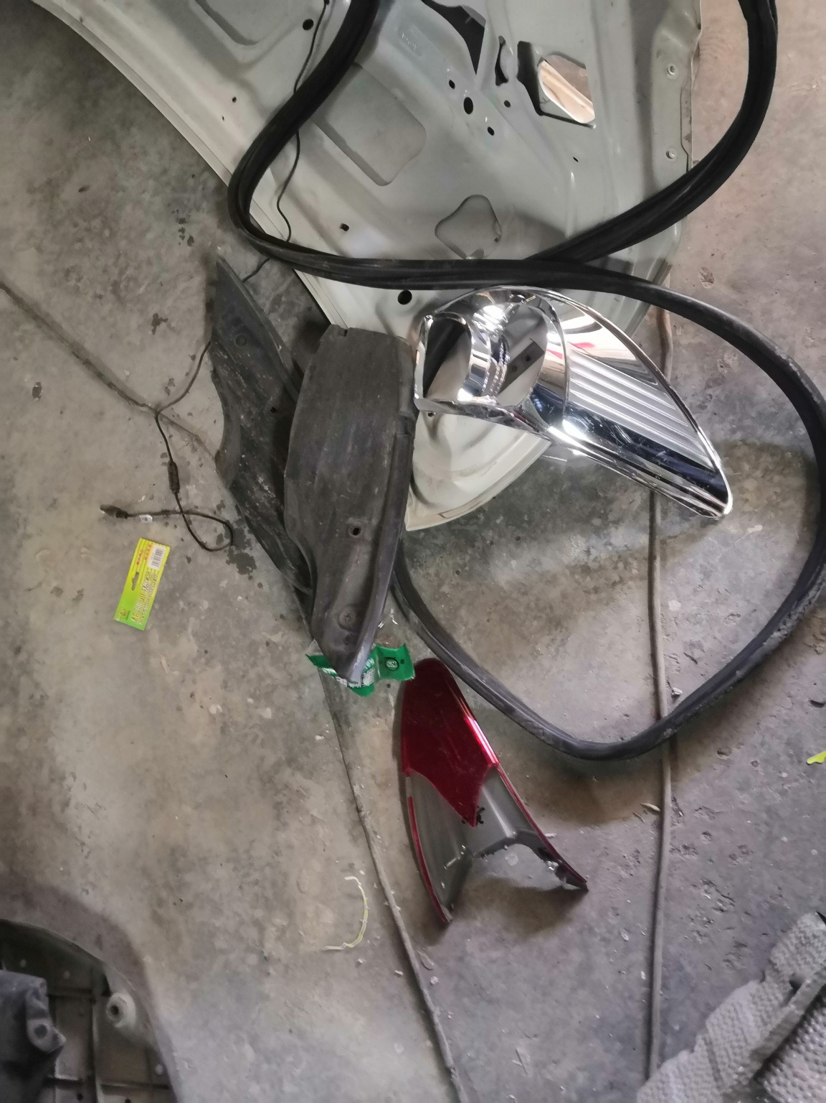 | 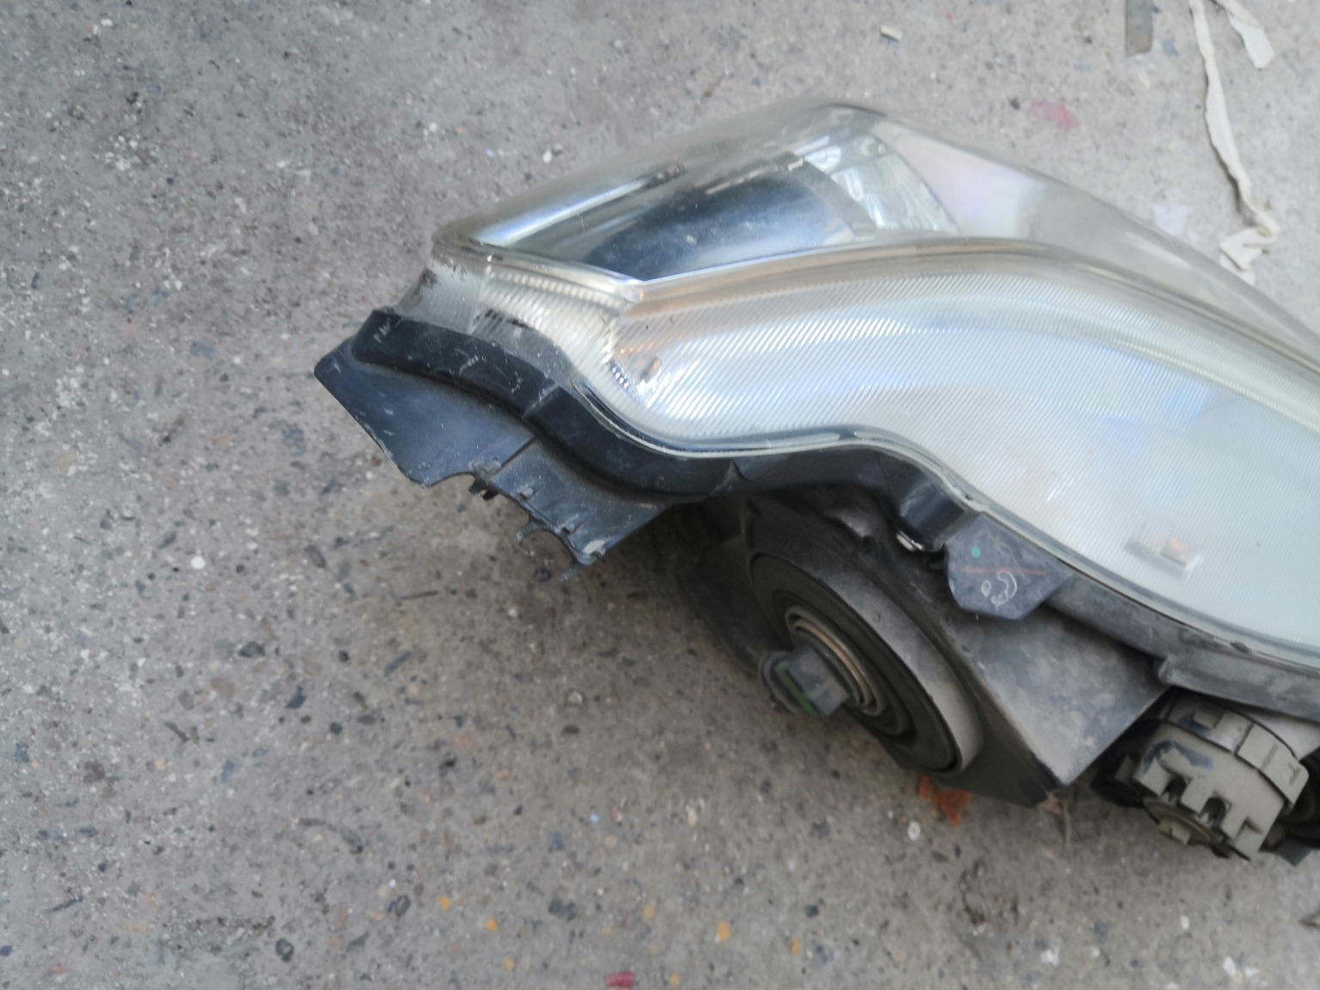 | 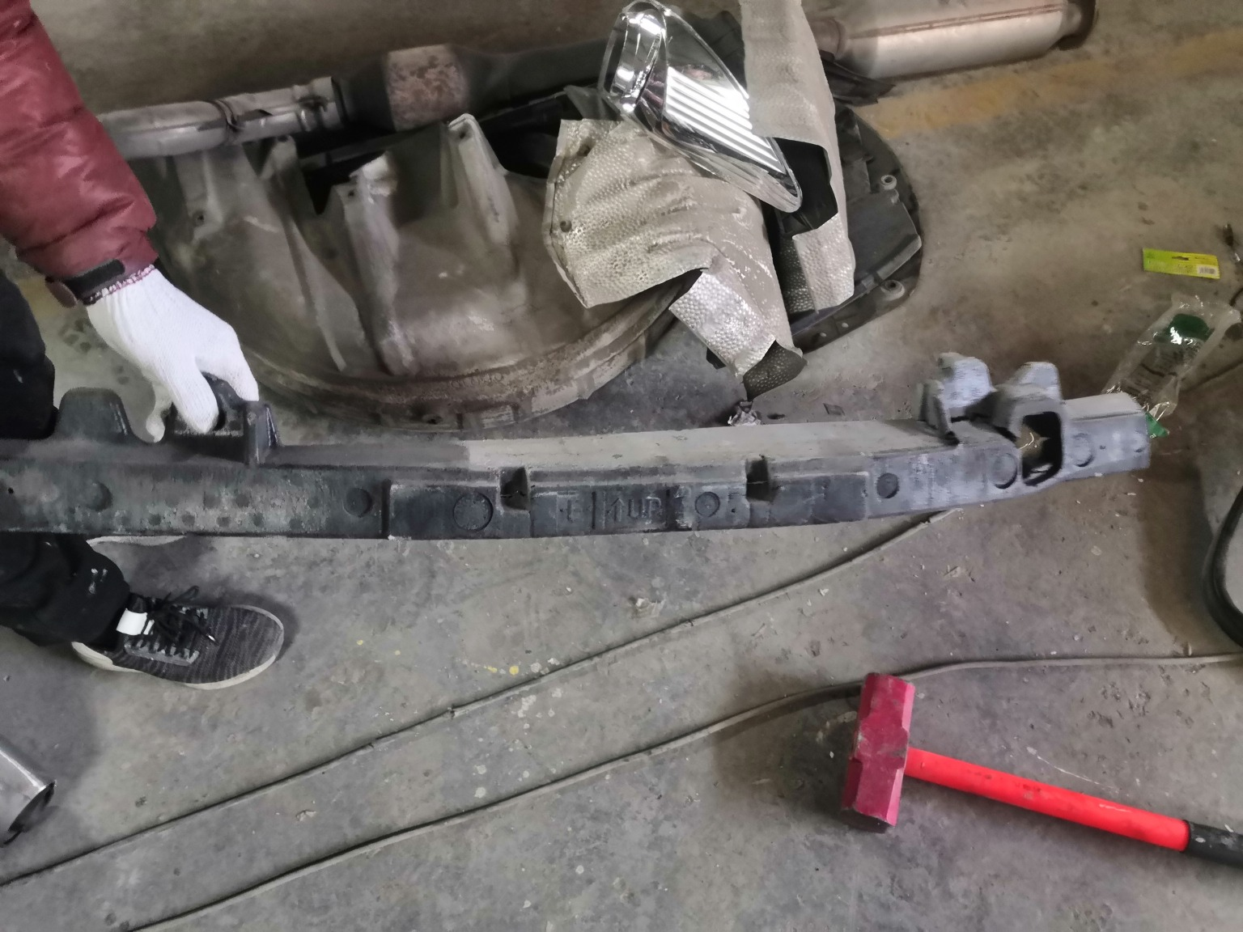
IMG_20201127_134537.jpg | IMG_20201127_134933.jpg | IMG_20201127_134444.jpg
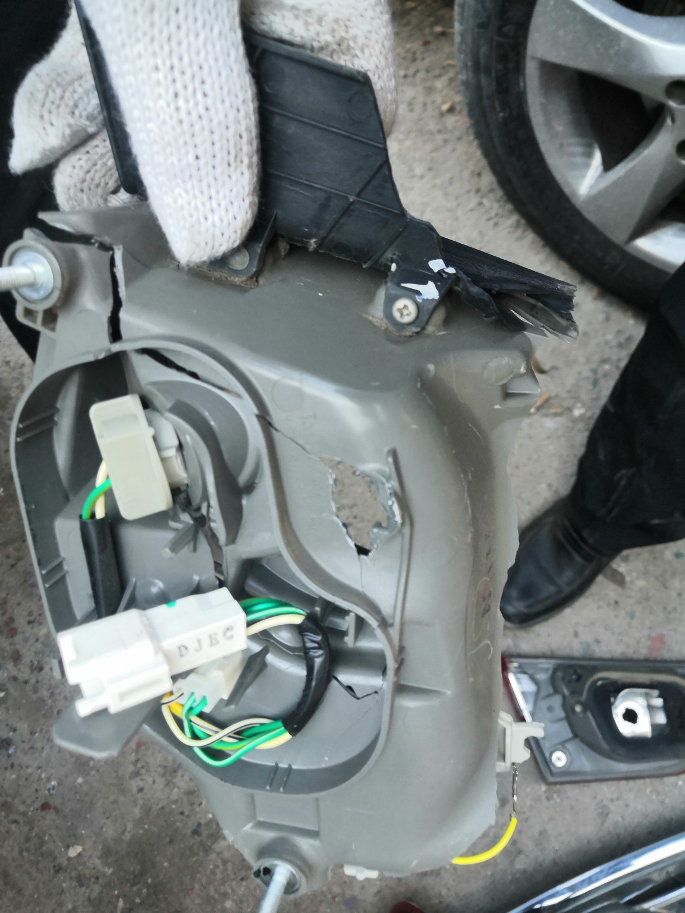 | 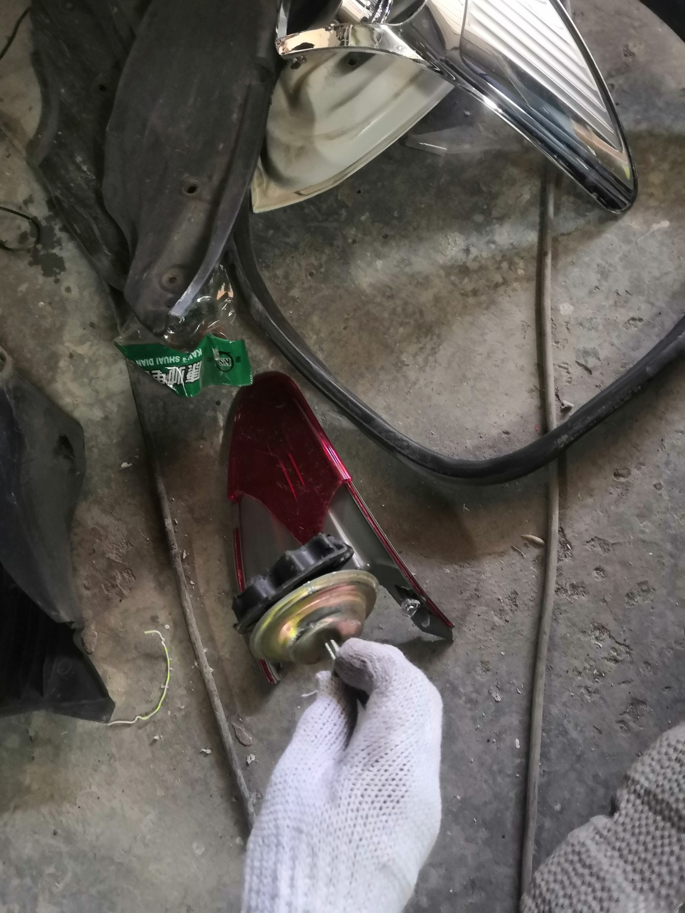 | 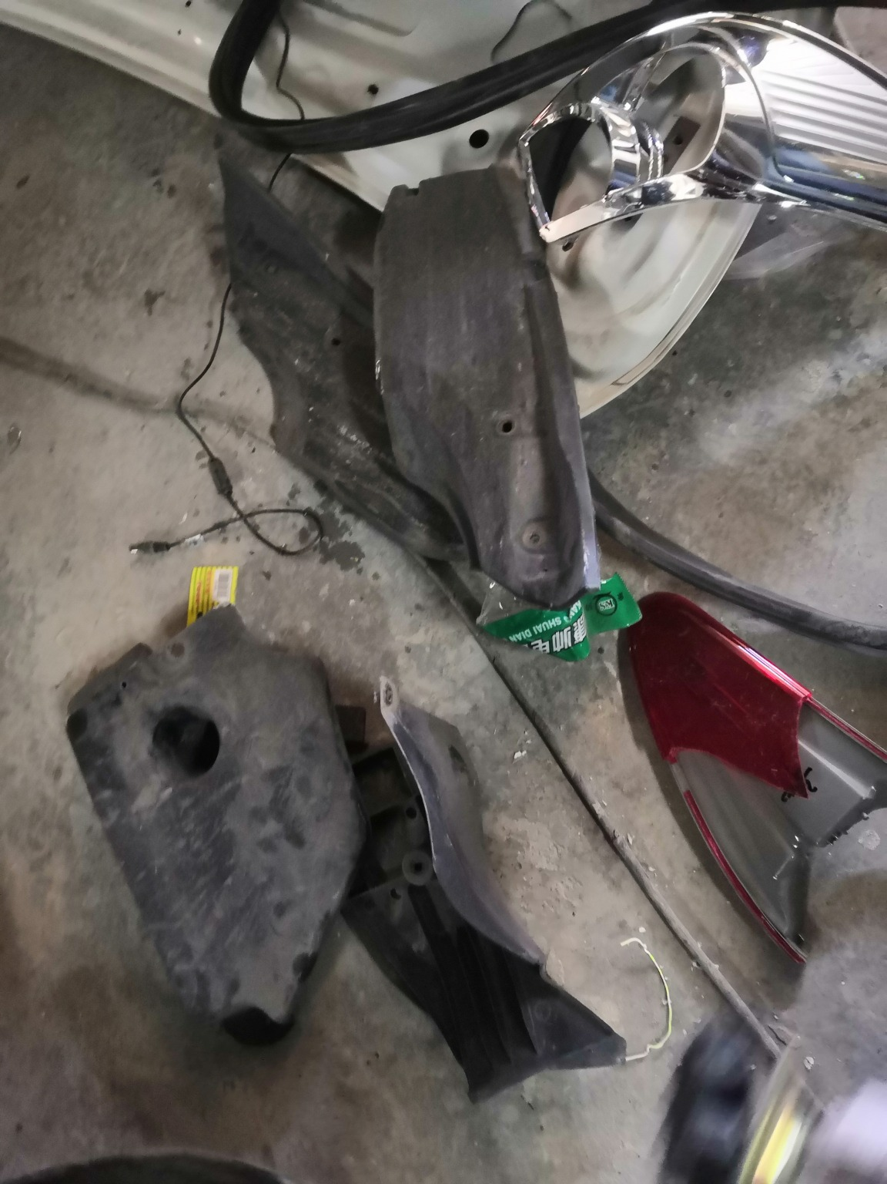
IMG_20201127_135057.jpg | IMG_20201127_134545.jpg | IMG_20201127_134543.jpg
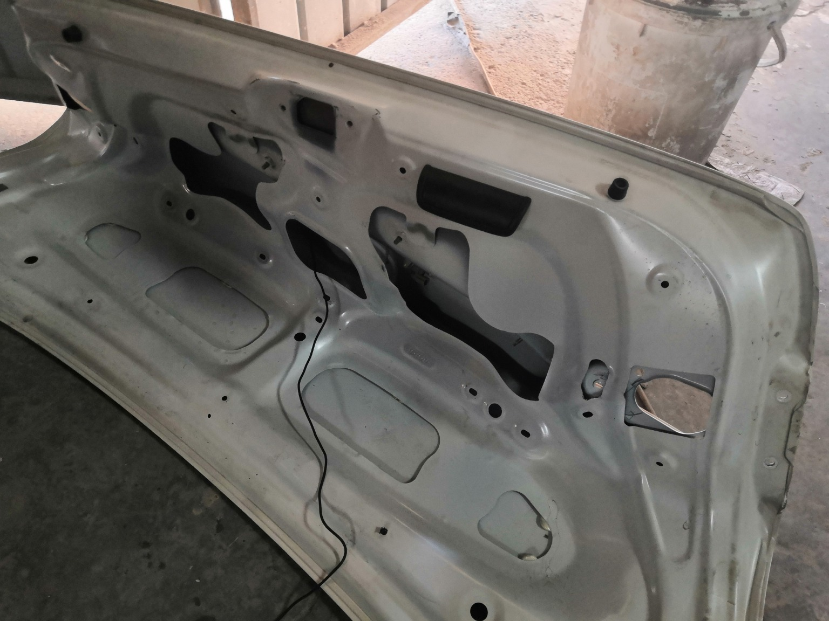 | 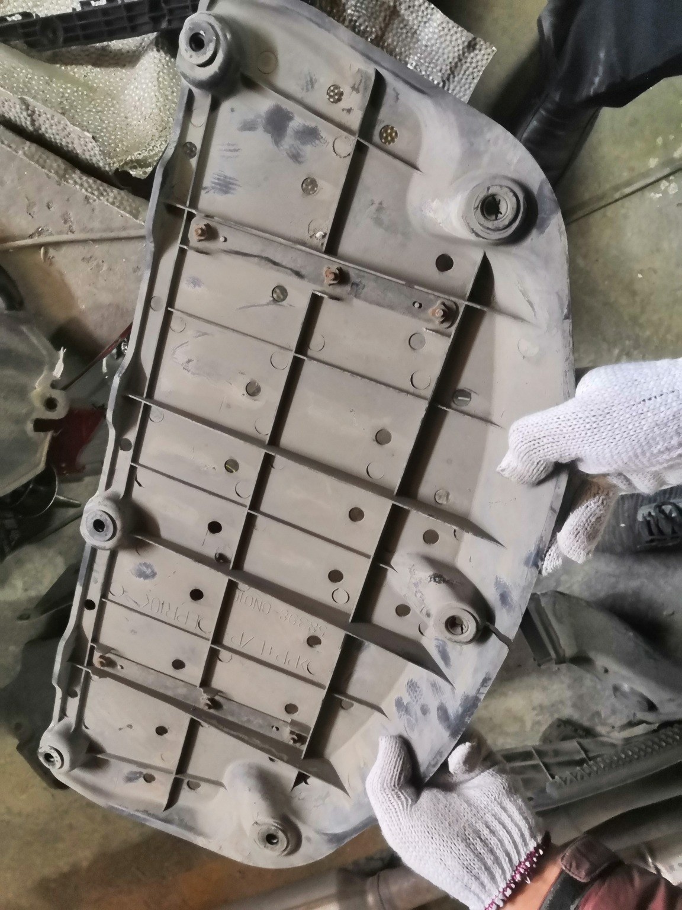 | 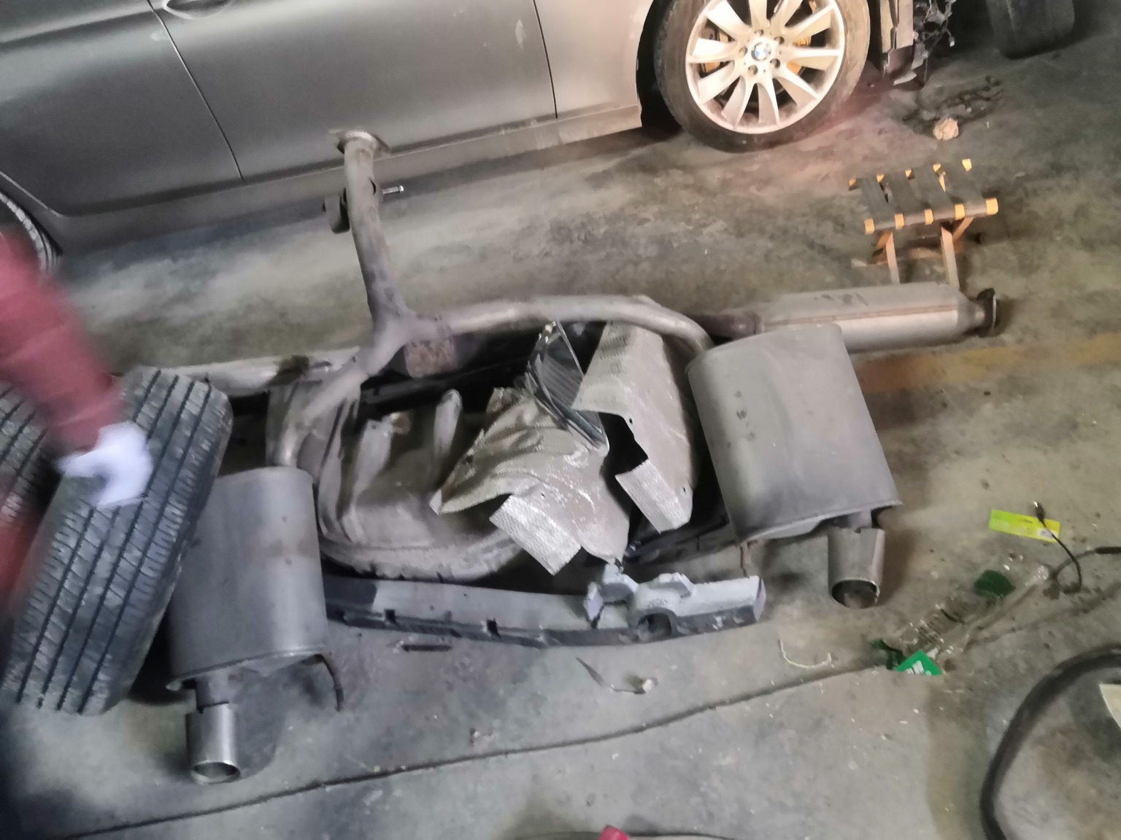
IMG_20201127_134259.jpg | IMG_20201127_134631.jpg | IMG_20201127_134324.jpg

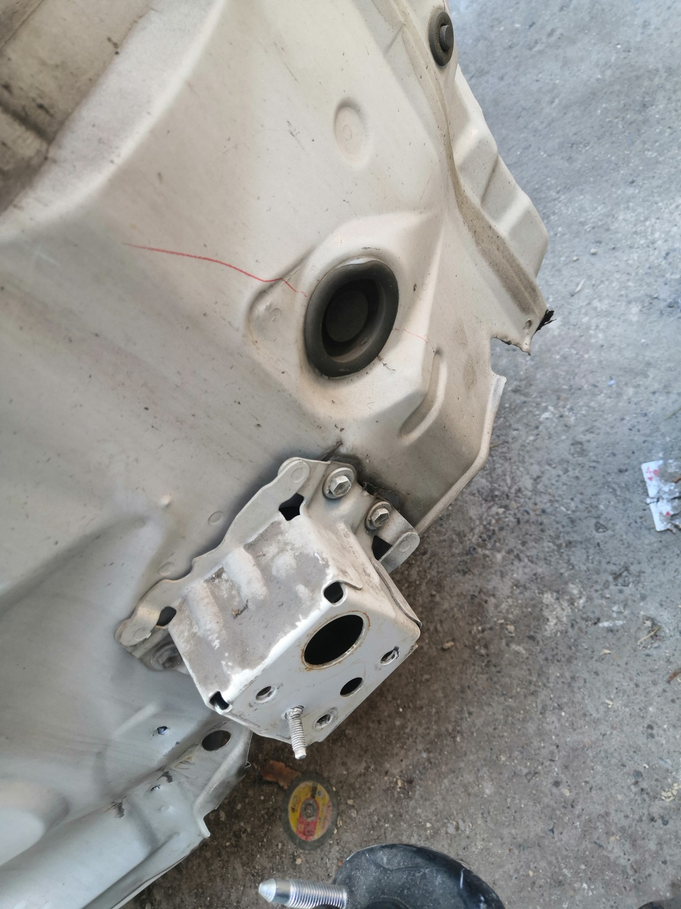 | 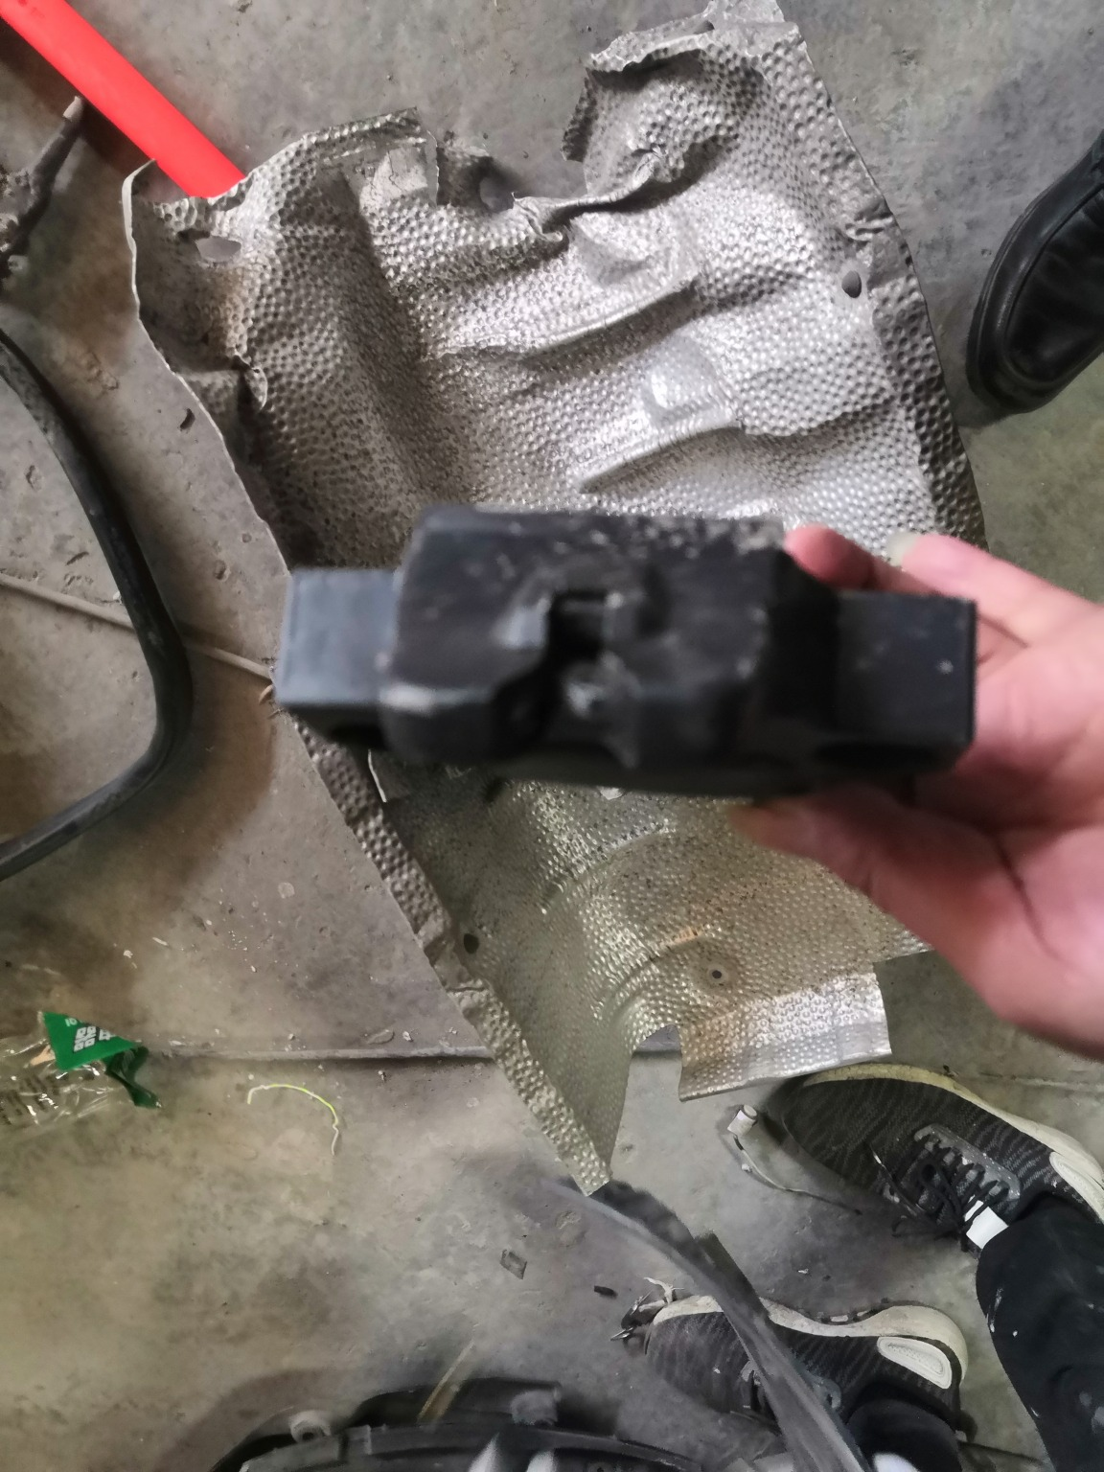 | 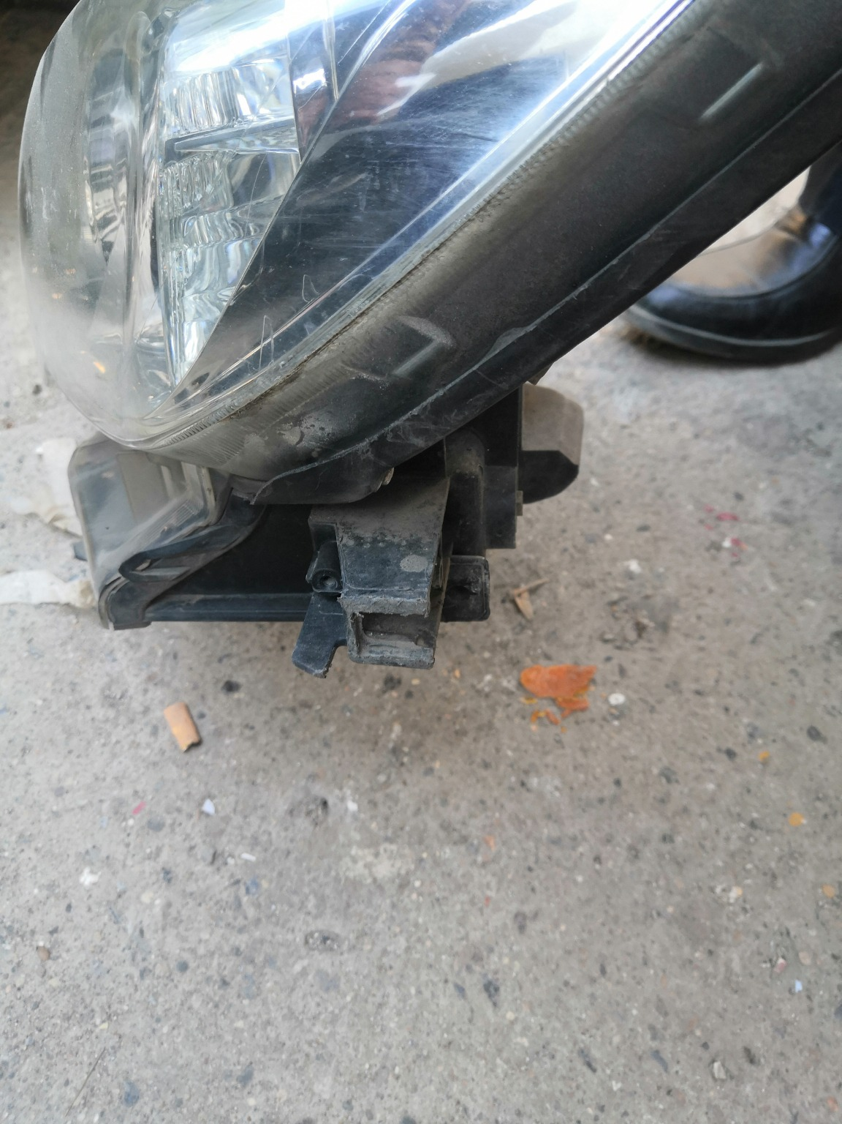
IMG_20201127_134206.jpg | IMG_20201127_134521.jpg | IMG_20201127_134948.jpg
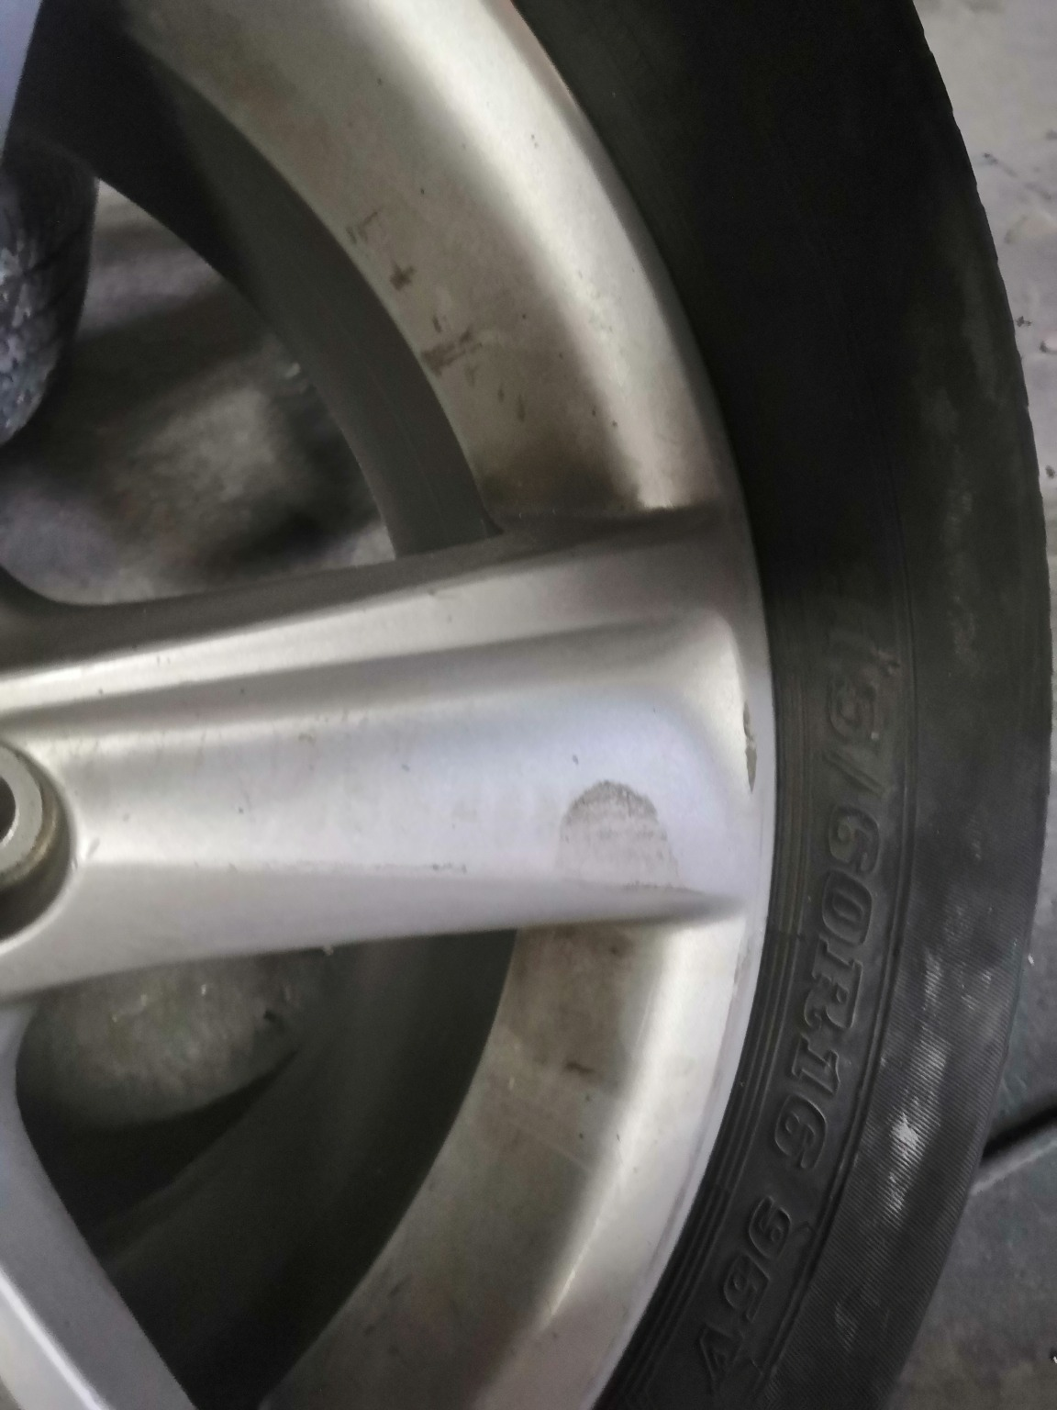 | 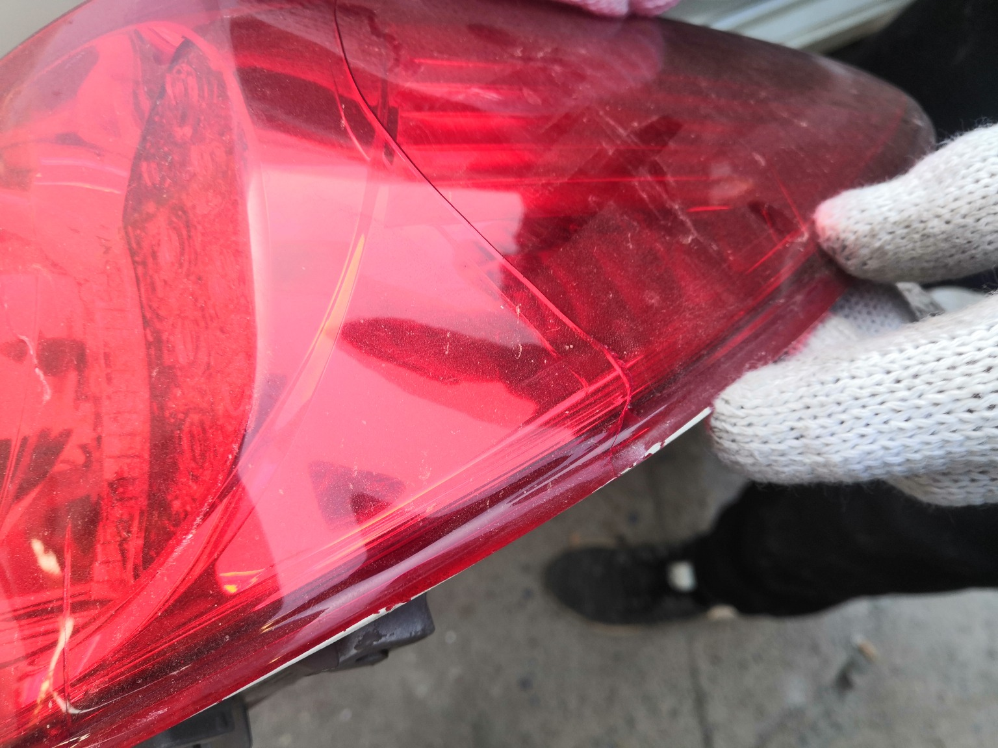 | 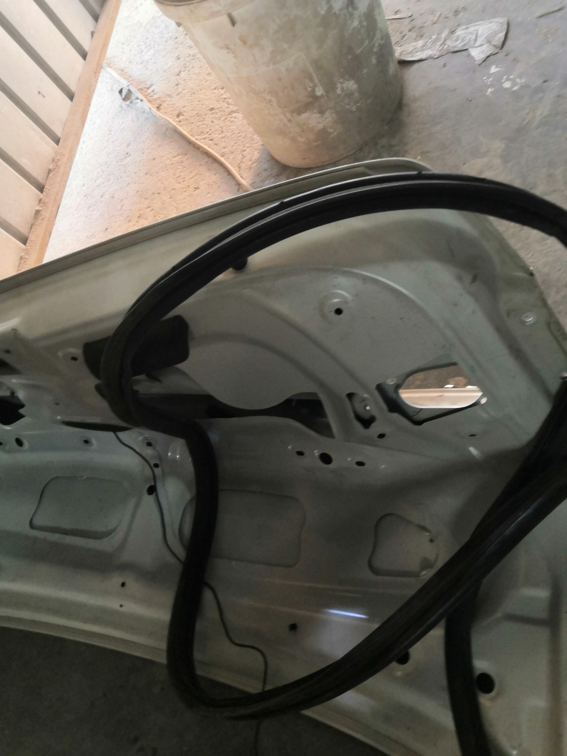
IMG_20201127_134438.jpg | IMG_20201127_135038.jpg | IMG_20201127_134319.jpg
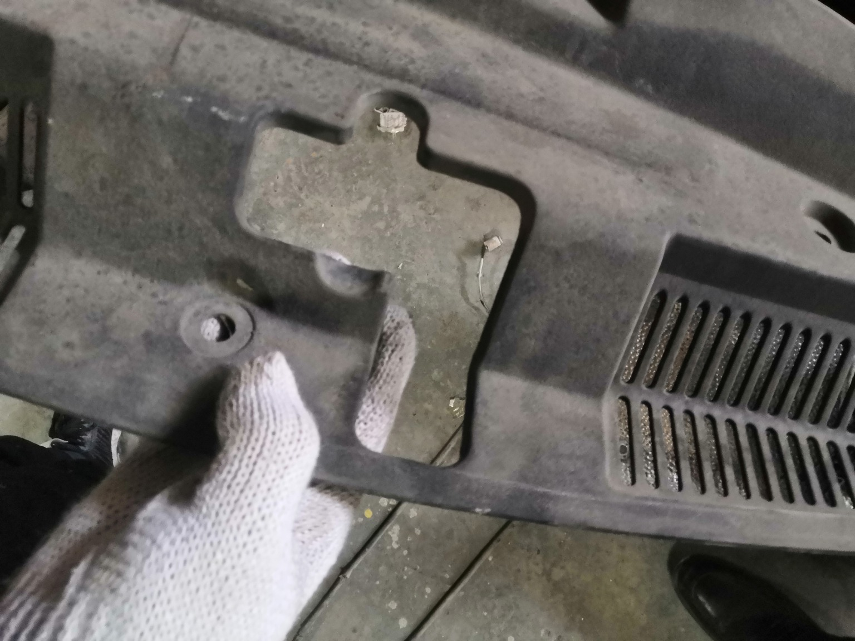 | 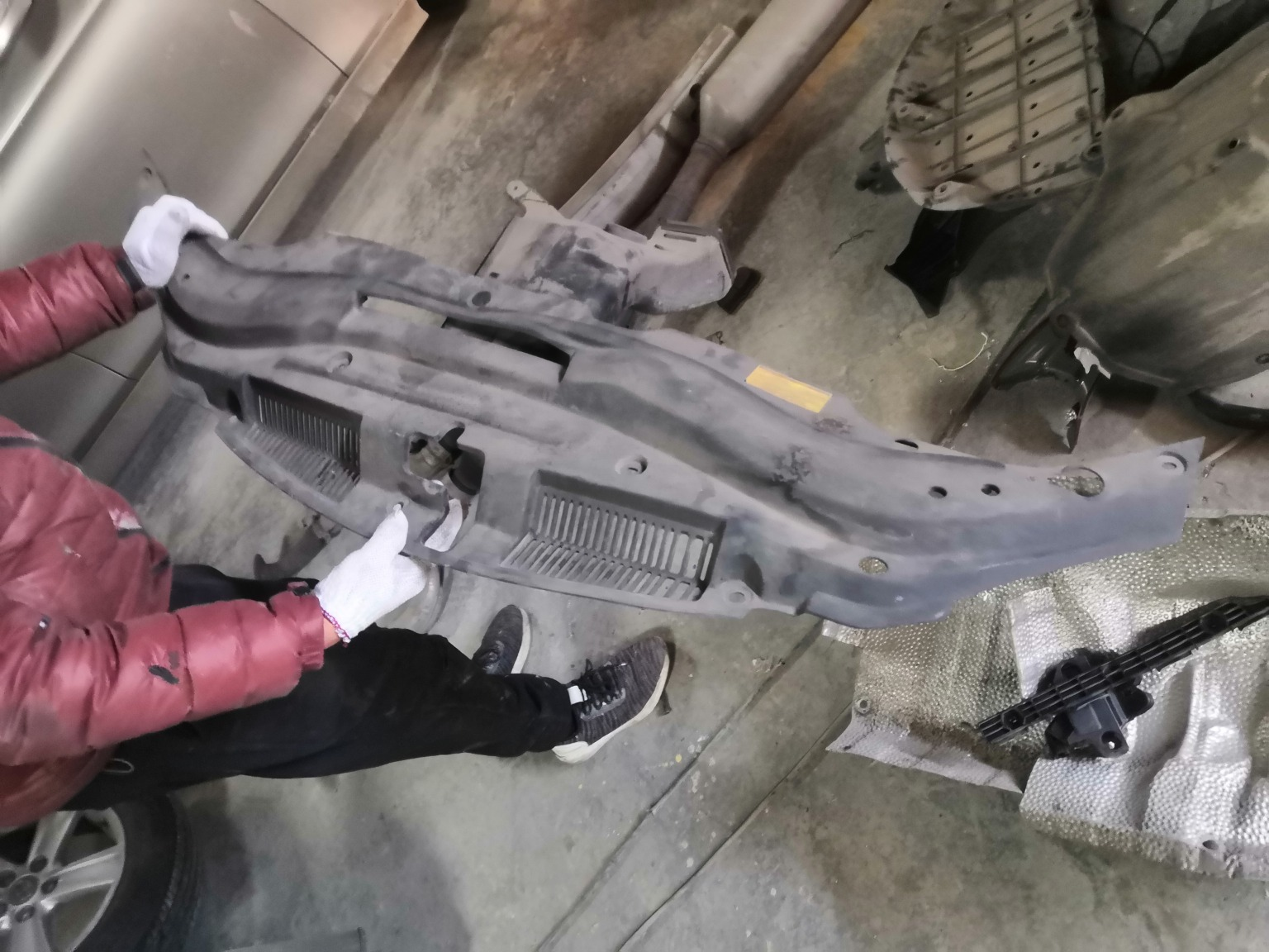
IMG_20201127_134643.jpg | IMG_20201127_134640.jpg | IMG_20201127_135047.jpg

IMG_20201127_134626.jpg | IMG_20201127_134530.jpg | IMG_20201127_134108.jpg
IMG_20201127_134507.jpg | IMG_20201127_133955.jpg | IMG_20201127_134123.jpg
IMG_20201127_134552.jpg | IMG_20201127_134010.jpg | IMG_20201127_134913.jpg

IMG_20201127_134143.jpg | IMG_20201127_134053.jpg | IMG_20201127_135055.jpg
IMG_20201127_134930.jpg | IMG_20201127_134141.jpg | IMG_20201127_135133.jpg
IMG_20201127_134910.jpg | IMG_20201127_134003.jpg | IMG_20201127_134129.jpg

IMG_20201127_134158.jpg | IMG_20201127_133921.jpg | IMG_20201127_134512.jpg
IMG_20201127_134611.jpg | IMG_20201127_134016.jpg | IMG_20201127_134902.jpg
IMG_20201127_134055.jpg | IMG_20201127_134131.jpg | IMG_20201127_134200.jpg

IMG_20201127_134126.jpg | IMG_20201127_134133.jpg | IMG_20201127_135017.jpg
IMG_20201127_134051.jpg | IMG_20201127_134951.jpg | IMG_20201127_135137.jpg
IMG_20201127_134138.jpg | IMG_20201127_134148.jpg | IMG_20201127_134959.jpg

IMG_20201127_134011.jpg | IMG_20201127_135020.jpg | IMG_20201127_135009.jpg
IMG_20201127_134150.jpg | IMG_20201127_135112.jpg | IMG_20201127_135013.jpg
IMG_20201127_134104.jpg | IMG_20201127_134114.jpg | IMG_20201127_134034.jpg

