拆解过程
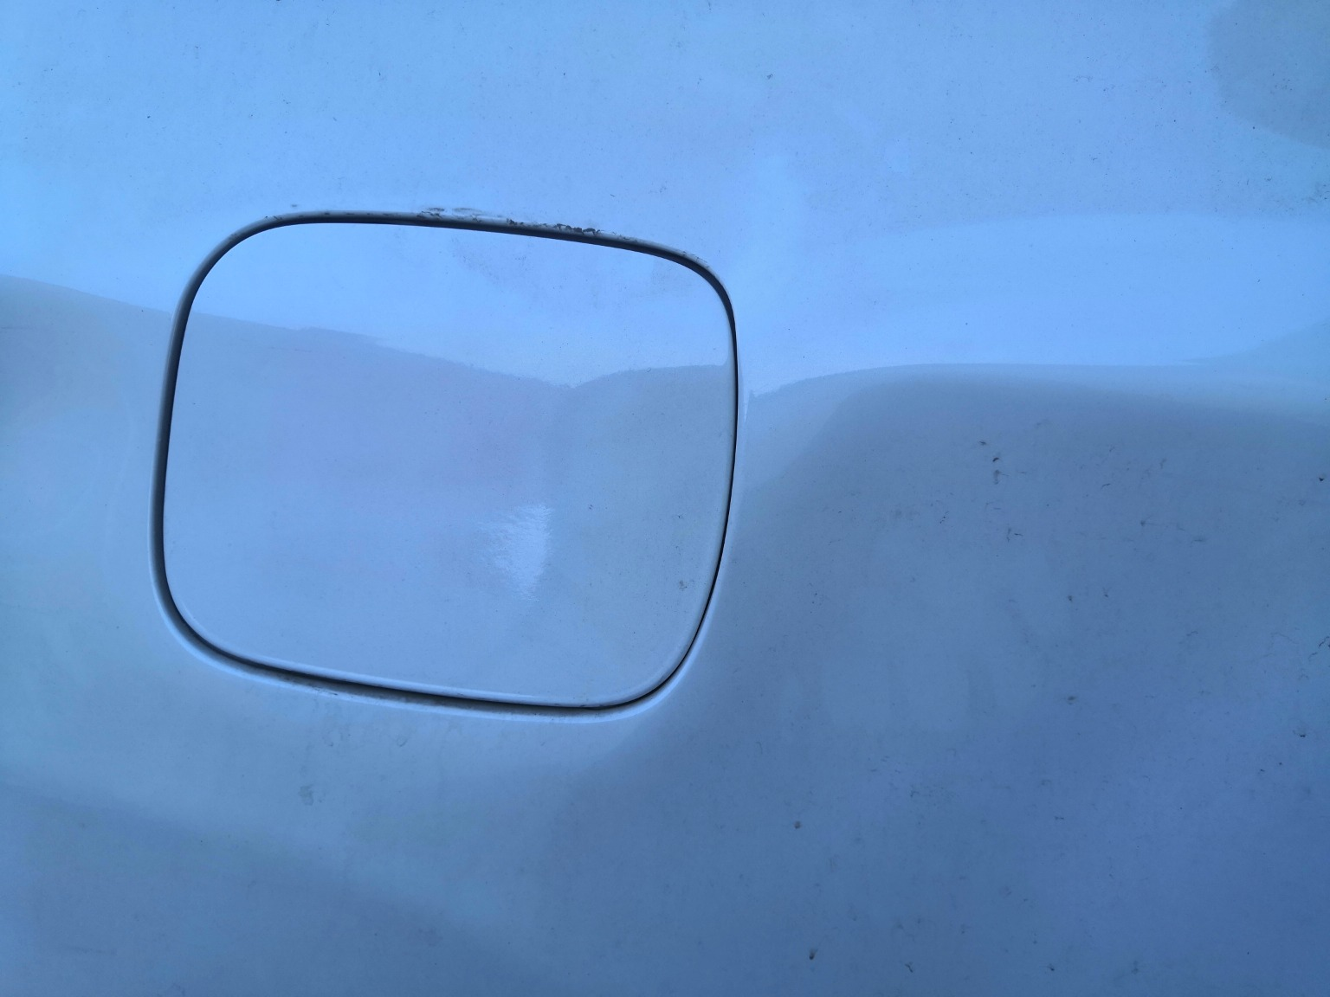 | 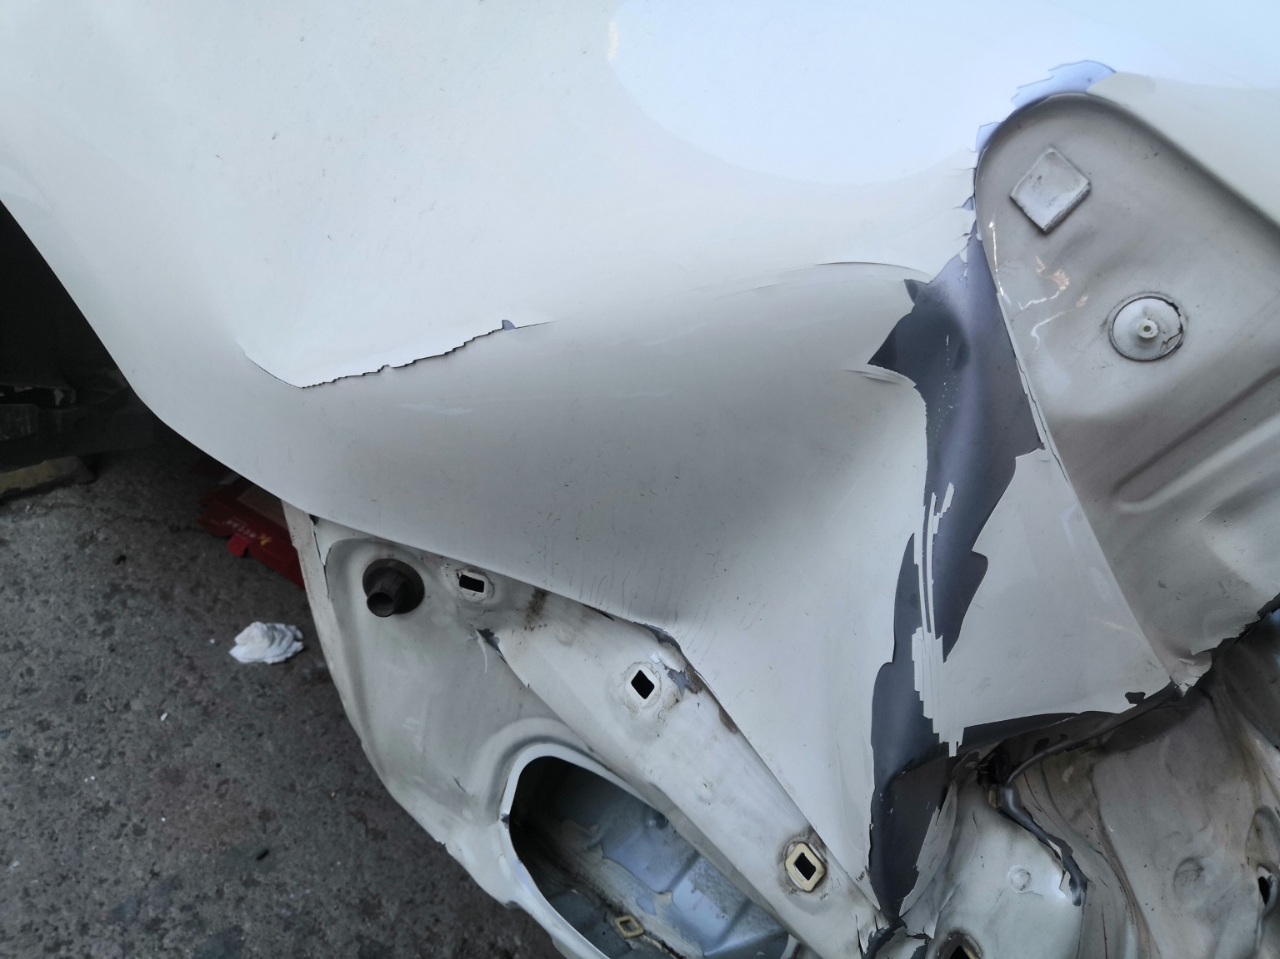 | 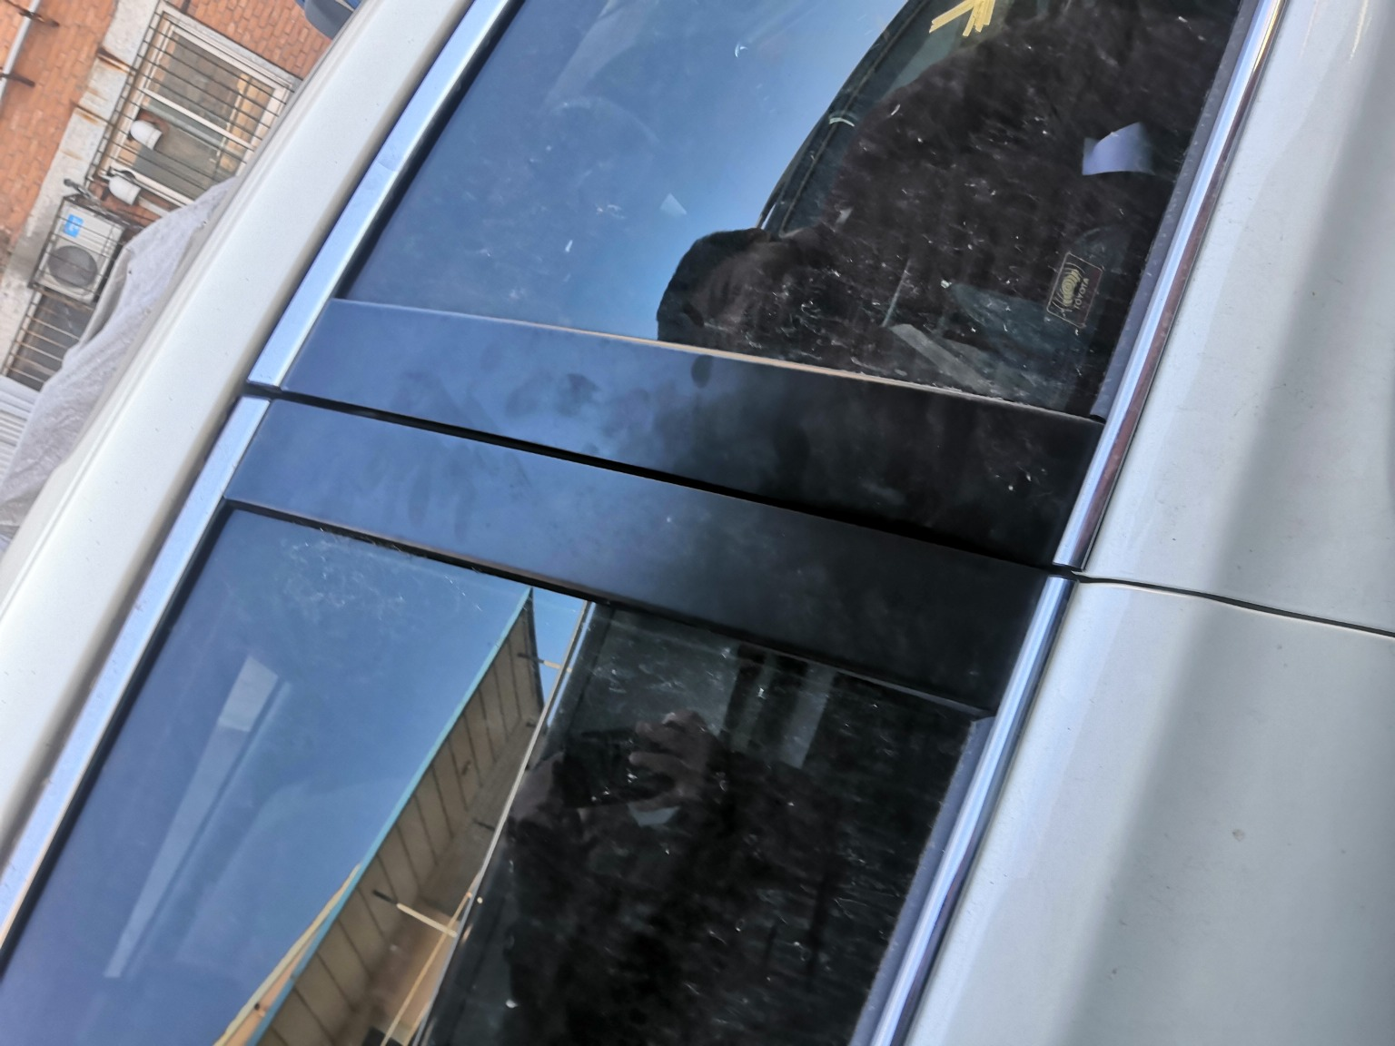
IMG_20201127_133350.jpg | IMG_20201127_133344.jpg | IMG_20201127_133519.jpg
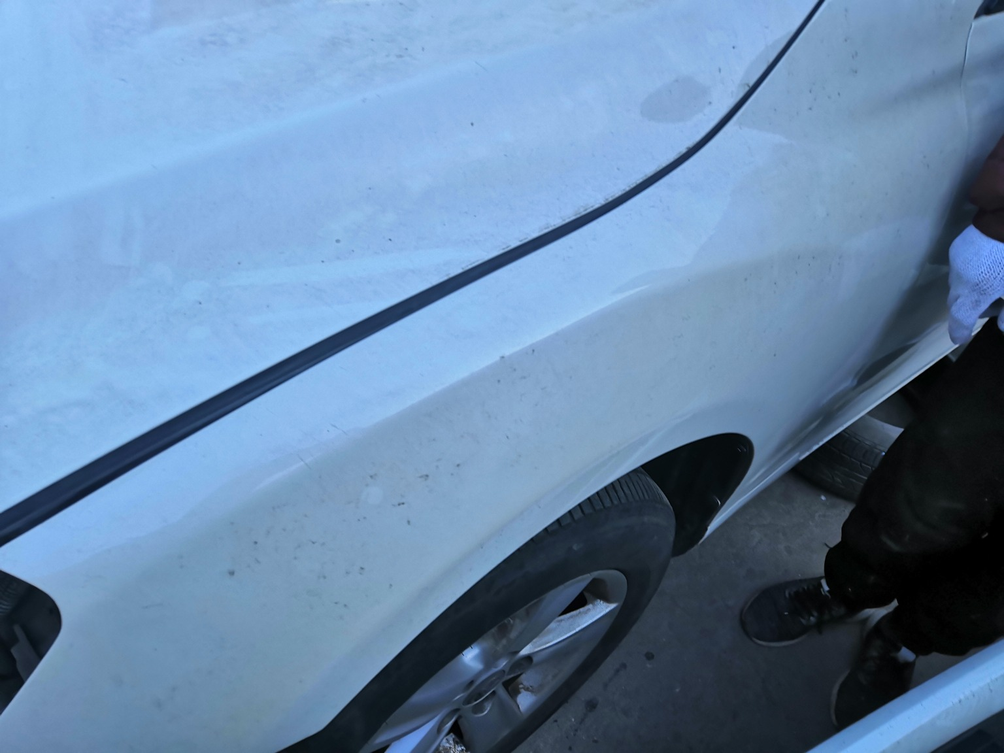 | 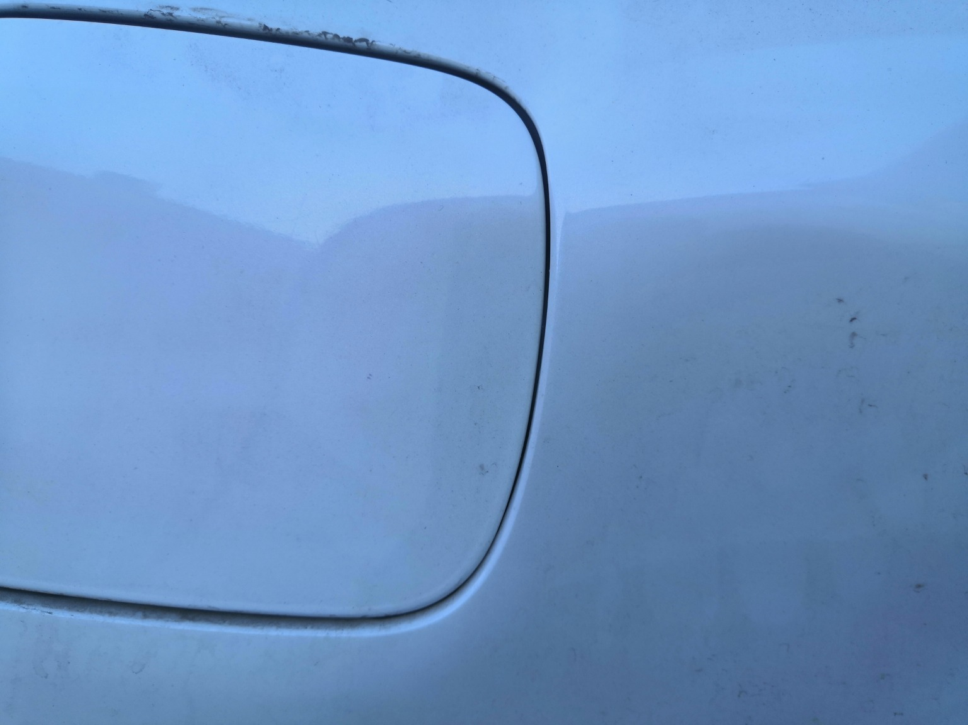 | 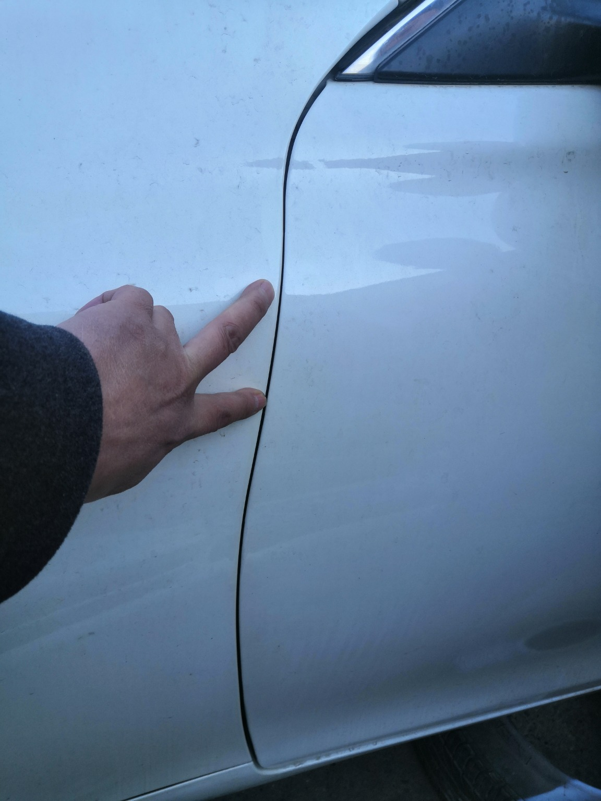
IMG_20201127_133450.jpg | IMG_20201127_133348.jpg | IMG_20201127_133446.jpg
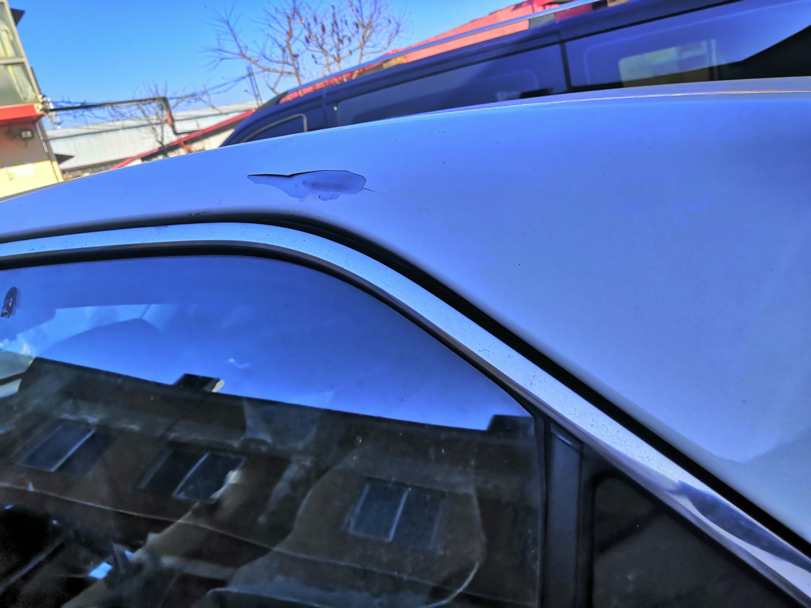 | 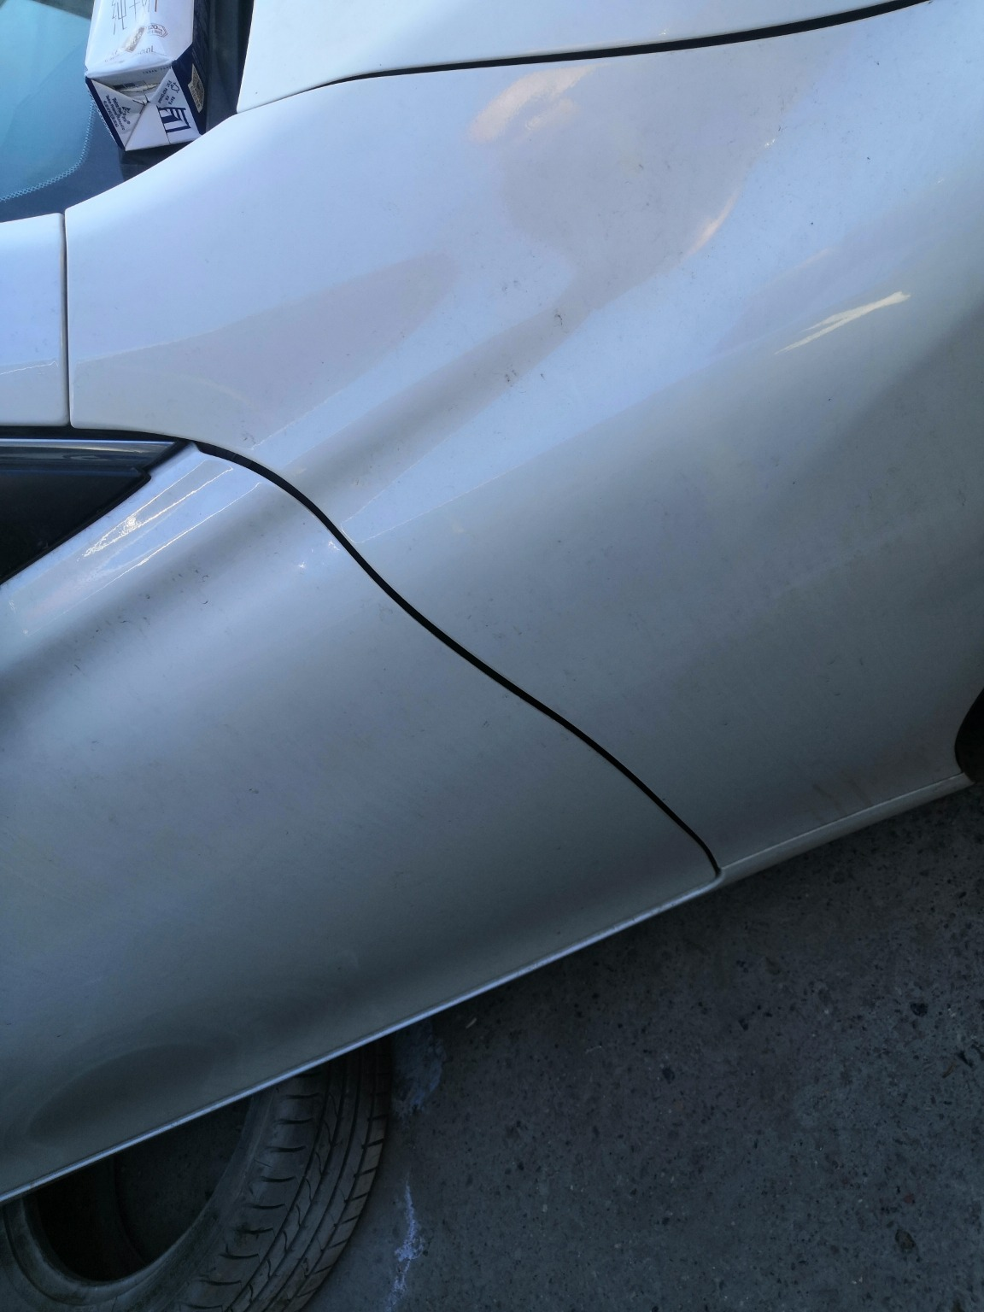 | 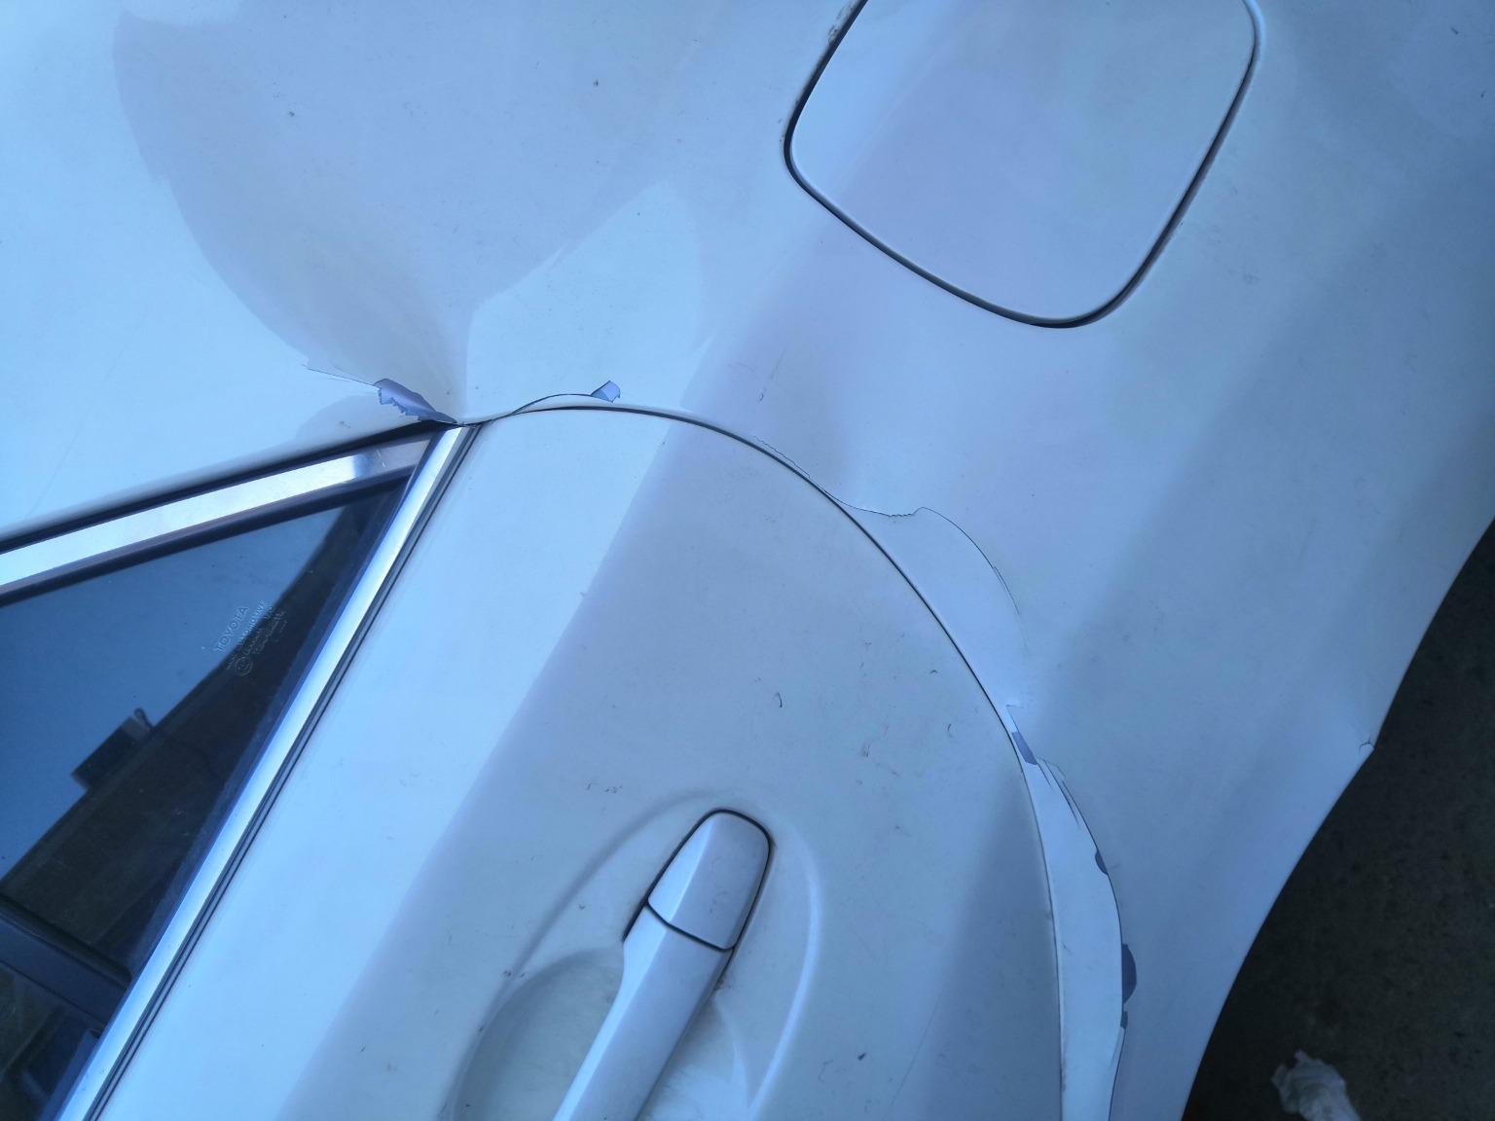
IMG_20201127_133412.jpg | IMG_20201127_133509.jpg | IMG_20201127_133355.jpg

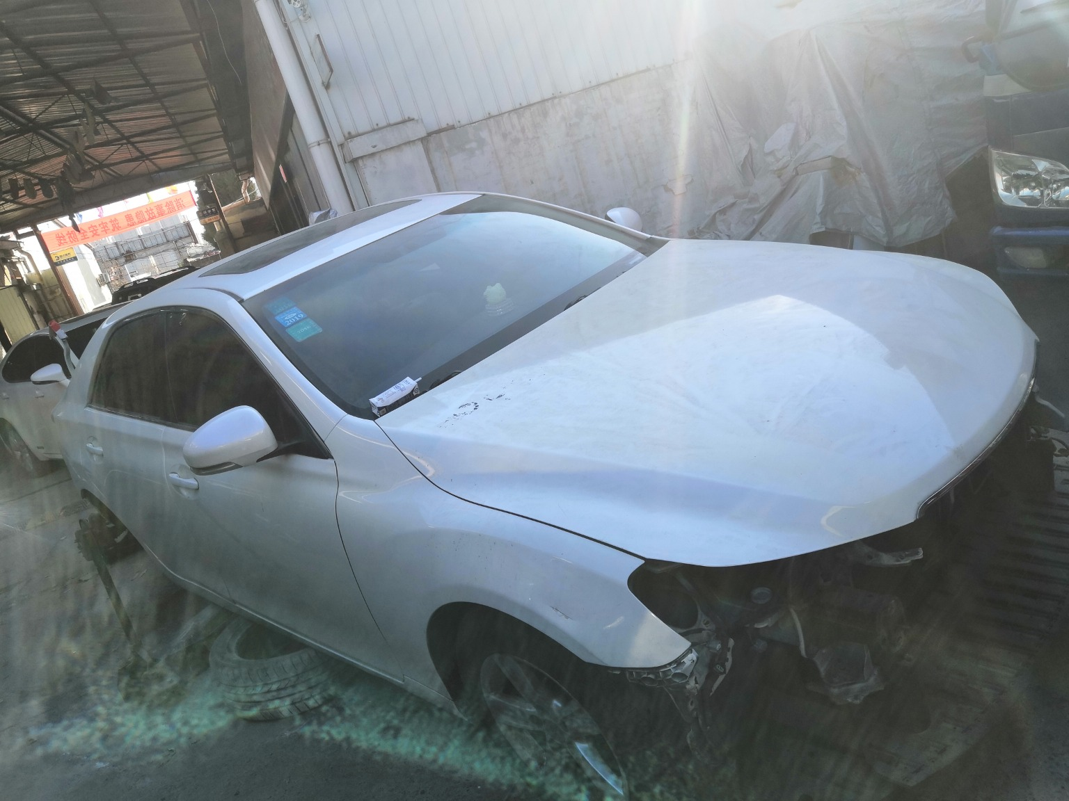 | 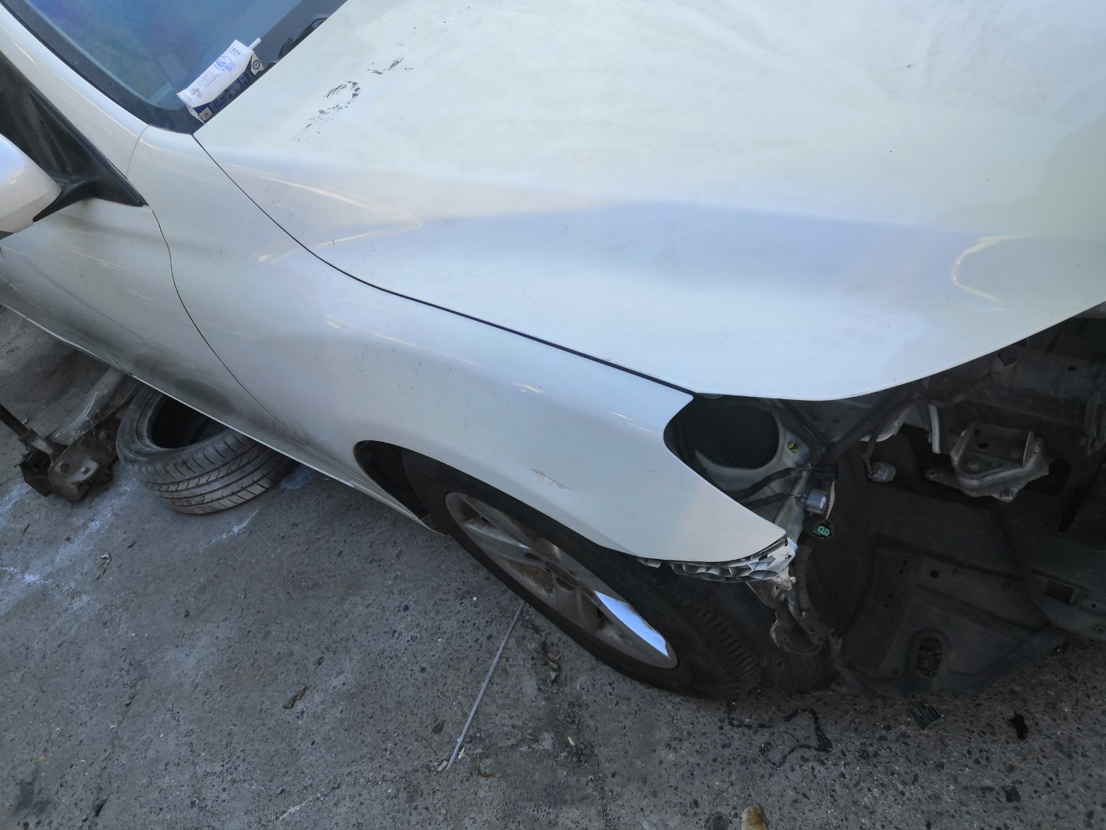 | 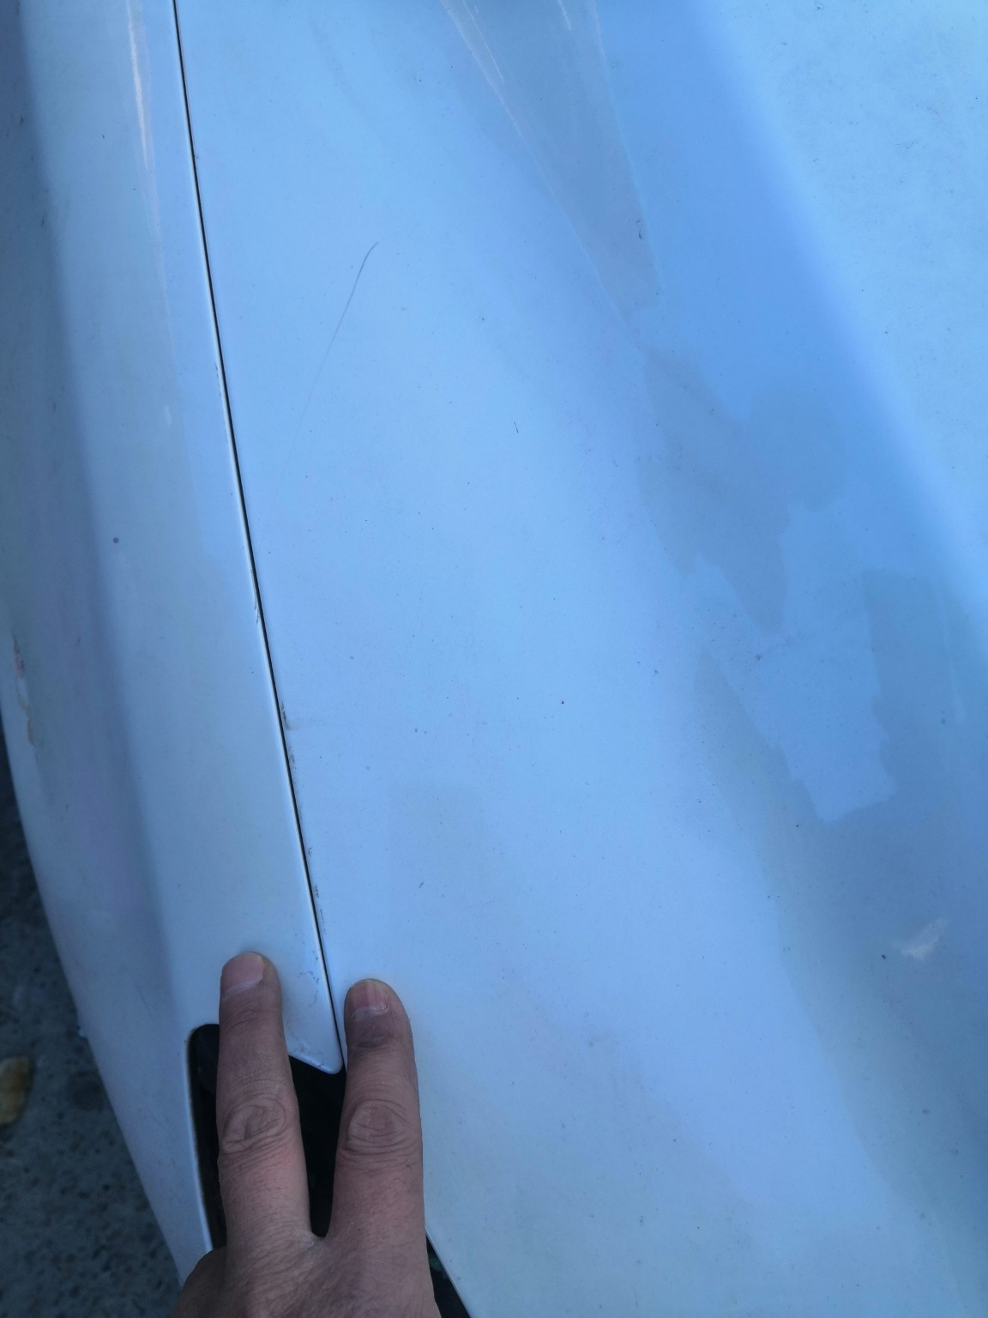
IMG_20201127_133312.jpg | IMG_20201127_133501.jpg | IMG_20201127_135318.jpg
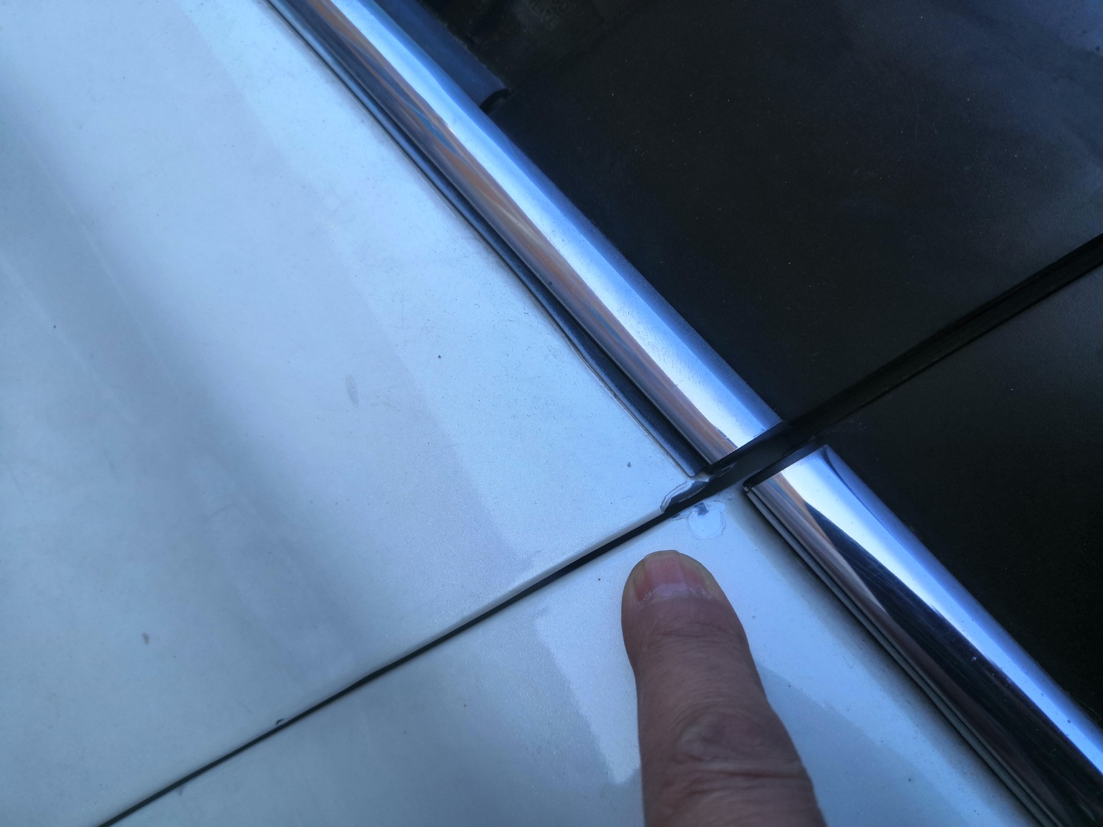 | 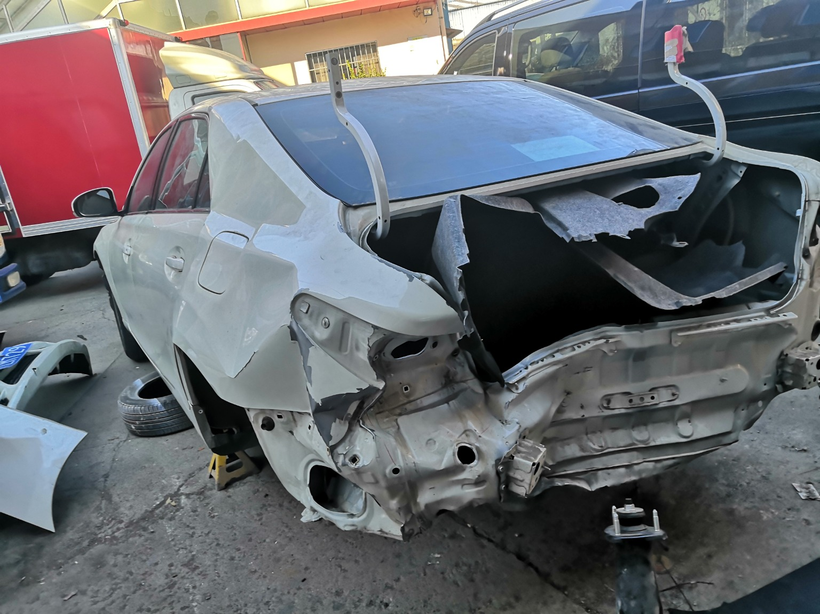 | 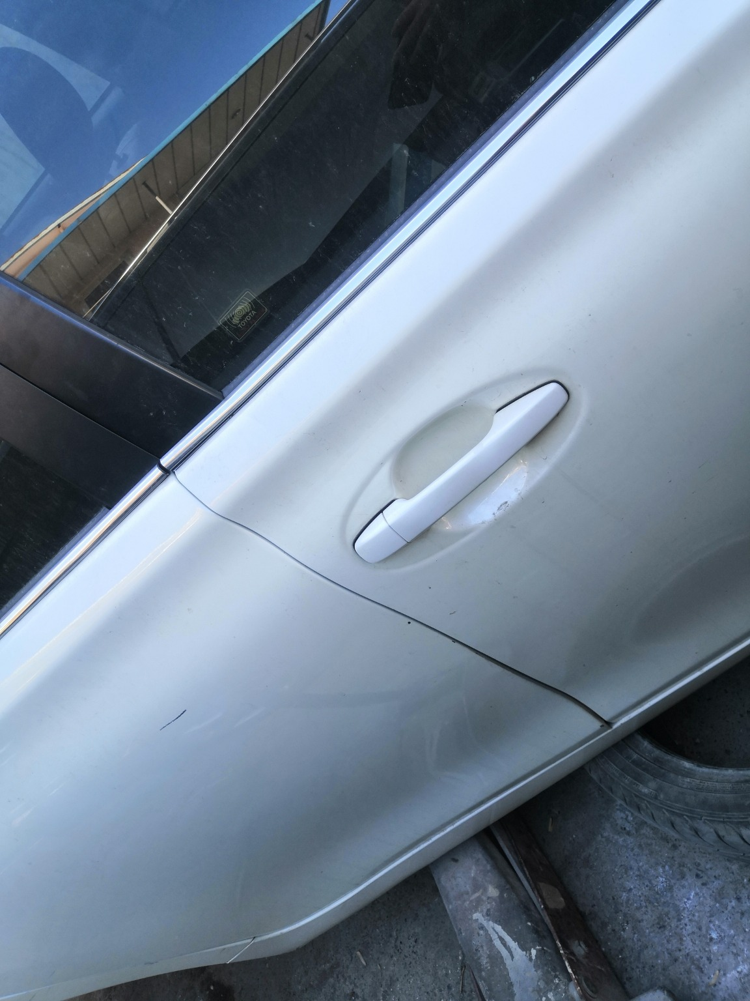
IMG_20201127_133433.jpg | IMG_20201127_133336.jpg | IMG_20201127_133515.jpg
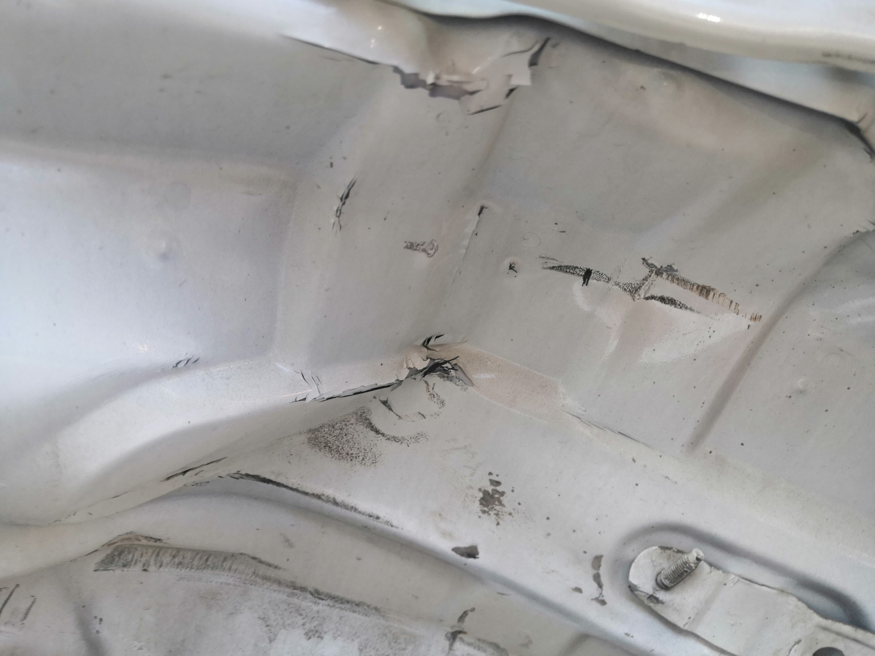 | 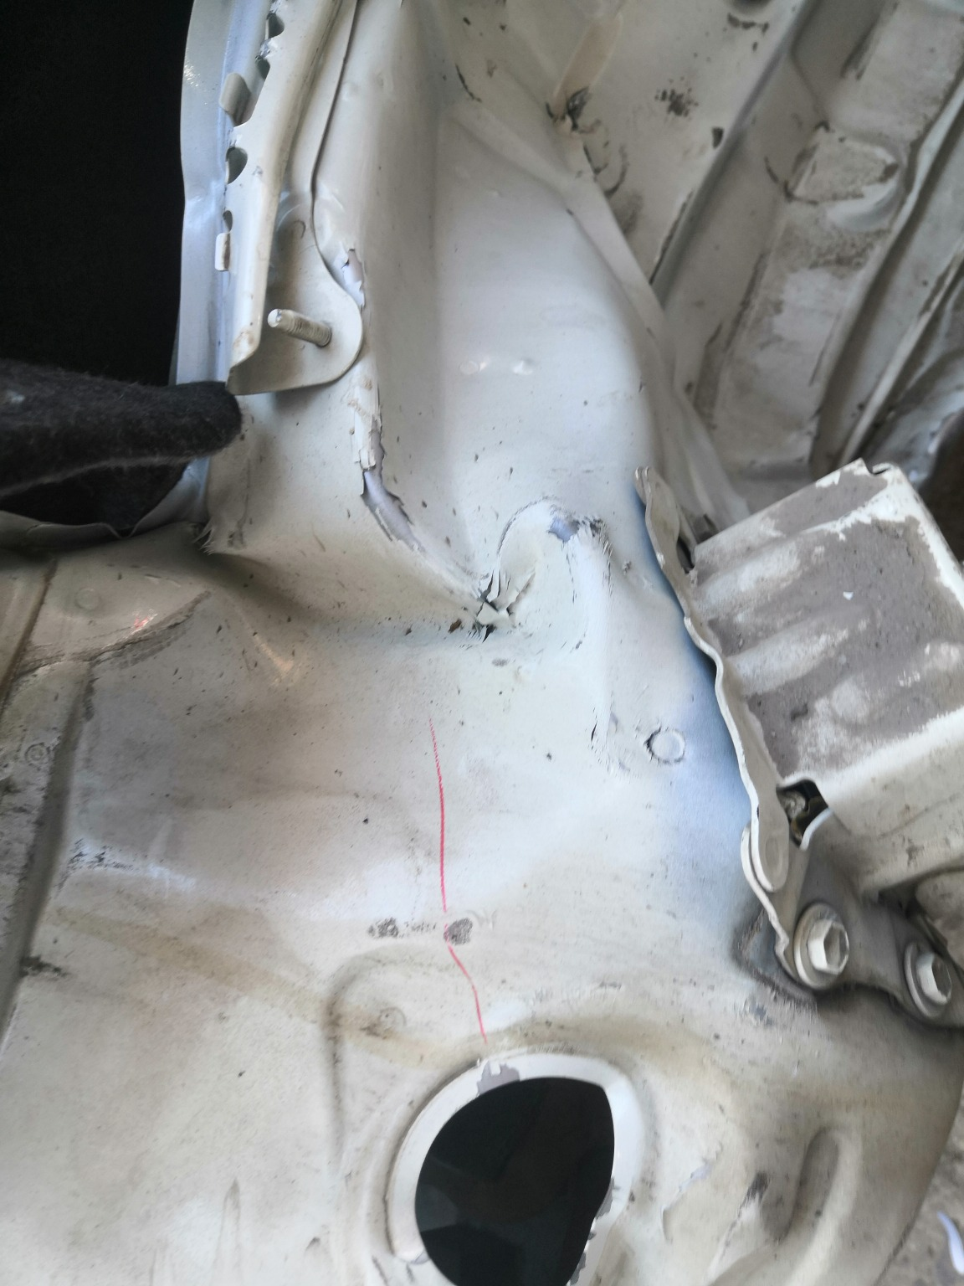 | 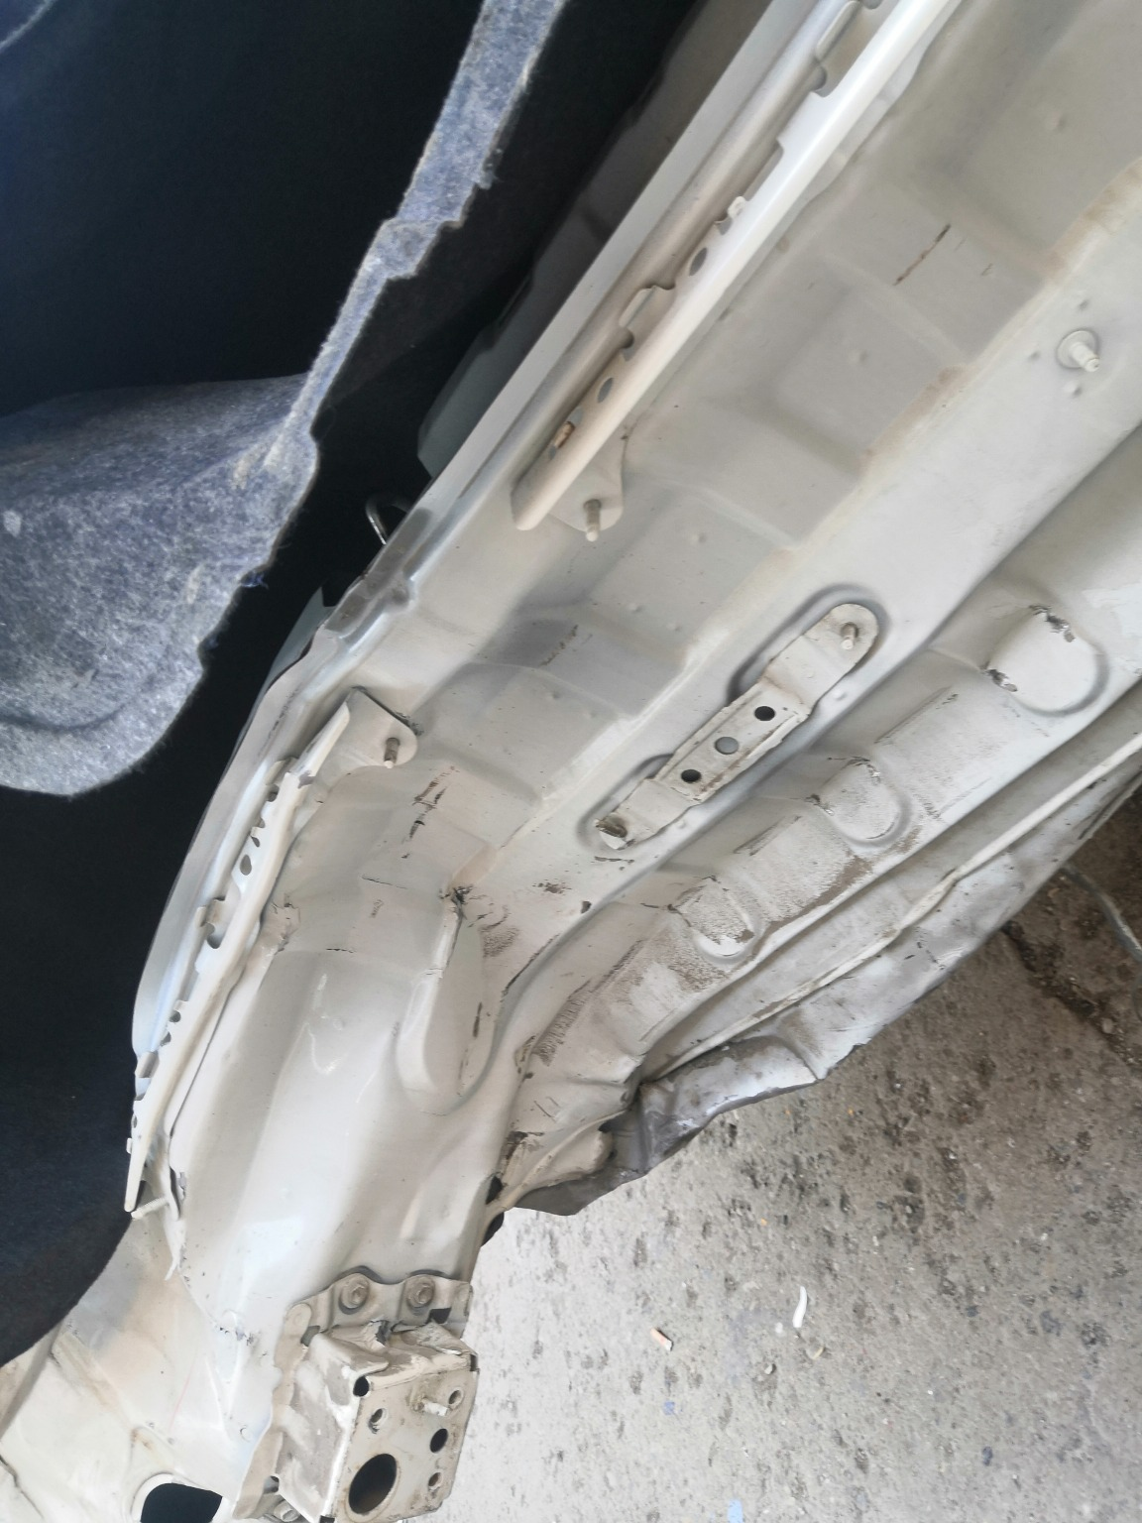
IMG_20201127_133600.jpg | IMG_20201127_133547.jpg | IMG_20201127_133543.jpg

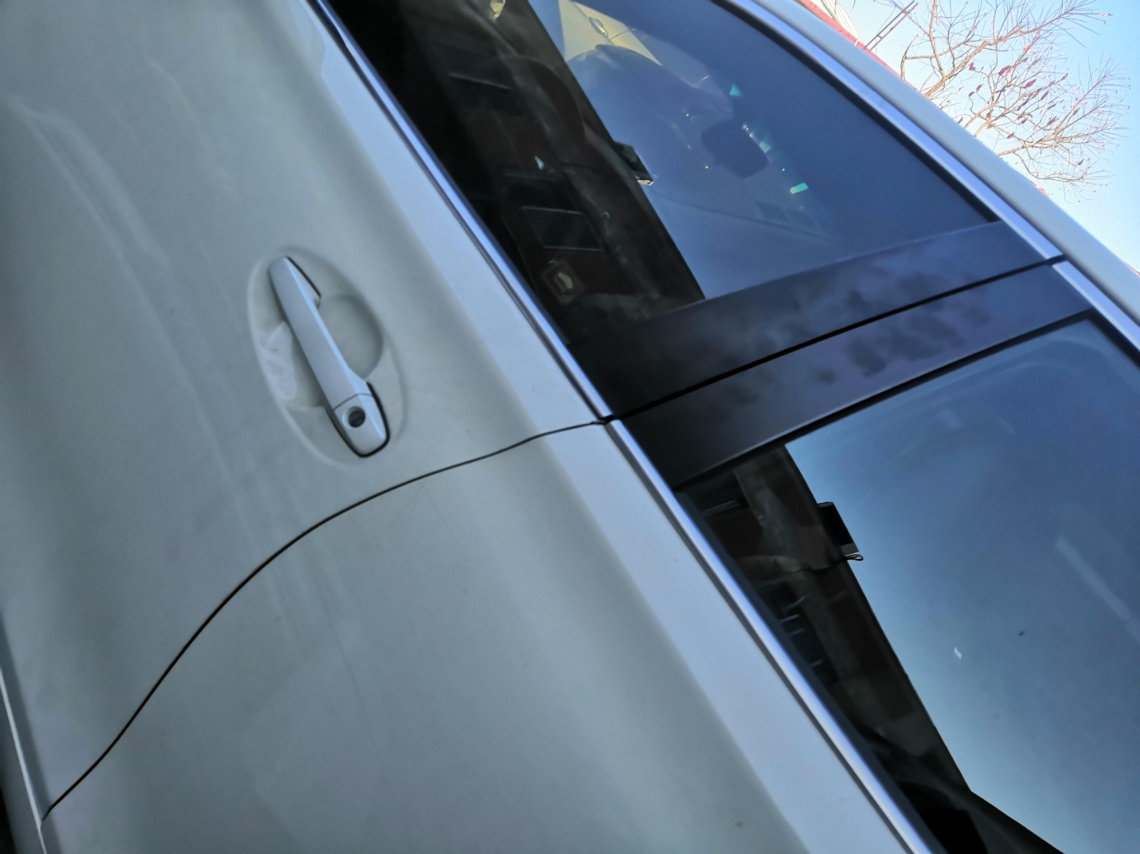 | 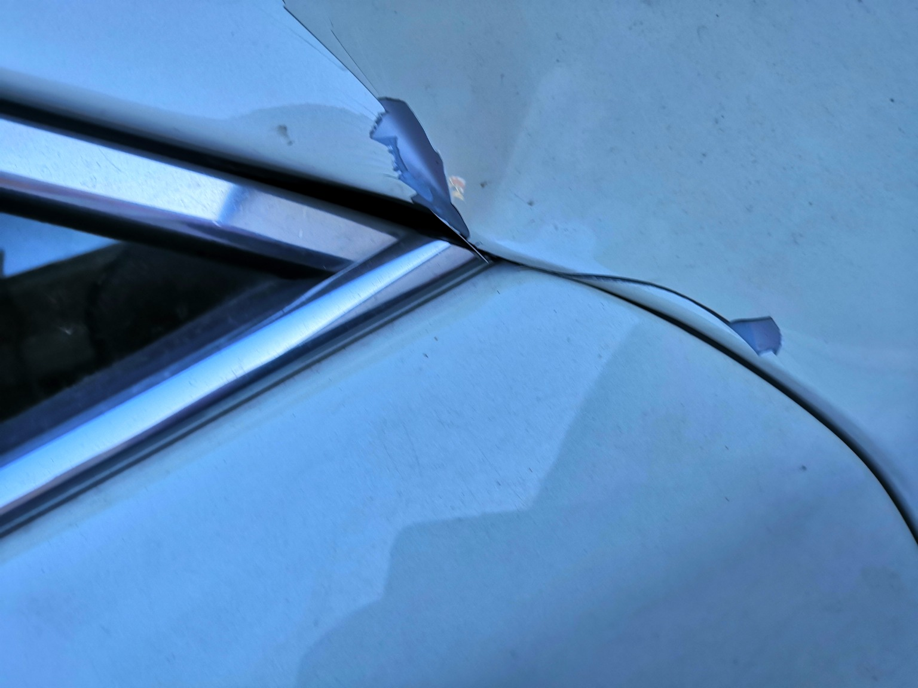 | 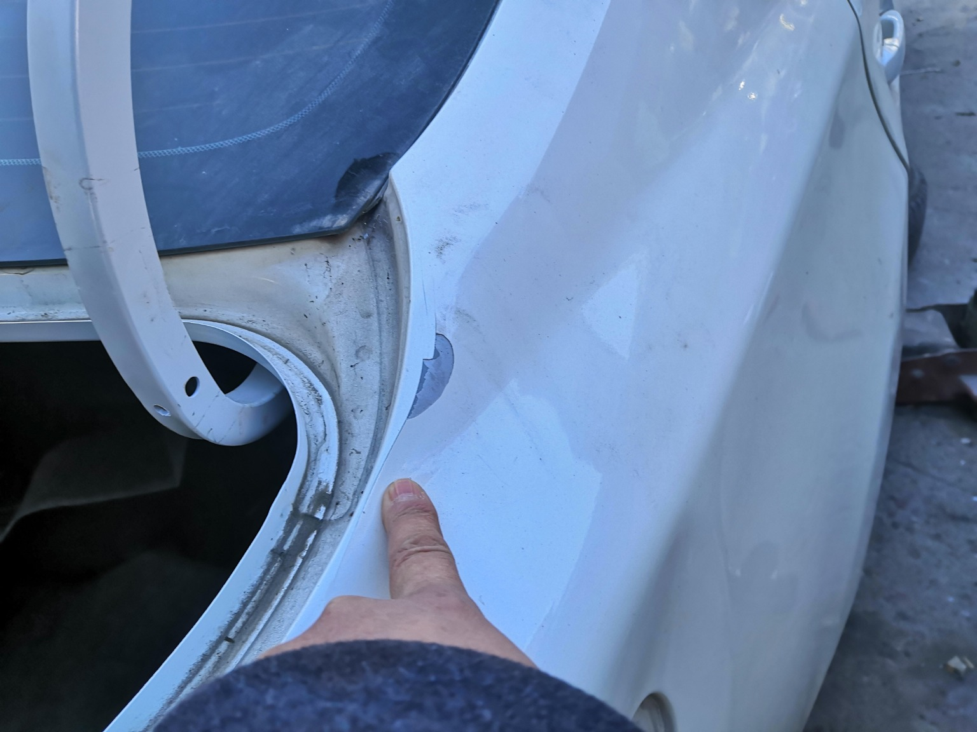
IMG_20201127_133430.jpg | IMG_20201127_133358.jpg | IMG_20201127_133531.jpg
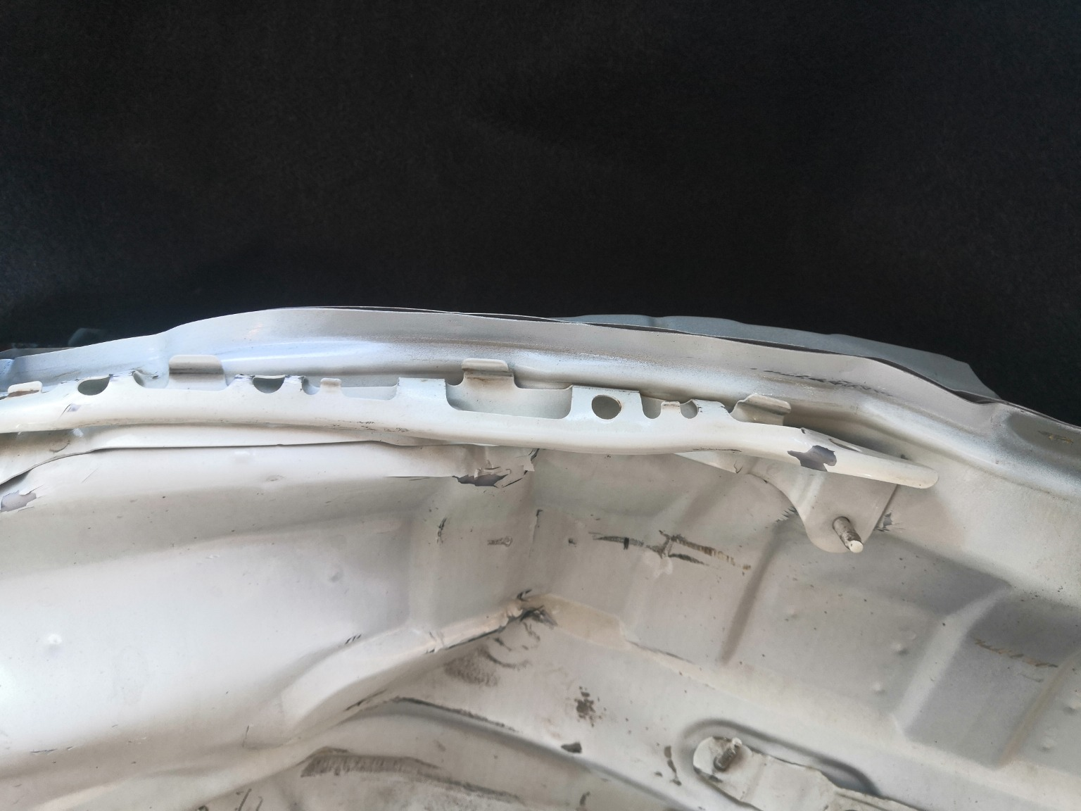 | 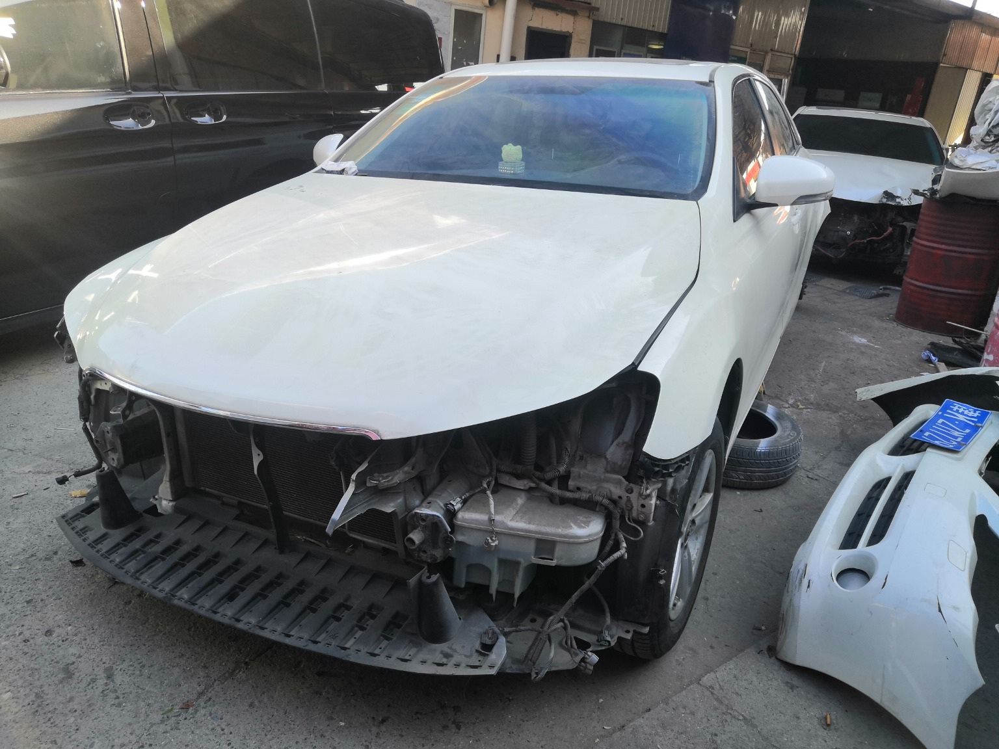 | 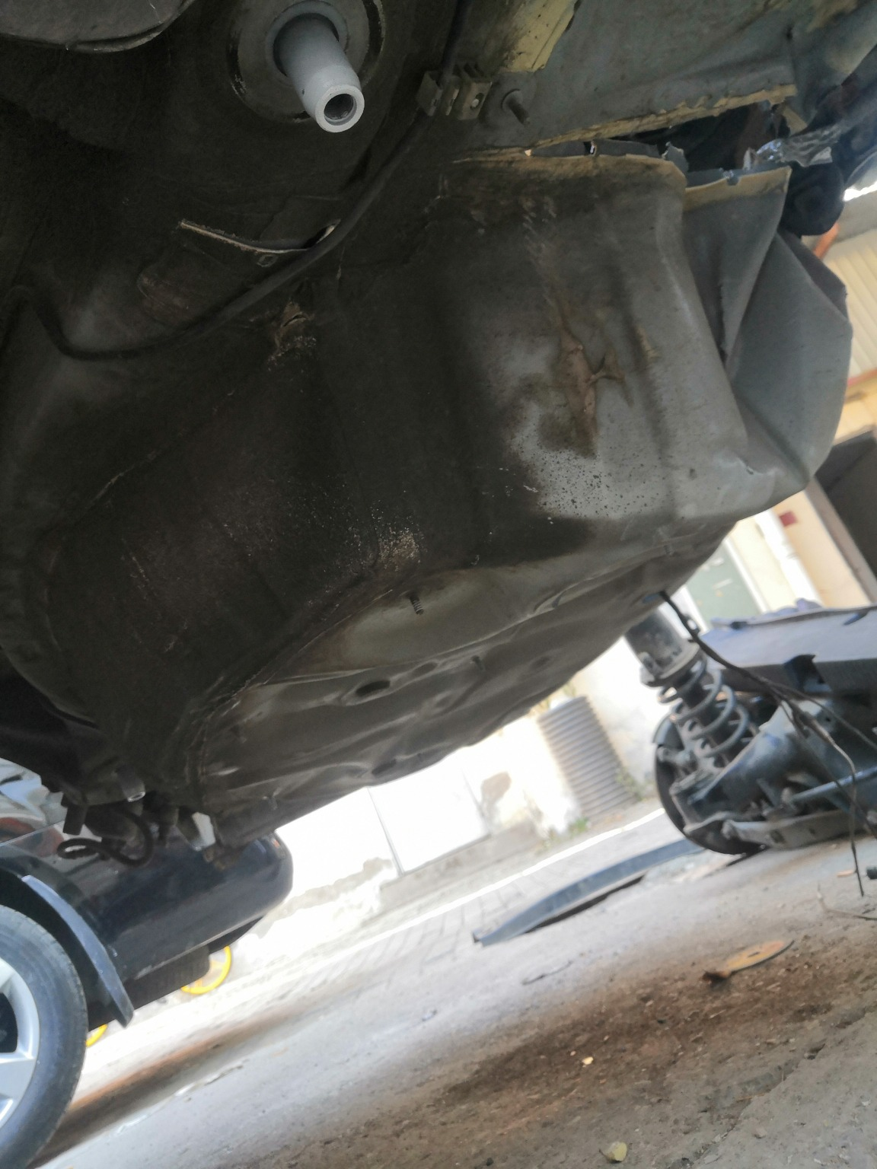
IMG_20201127_133603.jpg | IMG_20201127_133302.jpg | IMG_20201127_133800.jpg
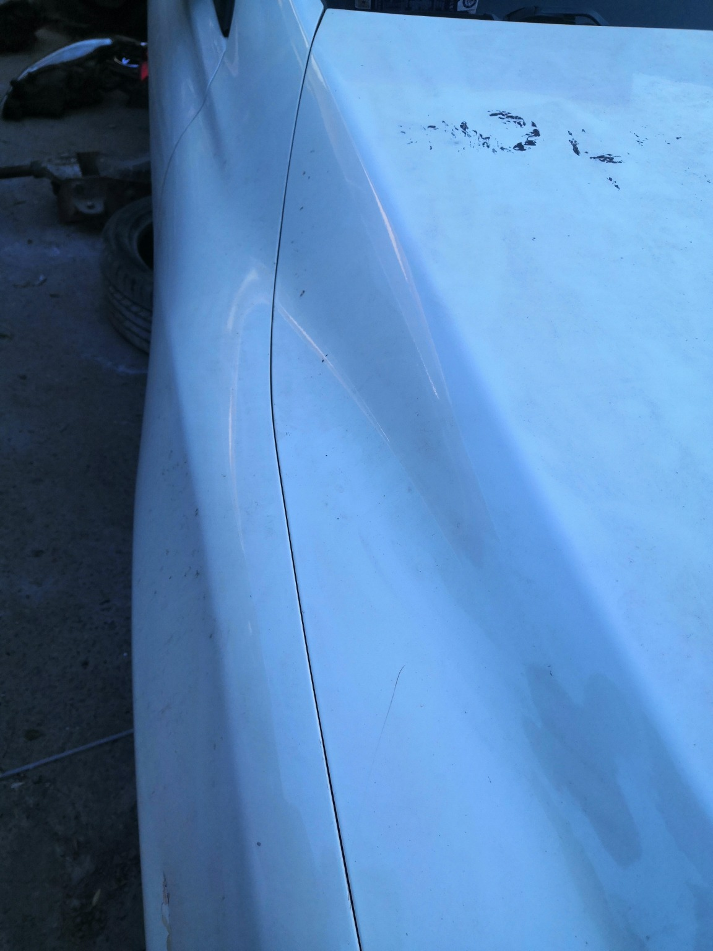 | 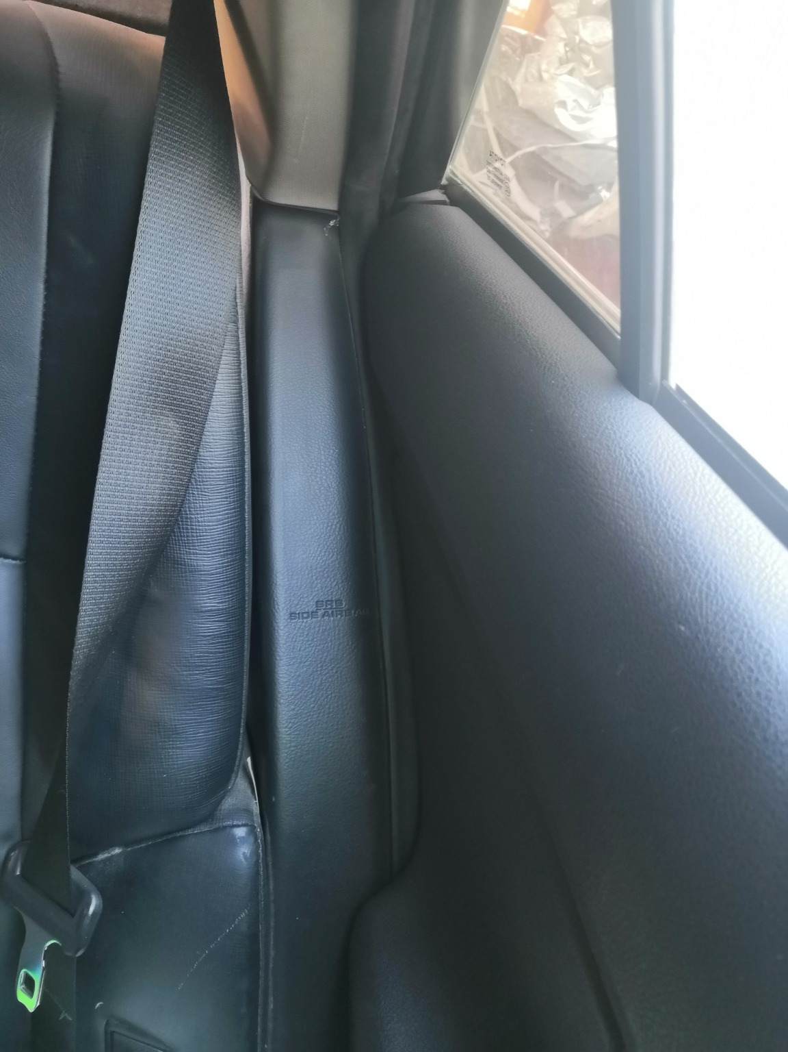 | 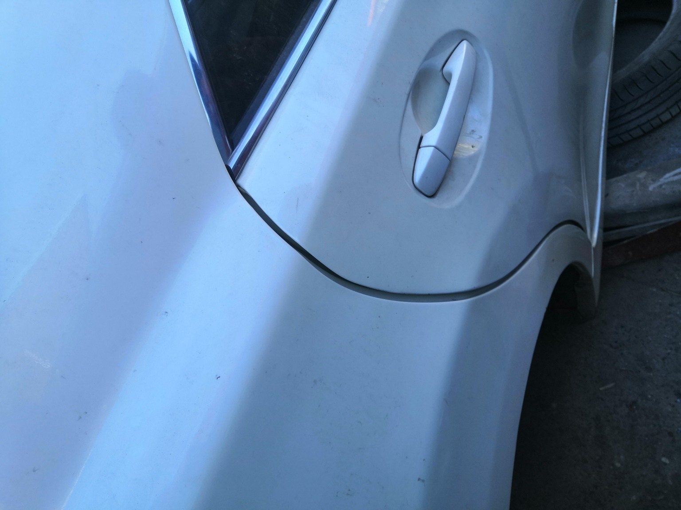
IMG_20201127_135321.jpg | IMG_20201127_135221.jpg | IMG_20201127_133525.jpg

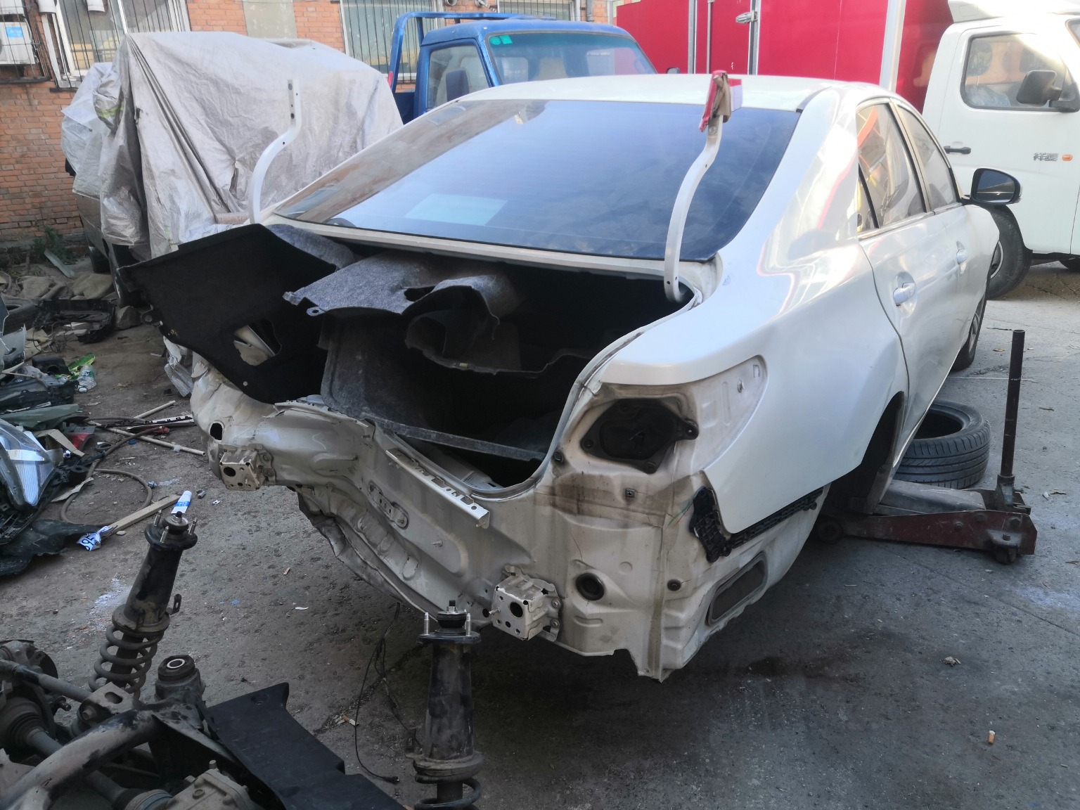 | 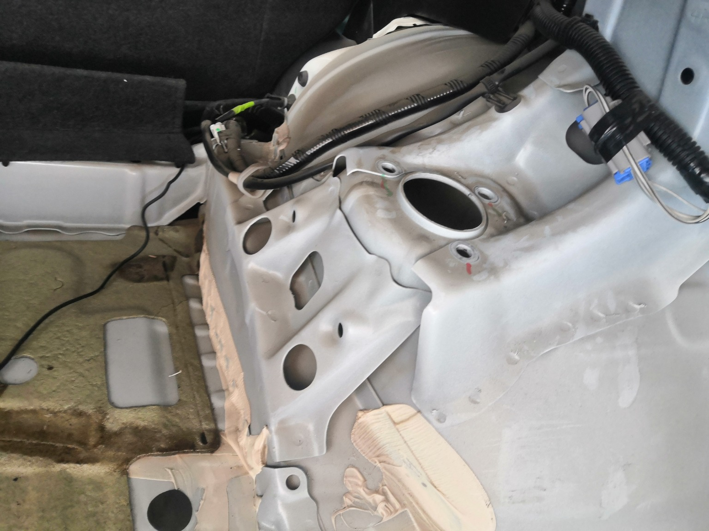 | 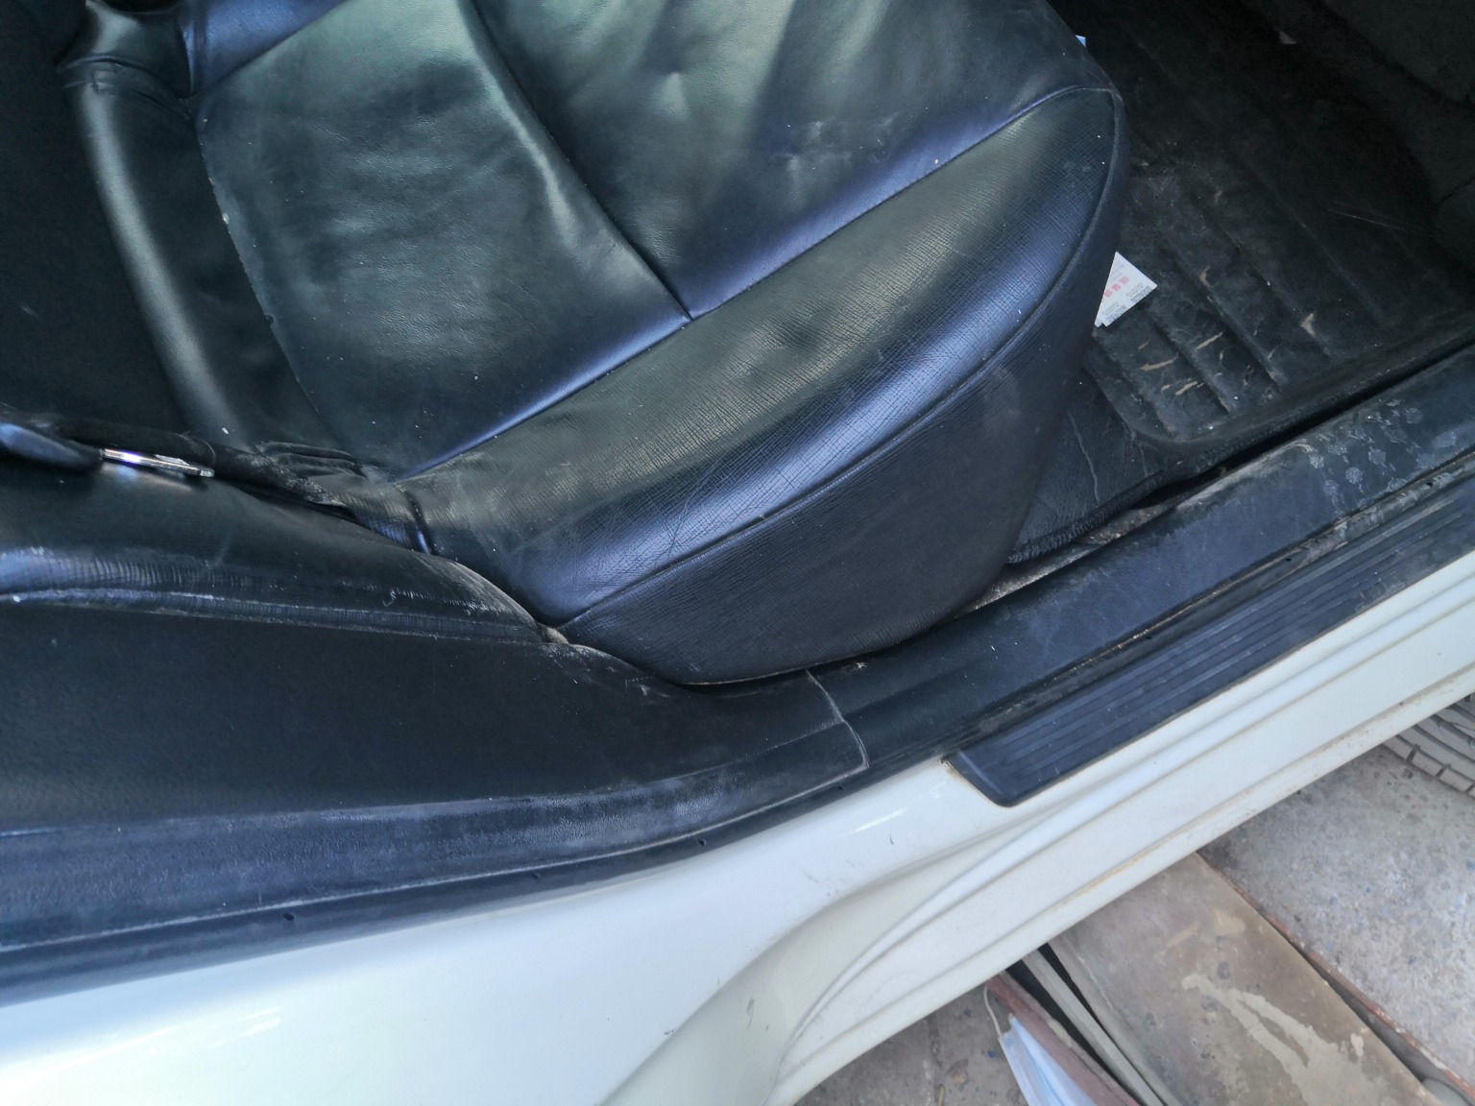
IMG_20201127_133328.jpg | IMG_20201127_133719.jpg | IMG_20201127_135212.jpg
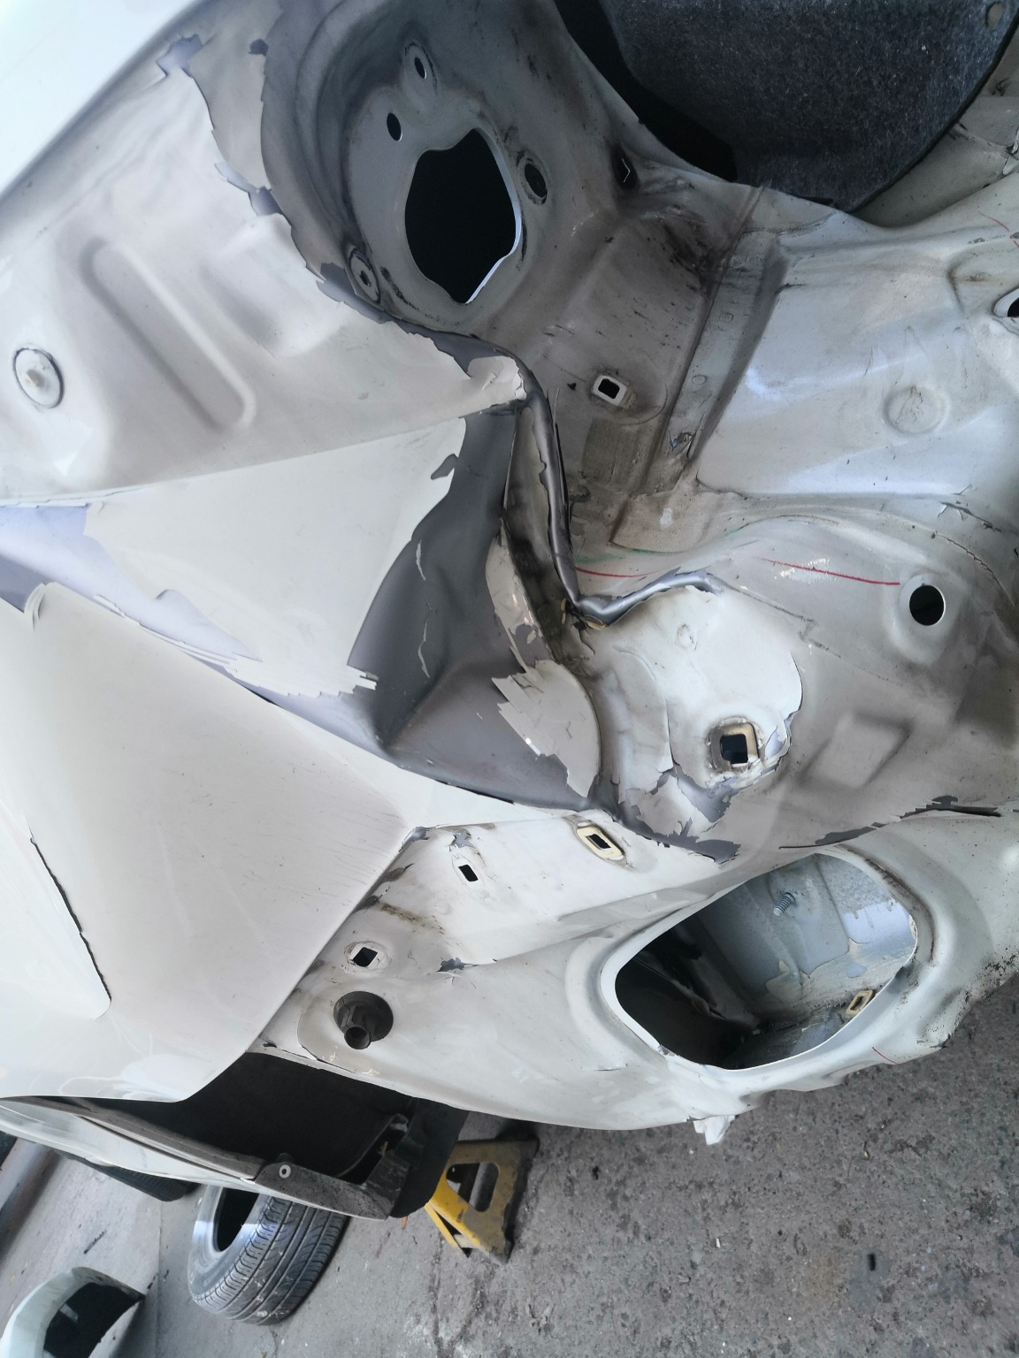 | 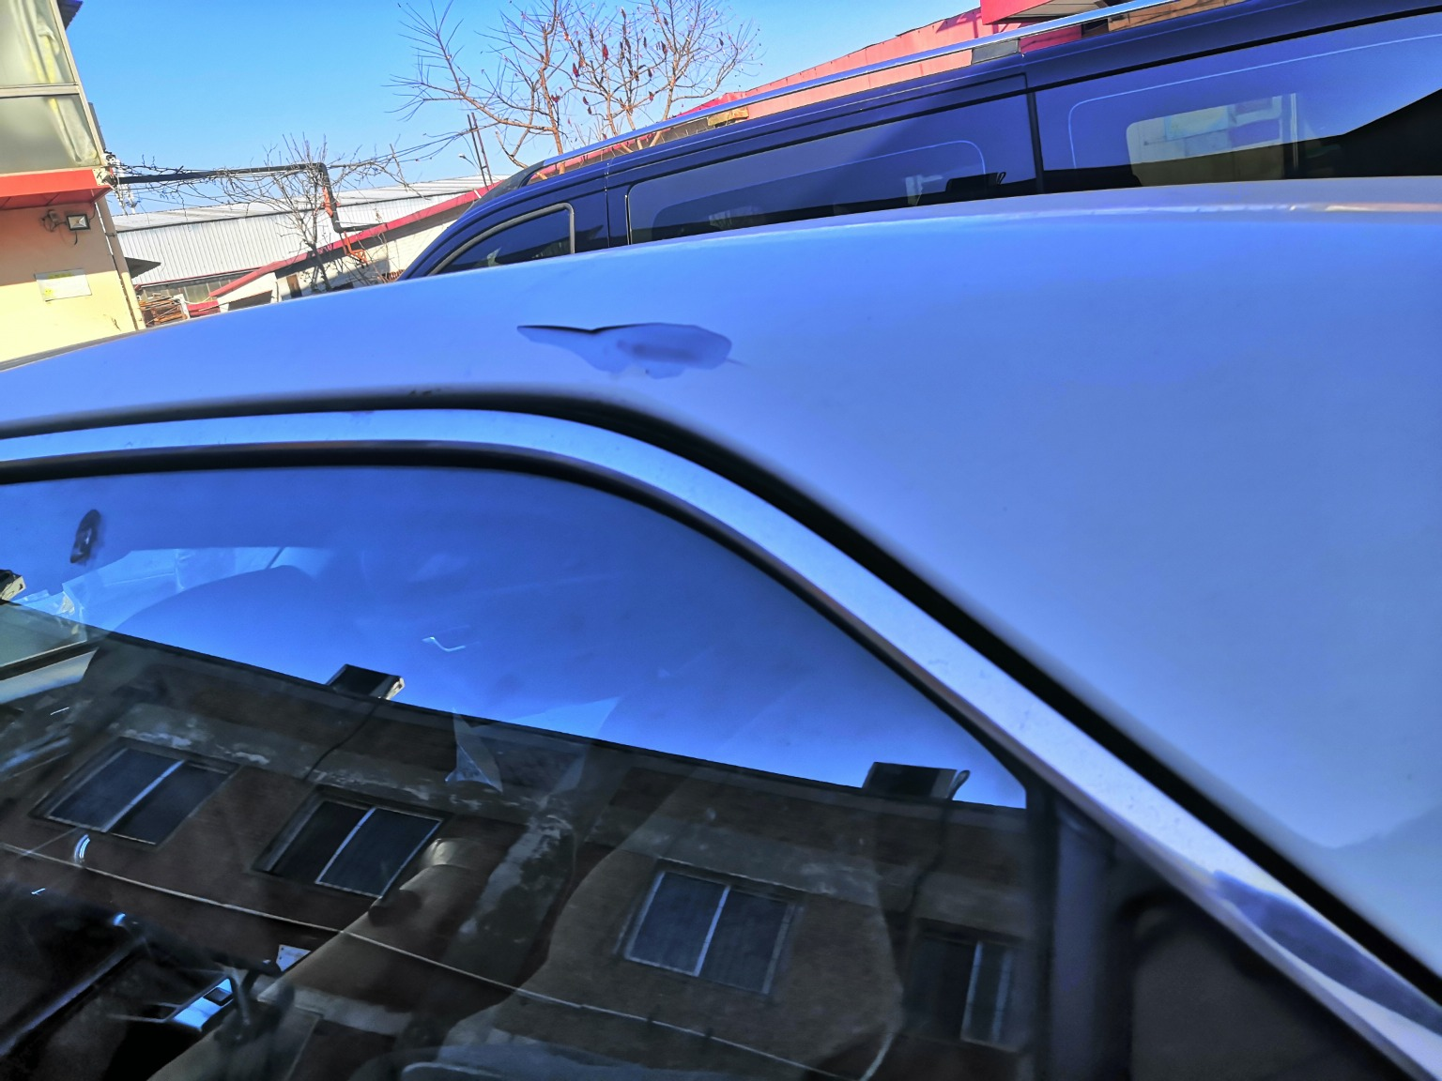 | 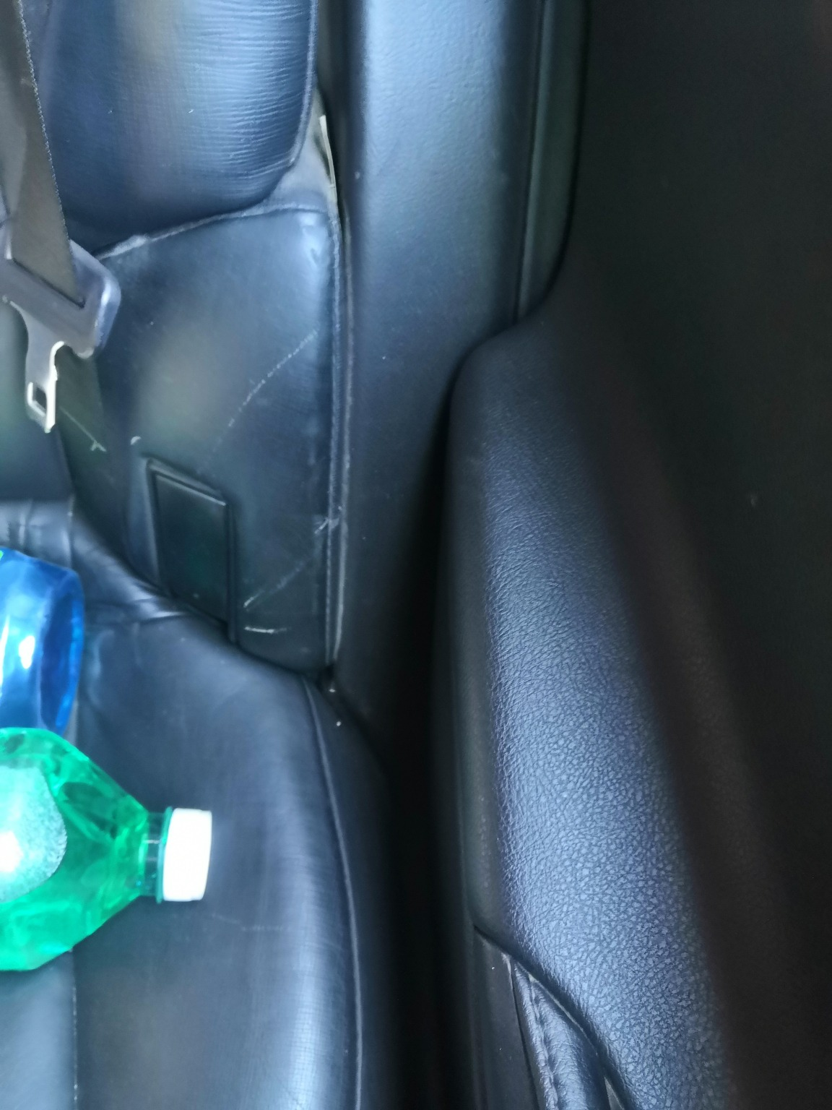
IMG_20201127_133608.jpg | IMG_20201127_133408.jpg | IMG_20201127_135224.jpg
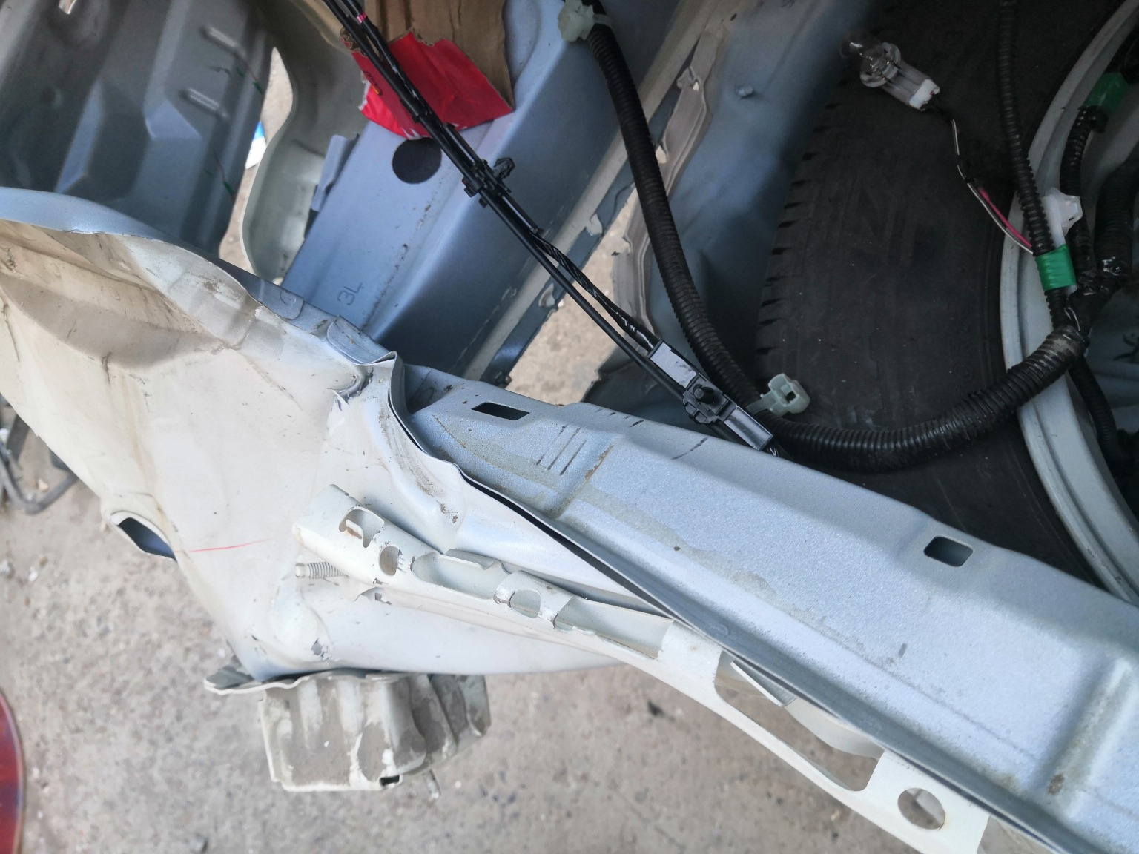 | 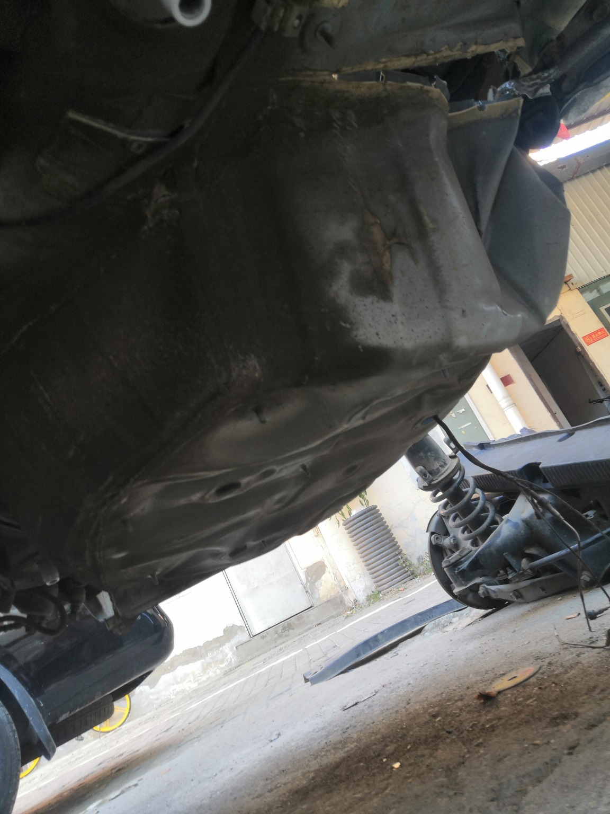 | 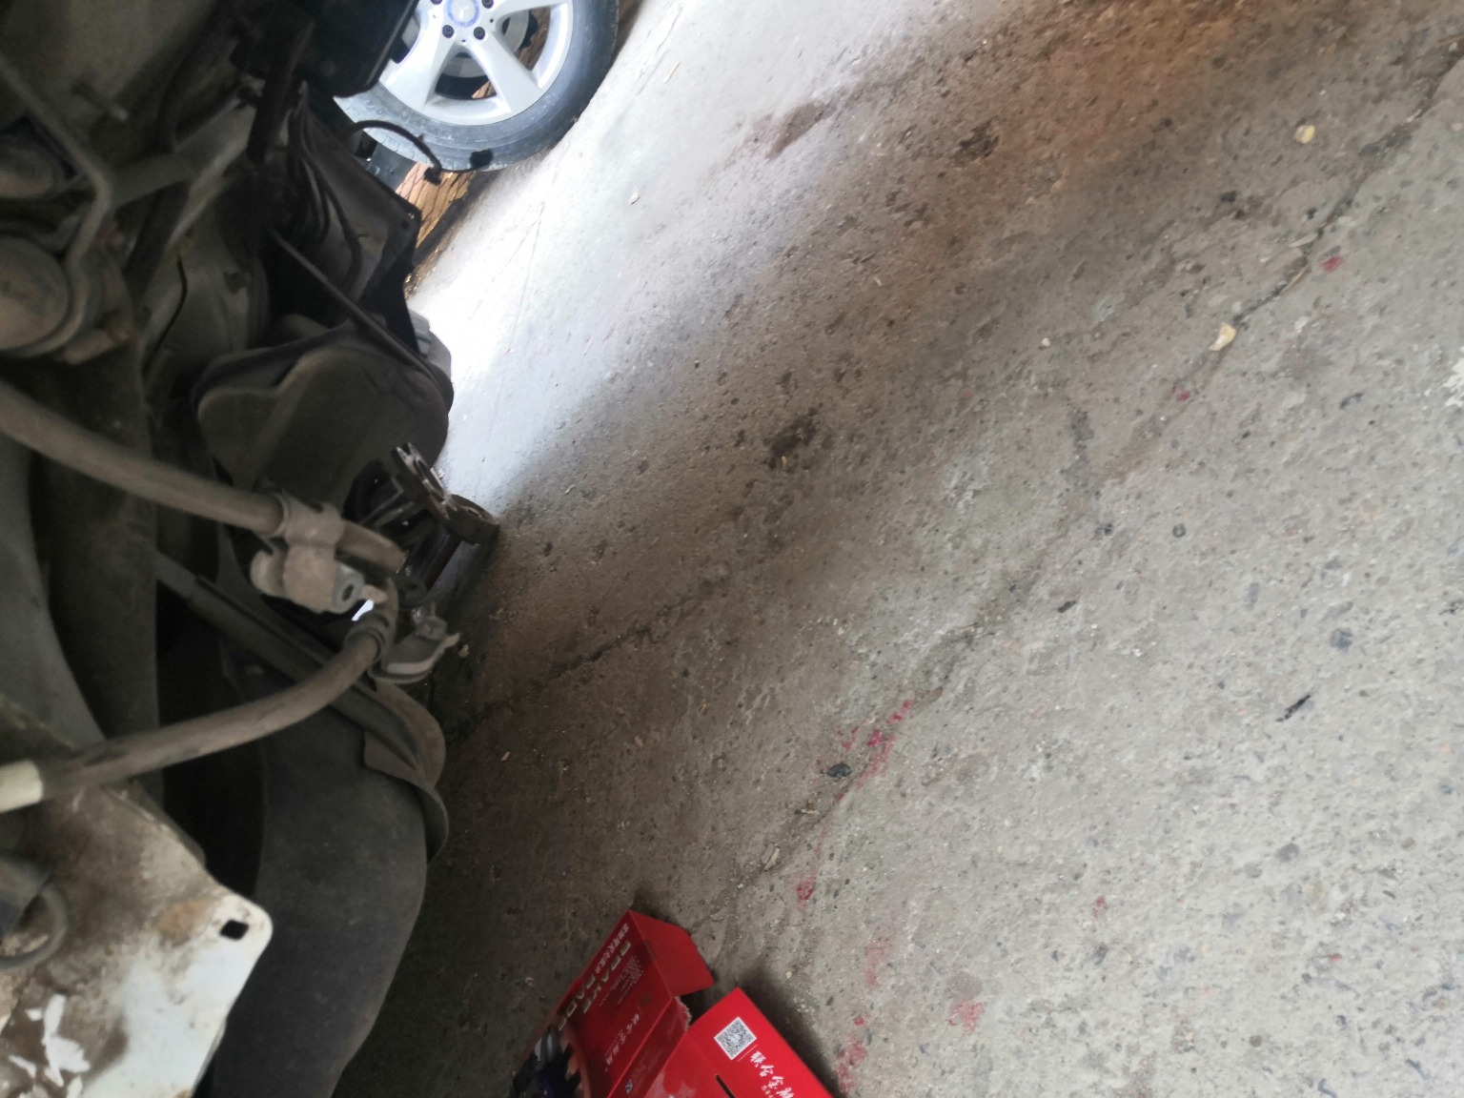
IMG_20201127_133708.jpg | IMG_20201127_133802.jpg | IMG_20201127_133810.jpg

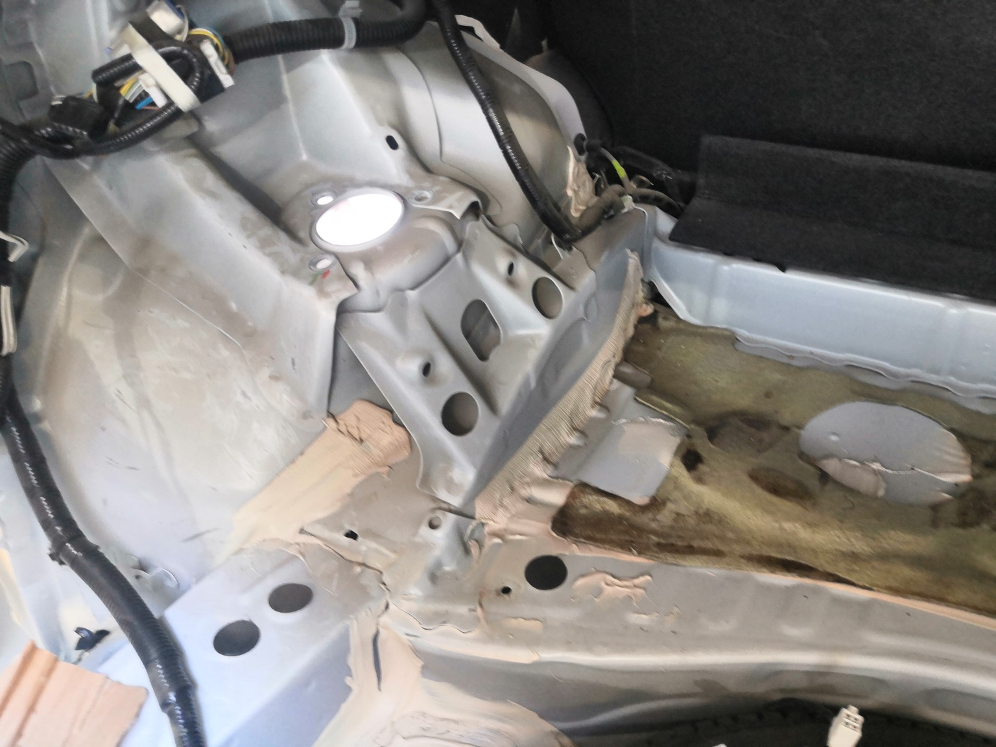 | 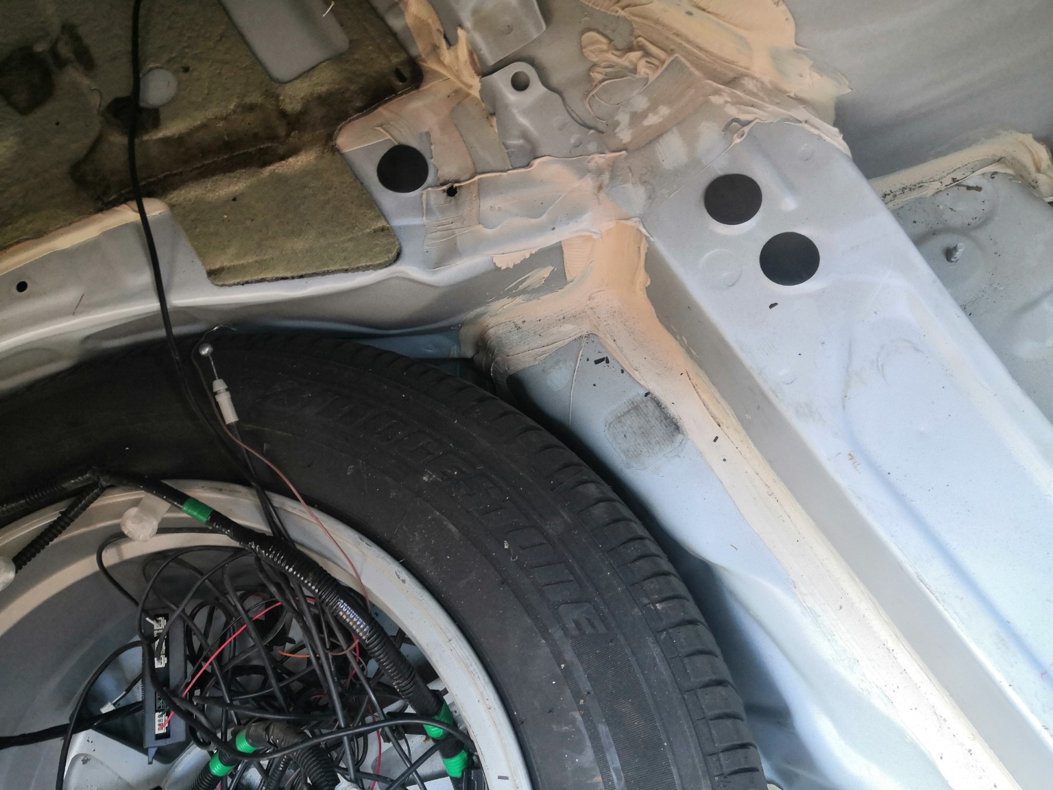 | 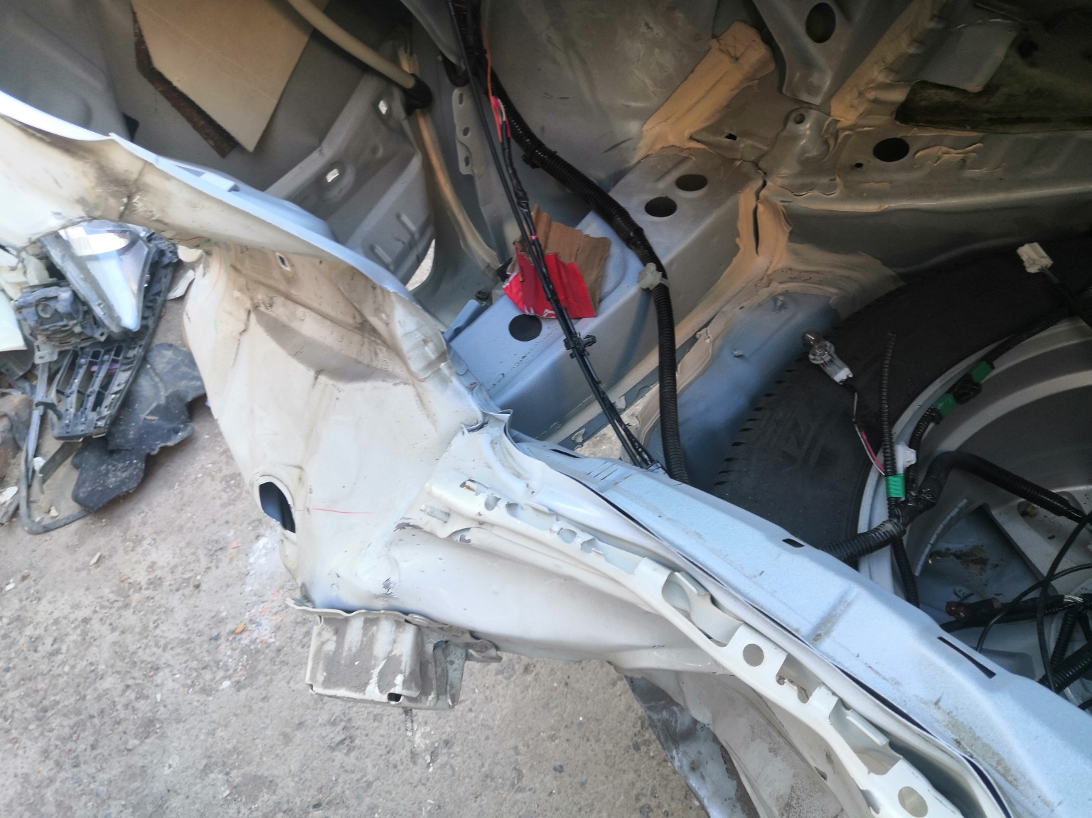
IMG_20201127_133711.jpg | IMG_20201127_133723.jpg | IMG_20201127_133702.jpg
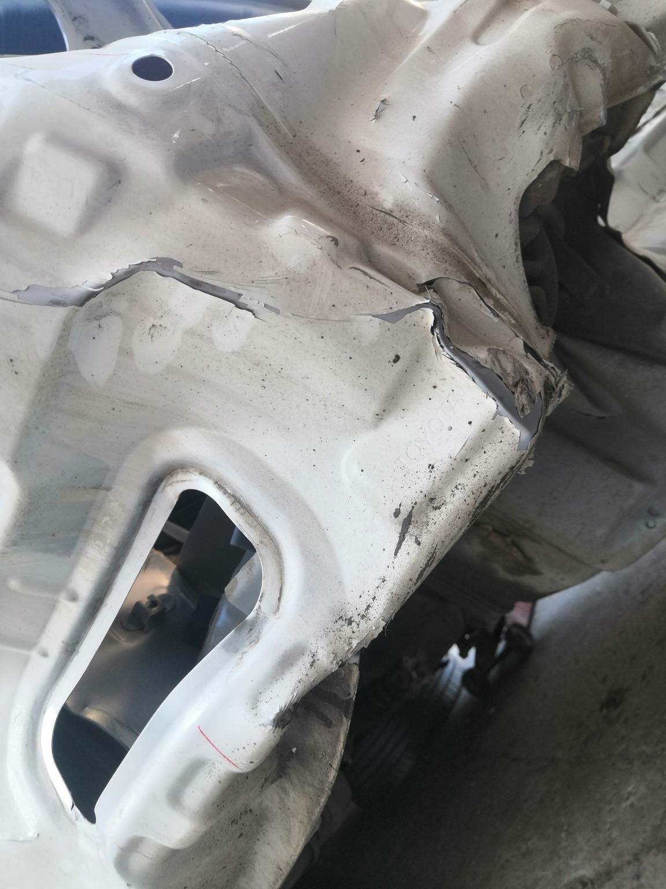 | 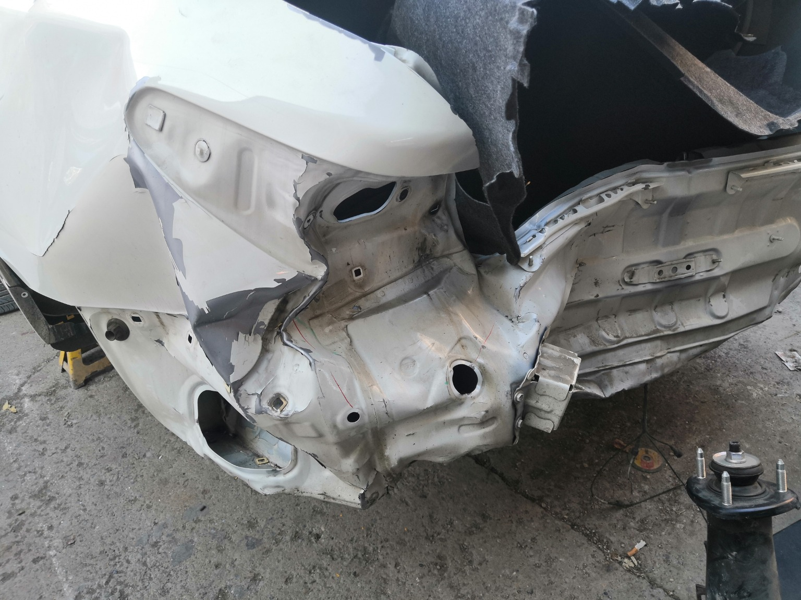 | 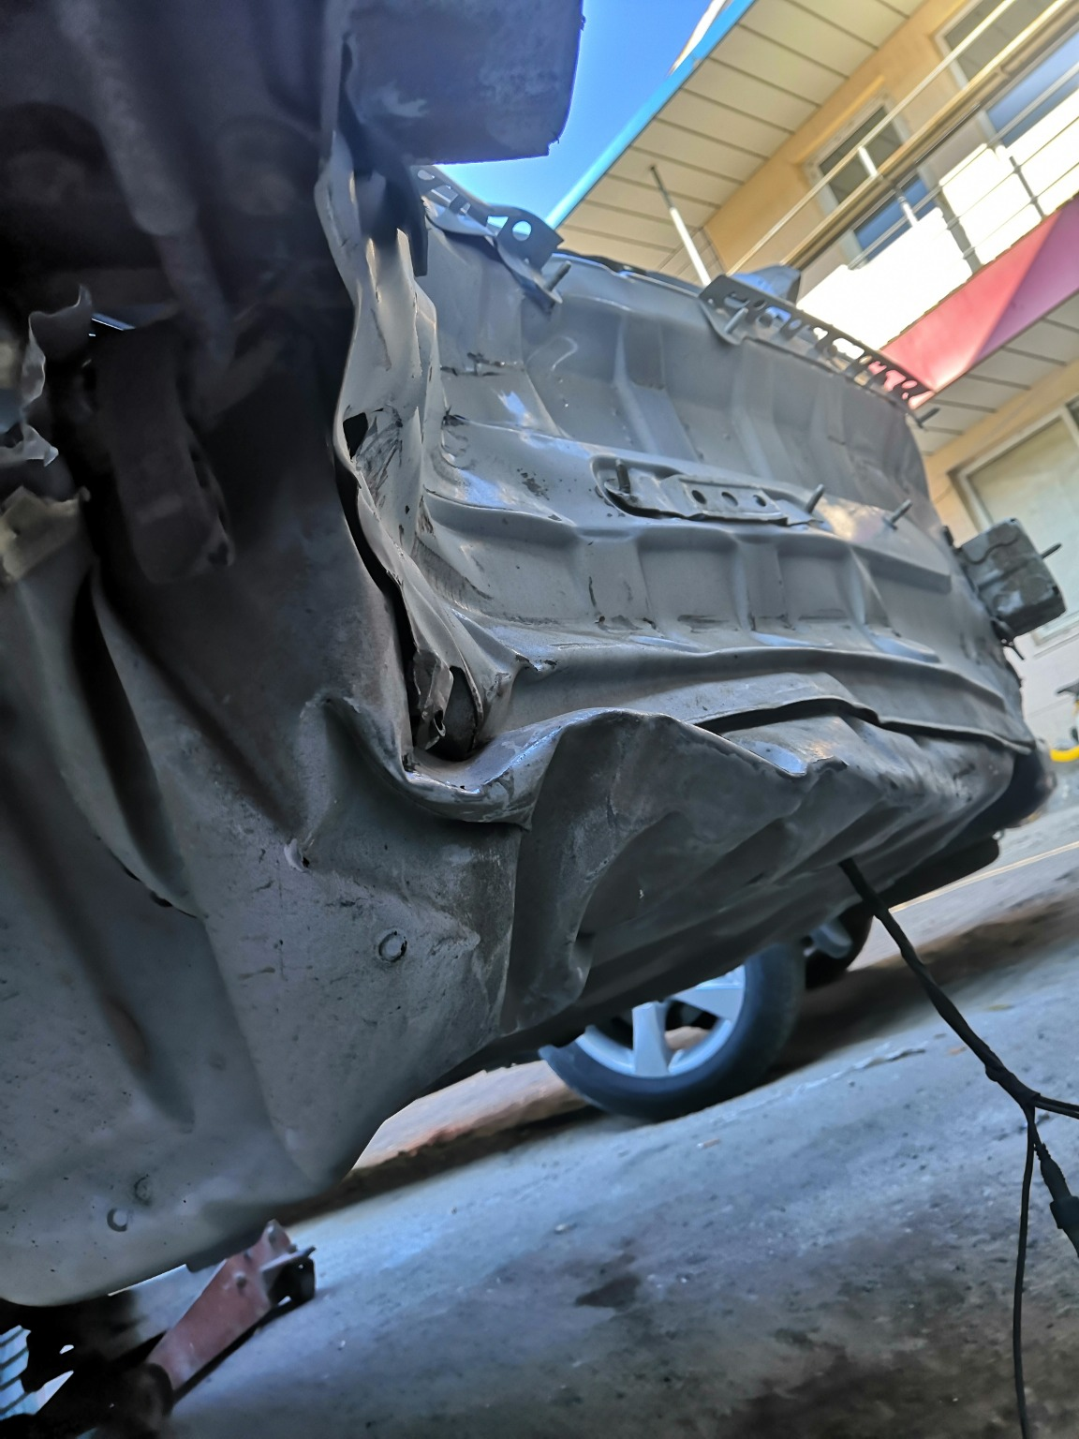
IMG_20201127_133747.jpg | IMG_20201127_133341.jpg | IMG_20201127_133743.jpg
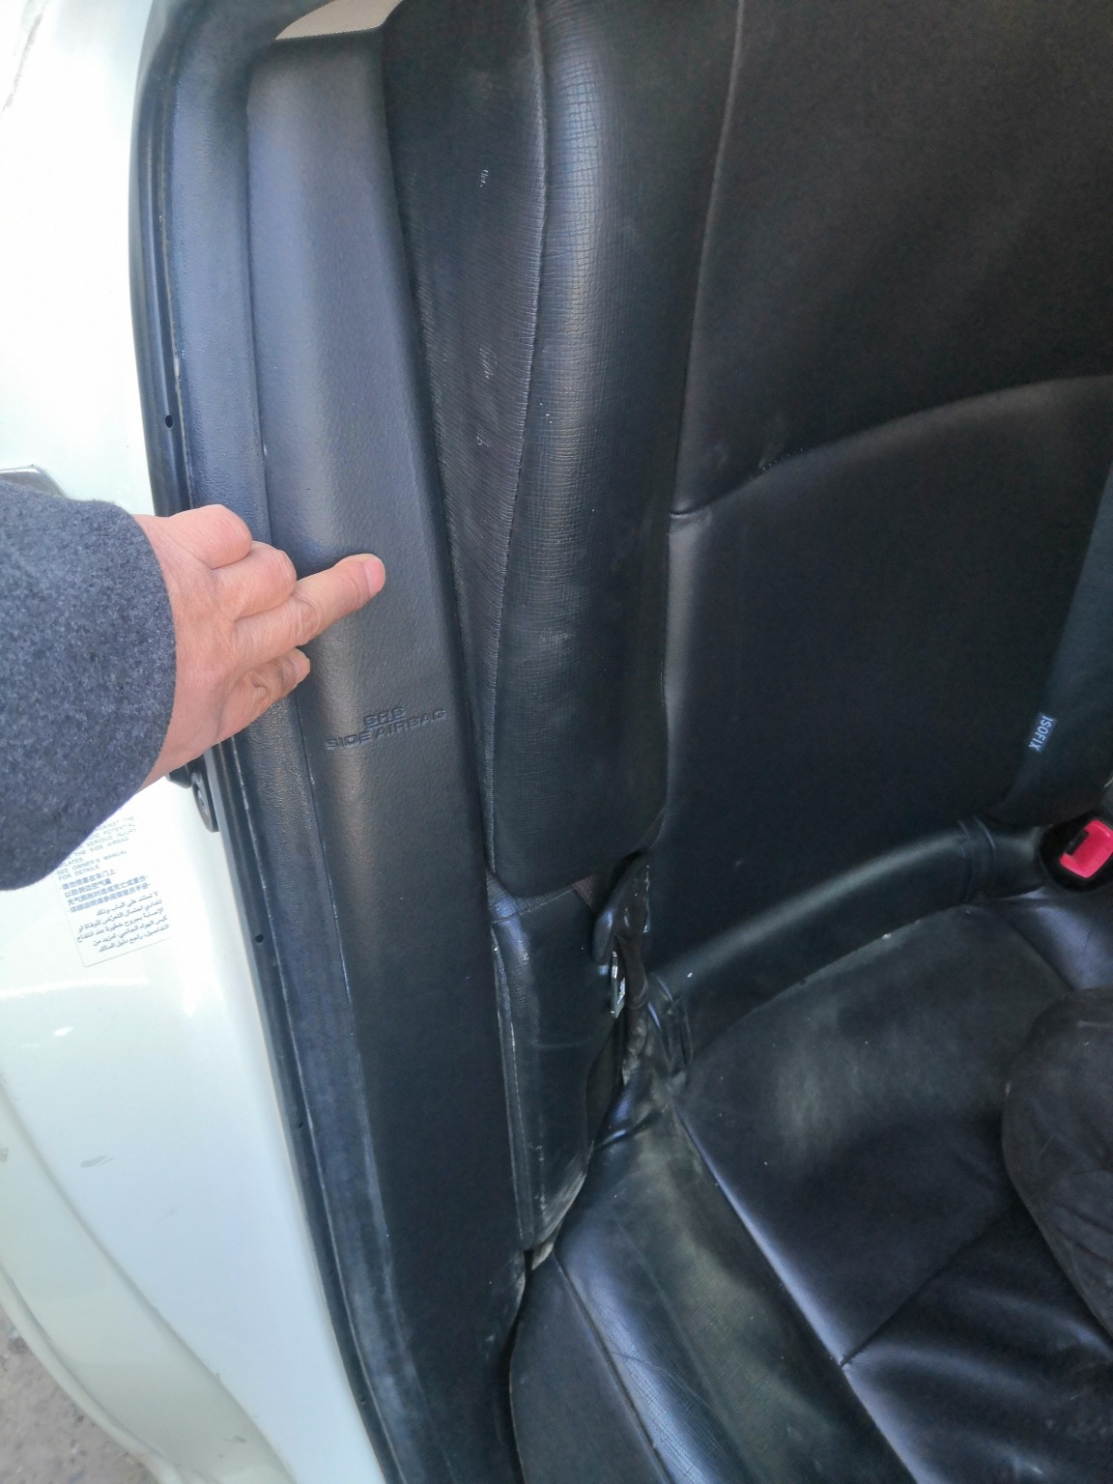 | 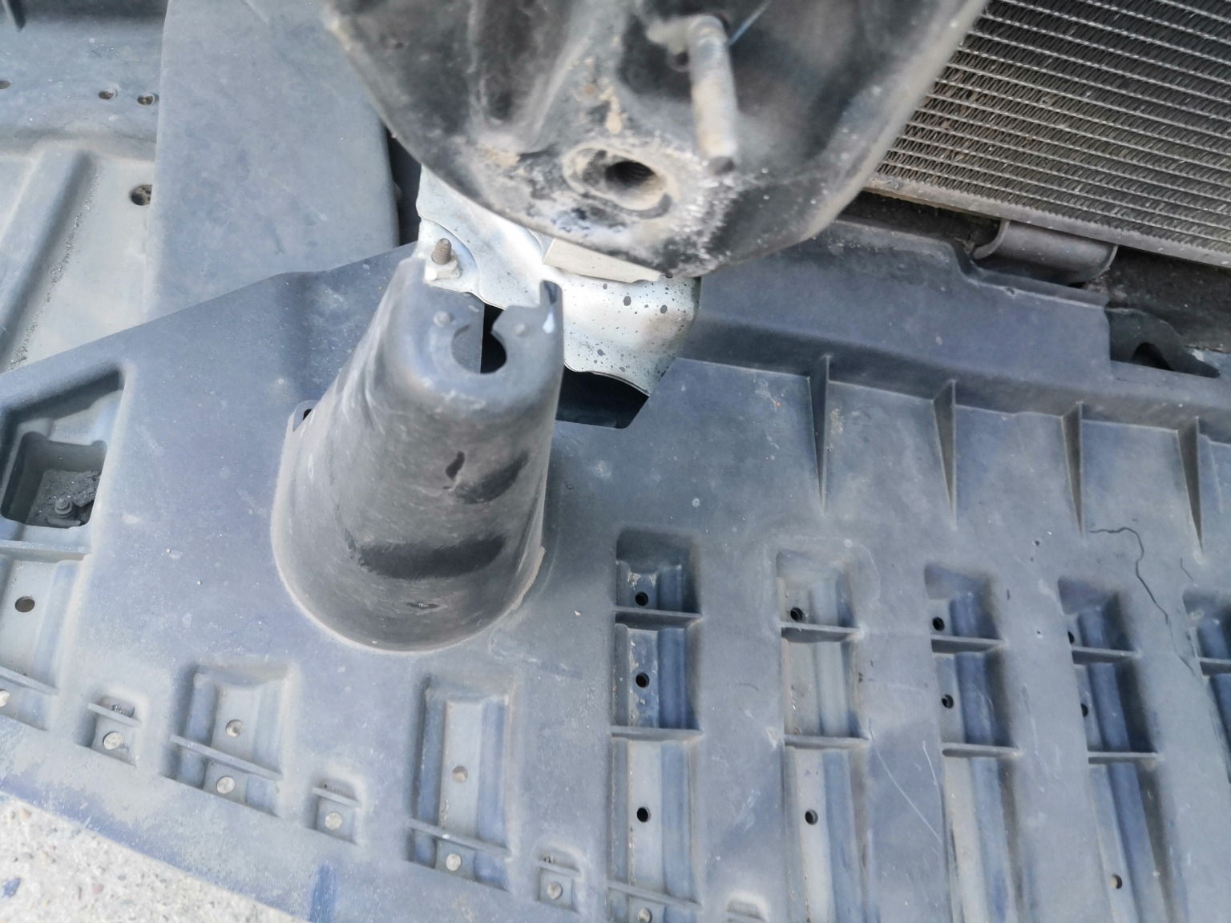 | 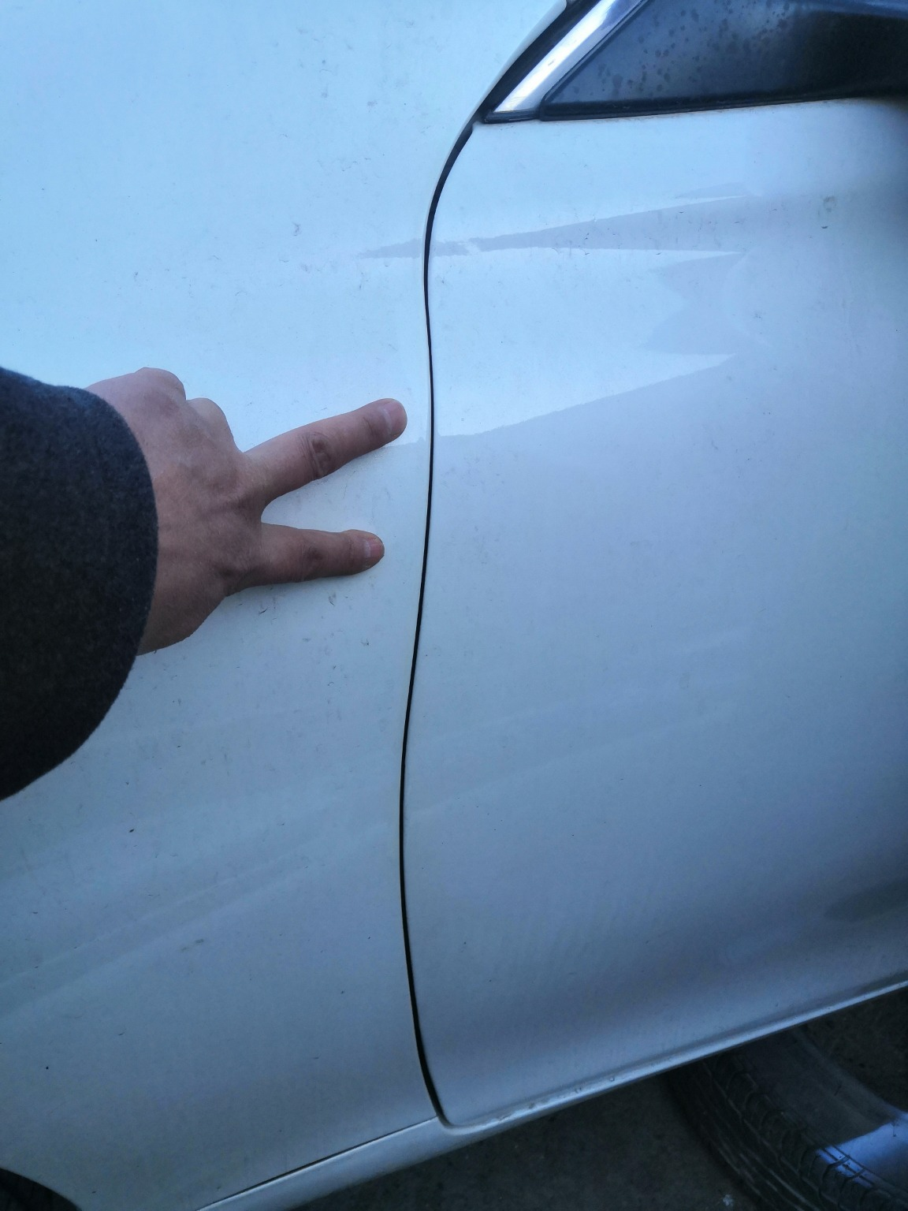
IMG_20201127_135156.jpg | IMG_20201127_133914.jpg | IMG_20201127_133444.jpg

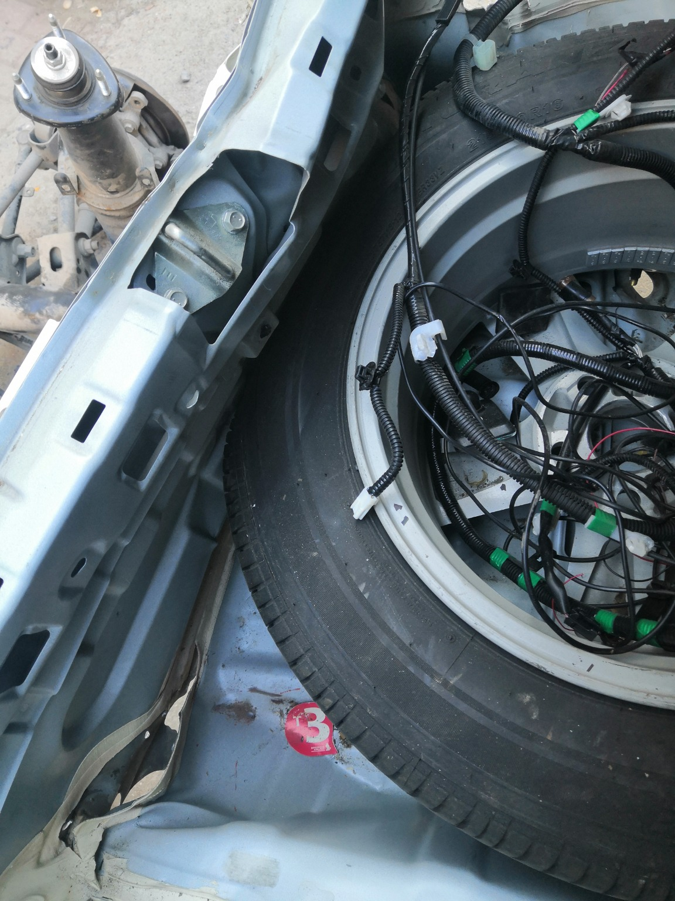 | 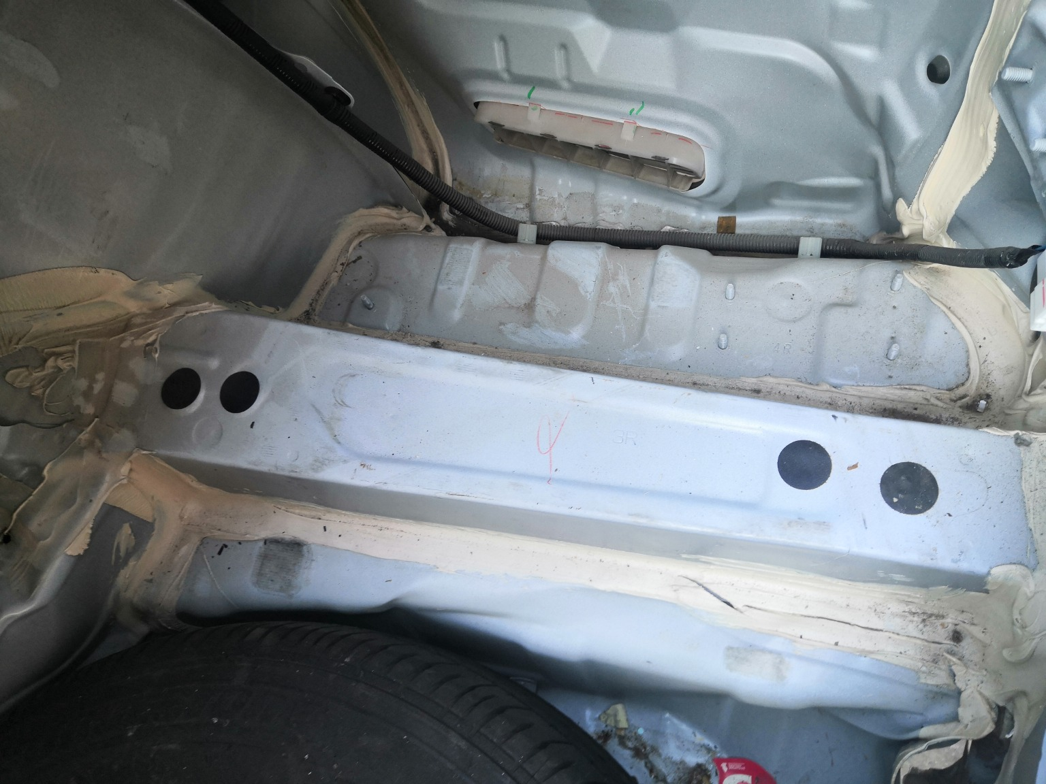 | 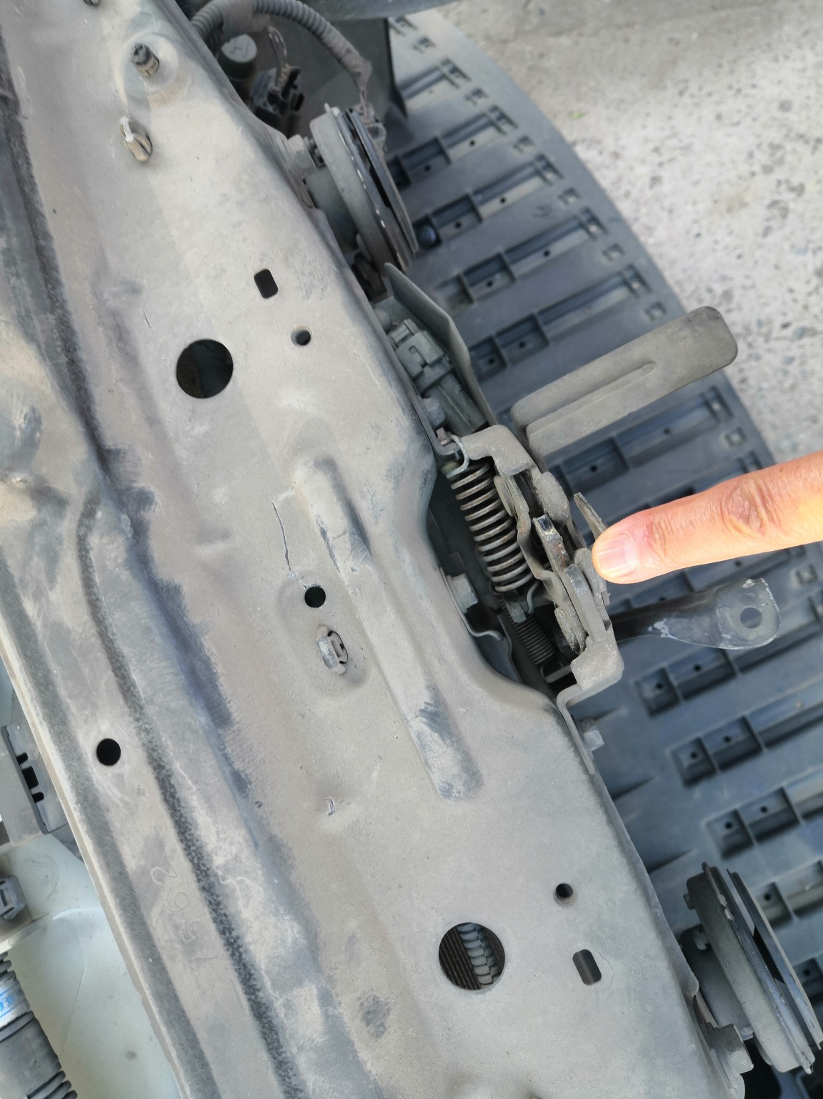
IMG_20201127_133730.jpg | IMG_20201127_135414.jpg | IMG_20201127_133841.jpg
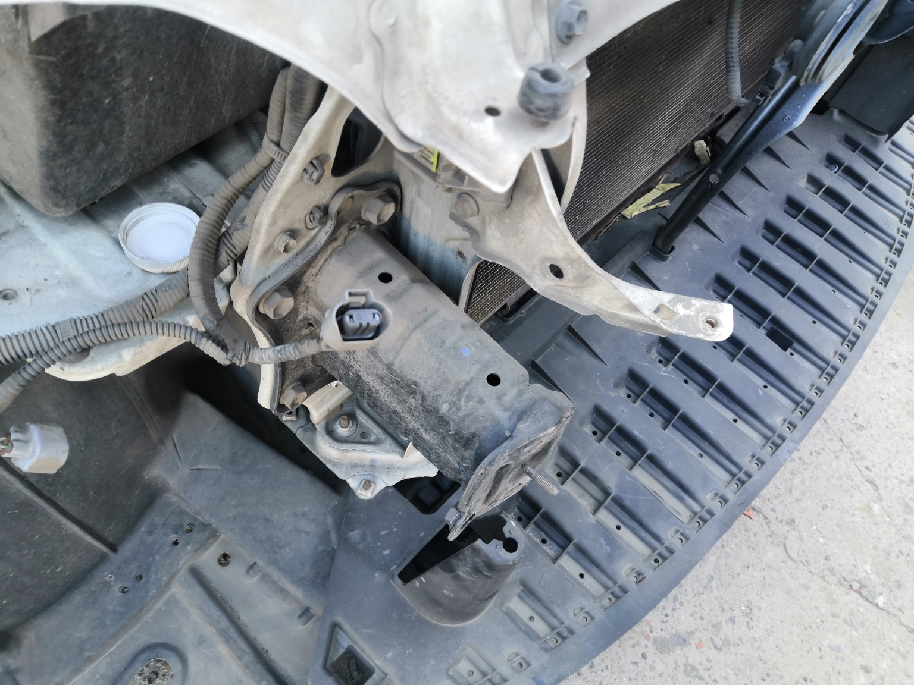 | 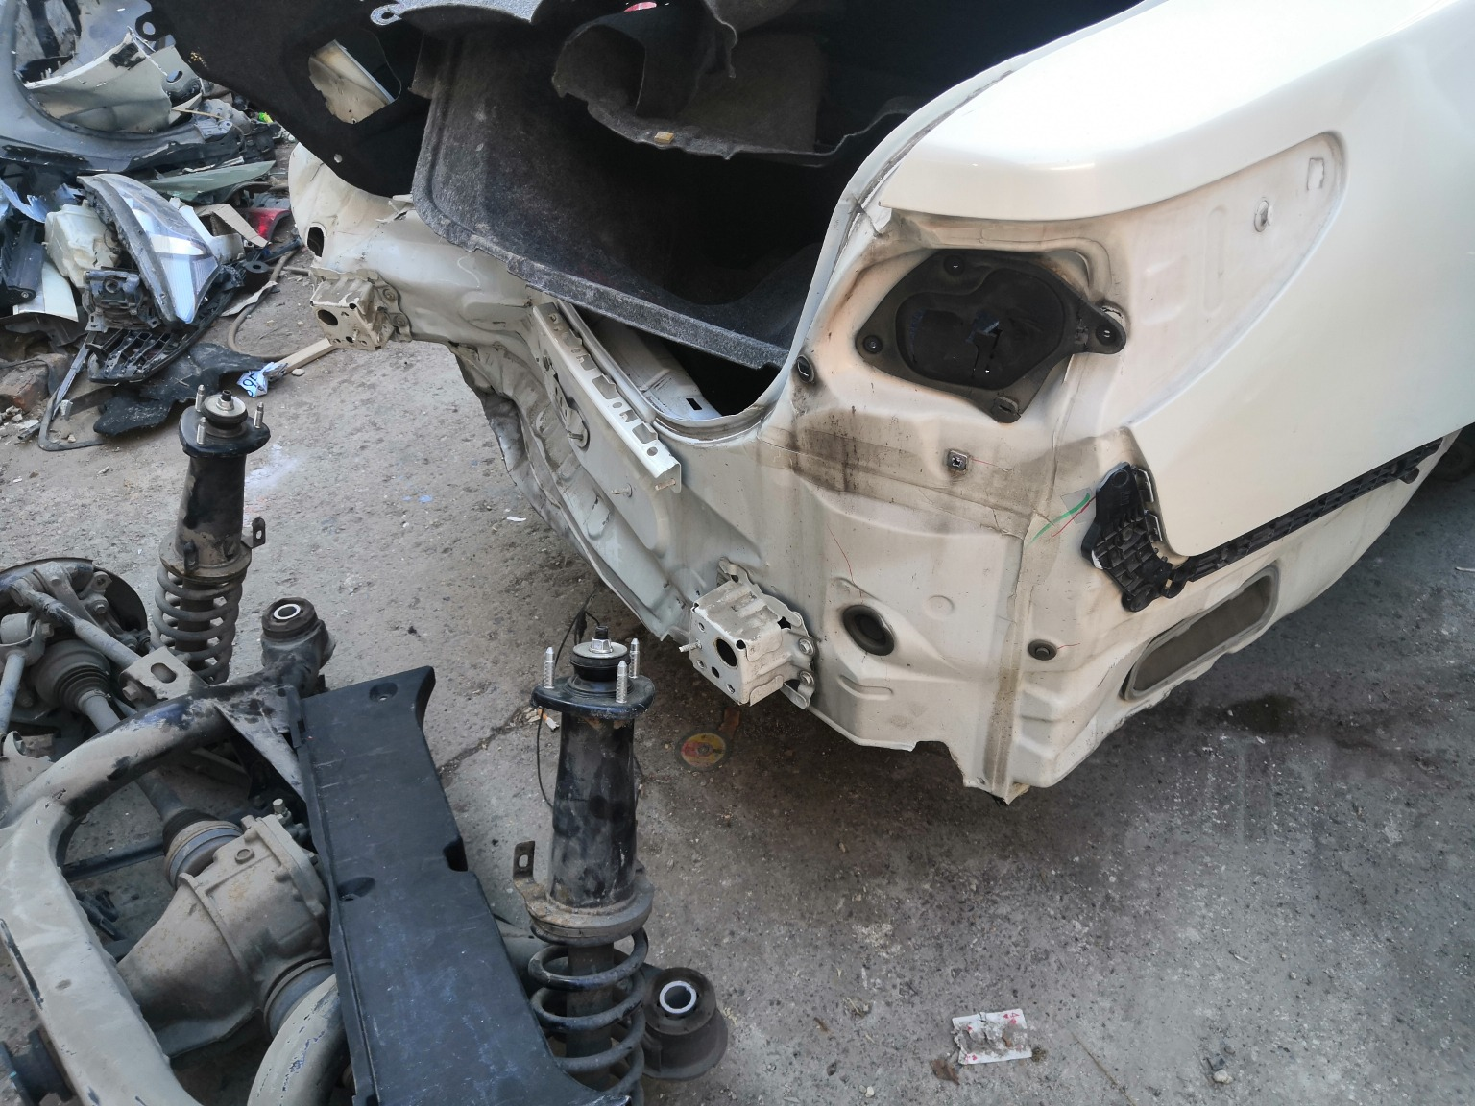 | 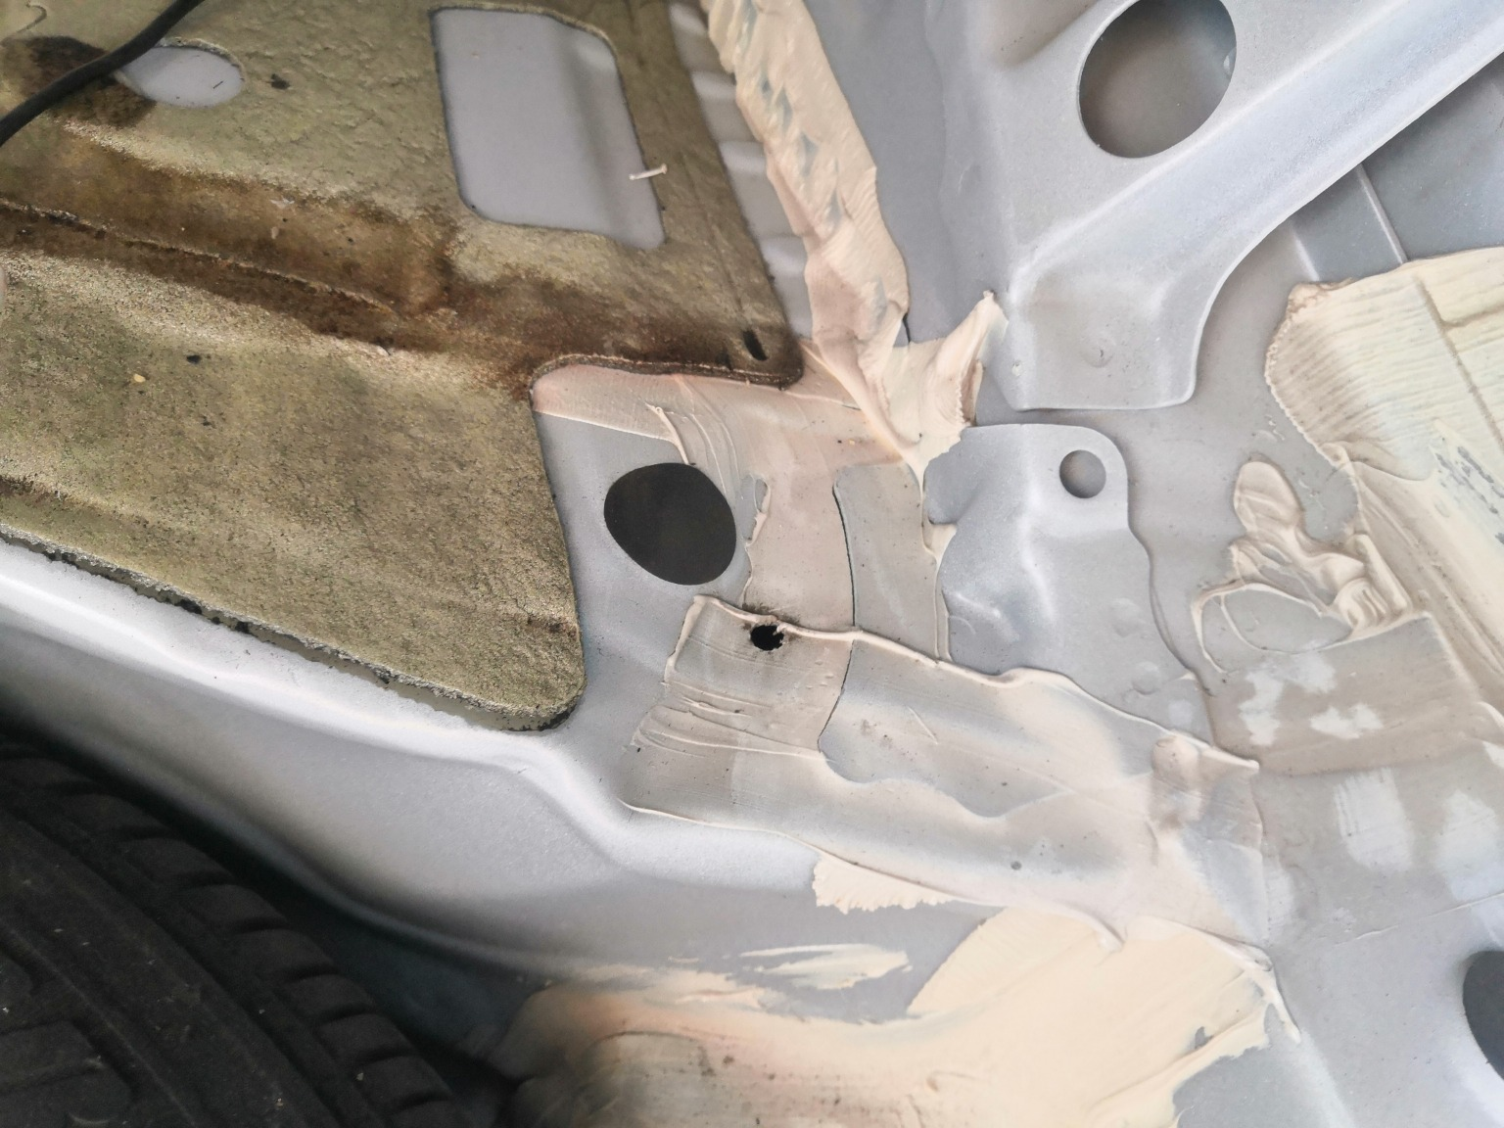
IMG_20201127_133851.jpg | IMG_20201127_133539.jpg | IMG_20201127_133717.jpg
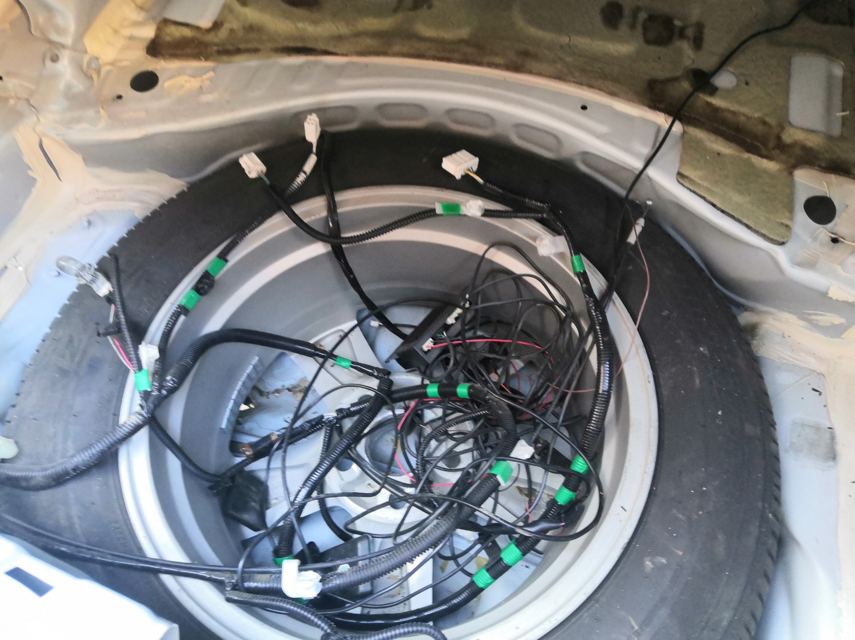 | 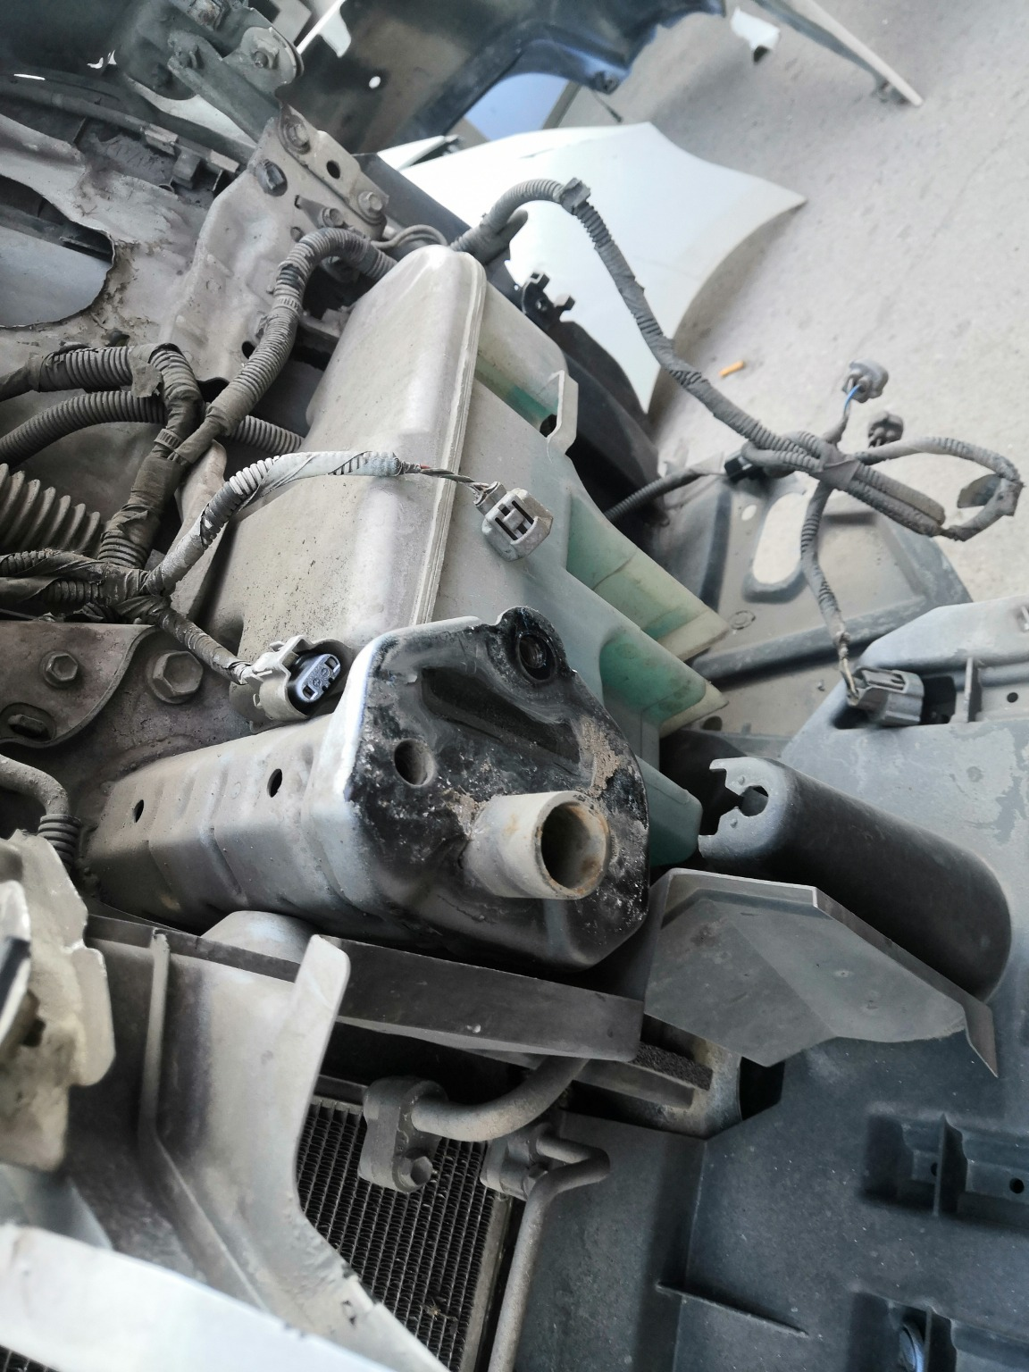 | 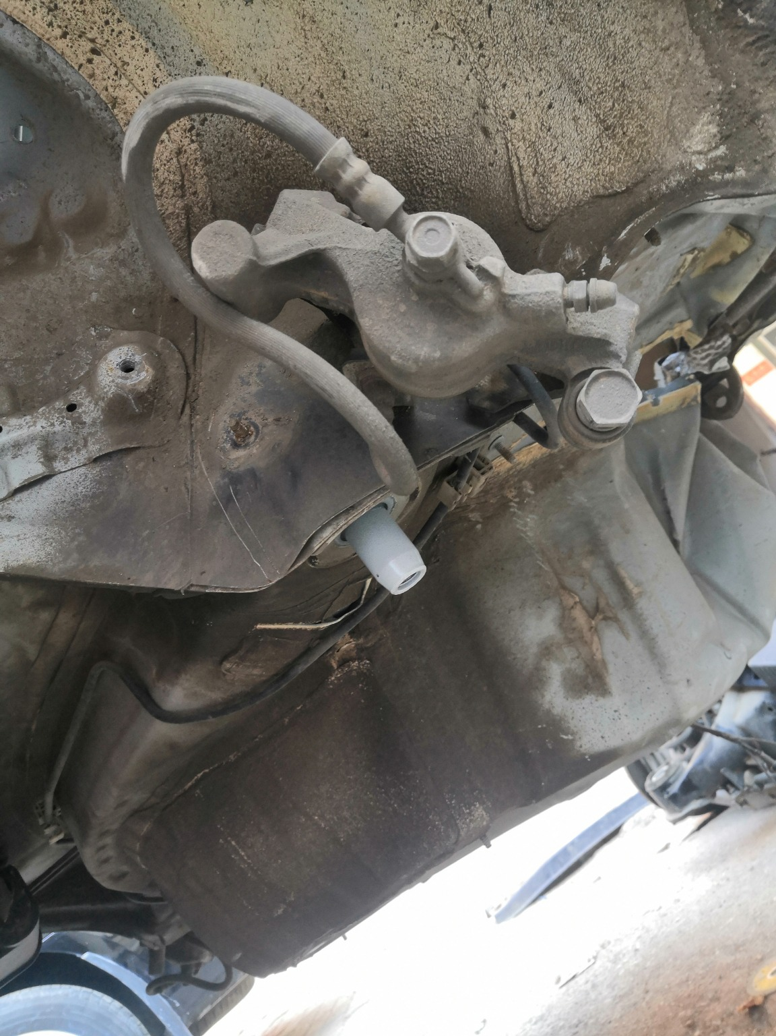
IMG_20201127_133734.jpg | IMG_20201127_133909.jpg | IMG_20201127_133757.jpg

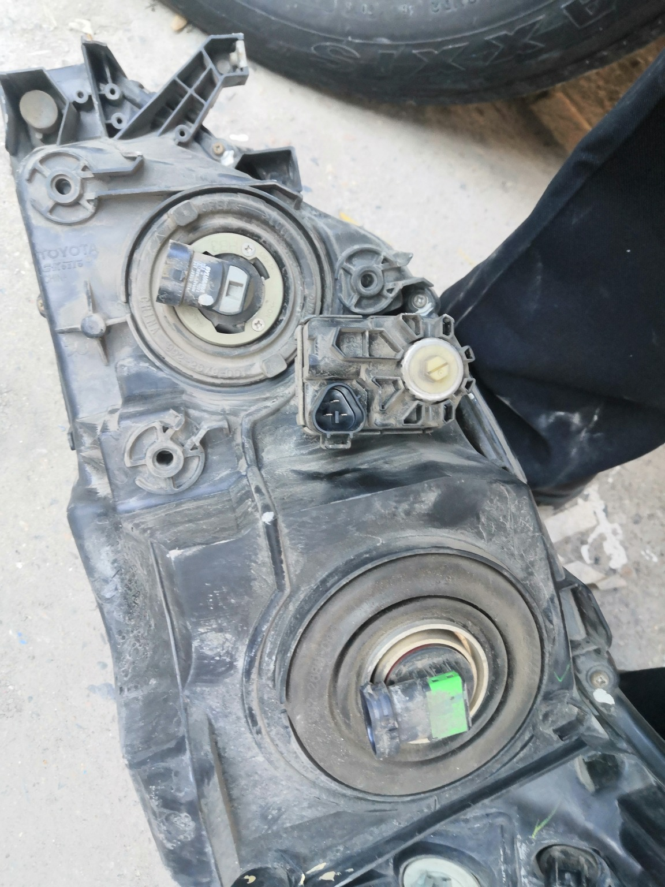 | 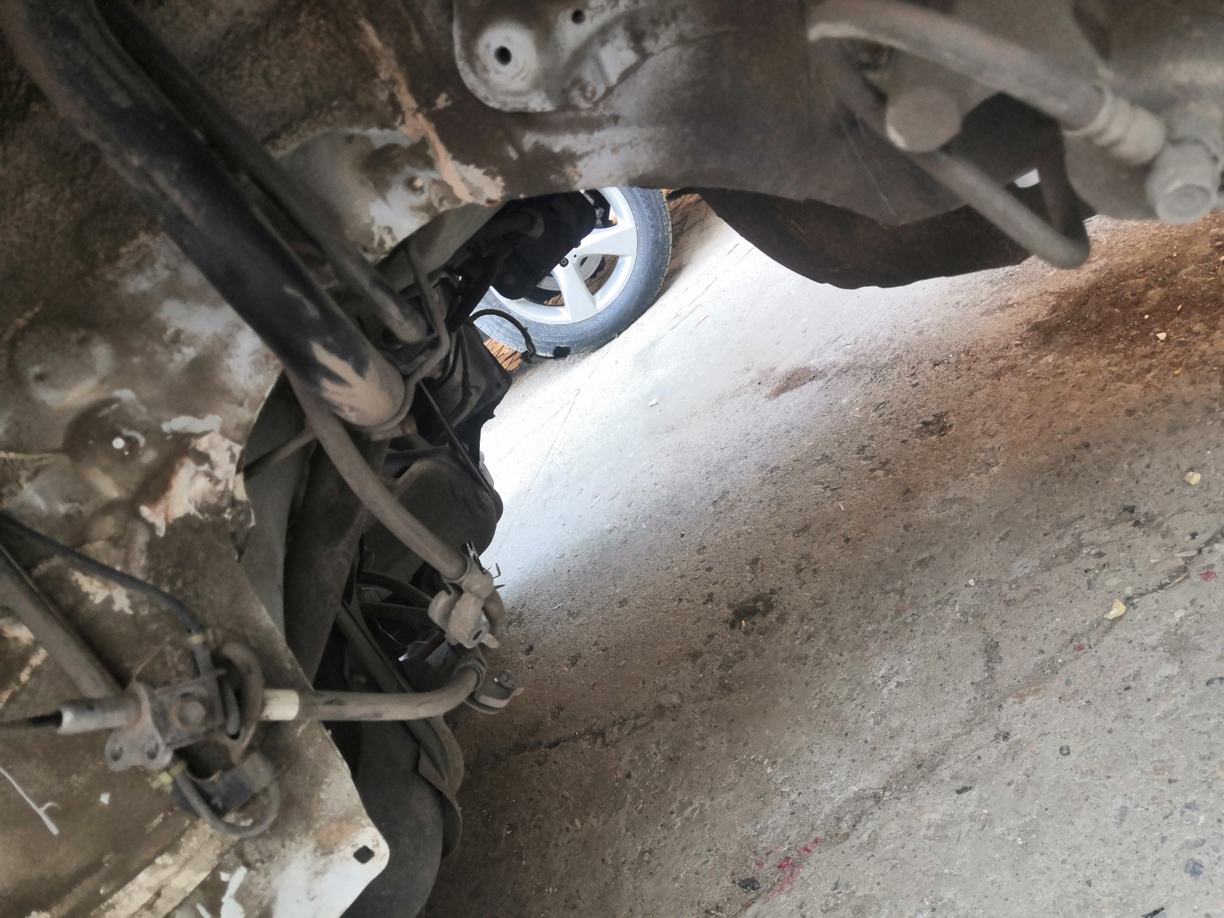 | 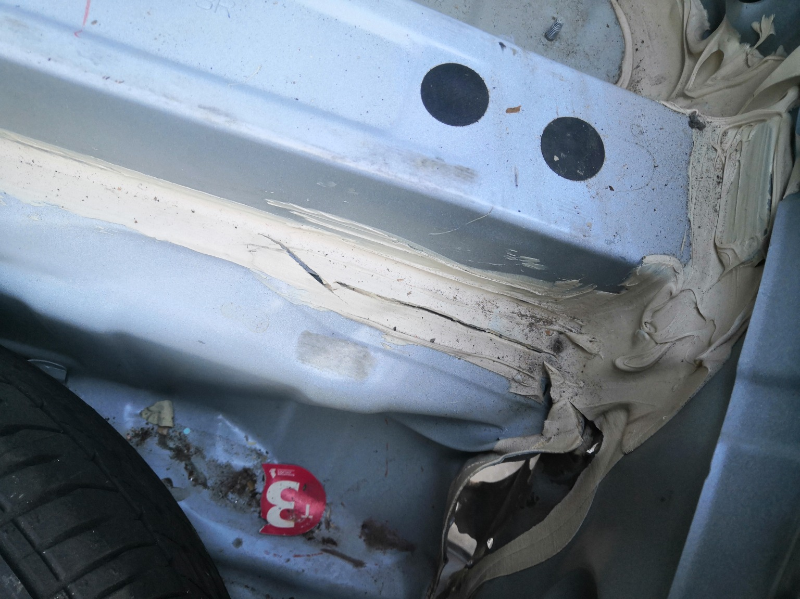
IMG_20201127_135139.jpg | IMG_20201127_133813.jpg | IMG_20201127_135420.jpg
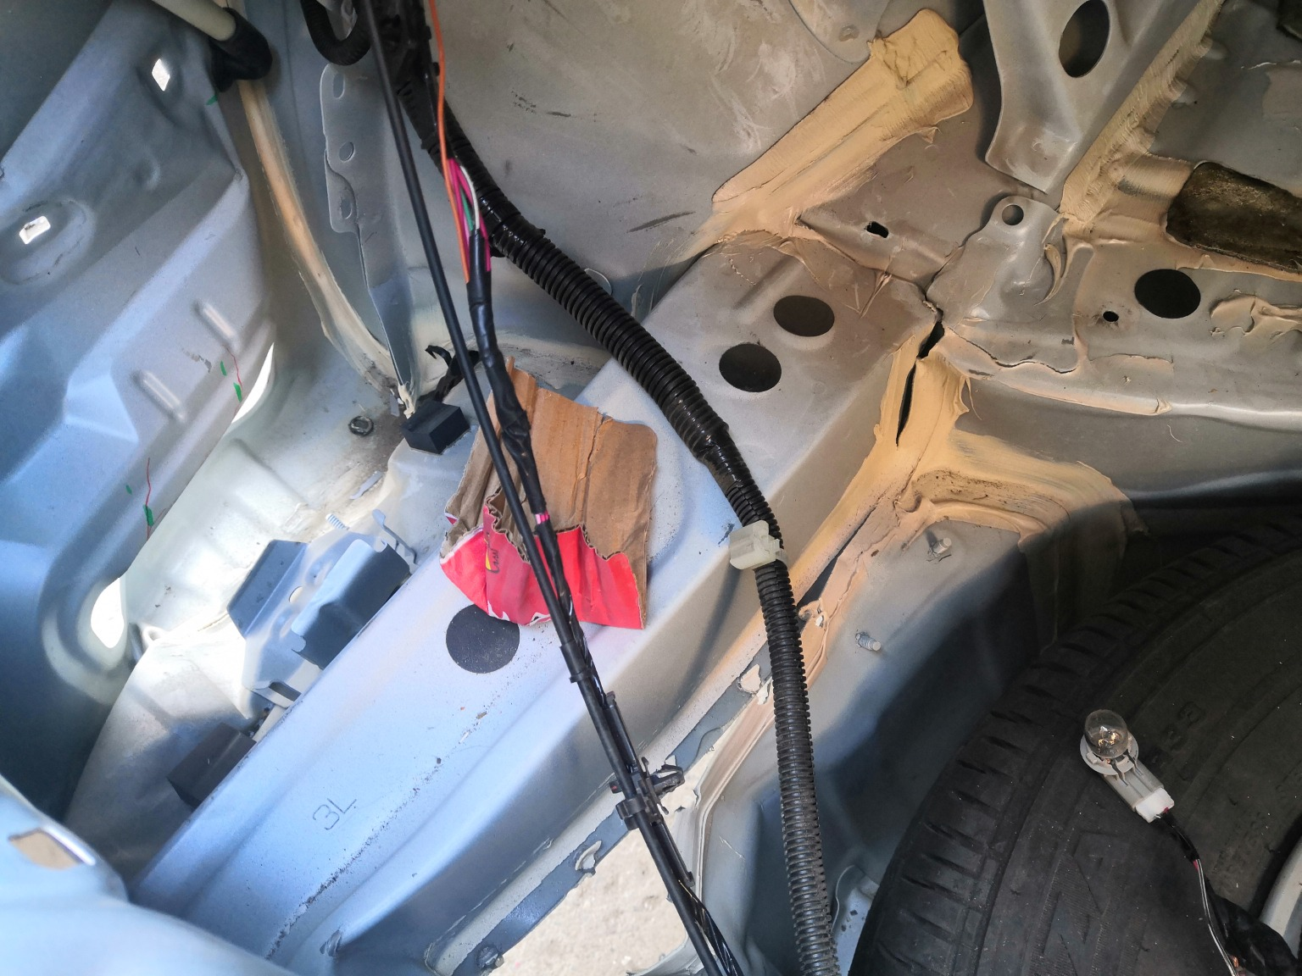 | 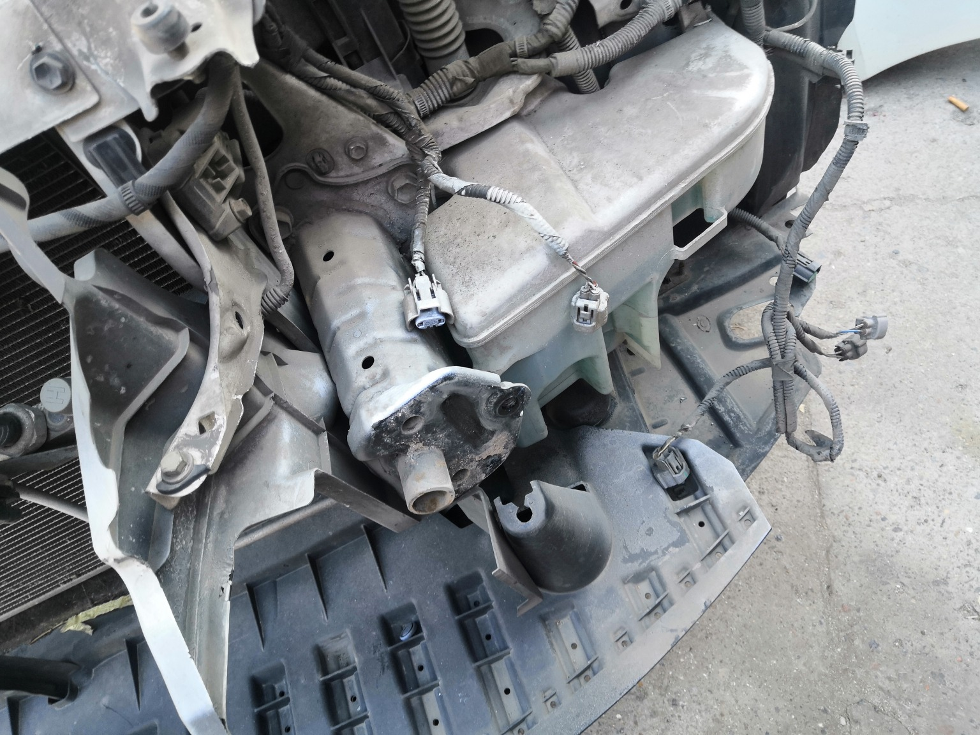 | 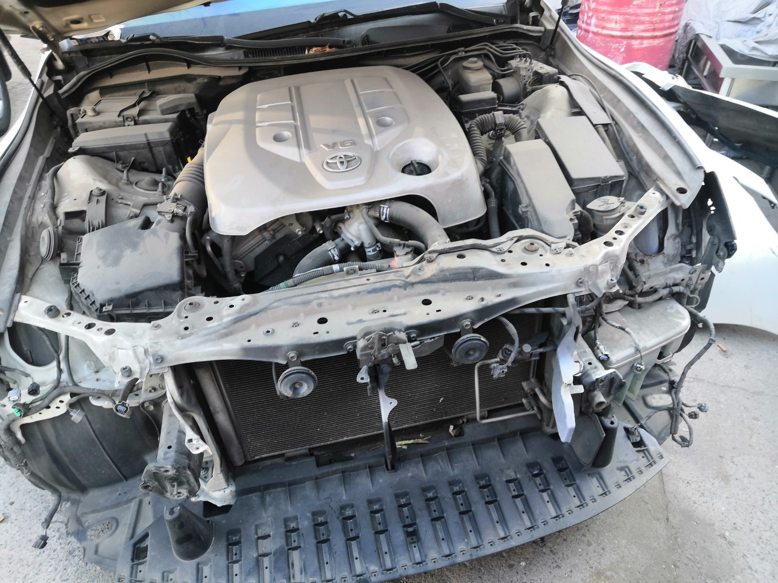
IMG_20201127_135409.jpg | IMG_20201127_133904.jpg | IMG_20201127_133828.jpg
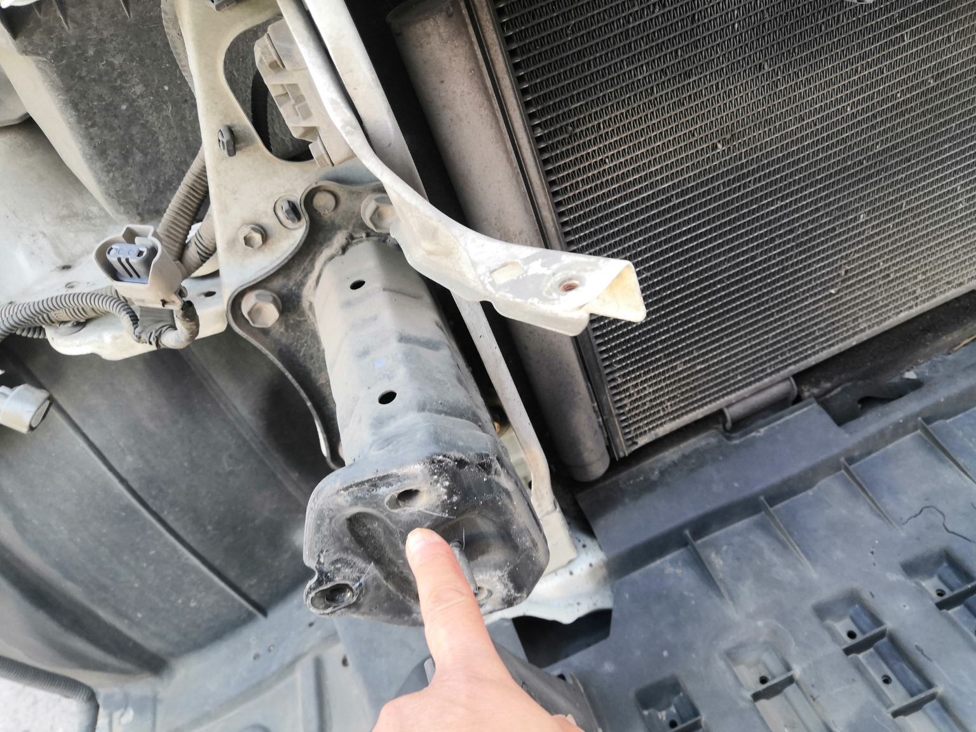 | 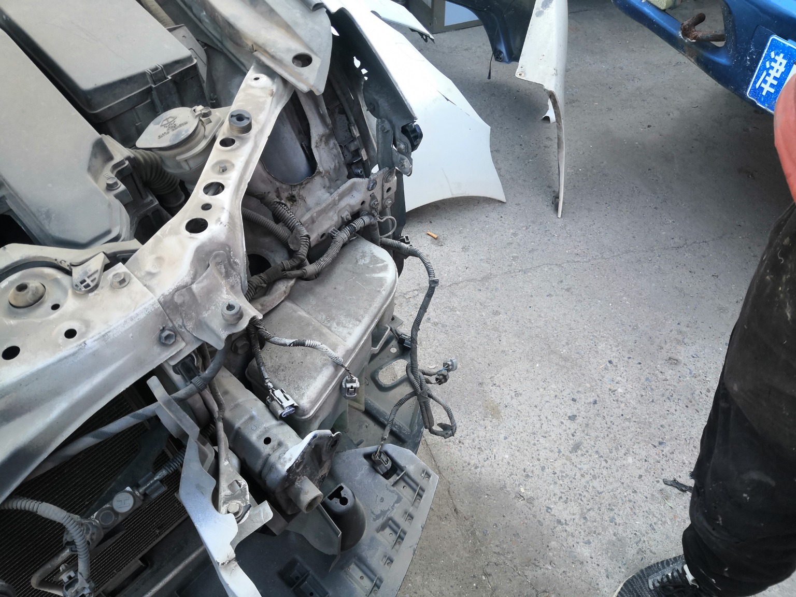 | 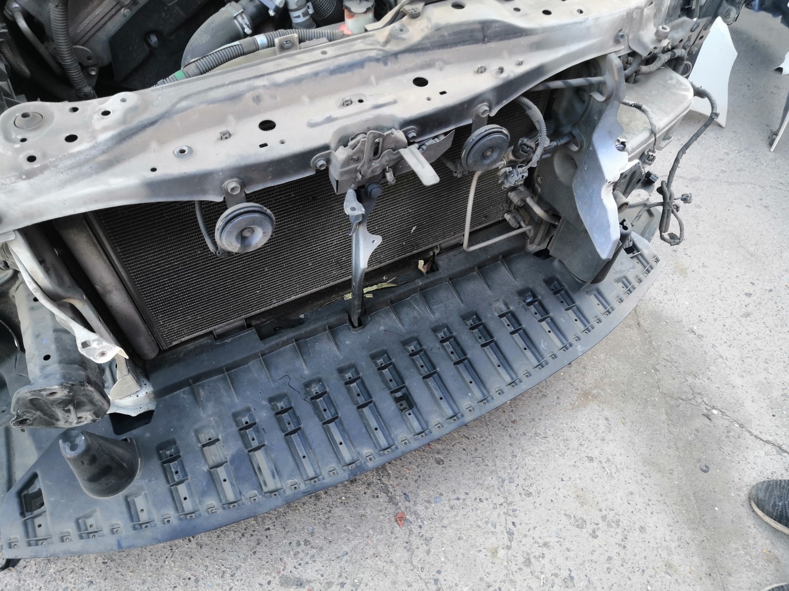
IMG_20201127_133900.jpg | IMG_20201127_133834.jpg | IMG_20201127_133831.jpg

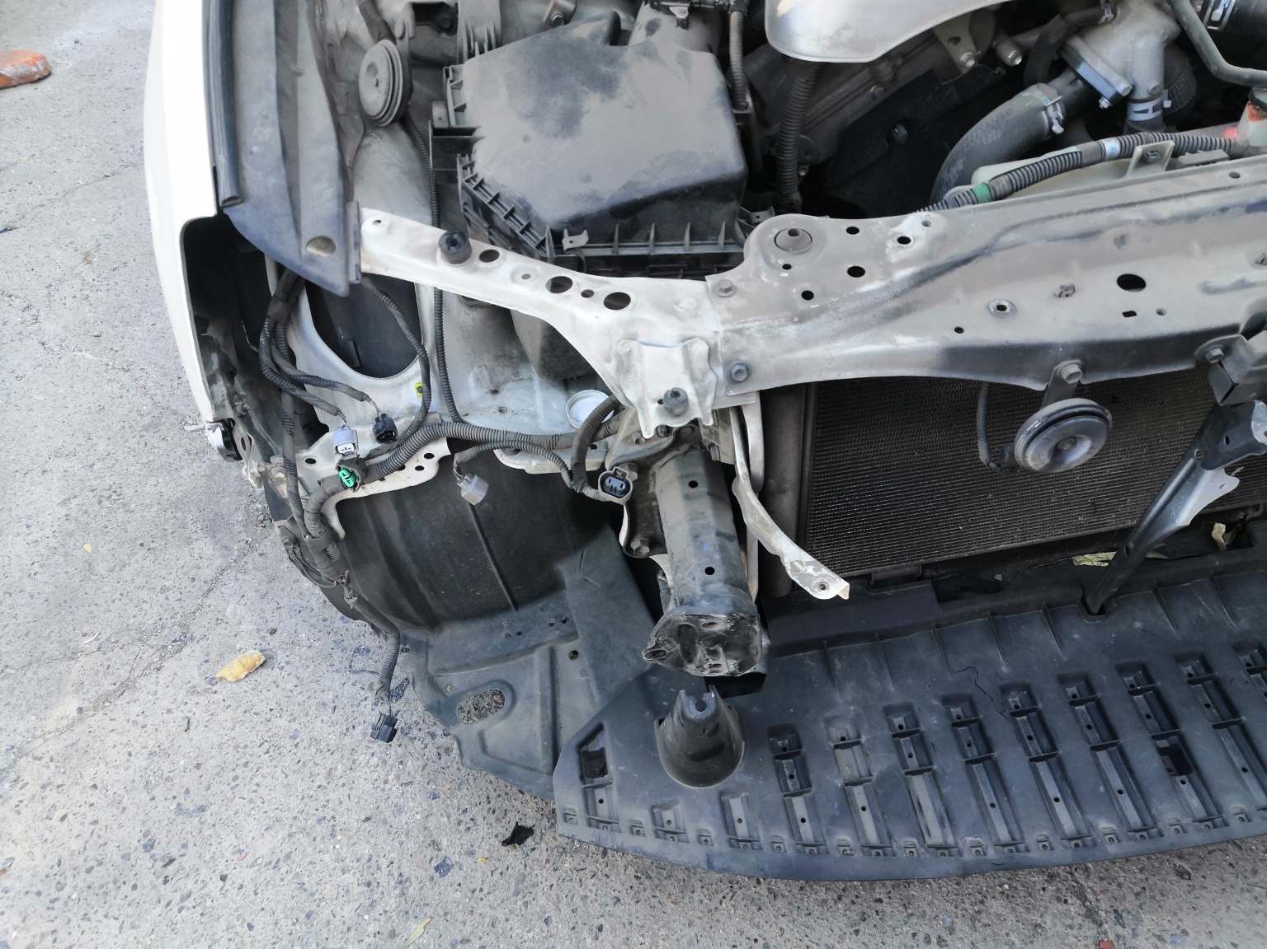 | 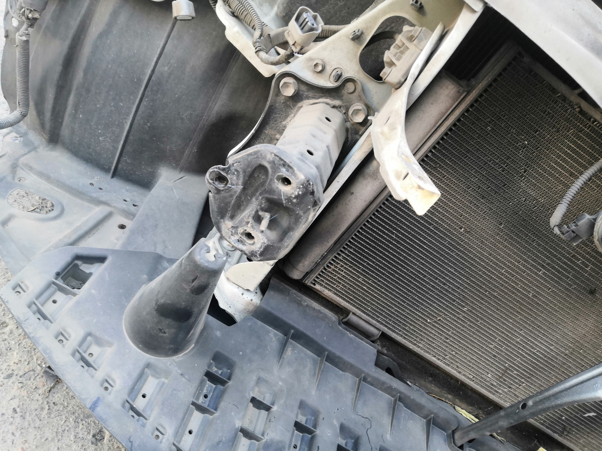
IMG_20201127_133830.jpg | IMG_20201127_133912.jpg

