内饰
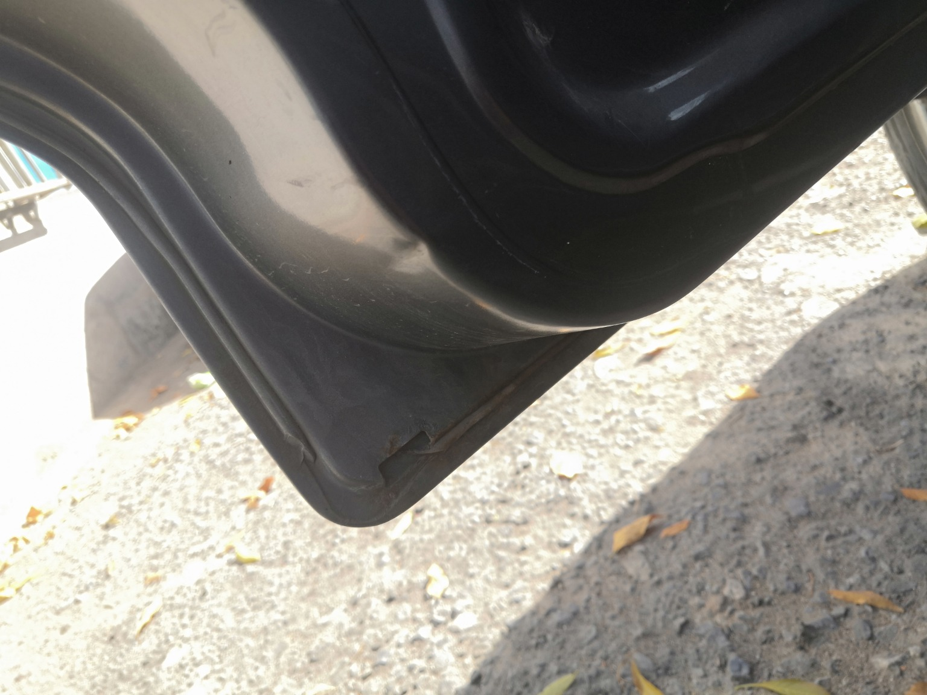 | 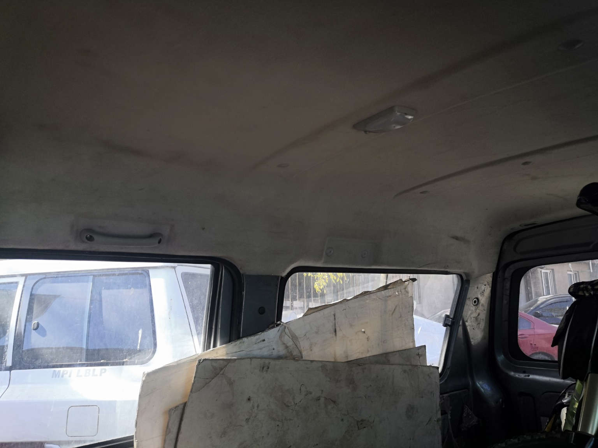 | 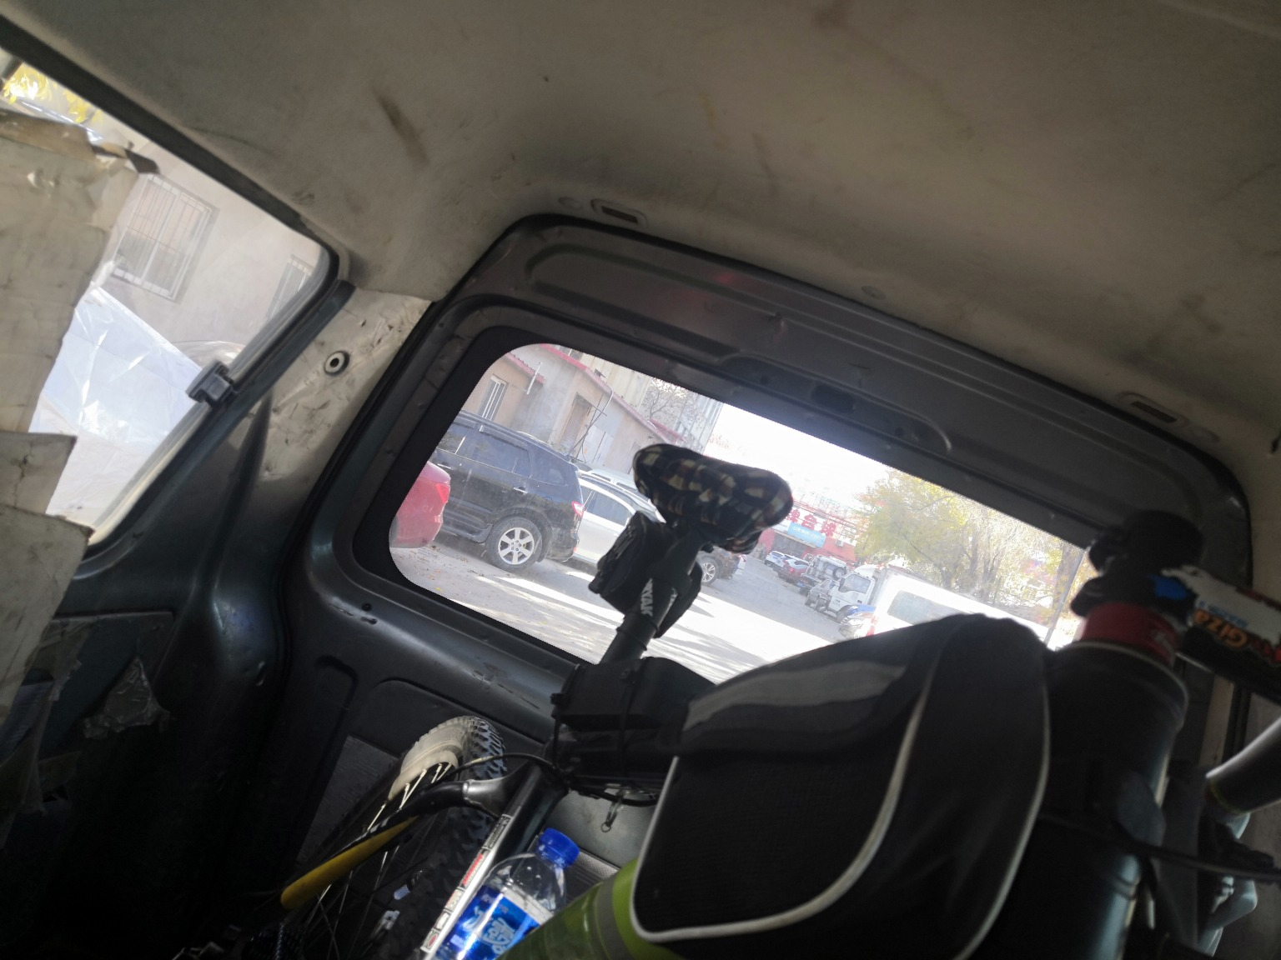
IMG_20201107_123152.jpg | IMG_20201107_123509.jpg | IMG_20201107_123529.jpg
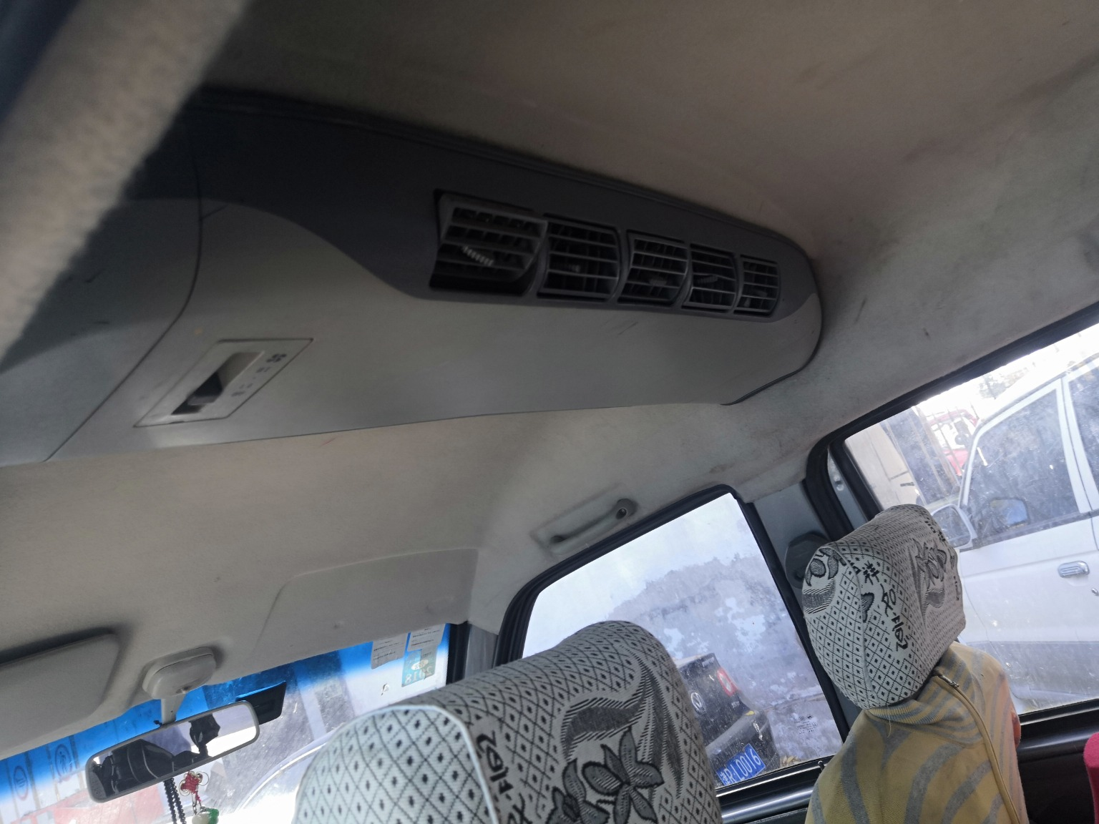 | 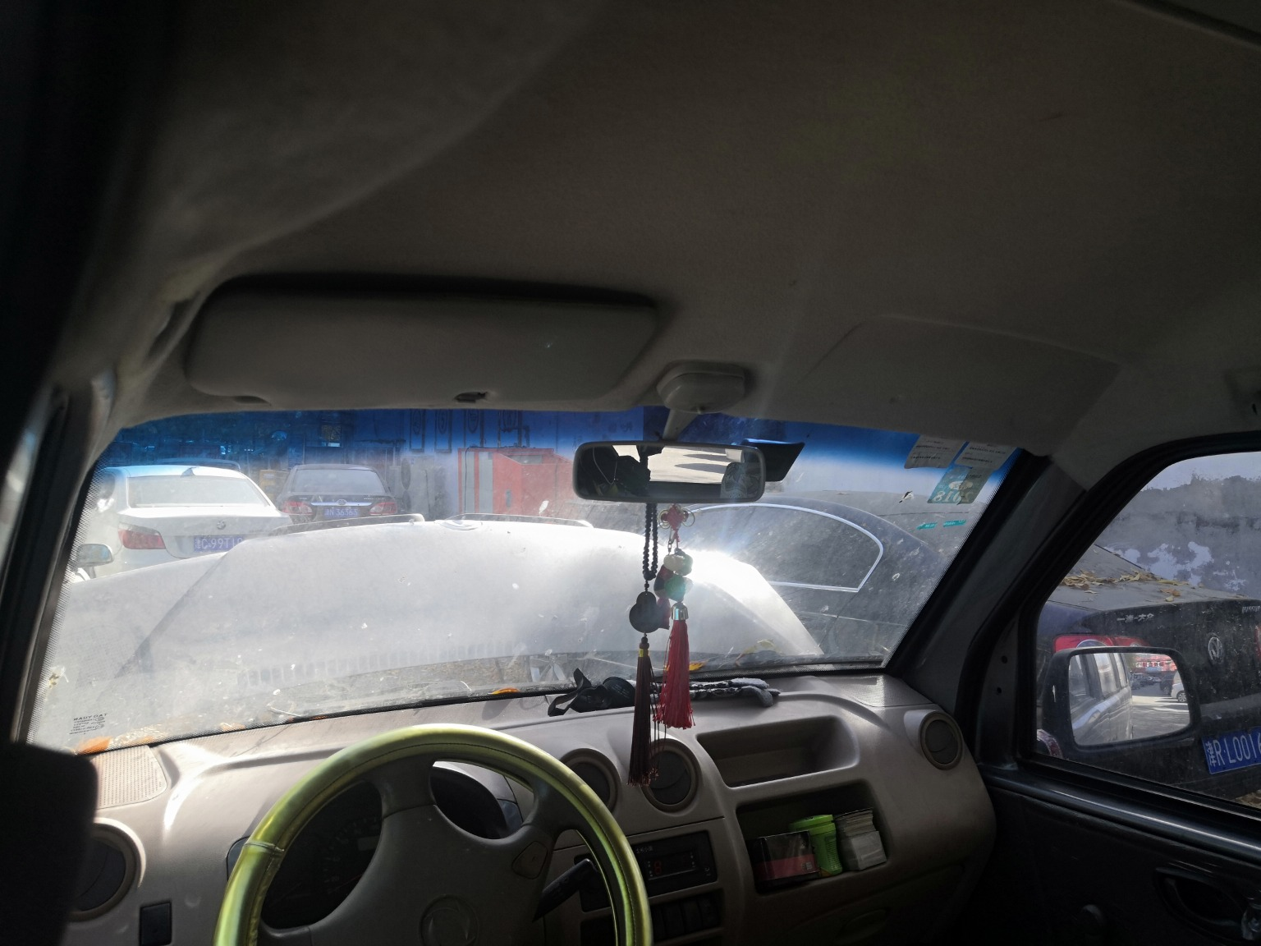 | 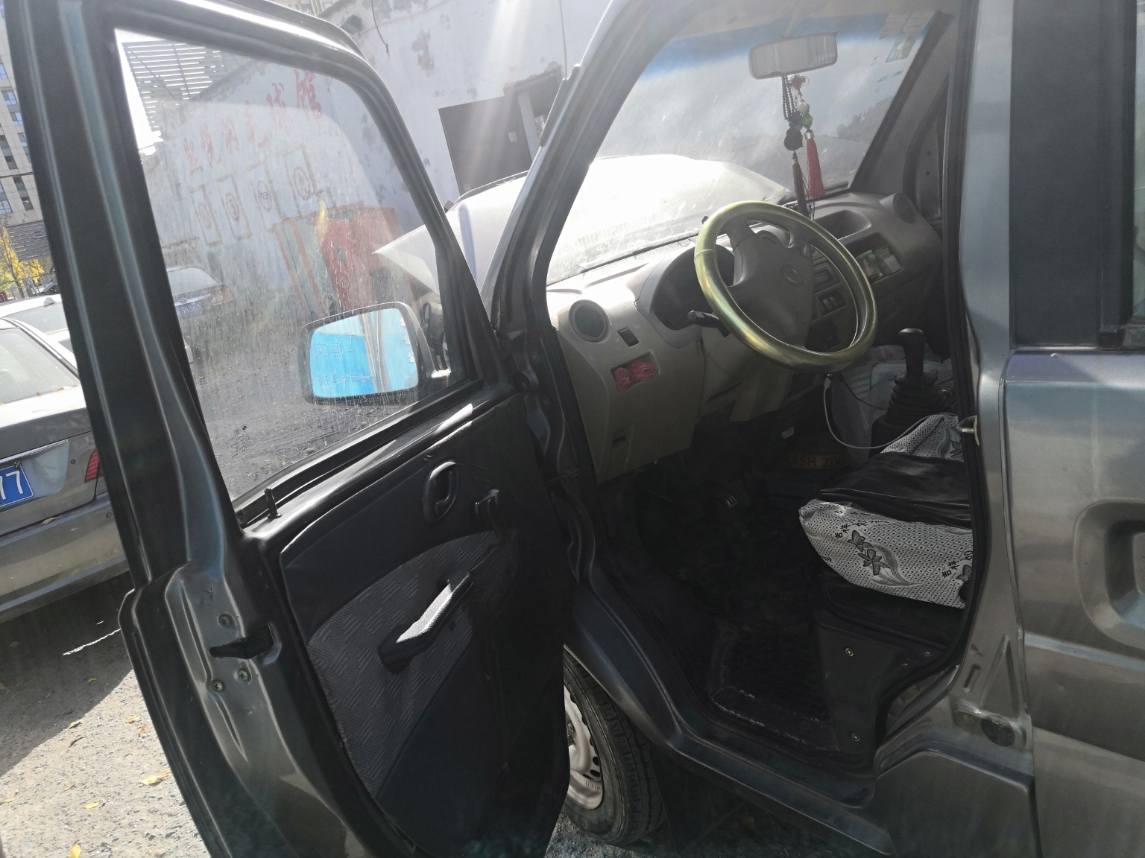
IMG_20201107_123536.jpg | IMG_20201107_123539.jpg | IMG_20201107_123136.jpg
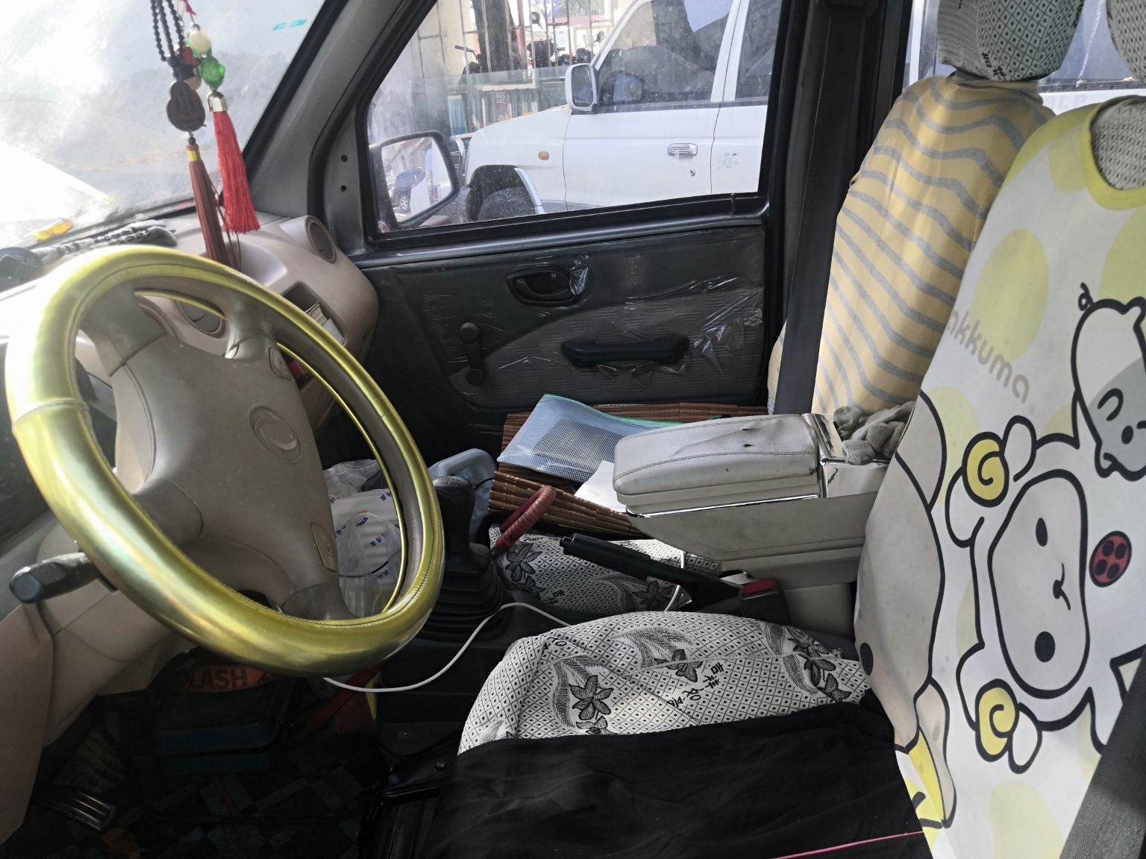 | 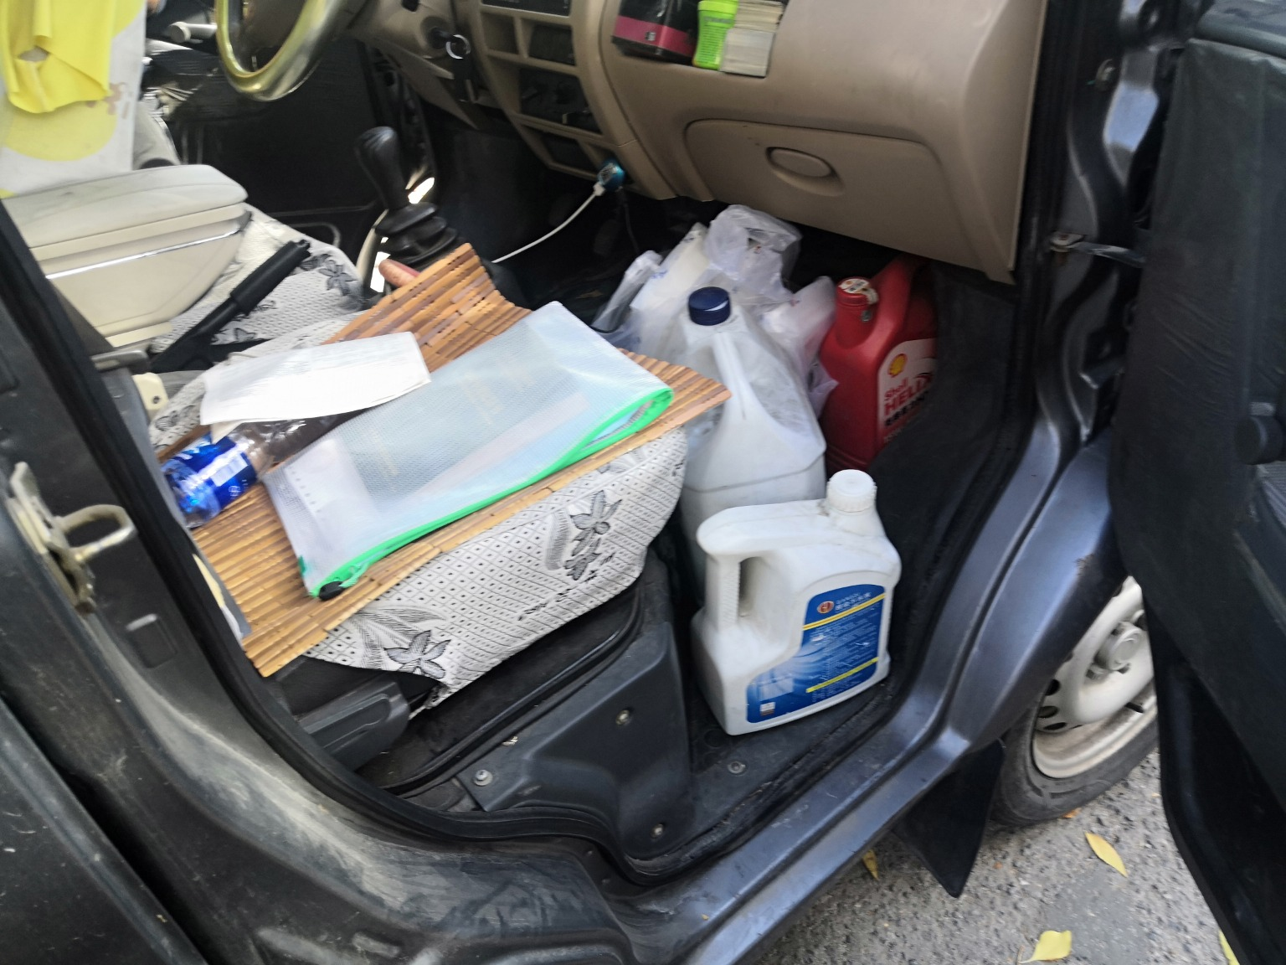 | 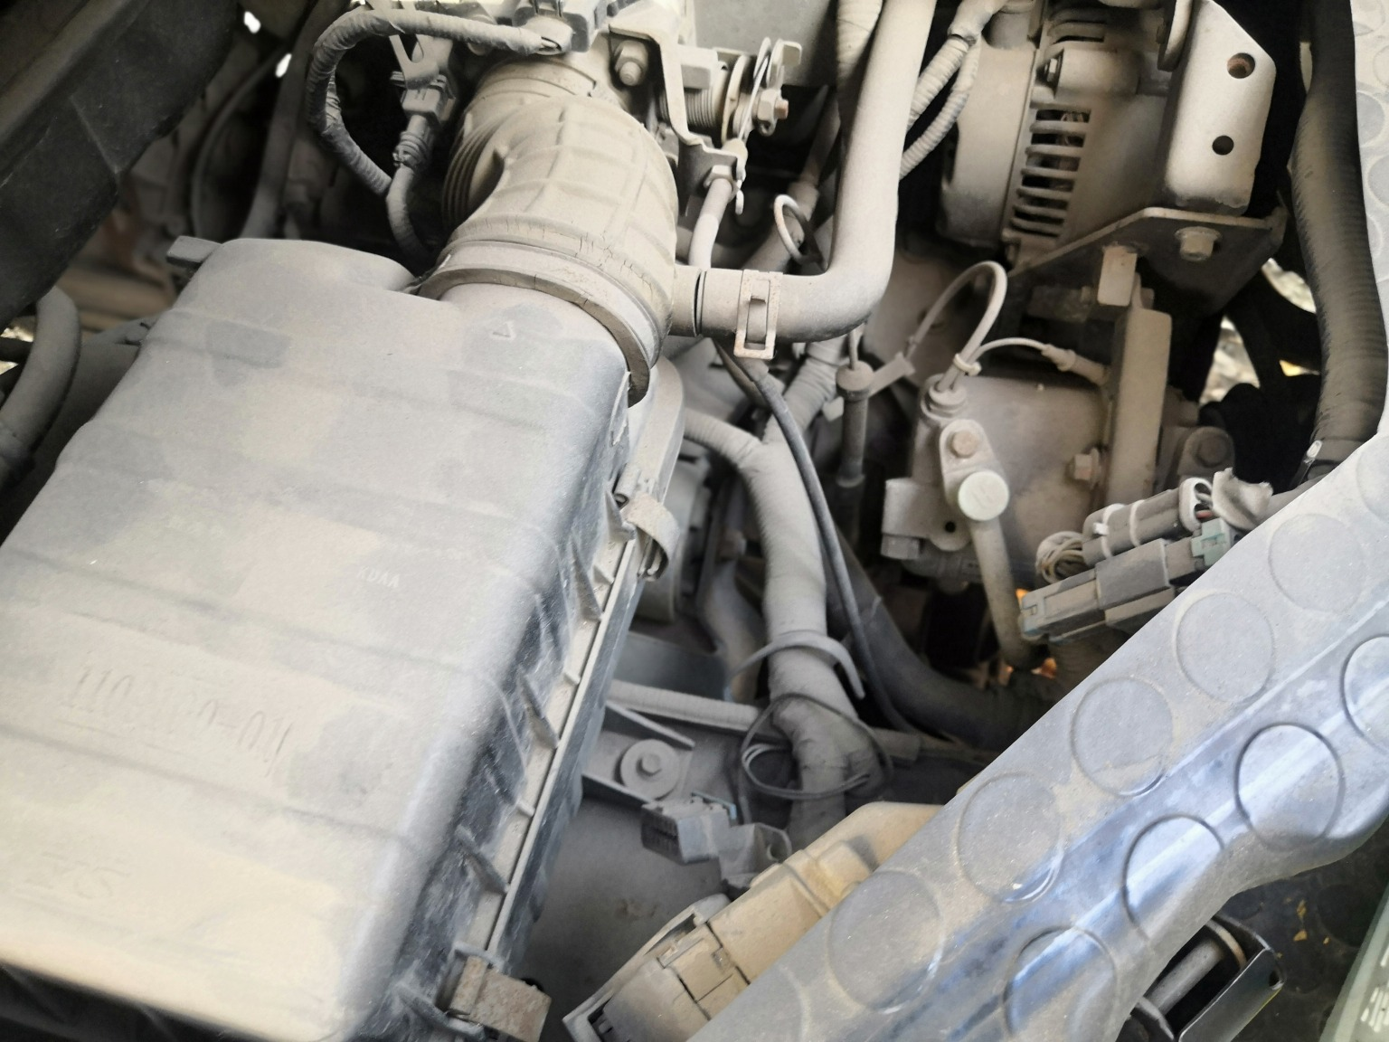
IMG_20201107_123200.jpg | IMG_20201107_123346.jpg | IMG_20201107_123433.jpg

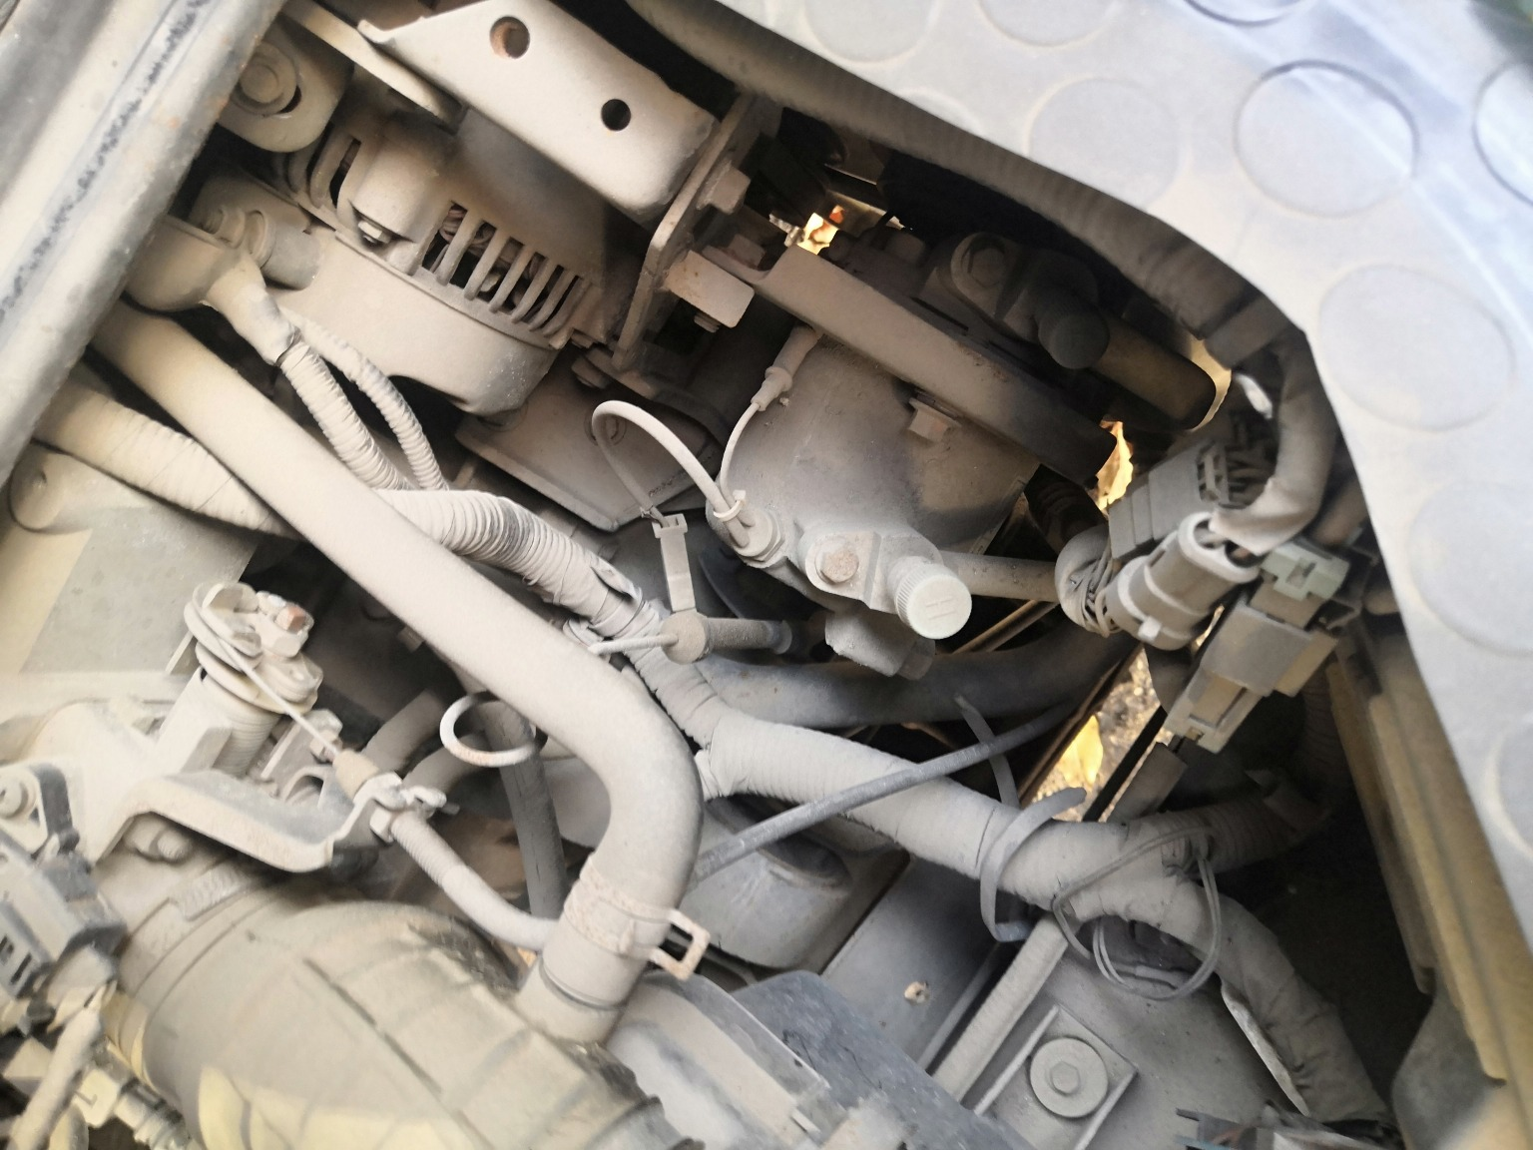 | 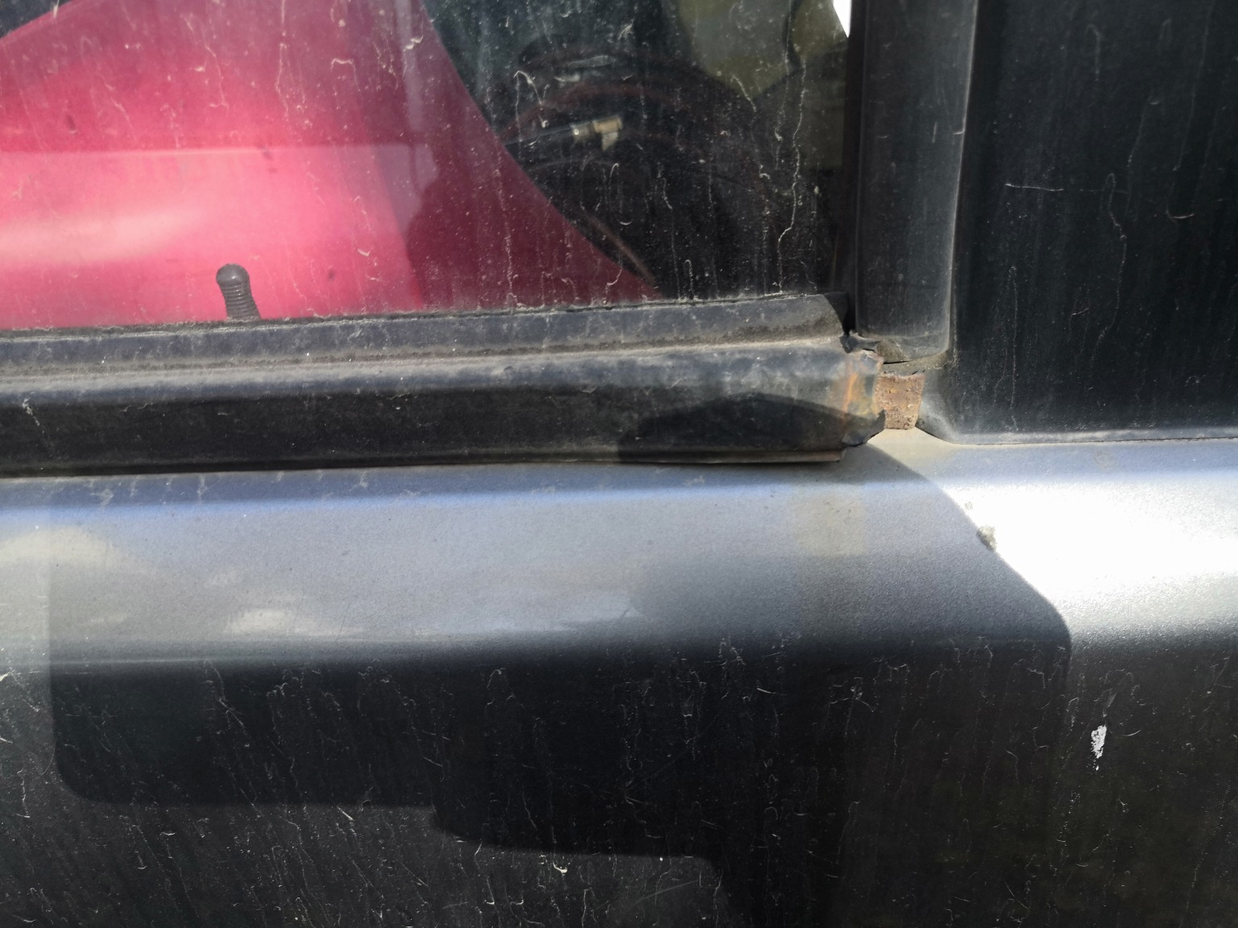 | 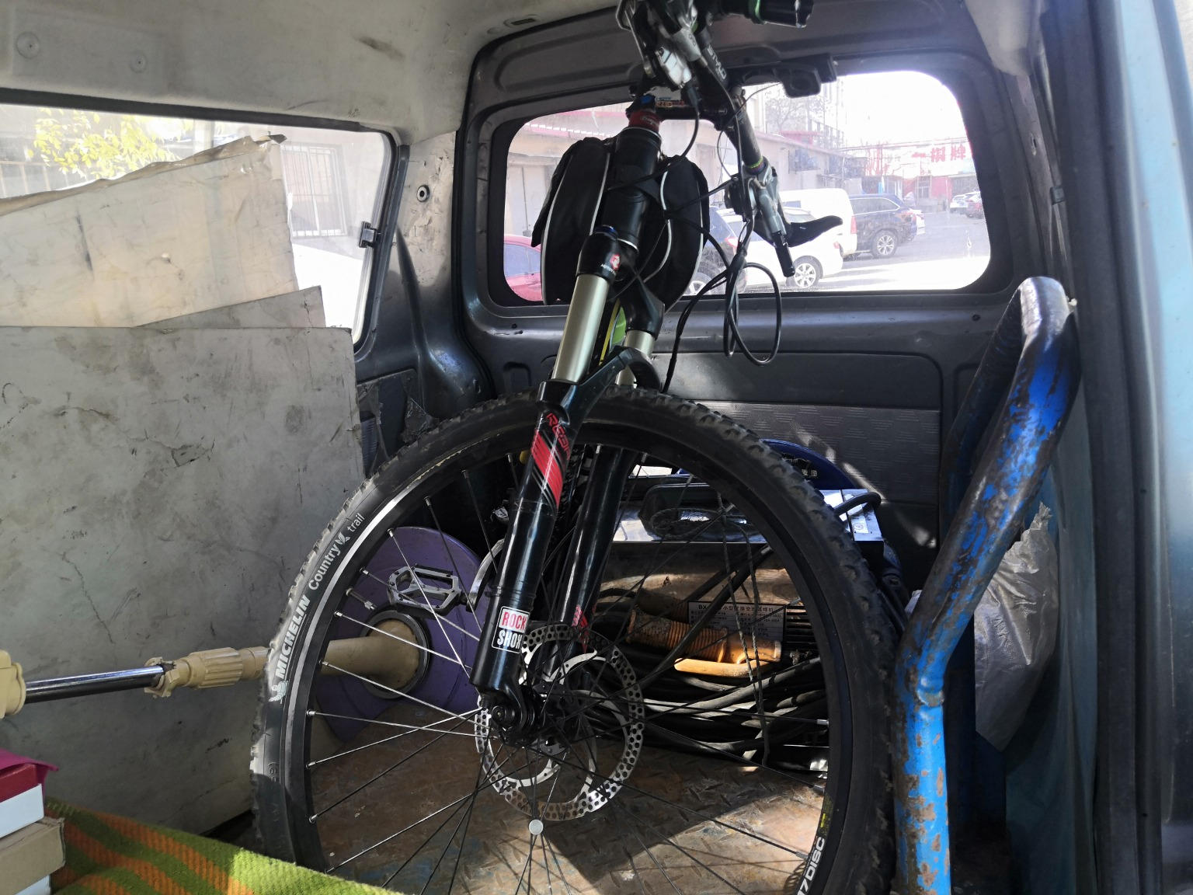
IMG_20201107_123436.jpg | IMG_20201107_123447.jpg | IMG_20201107_123511.jpg
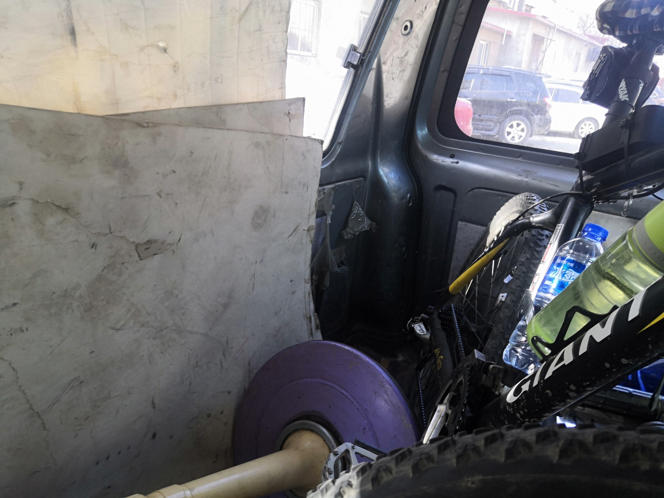 | 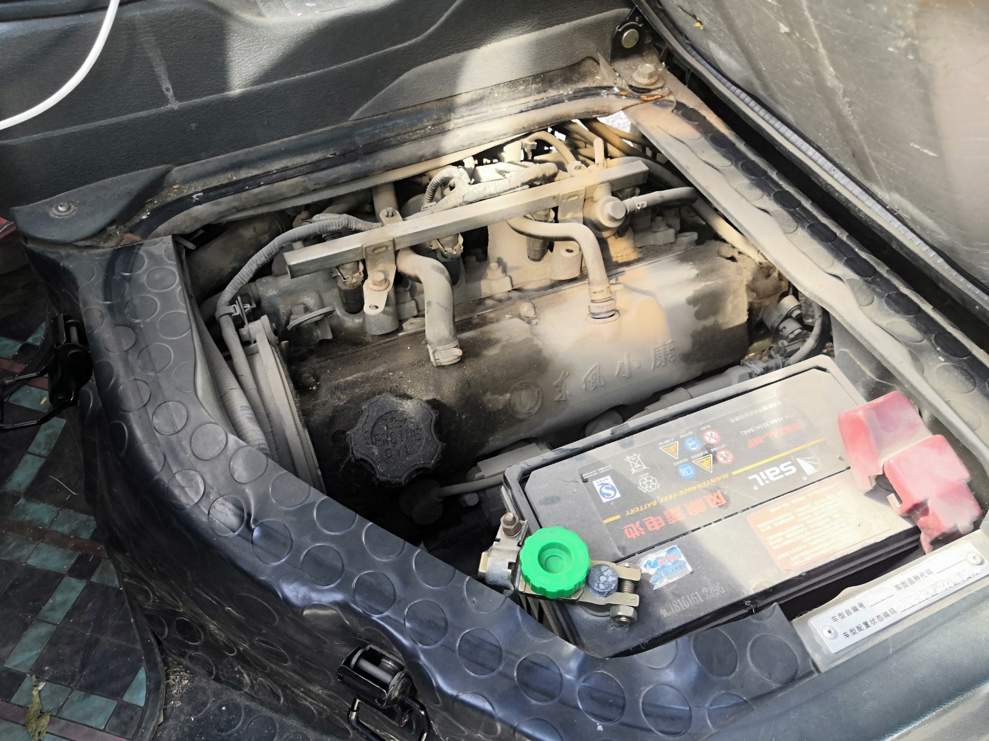 | 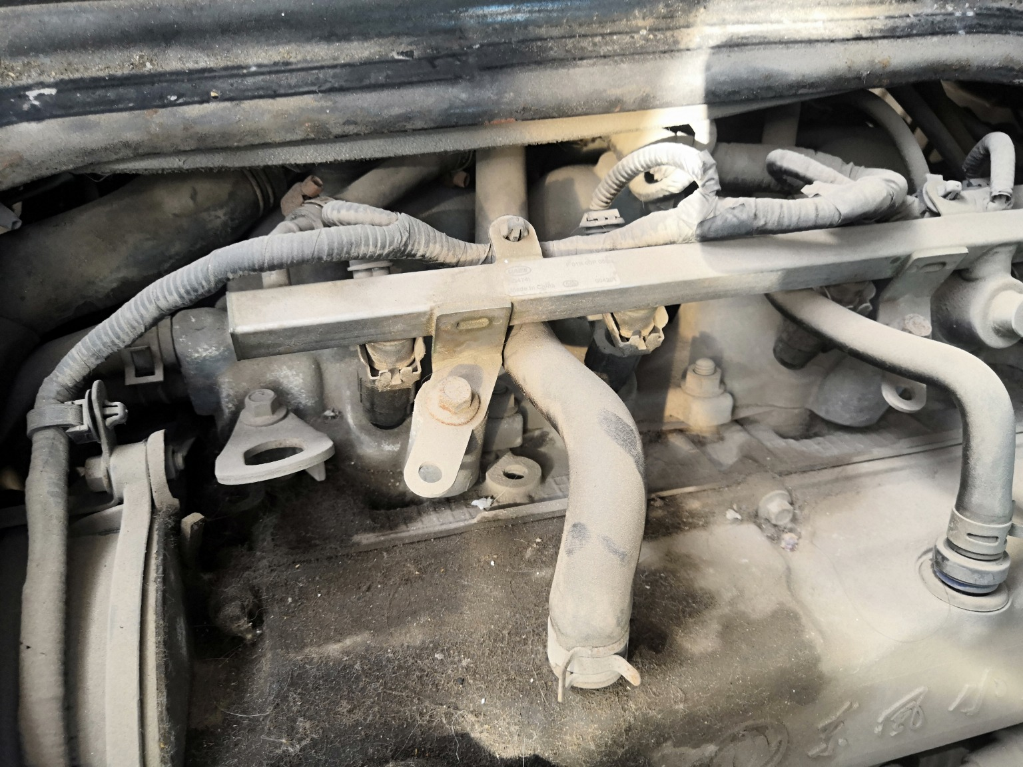
IMG_20201107_123522.jpg | IMG_20201107_123302.jpg | IMG_20201107_123324.jpg
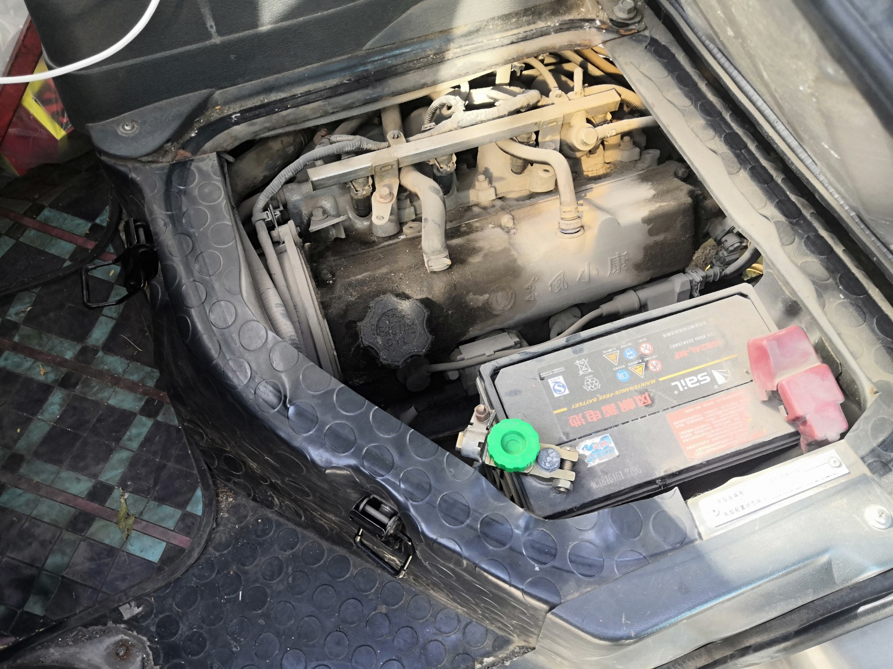 | 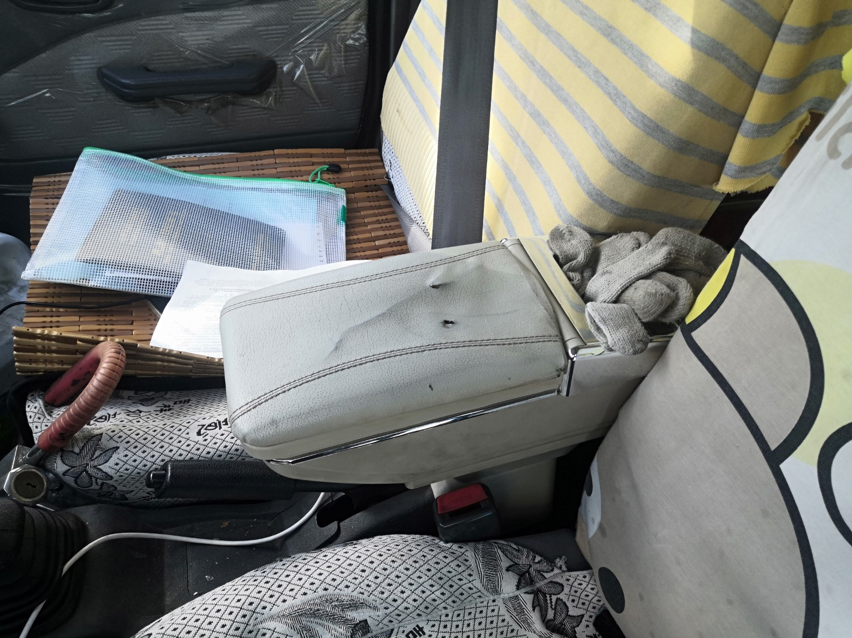
IMG_20201107_123330.jpg | IMG_20201107_123234.jpg

